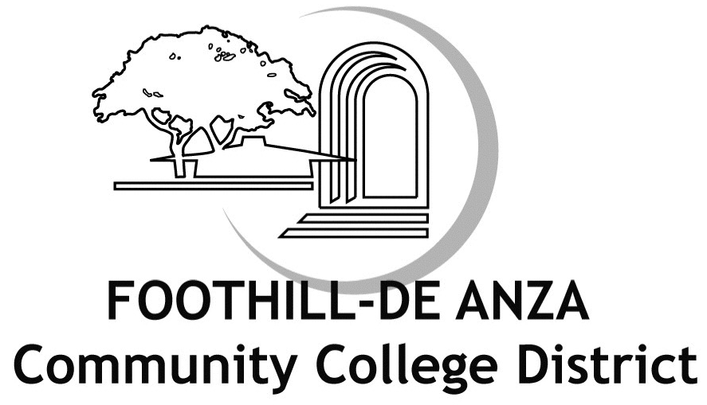
FHDA Verification#: Last Four of SSNMMDDYYYY

COVER SHEET FOR DEPENDENT VERIFICATION

You must submit this Cover Sheet for Dependent Verification along with the required documents for ALL selected eligible dependents by June 22, 2011 to avoid a lapse in benefits coverage.
<Employee Name>
Refer to the enclosed Verification Letter for detailed instructions on how to submit your documentation via one of the following methods:
UPLOAD ONLINE: https://verify.secova.com/FHDA
FAX: 1-866-585-6860 MAIL: Secova Service Center
PO Box 1901
Wall, NJ 07719-9966

<Address 1>
<Address 2>
<City, State Zip>

Please be advised that the list provided below only includes “SELECTED” dependents for the Dependent Eligibility Audit (DEA) for the benefits Plan Year 2011/2012.

Other enrolled dependents not listed below do not require verification for this plan year only. This process may be subject to change.
If you select “No” or do not respond for any dependent(s) listed below by June 22, 2011, your dependent(s) will be removed from your coverage effective June 30, 2011.

Dependent Name  (Proof of eligibility is required for all selected eligible dependents listed below) | Is dependent eligible for coverage? | Relation | Dependent Type  Check all that apply for each selected eligible dependent
SUZY SAMPLE | Yes No | Spouse or  Domestic Partner | Legally Married  CA-Registered Same-Sex Domestic Partner
MARY SAMPLE | Yes No | Child | Biological  Biological (Domestic Partner’s)  Adopted  Adopted (Domestic Partner’s)  Stepchild | Foster child  Legal Guardianship  Court Ordered (NQMSO)  Disabled
JOE SAMPLE | Yes No | Child | Biological  Biological (Domestic Partner’s)  Adopted  Adopted (Domestic Partner’s)  Stepchild | Foster child  Legal Guardianship  Court Ordered (NQMSO)  Disabled

Remember, you must send “ALL” required documents…not just this Verification Cover Sheet. Please refer to the enclosed Dependent Definitions and Required Documents for a detailed listing of acceptable documentation (selected dependents ONLY).
Contact Information
Please provide an email address and telephone number at which you can be reached if we have questions about your dependent’s eligibility for coverage.
E-mail address: | Telephone: ( )
Please indicate your preferred method for receiving communications throughout the course of this verification project:
E-mail First Class Mail
Declaration: Signature is required. Cover Sheets submitted without a signature will be considered incomplete.
I declare that the attached information I am submitting to prove eligibility for my spouse, domestic partner and/or dependent child(ren) under the District’s benefit plans is true, accurate, and complete. I understand that if I have provided false, incomplete or misleading information or if I fail to update this information in accordance with eligibility guidelines, I may be subject to the following: reduced coverage levels, repayment of any claims or premiums paid by the District and/or termination of dependent(s) District benefit coverage.

Employee’s Signature Date

If you have questions, please call Secova at 1-866-364-2594.
Representatives are available M-F 8:00 AM-6:00 PM PST.

