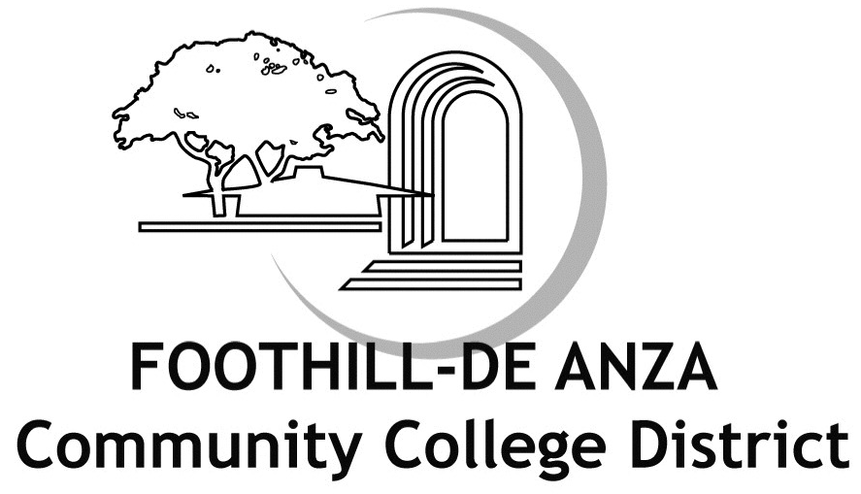
FHDA Verification#: Last Four of SSNMMDDYYYY

VERIFICATION FORM
FOR DEPENDENT ELIGIBILITY

Return form to Secova by September 30, 2010

FAX: 1-866-585-6860
EMAIL: fhda.benefits@secova.com

MAIL TO: Secova Eastern Service Center
P O Box 7701
Brick, NJ 08723-9906

*WEB SITE: https://verify.secova.com/fhda

<Employee Name>
<Address 1>
<Address 2>
<City, State Zip>

September 1, 2010

As of the date above, your dependents listed below are enrolled in the District’s health benefits. Please review the Definitions and Required Documents and confirm that these dependents are eligible for coverage by taking one of the following actions:

Option #1:
* ACCESS the District’s Dependent Eligibility Verification web site at https://verify.secova.com/fhda for instructions on verifying dependent eligibility on-line; OR

Option #2:
* Complete this Verification Form for Dependent Eligibility, verifying each dependent’s eligibility for benefits by checking the specific Dependent Type and “Yes” or “No” to indicate if the dependent is eligible for coverage.
a) Review the Required Documents list for each dependent type currently enrolled.
b) Submit the Required Documentation, along with the completed Verification Form for Dependent Eligibility to Secova by mail
using the enclosed postage-paid envelope or fax to 1-866-585-6860 no later than September 30, 2010. Please write your full name and FHDA Verification Number (Last 4 digits of your Social Security Number, followed by SSN#MMDDYYYY) in the top right hand corner of each document copy.
If If you select “No” or do not provide the required documentation for any dependent(s) listed below by September 30, 2010 that dependent’s health benefits coverage will be terminated effective September 30, 2010.
(Proof of eligibility is required for all boxes checked “YES”)
Dependent | Relation | Dependent Type (Please check all boxes that apply for each dependent) |  | Is dependent eligible for coverage?
Suzy Doe | Spouse | Legally Married |  | Yes No
John Doe | Son | Biological  Adopted  Stepchild  Disabled | Full-time Student  Legal Guardianship  Court Ordered | Yes No
Susie Doe | Daughter | Biological  Adopted  Stepchild  Disabled | Full-time Student  Legal Guardianship  Court Ordered | Yes No
Contact information
Please provide a telephone number at which you can be reached if we have questions about your dependent’s eligibility for benefits coverage.

Telephone: Best time to call: Day Evening

E-mail address: (circle one)

I declare that the attached information I am submitting to prove eligibility for my spouse and/or dependent child(ren) under the District’s benefit plans is true, accurate, and complete. I understand that if I have provided false, incomplete or misleading information, or if I fail to update this information in accordance with eligibility guidelines, I may be subject to the following: reduced coverage levels, repayment of any claims or premiums paid by the District, termination of dependent(s) District benefit coverage.

Signature Date

If you have questions, please call Secova at 1-866-364-2594.
Representatives are available M-F 8:00 AM-6:00 PM PST.

