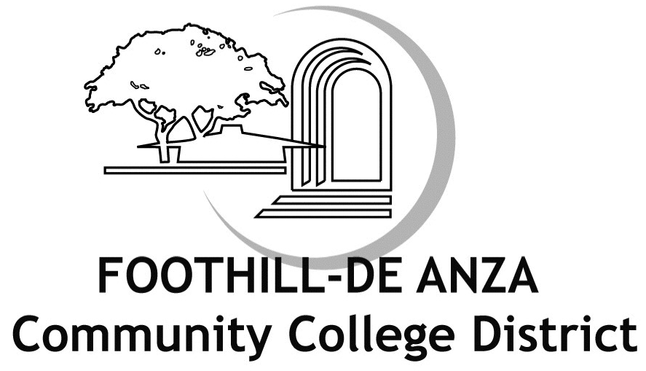
FHDA Verification#: SSN#DDMMYYYY

VERIFICATION FORM
FOR DEPENDENT ELIGIBILITY

Return form to Secova by June 15, 2009

FAX: 1-866-585-6860
EMAIL: fhda.benefits@secova.com

MAIL TO: Secova Western Service Center
PO Box 50490
Pasadena, CA 91115-9962

*WEB SITE: https://verify.secova.com/fhda

EMPLOYEE NAME
STREET ADDRESS
CITY, STATE ZIP CODE

May 27, 2009

As of the date above, your dependents listed below are enrolled in the District’s health benefits. Please review the Definition of Eligible Dependents and confirm that these dependents are eligible for coverage by taking one of the following actions:

Option #1:
* ACCESS the District’s Dependent Eligibility Verification web site at https://verify.secova.com/fhda for
instructions on verifying dependent eligibility on-line; OR

Option #2:
* Complete this Verification Form, verifying each dependent’s eligibility for benefits by checking the specific Dependent Type and “Yes” or “No” to indicate if the dependent is eligible for coverage.
a) Review the Required Documents list for each dependent type currently enrolled
b) Submit the Required Documentation, along with the completed Verification Form to Secova by mail using the enclosed postage-paid envelope or fax to 1-866-585-6860 no later than June 15, 2009. Please write your full name and FHDA Verification Number (Last 4 digits of your Social Security Number, followed by your date of birth: SSN#MMDDYYYY) in the top right hand corner of each document copy.
If If you select “No” or do not provide the required documentation for any dependent(s) listed below by June 15, 2009 that dependent’s health benefits coverage will be terminated effective June 30, 2009.
(Proof of eligibility is required for all boxes checked “YES”)
Dependent | Relation | Dependent Type (Please check all boxes that apply for each dependent) |  | Is dependent eligible for coverage?
Last Name, First Name | Spouse | Legally Married |  | Yes No
Last Name, First Name | Son | Biological  Adopted  Stepchild  Disabled | Full-time Student  Legal Guardianship  Court Ordered | Yes No
Last Name, First Name | Daughter | Biological  Adopted  Stepchild  Disabled | Full-time Student  Legal Guardianship  Court Ordered | Yes No
Contact information
Please provide a telephone number at which you can be reached if we have questions about your dependent’s eligibility for benefits coverage.

Telephone: Best time to call: Day Evening

E-mail address: (circle one)

I declare that the attached information I am submitting to prove eligibility for my spouse and/or dependent child(ren) under the District’s benefit plans is true, accurate, and complete. I understand that if I have provided false, incomplete or misleading information, or if I fail to update this information in accordance with eligibility guidelines, I may be subject to the following: reduced coverage levels, repayment of any claims or premiums paid by the District, termination of dependent(s) District benefit coverage.

Signature Date
If you have questions, please call Secova at 1-866-364-2594. (Representatives are available M-F 8:00 AM-6:00 PM PST.)

