ARGOS Report Writer Training

A consultant will be on-site the week of June 13th to train end-user on writing ARGOS reports. Users who wish to attend a one-day training session need to:
- Send Kari Elliot (elliottkari@fhda.edu) an e-mail no later than May 23 if you want to be included in the end-user Report Writer training. You will be scheduled via Meeting Maker into one of the three sessions on June 14th, 15th or 16th. If you have a preference for one day, please indicate it in the e-mail.
- Complete the following tasks by June 6th:
  - Sign in to the EVISIONS web site and complete the Online Live or Online Recorded training for Report Viewer and Report Writer. Go to www.evisions.com and login using the User Name: “Chien Shih” and Password “12345”.
  - Select Services/Training and then Online Live or Online Recorded.
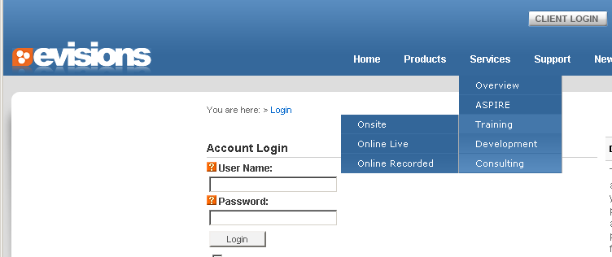

  - Send Susan Malmgren (malmgrensusan@fhda.edu) an e-mail with a statement that you have completed the prerequisite training and will be attending the class on the scheduled date. Include you 8 digit CWID. This will insure that you will have access to ARGOS during the class.

- If you wish to access “Student Data” such as grades, contact information, student schedules, etc, that is covered by FERPA regulations, you must be granted access to that data under the Student Dashboard. Permissions are granted by Admissions and Records for each college. The “Permission Request Form” can be downloaded here: http://fhdafiles.fhda.edu/downloads/callcenter/PermissionRequestForm.pdf
You will not be given access to ARGOS reports or datablocks containing this information without approval from A&R.

