Overview
The migration to Meeting Maker Ver 8.5 requires that the client software that runs on computers using the MS/Windows operating system have to change. The client software installation effort is accomplished as part of the initial login to Meeting maker Ver 8.5.

If you do not have Meeting Maker already installed on your workstation, contact the Call Center at x8324.

If you have Meeting Maker already installed on your workstation, execute the following instructions. If you encounter problems, contact the Call Center at x8324.

Login Into Meeting Maker
On your computer’s desktop, double click on the Meeting Maker icon. The following login screen is displayed:

Type in your current Meeting Maker user name
Type in your current Meeting Maker password

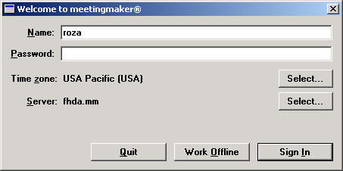

Click on the Sign In Button

After clicking on the Sign In button, the following dialog box is displayed. Meeting Maker has determined that the client software is not the same version as the software running on the Meeting Maker server.

Click on the Yes button to install the Version 8.5 client software

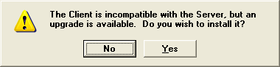

The client software installation process is working. Depending on the speed of your computer and other activities occurring on the Network, this portion of the install process could take anywhere form 5-15 minutes.

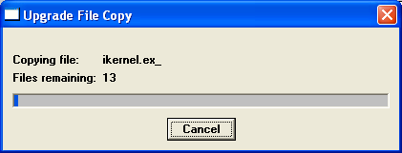

Meeting Maker will automatically being the client software install process by loading what is called a Wizard. The following screen will be displayed. Do NOT click on the Cancel button

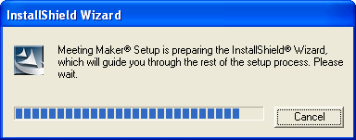

The Meeting Maker Client software install Wizard window is displayed.

Click on the Next button

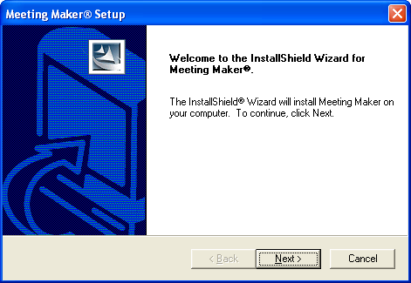

The Wizard then begins the install of the various software routines required for the Version 8.5 client. The following screen will be displayed and reflect the status of installing the software:

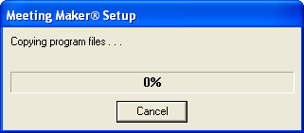

Once the Wizard has downloaded the software routines, the following screen is displayed.

Make sure only the first of the 3 buttons (Move local Meeting Maker database) are highlighted

If the others are also highlighted,
click on the circle next to each to turn them off

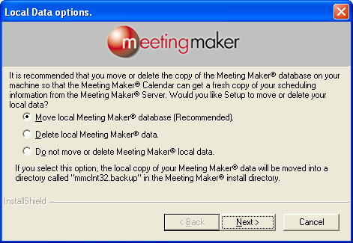

Then click on the Next button to continue the process

When the following screen is displayed, click on the Yes button

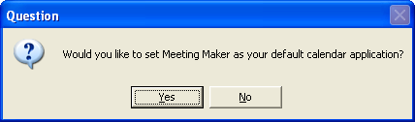

When the following screen is displayed, uncheck the first two items in the list by clicking on the box next to each:

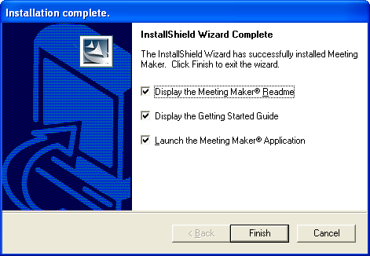

After unchecking the first two items, the page should appear as shown here:

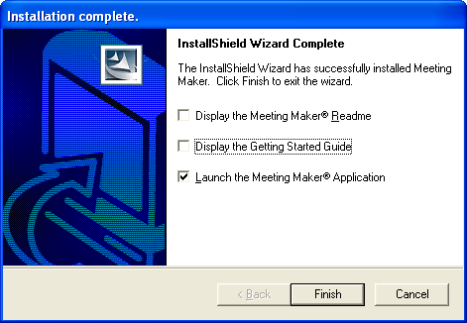

Click on the Finish button

When the installation process completes, you will need to re-login into Meeting Maker.

On your computer’s desktop, double click on the Meeting Maker icon. The following login screen is displayed:

Type in your current Meeting Maker user name
Type in your current Meeting Maker password

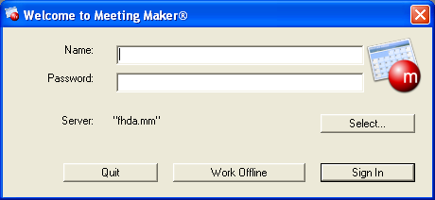

Click on the Sign In Button

The following screen is displayed as Meeting Maker loads your current calendar. This process could take from 1-10 minutes depending on the number of appointments in your calendar and traffic on the Network

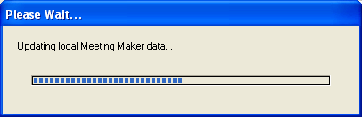

Once your calendar is loaded, Meeting Maker will display your calendar using one several view. This example is a Daily View

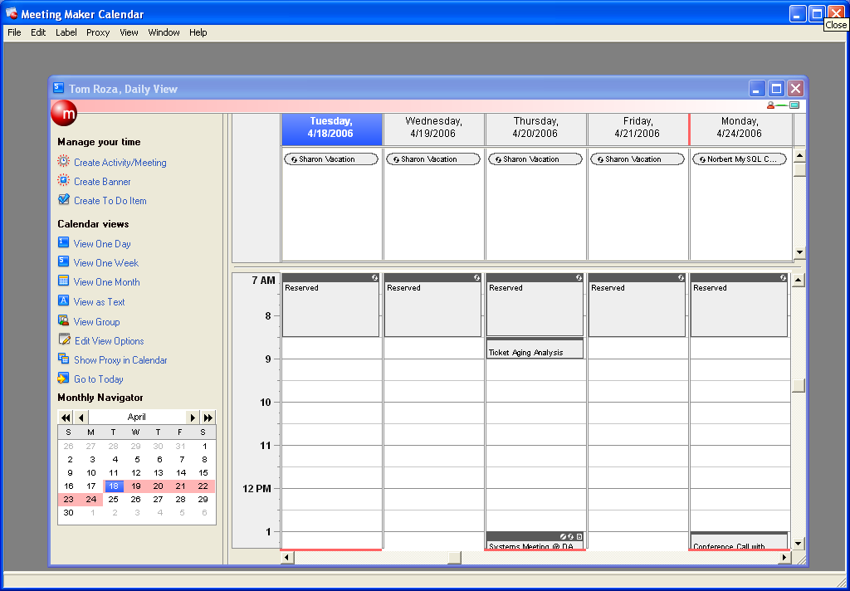

This completes the Version 8.5 client software installation for MS/Windows computers

