Webmail User’s Guide

Overview
Webmail from the SquirrelMail Project Team consortium provides a secured web-based capability to access email that has been sent to a person’s Foothill-De Anza email account. The SquirrelMail version of Webmail has much more functionality then the previous version of “Webmail” or the software product called “Mailreader”.

The new Webmail provides access to email that is still resident in a person’s District mailbox that resides on the main email server. Said another way, email can be viewed that has not yet been transferred (downloaded or copied) to a person’s computer using an email client such as Eudora or Outlook. Once email has been transferred (downloaded or copied) to a person’s computer, email messages are removed from the mailbox on the District’s main email server.

With Webmail, a person can read email messages, send email messages with text formatting, and lookup email addresses of other District email users. Unlike the previous version of Webmail or Mailreader, Webmail comes with a folder functionality. By default, there are 4 folders provided: Inbox, Drafts, Sent, and Trash. The new Webmail also provides the capability to create personally named folders.

Note: There is no capability in Webmail to access folders or email messages that have been transferred (downloaded or copied) to a person’s computer using the Eudora or Outlook email client. Webmail & Eudora/Outlook do not have any direct interface.
Webmail uses data encryption methods to secure the sending of email messages and your userid and password when they are used to log into Webmail.

ETS Support Policy for Webmail
As with the previous version of Webmail and Mailreader, Webmail from SquirrelMail is “shareware” software obtained from the Internet. Shareware software has been written by another organization or individuals and offered free-of-charge to anyone who wants to use it.

Therefore, ETS is only providing online documentation for support and will keep the software operational to the best of its ability.
Webmail Login Process & URL

From any browser either on the District network or from the Internet, enter the following URL:
https://webmail.fhda.edu

The Webmail Login Page is displayed

Enter username and password
Click the “Login” button

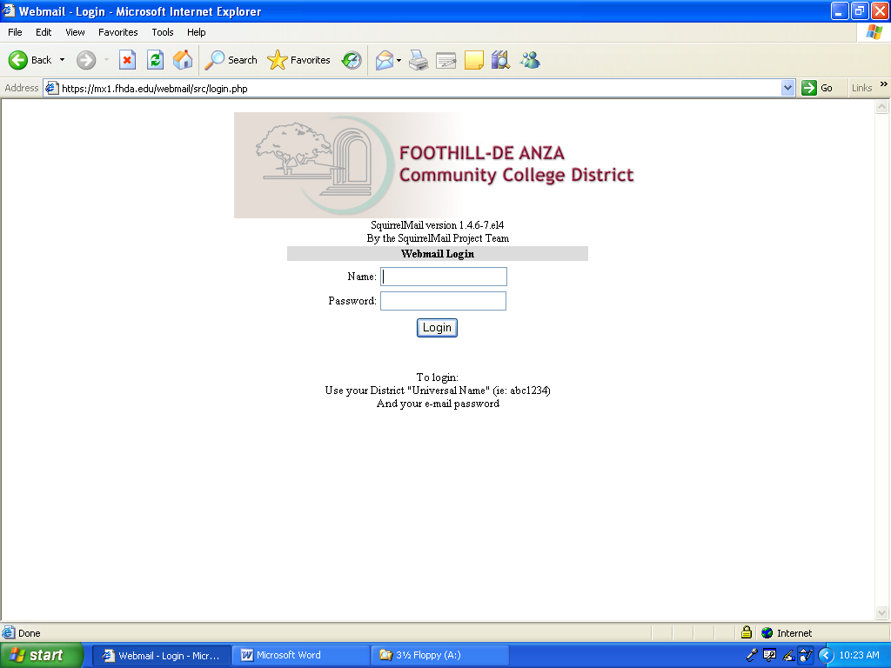

Webmail Home Page

Folders Function Links Number Sign
of Out
Inbox Display Messages

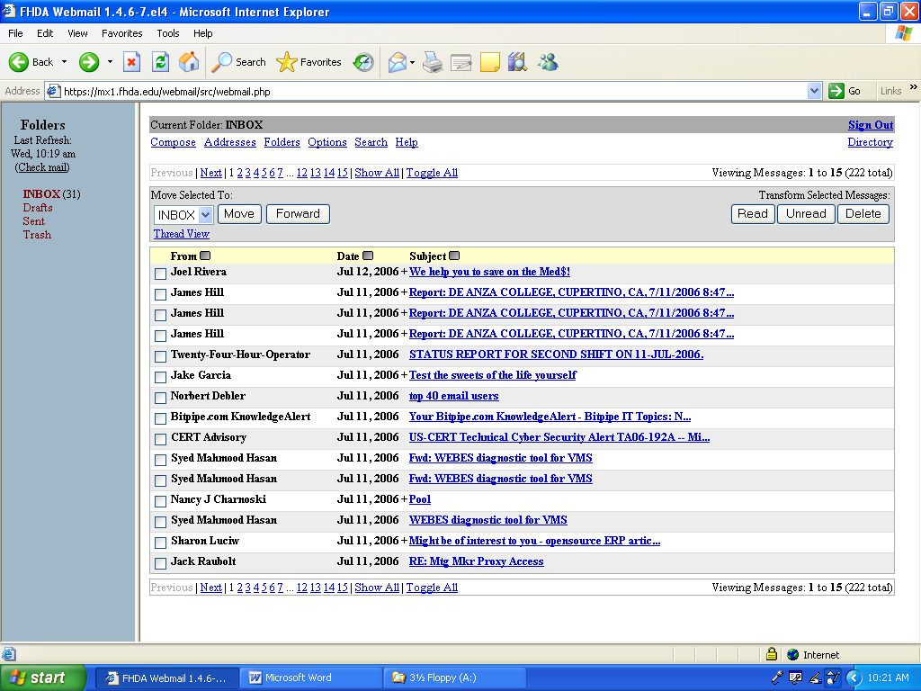

Message/Folder Inbox Scrolling Links Directory
Movement Functions

Compose an Email

Click on the Compose Link

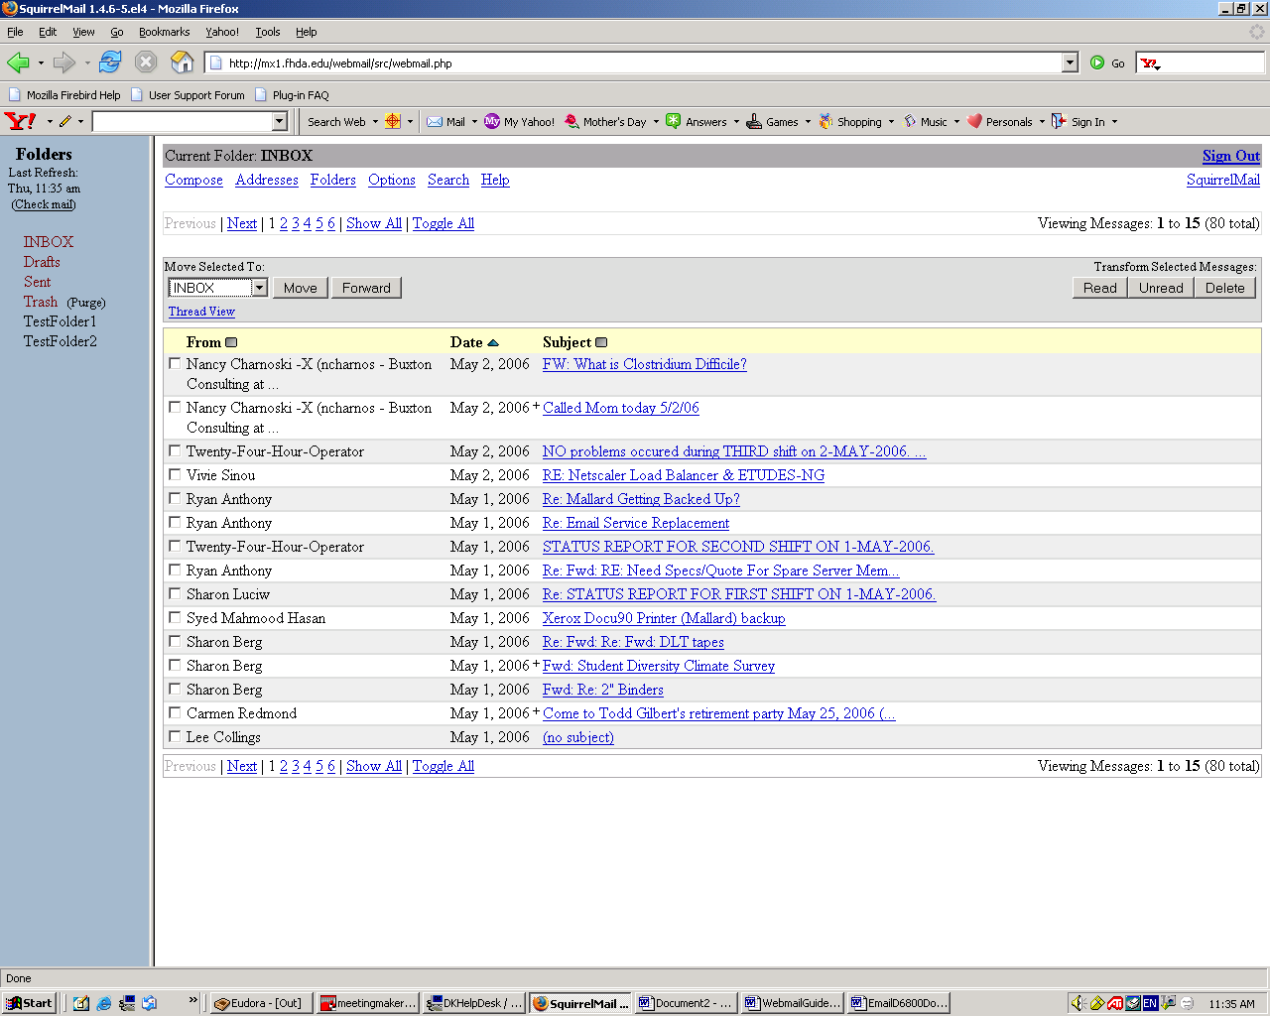

The Compose page is displayed

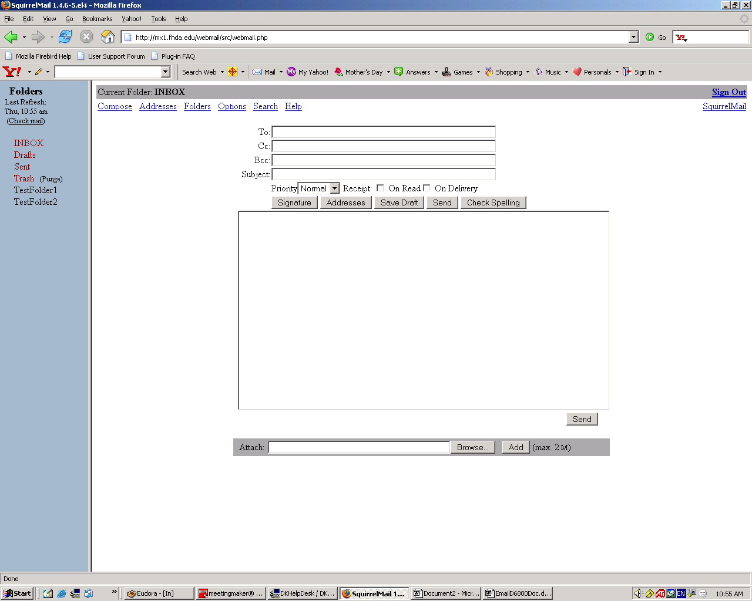
Compose an Email

Enter Mailing & Message Information Composing Options

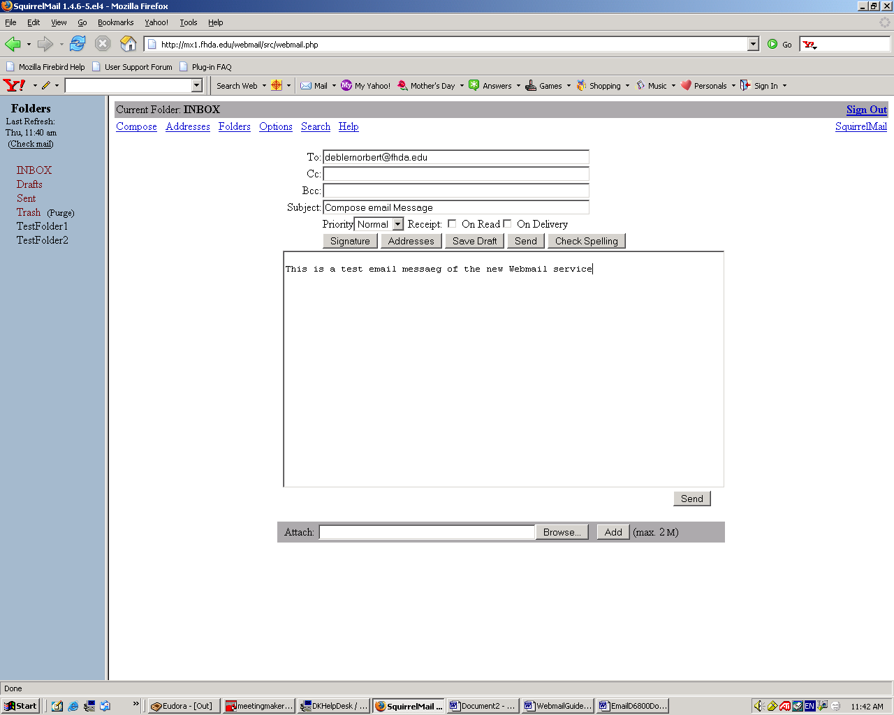

Add Attachments

Click the Send Message Button
to send email message

Updating Personal Address Book

Enter address information Click on Add Address
To add to Address Book

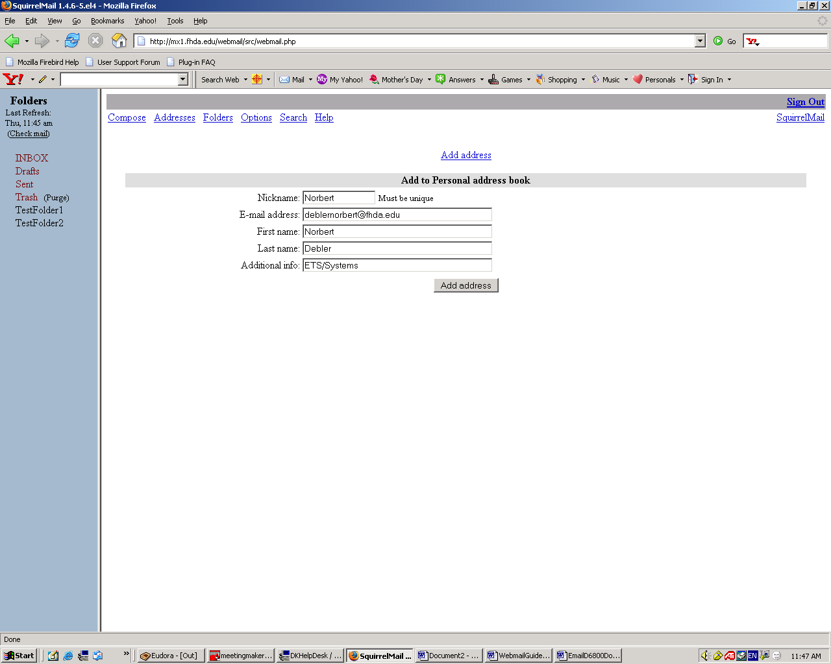

Using the Directory

To Look Up Email Information

To locate a person’s email address, click on the Directory link

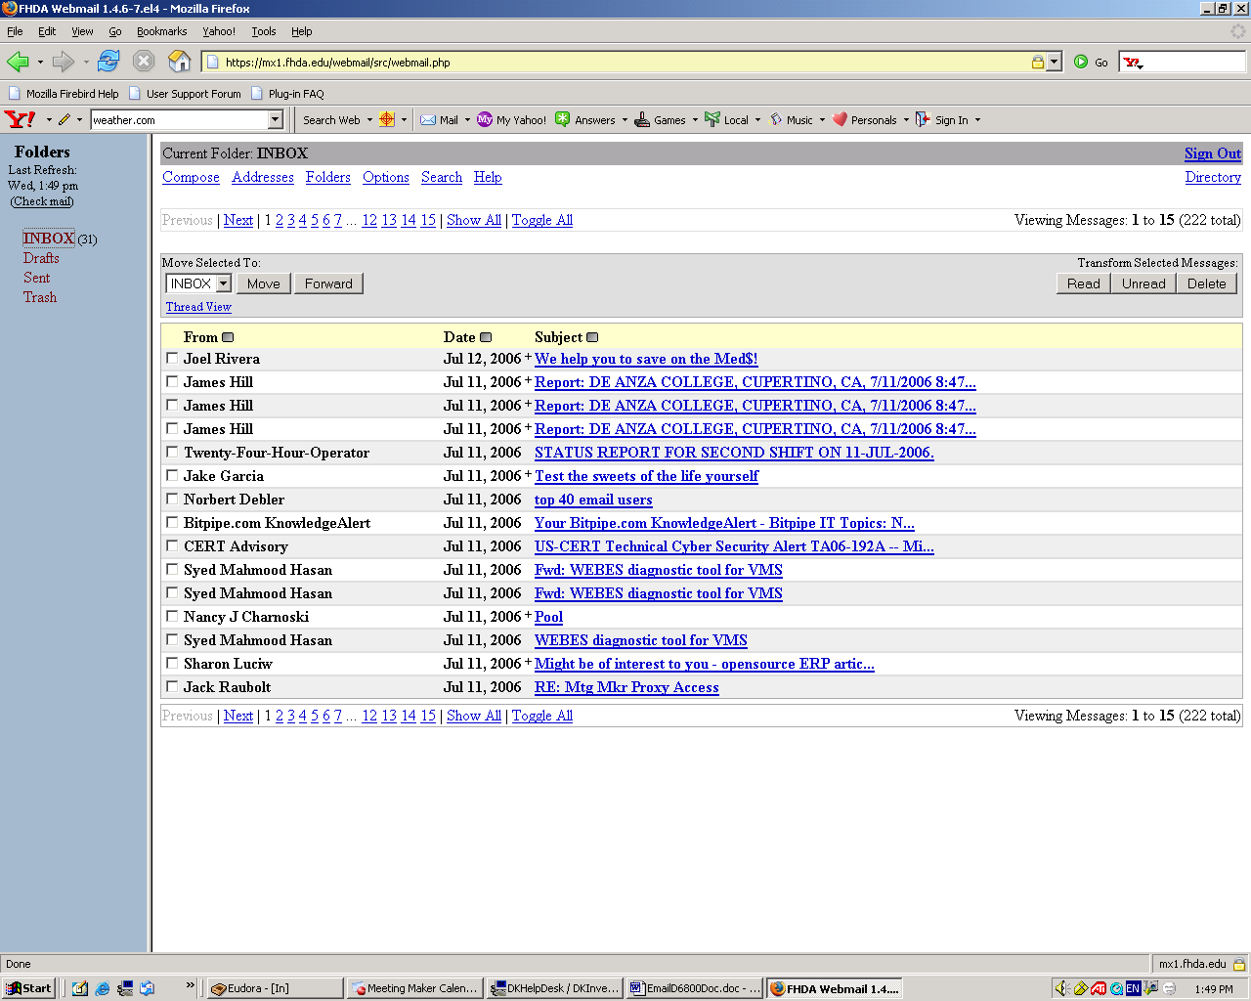

Using the Directory

To Look Up Email Information

Enter the last name of the person you wish to locate
Click on the Search button

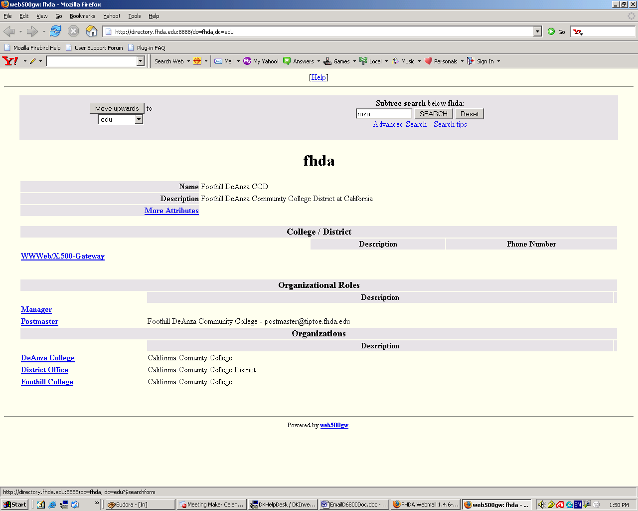

Using the Directory

To Look Up Email Information

The demographic information of the person is displayed as shown below

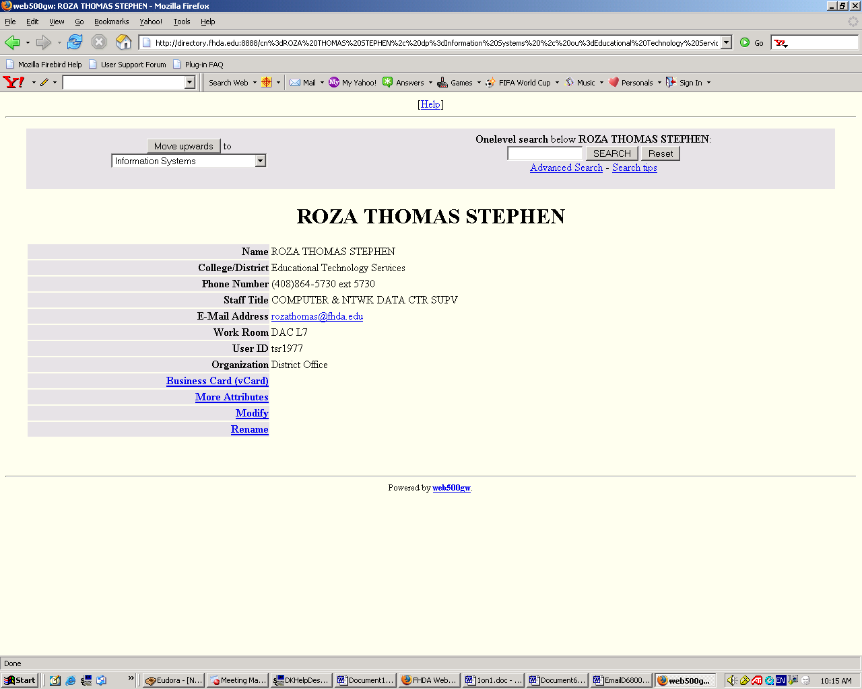

Creating Folders

To create a folder, click on the Folder link

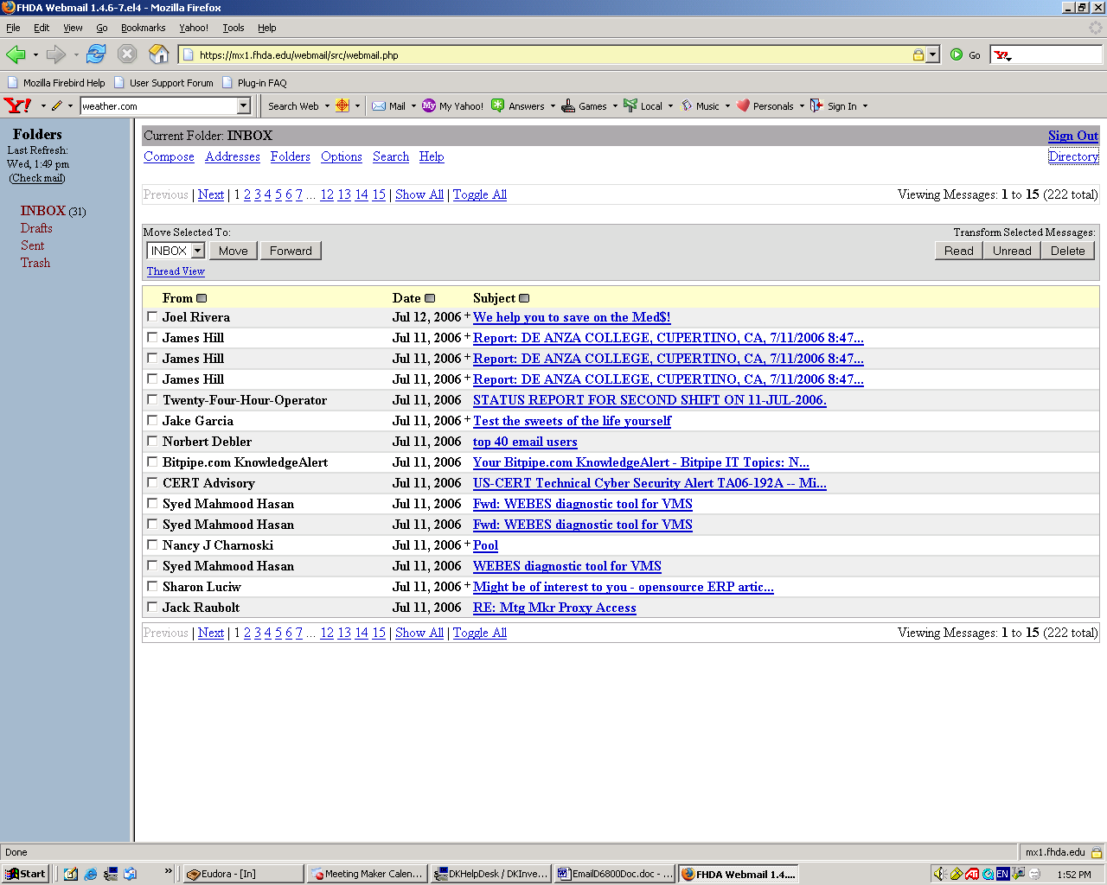

Creating Folders

Type in name of Rename Delete
New Folder Existing Folder Existing Folder

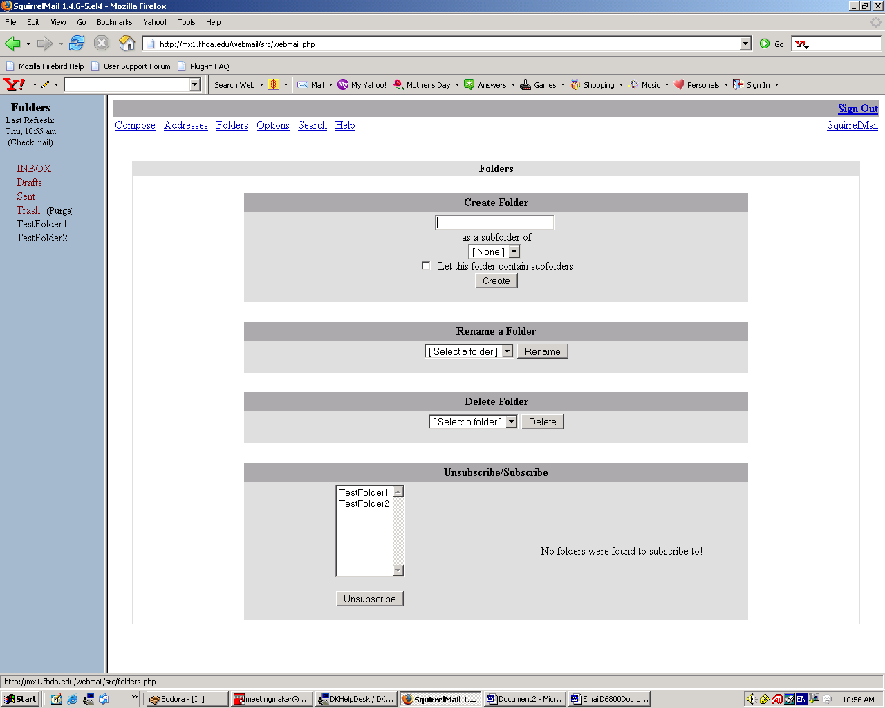

Unsubscribe: removes folder from Folder panel, but does not delete folder

1-Highlight folder name to be unsubscribed
2-Click on Unsubscribe button
Subscribing a Folder

Allows a folder to be used and displayed in the Folder navigation bar

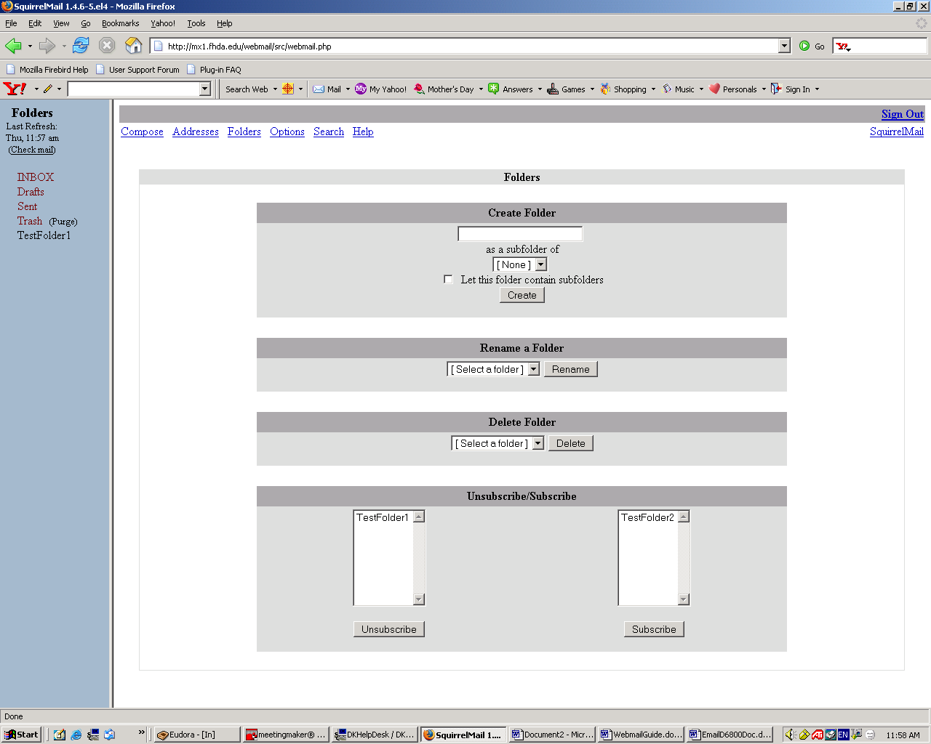

Highlight the folder name Click on the Subscribe button
Webmail Option Settings

To set or change options in Webmail,

click on the Options link

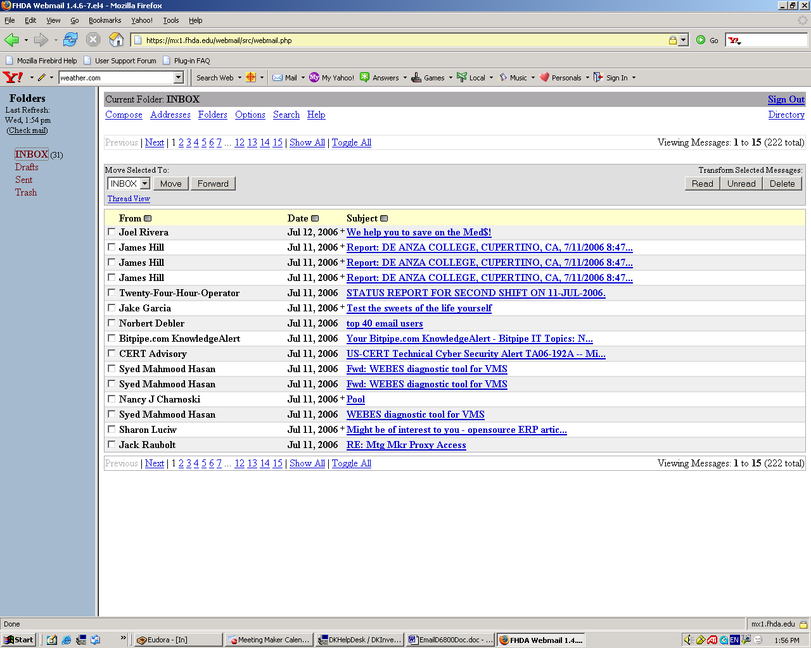
Webmail Option Settings

Options for customizing how your Webmail will function

Click on the links to select an option

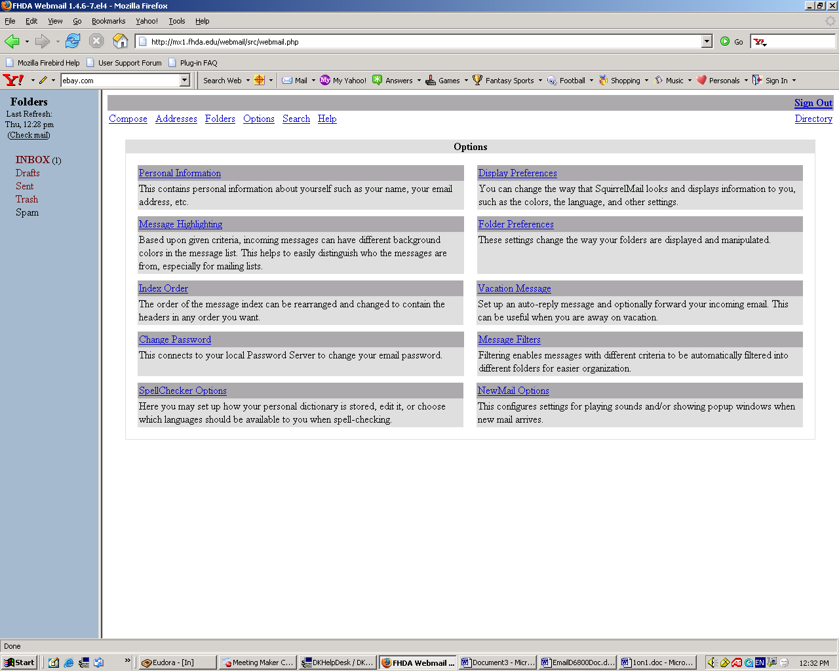
Options- Personal Information

Enter the applicable information

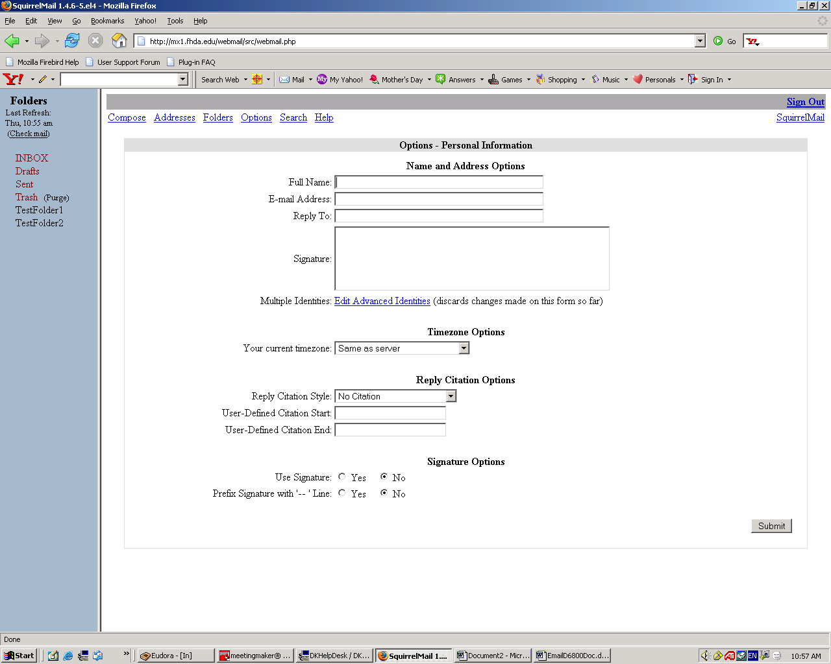

Click the Submit button to update
Options – Message Highlighting

Click on the buttons to select the highlighting shade

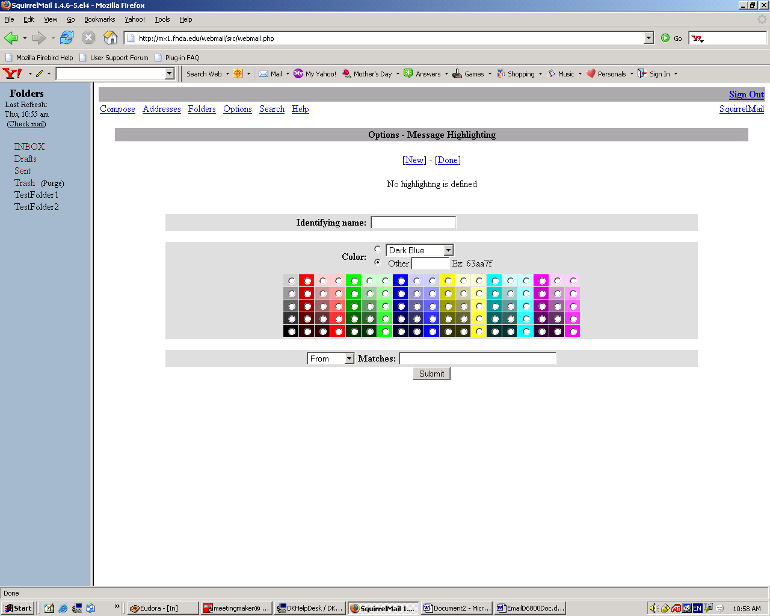

Click the Submit button to update
Options – Index Ordering

Click on the desired link

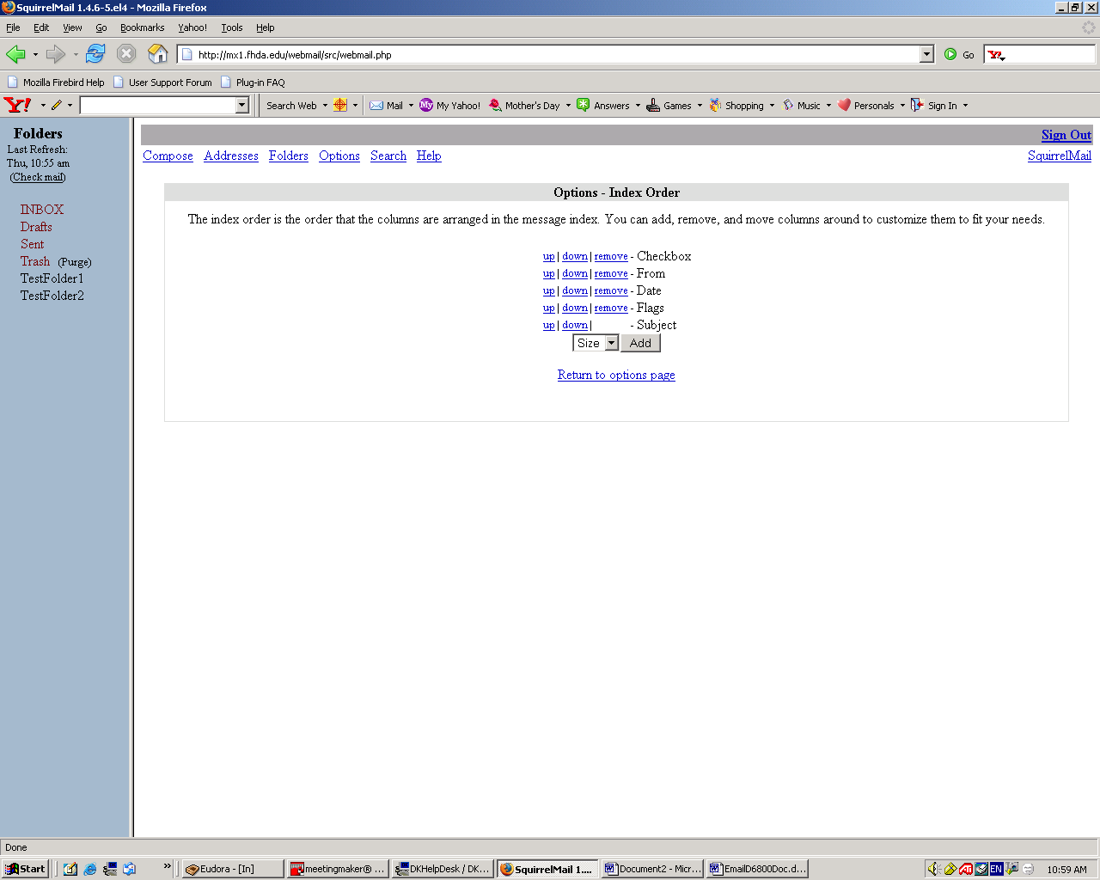
Options – New Mail

Click the appropriate button to configure your new mail options

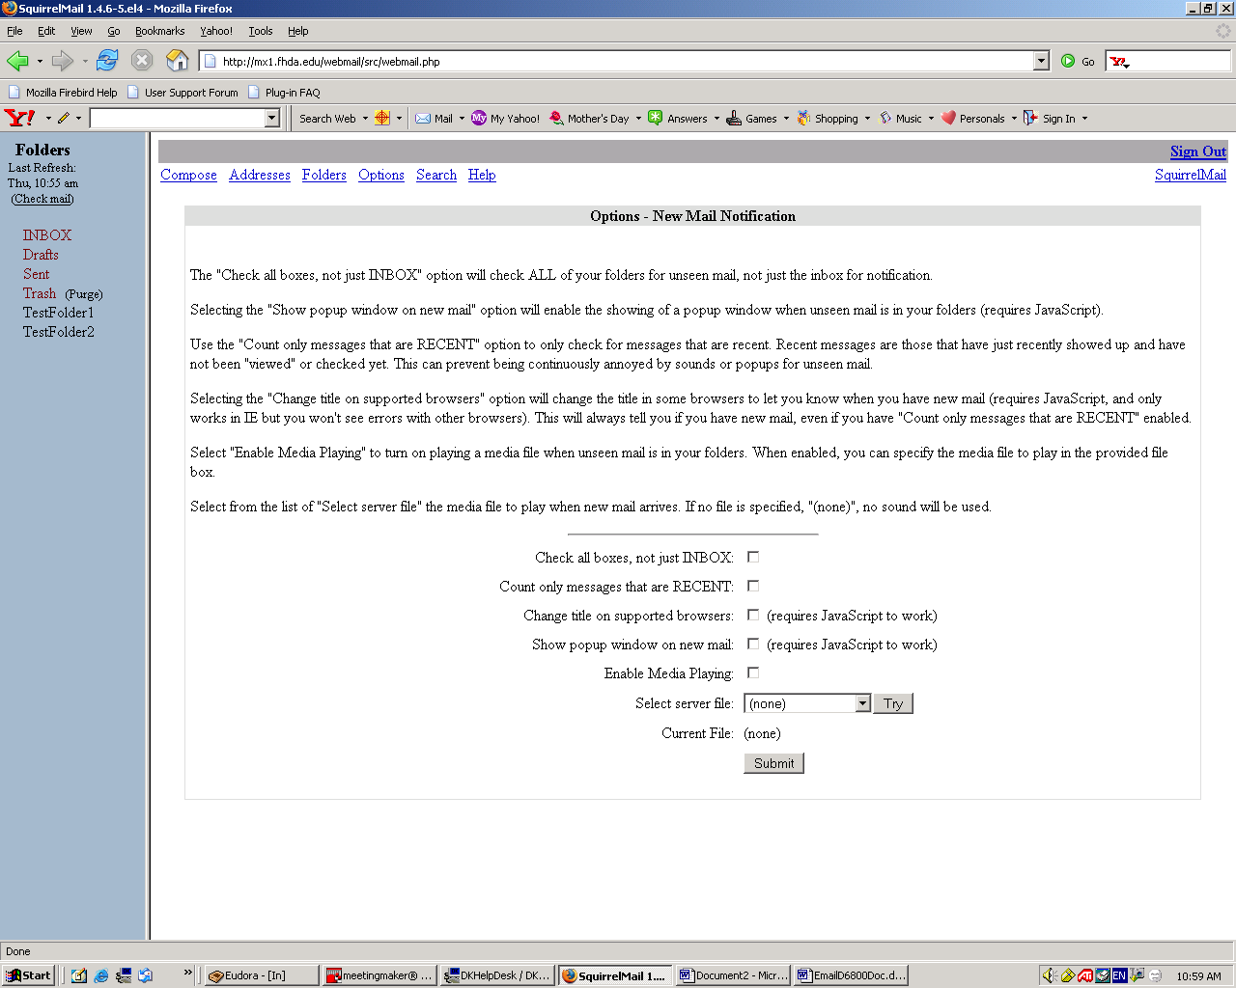

Click the Submit button to update
Options – Display Preferences

Click the appropriate button or fill in the boxes to configure your display options

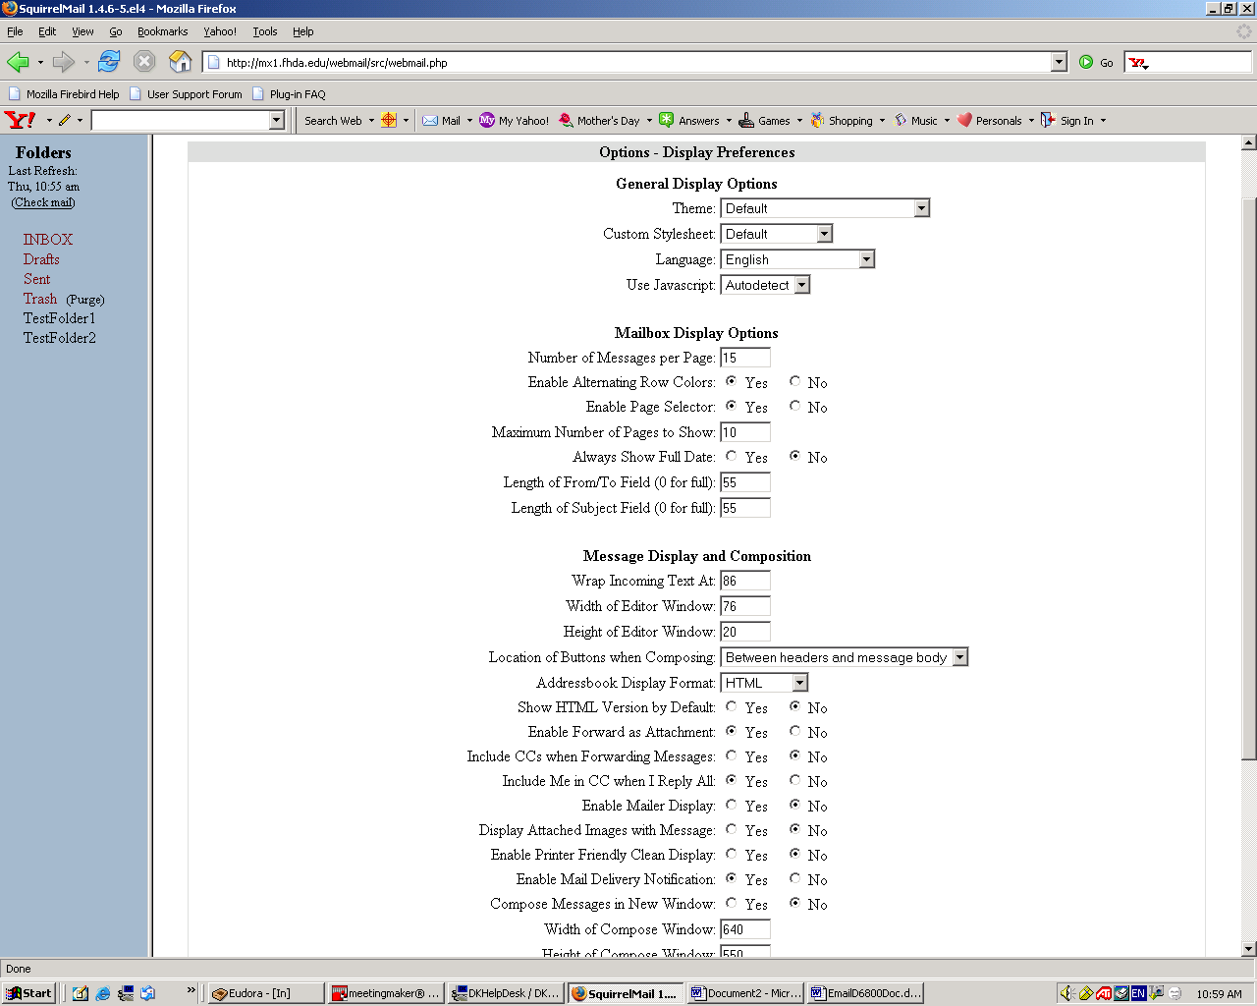

Click the Submit button to update
(it will appear in lower
right-hand corner of page)
Options – Folder Preferences

Click the appropriate button or fill in the boxes to configure your folder options

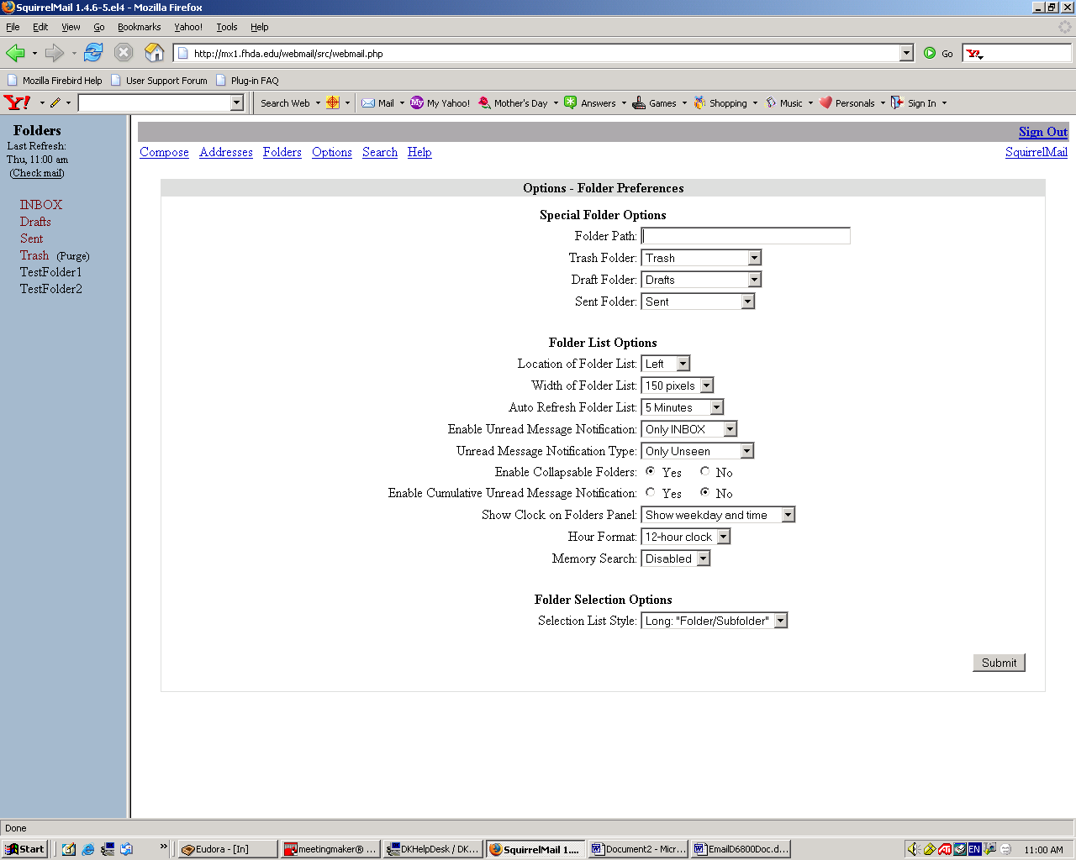

Click the Submit button to update
Options – Spell Check

Click on the appropriate links and following the instructions

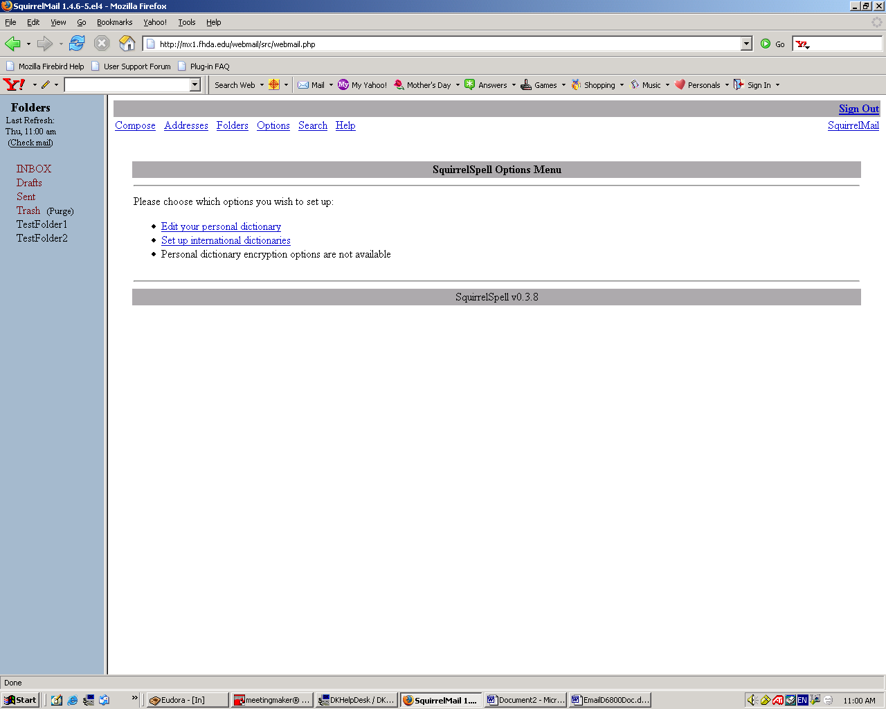
Email Topic Search

To search for email messages stored in your mailbox
Click on the Search link

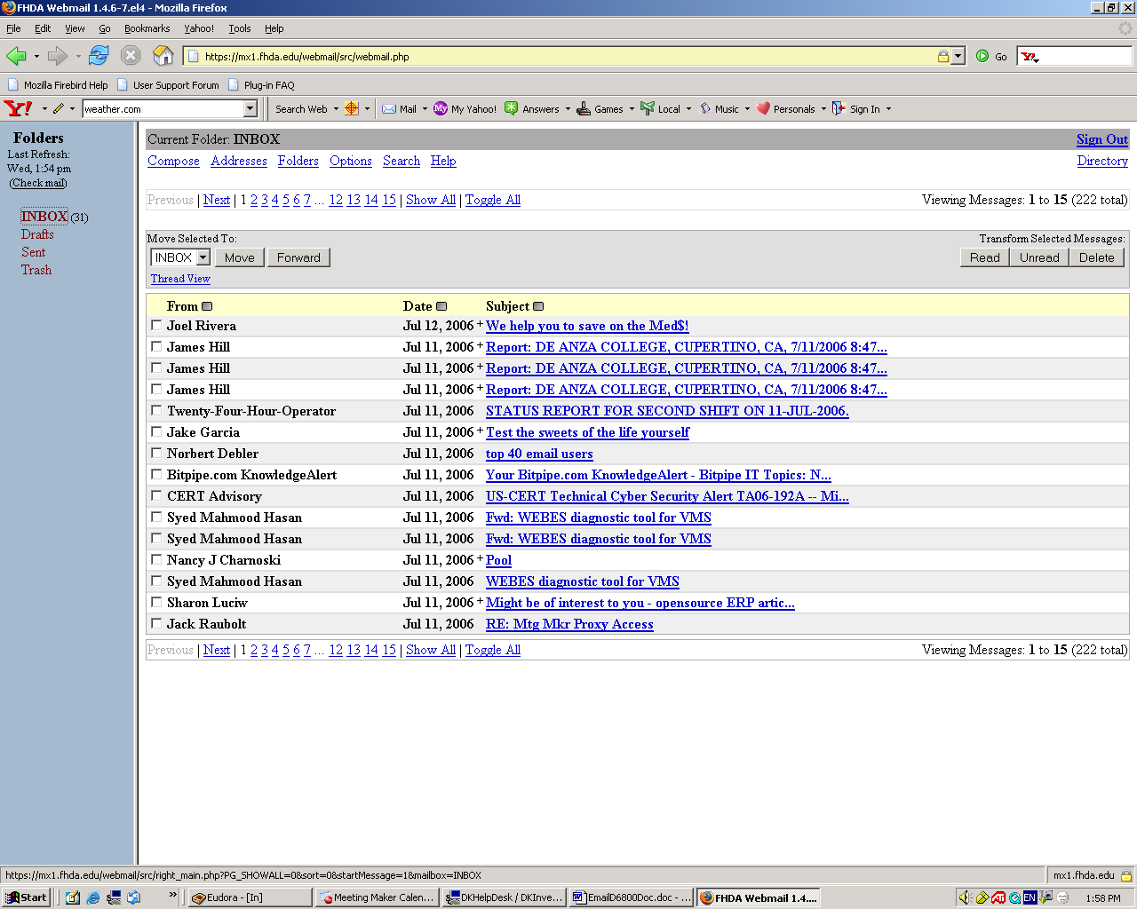
Email Topic Search

Select which Enter search criteria Select which section
folder to search of message to search
Click Search button

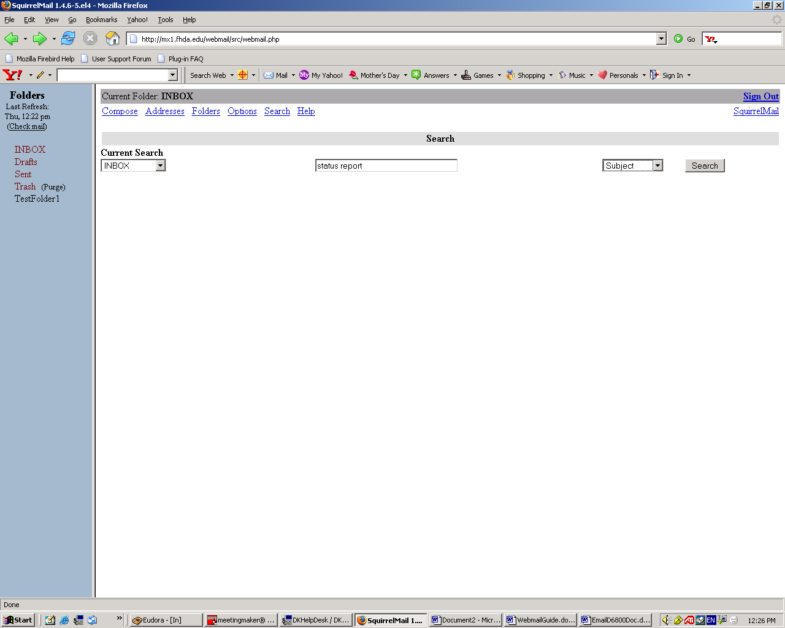
Email Topic Search Results Page

List of email messages matching search criteria

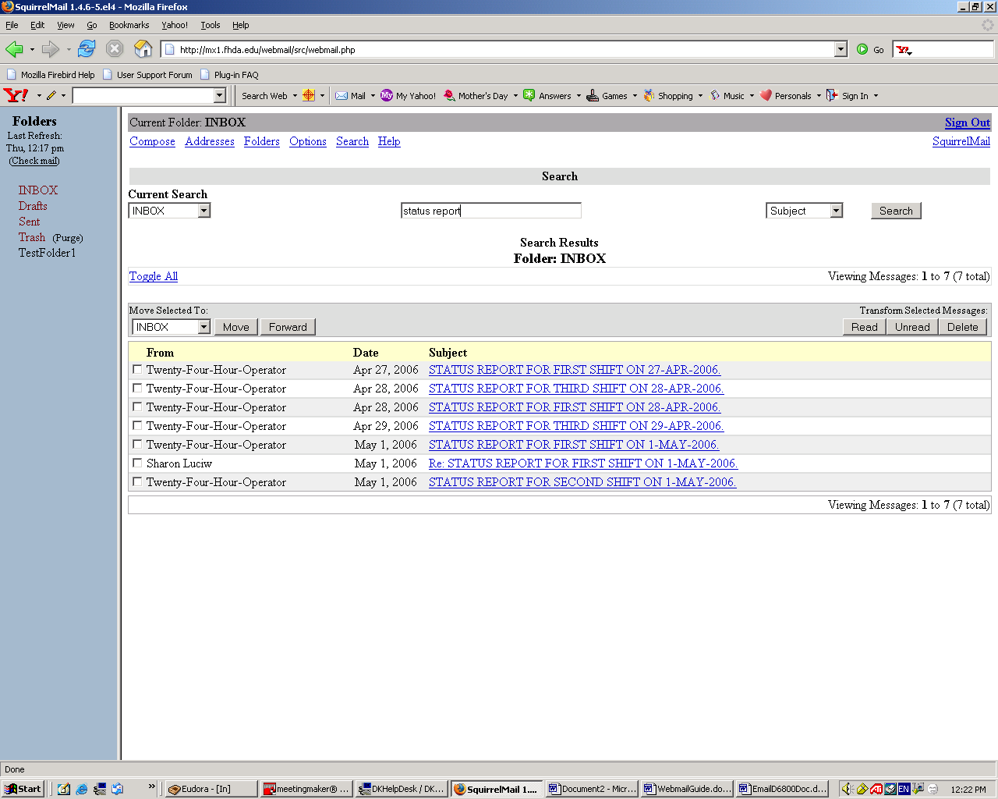
Help – Table of Contents

Click on a link to get help on a specific topic

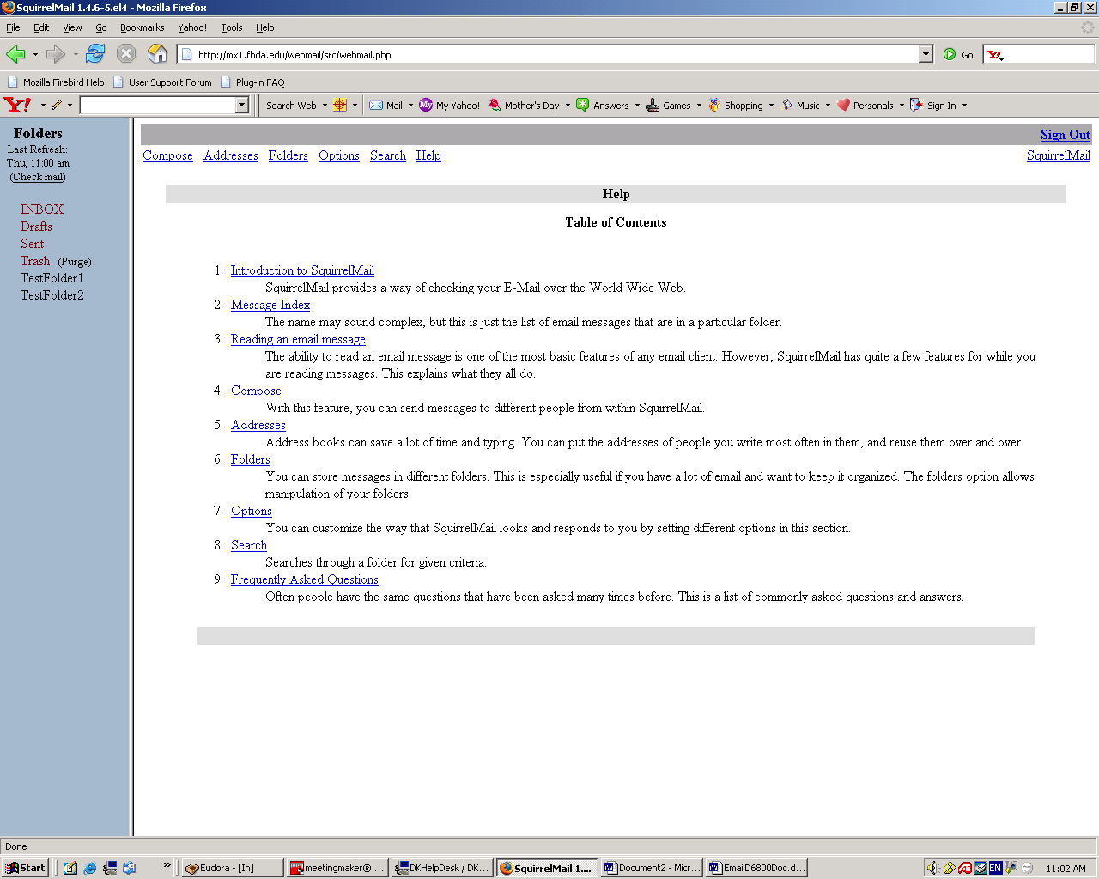
Setting Vacation Message

Before setting the vacation message to let others know you are out of the office, you should update your Personal Information in Webmail to reflect your email alias name (lastnamefirstname@fhda.edu). If you record your email alias name, the Vacation reply message that is sent to others will reflect your user name (also called the uglyname).

Here are the instructions for updating your Personal Information in Webmail. From the Inbox page, click on the Options link

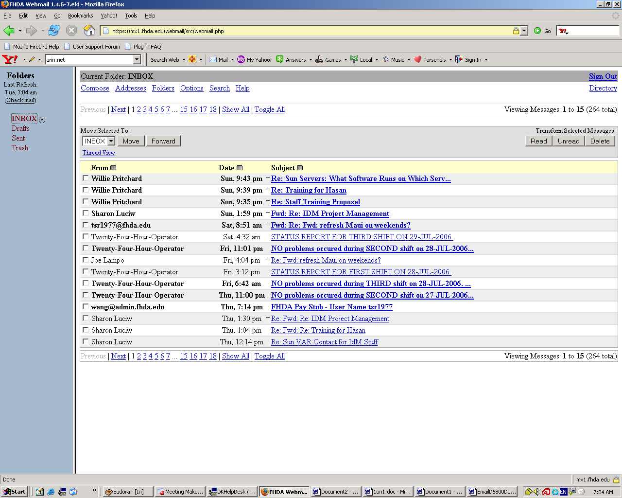
Setting Vacation Message
Updating Personal Information

Click on the Personal Information link

Setting Vacation Message
Updating Personal Information

The minimum information that needs to be recorded is your:

E-Mail Address Full Name

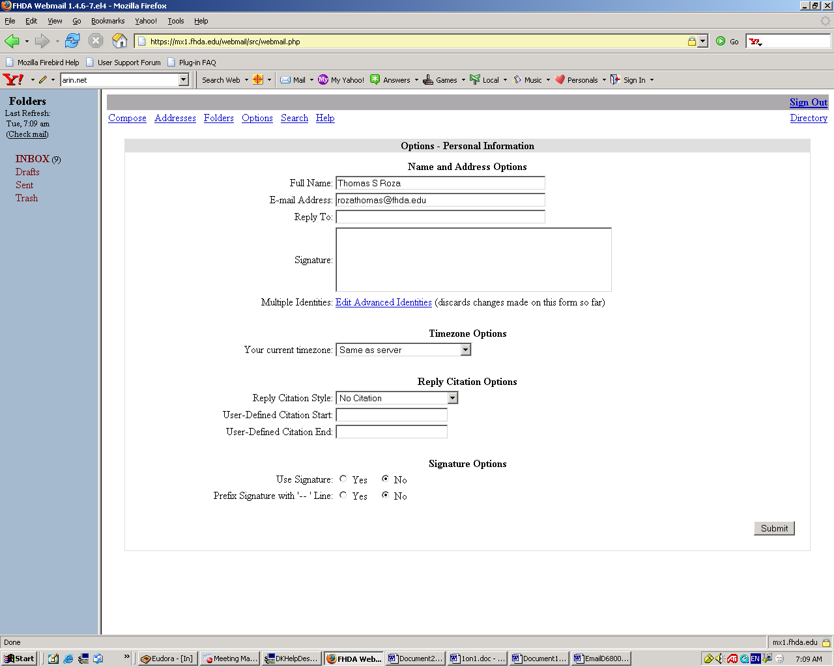

Click the Submit button to save your changes
Setting Vacation Message
Updating Personal Information

This message will be displayed indicating you have updated your Personal Information

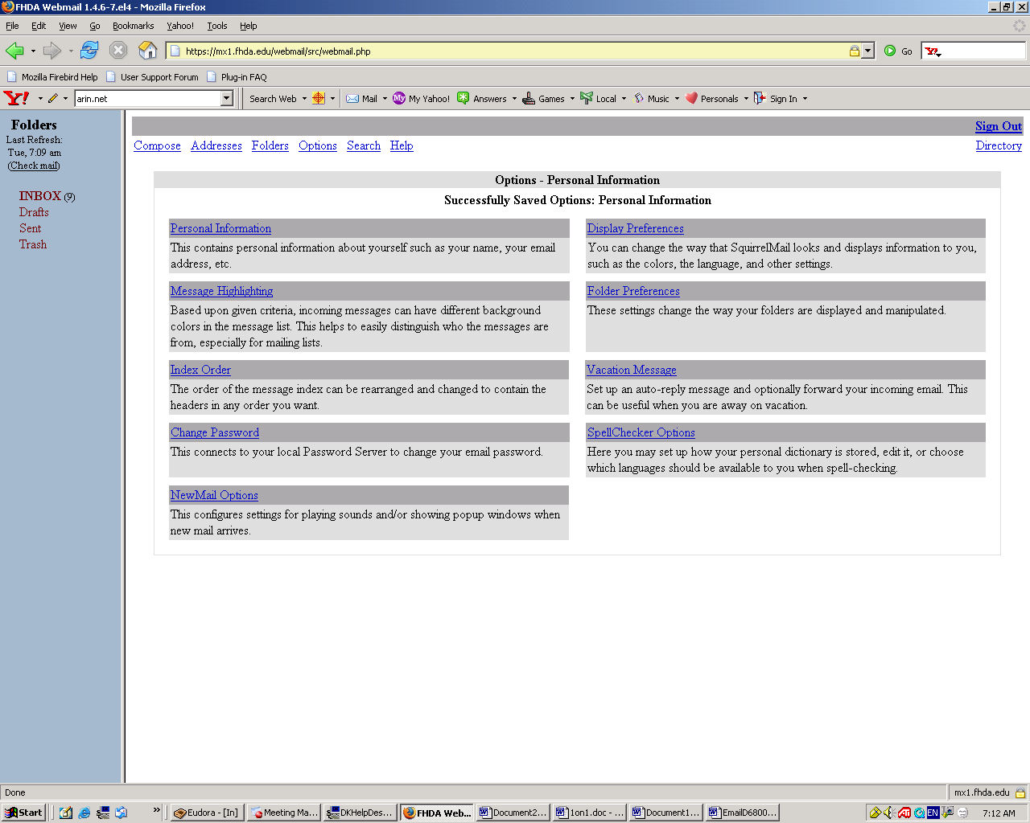

You are now ready to update your Vacation Message
Setting Vacation Message

To access the Vacation function,
Click on the Options link

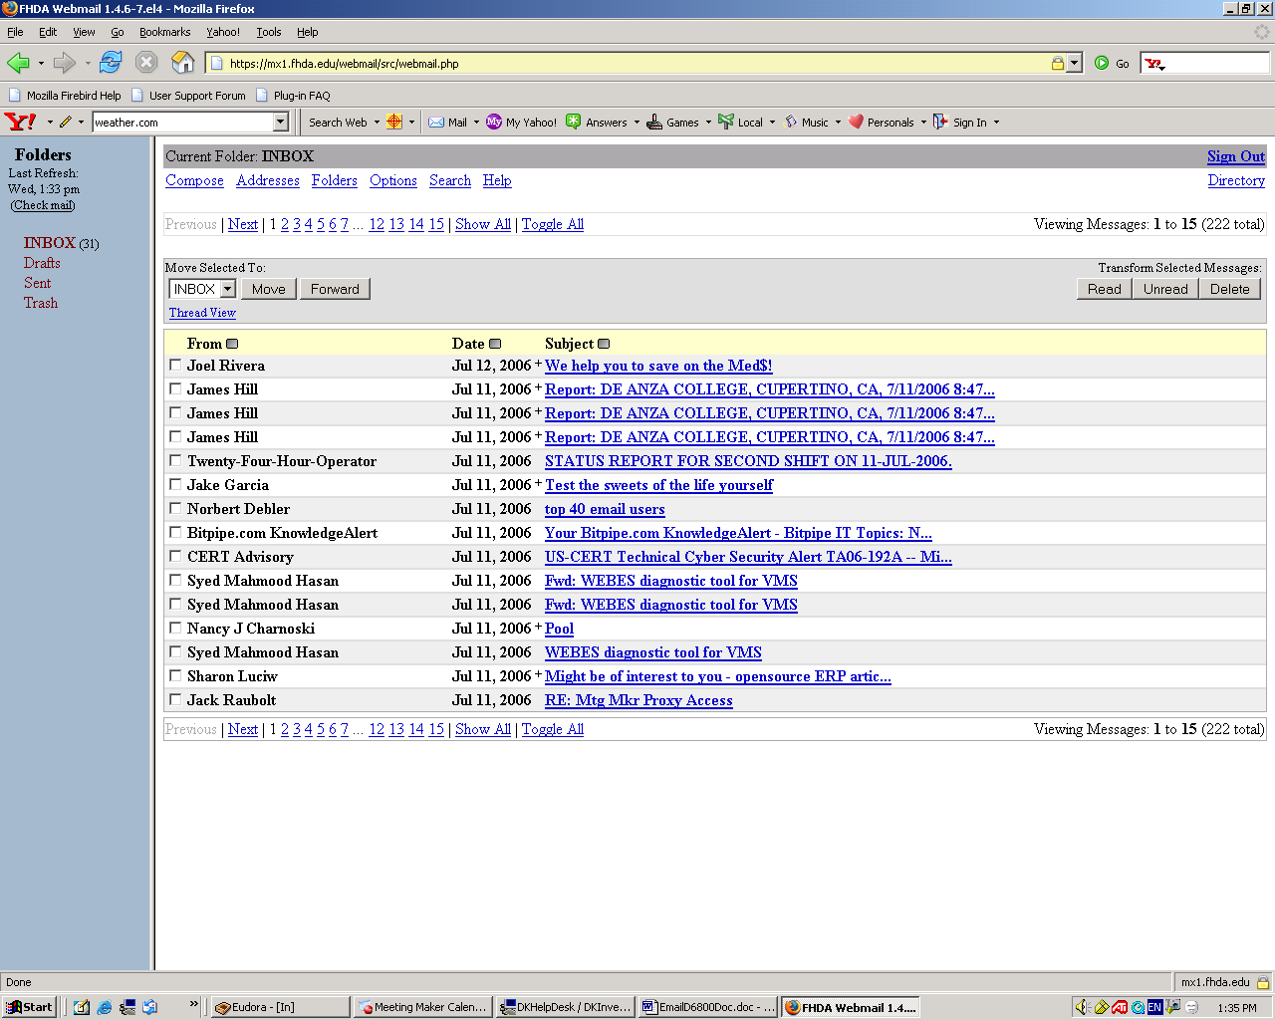
Setting Vacation Message

Click on Vacation Message link

Setting Vacation Message

1-Click on Send auto-reply to sender? Box. This activates the vacation message
Note: You can create a vacation message for future use and not activate by leaving the Send auto-reply to sender? Box unchecked

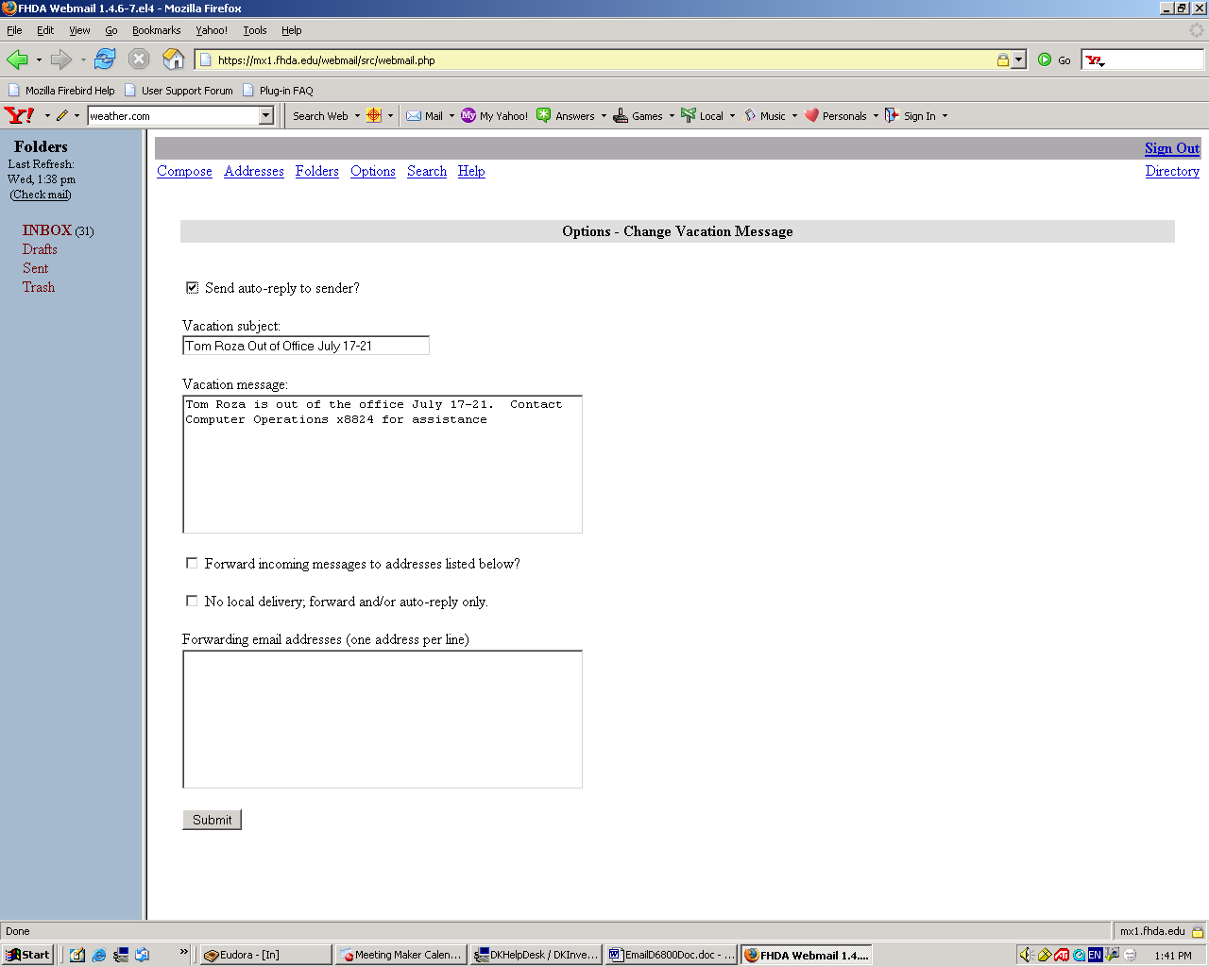

2-Complete the information in both the
Vacation Subject & Vacation Message Boxes

3-Click on the Submit button
to save & activate the message
Setting Vacation Message

The Settings Saved message is displayed indicating the Vacation Message was successfully created

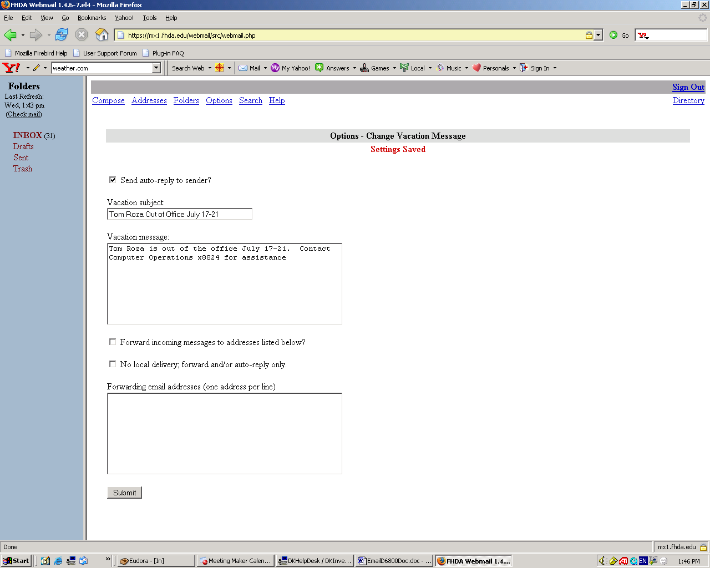
Setting Email Filters

Email that you suspect is spam that is not blocked by the spam firewall or just unwanted email messages can be automatically diverted to your Trash Folder for immediate deletion or another folder for viewing at a later time.

To setup email filtering, click of the Options link

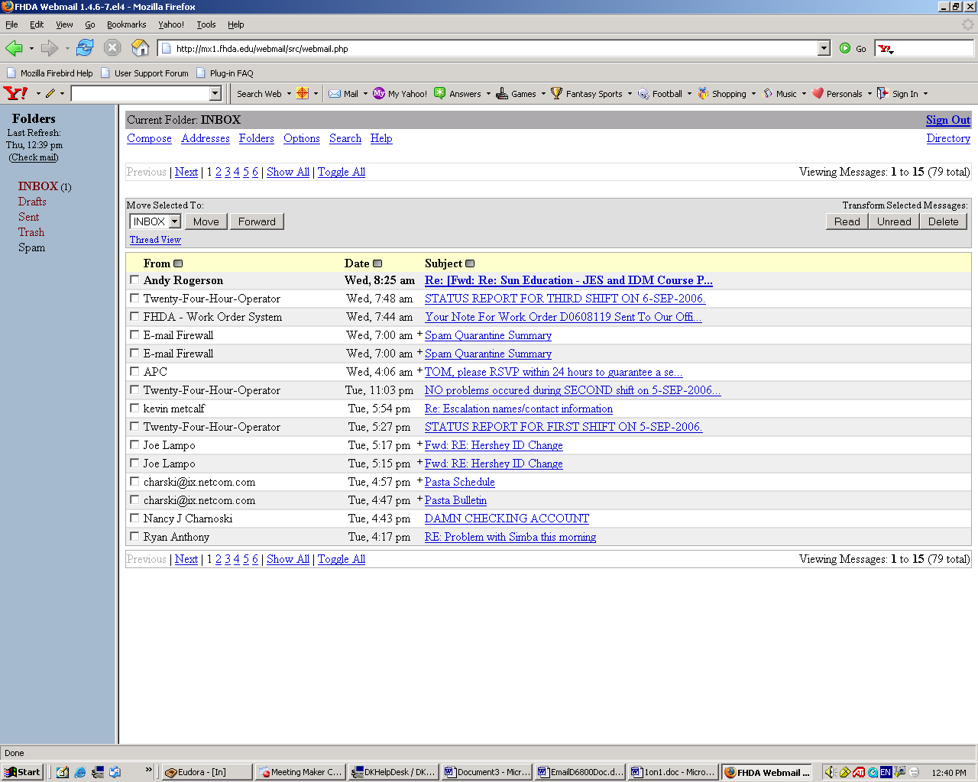
Setting Email Filters

Click on the Message Filters link

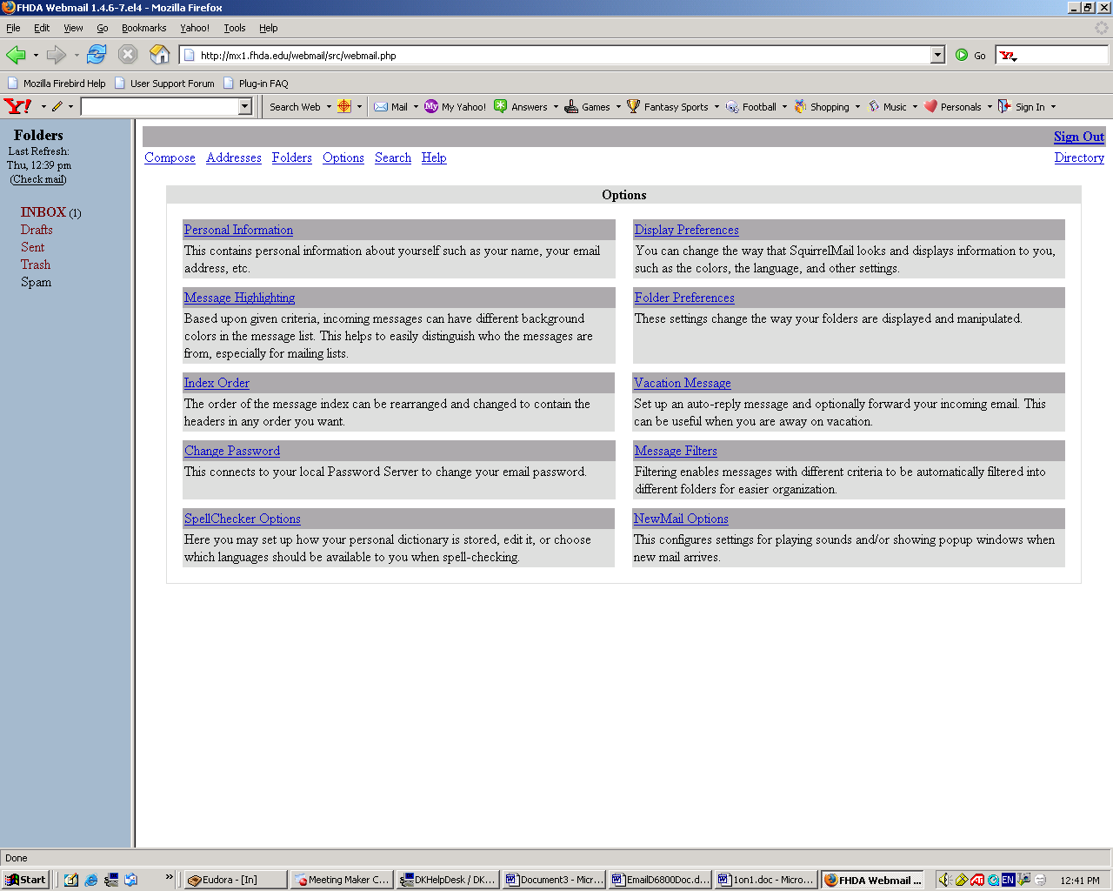
Setting Email Filters

Click on the What to Scan drop down menu
And select an option

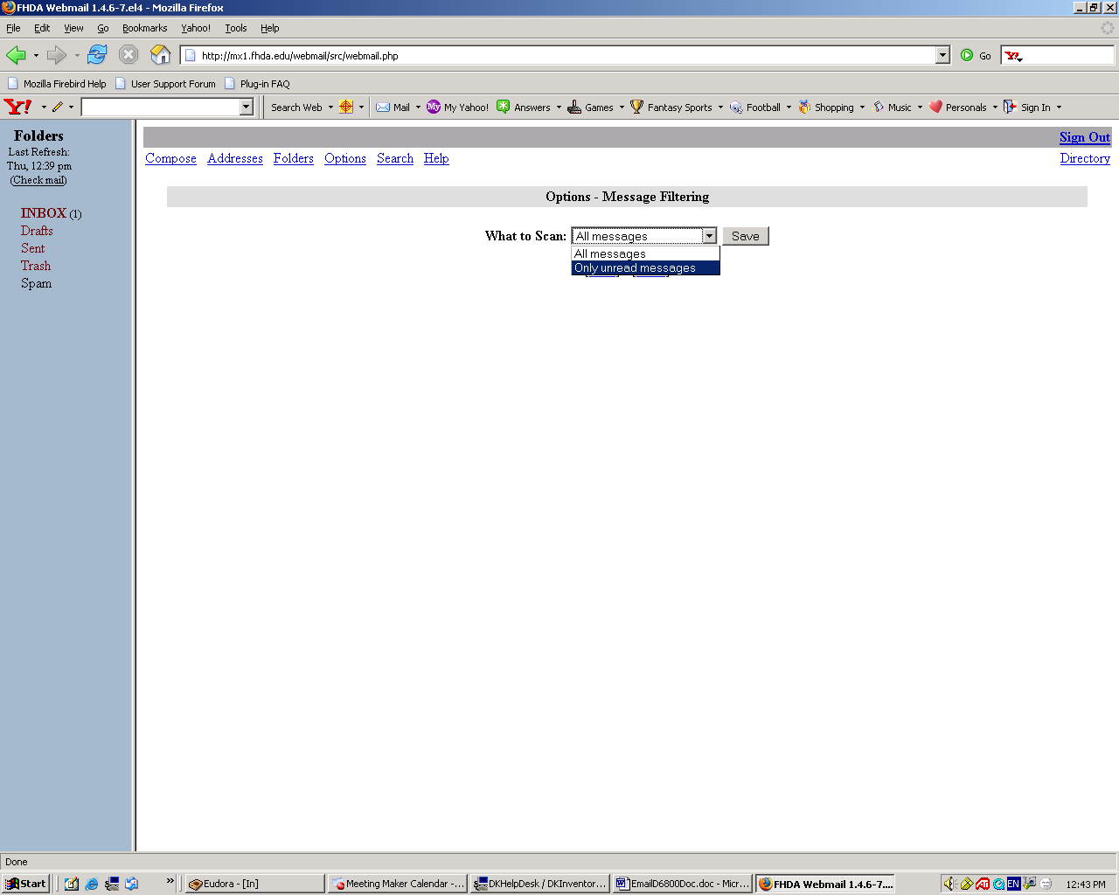
Setting Email Filters

Then click on the New link

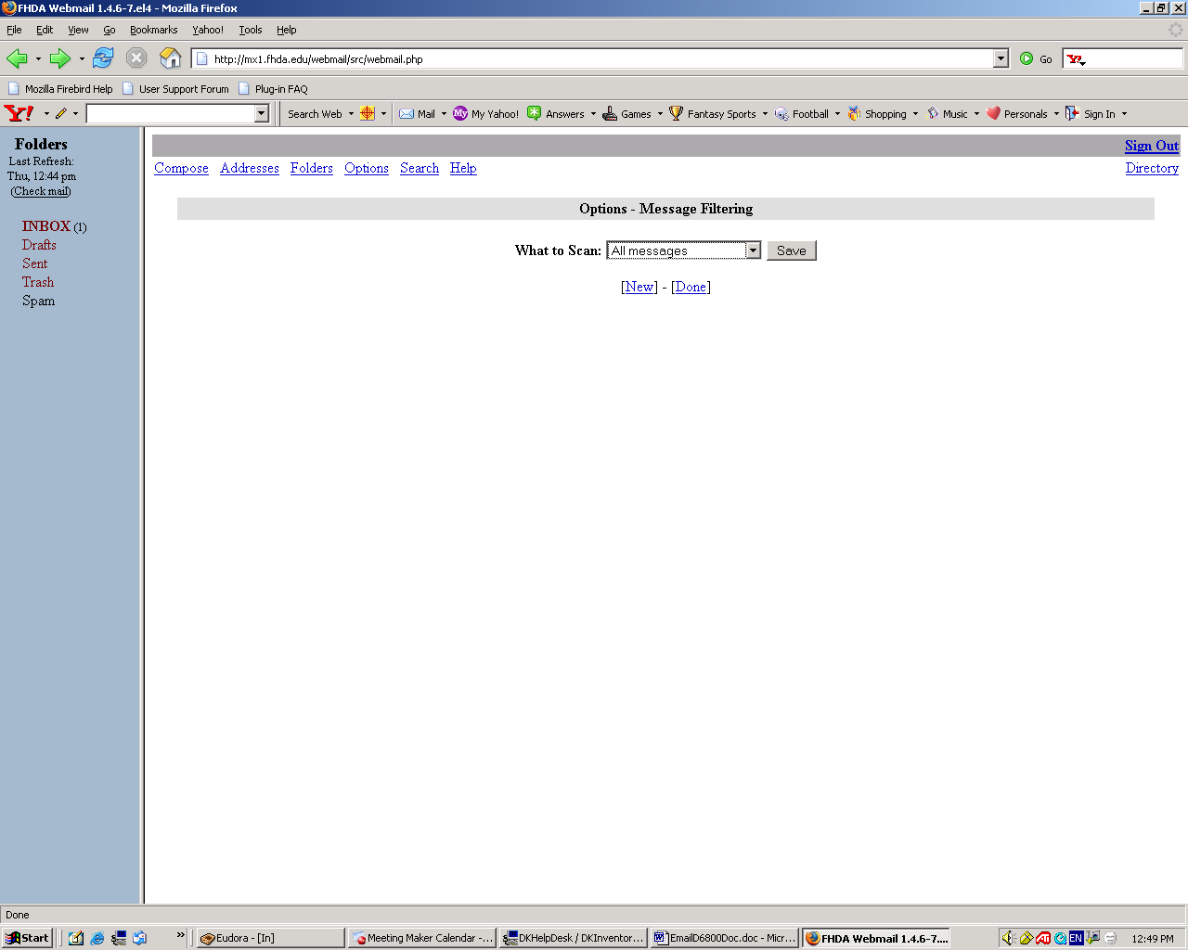
Setting Email Filters

To select what part of the email you want to filter on,

Click on the Match drop-down Menu

Then click on one of the options

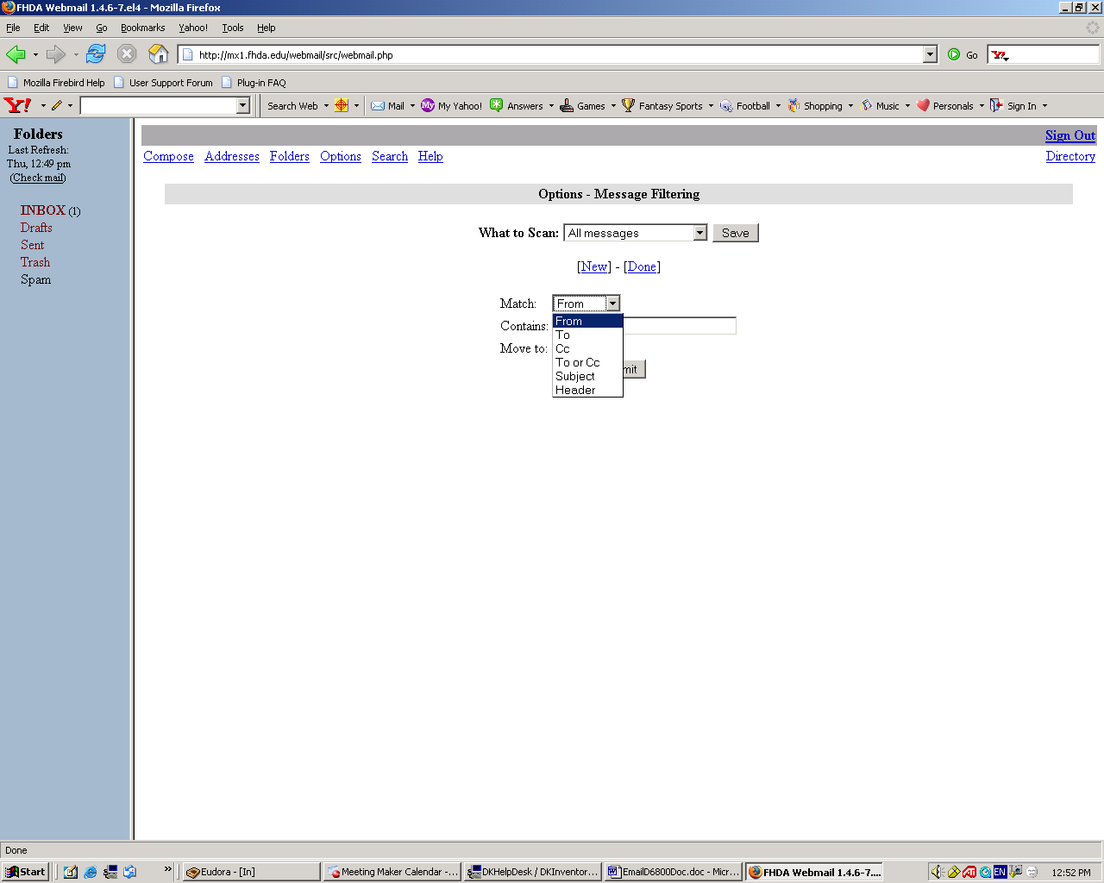
Setting Email Filters

To setup your filter,

Fill in the Contains section

with the filtering criteria

Select the folder that

filtered email will

be sent to

Click on

the Submit Button

to store the filtering

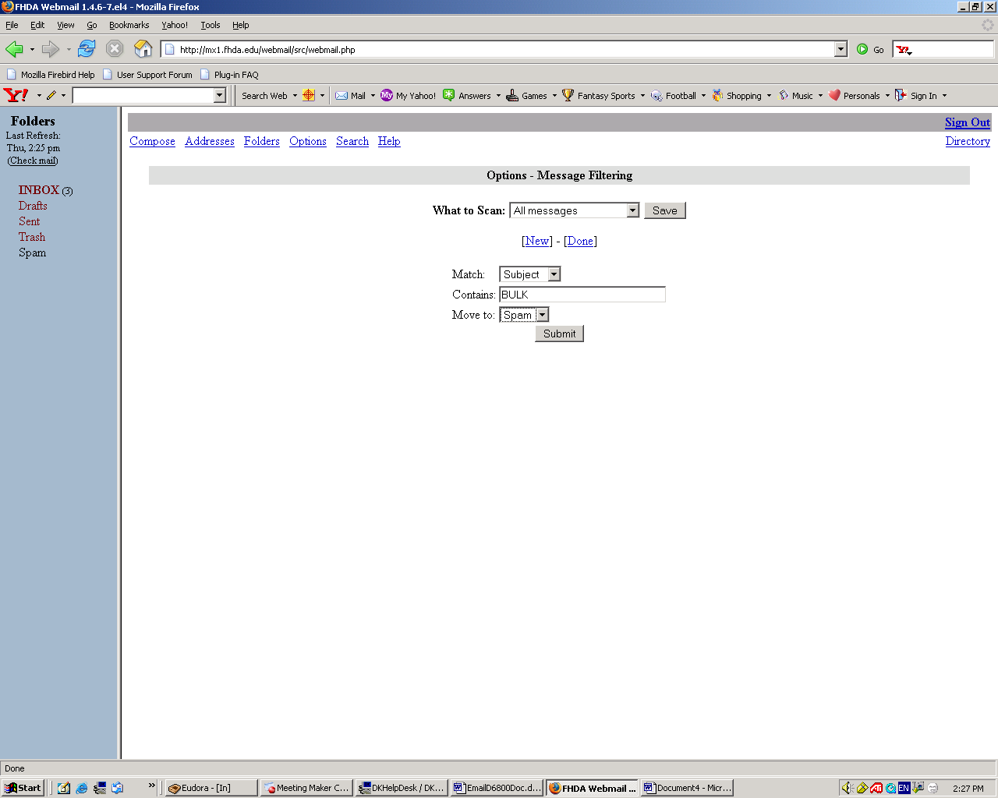
Setting Email Filters

After you click Submit,

This page is displayed

You can change or delete

the filer by clicking

the appropriate link

If you want to

save the filtering,

click on the Save Button

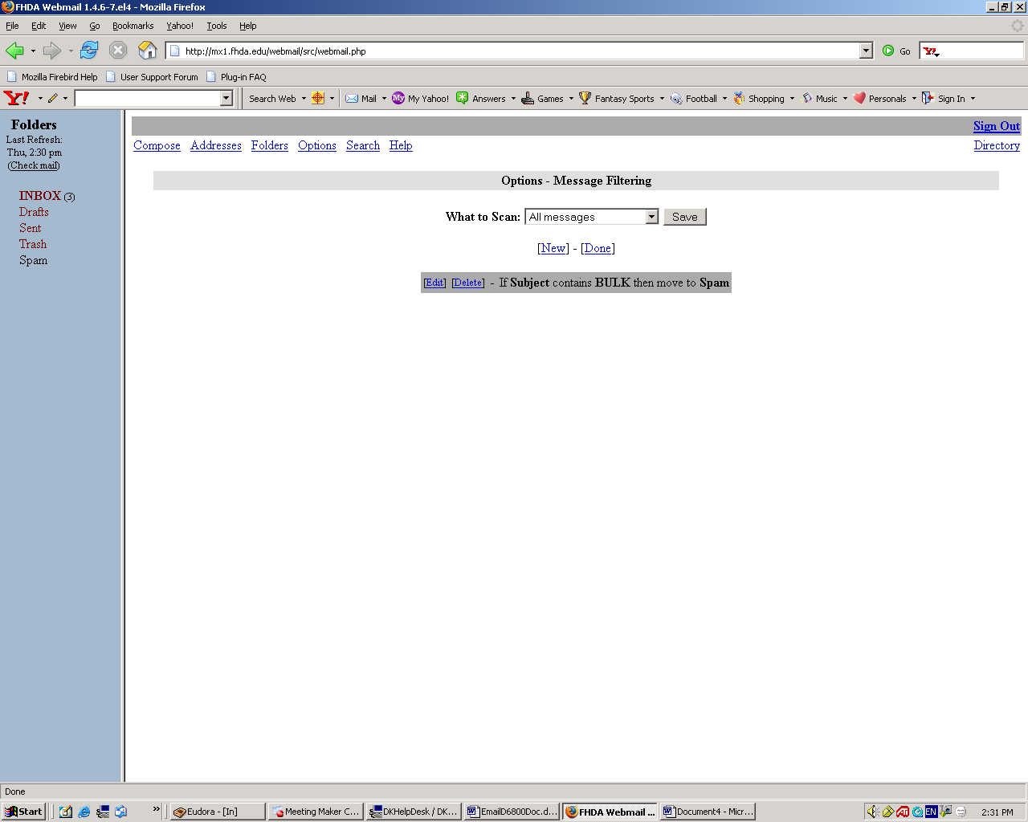
Setting Email Filters

After you click Save, the following page is displayed showing that your action has been stored

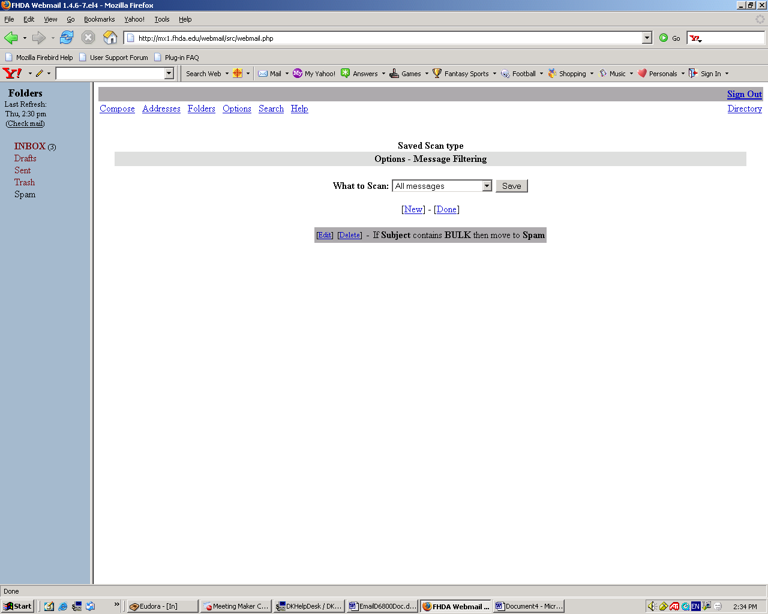
Setting Email Filters

This is an example where a folder called “SPAM” was created to hold all email that contain the word “BULK” in the subject line.

From the In-box page, click

on the folder called “SPAM”

Email messages that were

filtered to this folder

are then displayed

