Webmail User’s Guide

Overview
Webmail provides a secured web-based capability to access email that has been sent to a person’s Foothill-De Anza email account. Webmail is very similar to a software product called “Mailreader” which provided a similar capability.

Webmail provides access to email that is still resident in a person’s District mailbox that resides on the main email server. Said another way, email can be viewed that has not yet been transferred (downloaded or copied) to a person’s computer using an email client such as Eudora. Once email has been transferred (downloaded or copied) to a person’s computer, email messages are removed from the mailbox on the District’s main email server.

With Webmail, a person can read email messages, send email messages, and lookup email addresses of other District email users. As with Mailreader, Webmail does not have the ability to create folders such as outbox, sent, or personally named folders. Also, there is no capability to access email messages that have been transferred (downloaded or copied) to a person’s computer.
Webmail uses data encryption methods to secure the sending of email messages and your userid and password when they are used to log into Webmail.

ETS Support Policy for Webmail
As with Mailreader, Webmail is “shareware” software obtained from the Internet. Shareware software has been written by another organization or individuals and offered free-of-charge to anyone who wants to use it.

Therefore, ETS is only providing online documentation for support and will keep the software operational to the best of its ability.
Webmail Login Process & URL

From any browser either on the District network or from the Internet, enter the following URL:
https://webmail.fhda.edu

Depending on which operating system and browser you use, you can receive one of the following pages

Windows/Internet Explorer Browser Windows/Mozilla-Firefox Browser
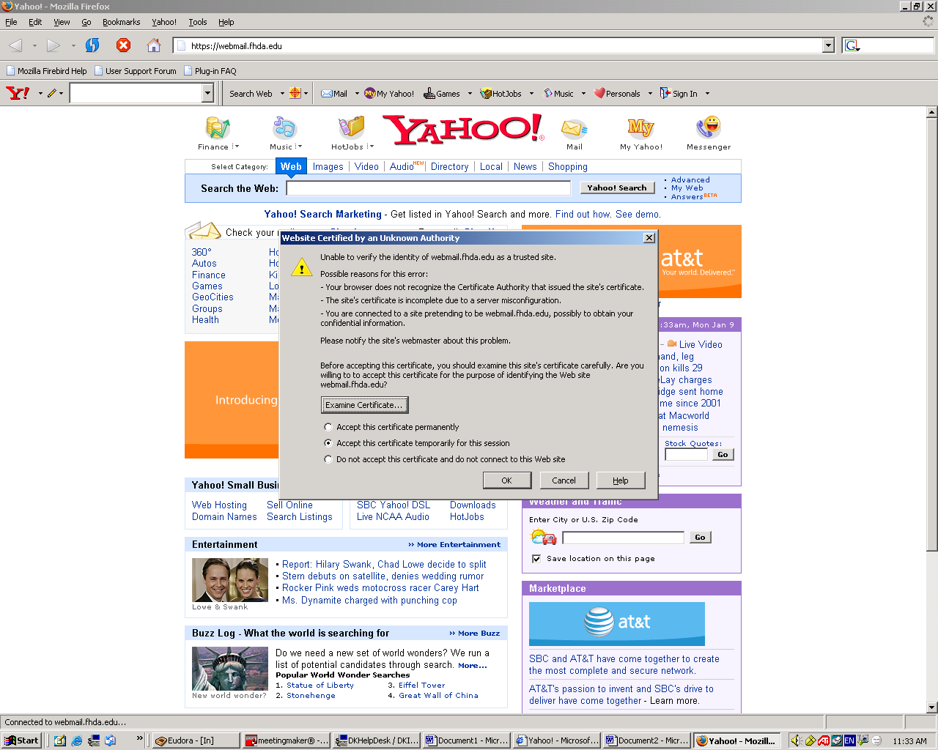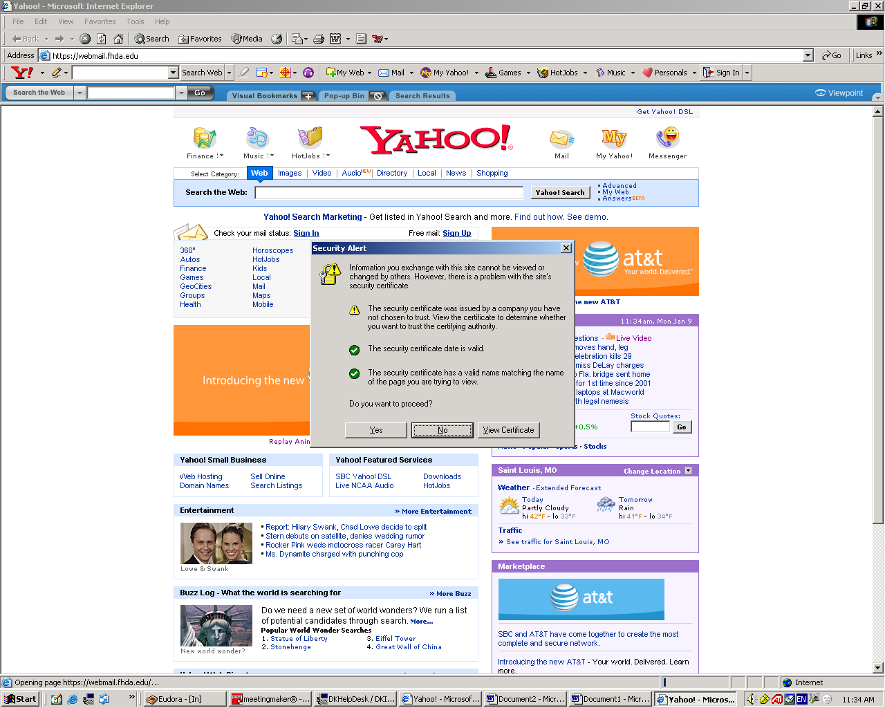

MAC/Safari Browser MAC/Mozilla-Firefox Browser

Click the appropriate button to proceed with the login process
Webmail Login Page

Enter username and password
Click the “Login” button

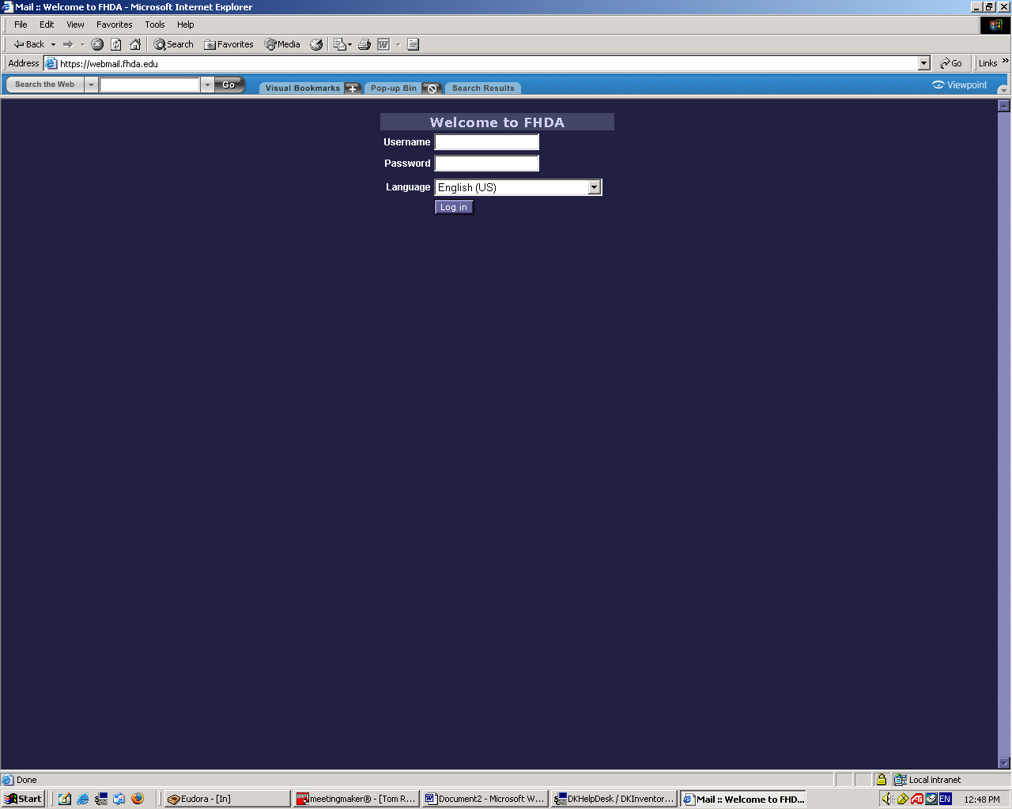
Webmail Email InBox Page

InBox Display Number of Pages Number of Messages
of Messages In InBox

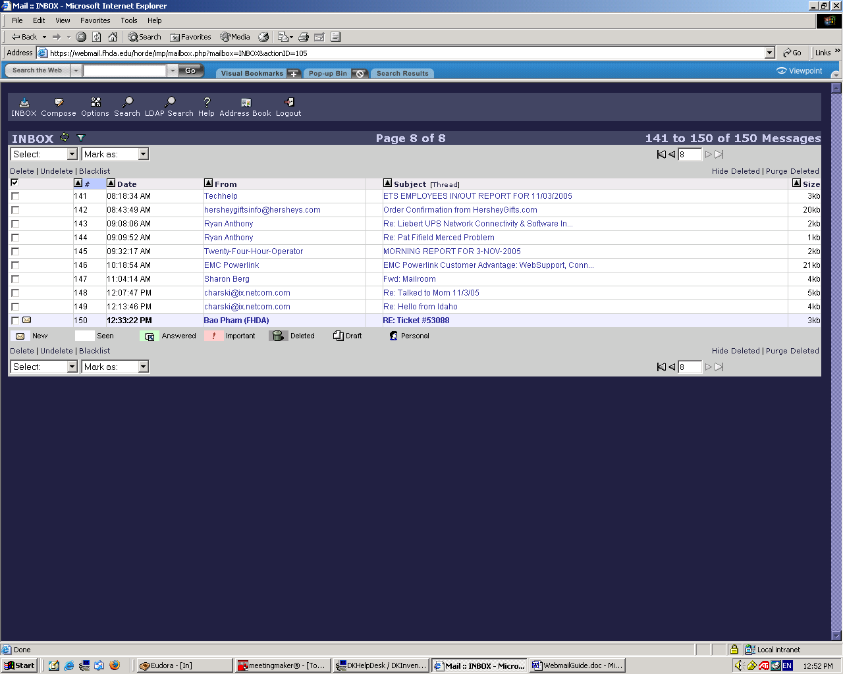
Webmail Message Composition Page

Click on Compose Button

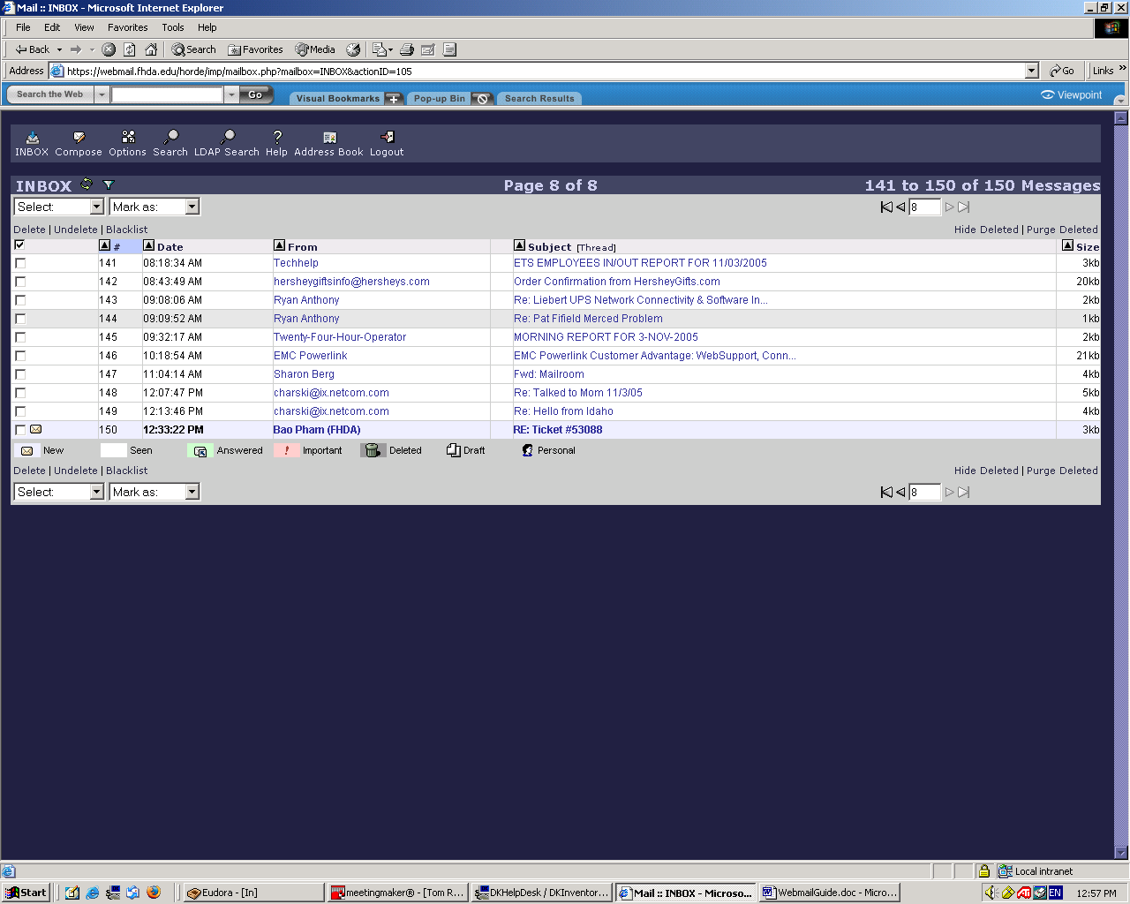

Message Composition Page Is Displayed

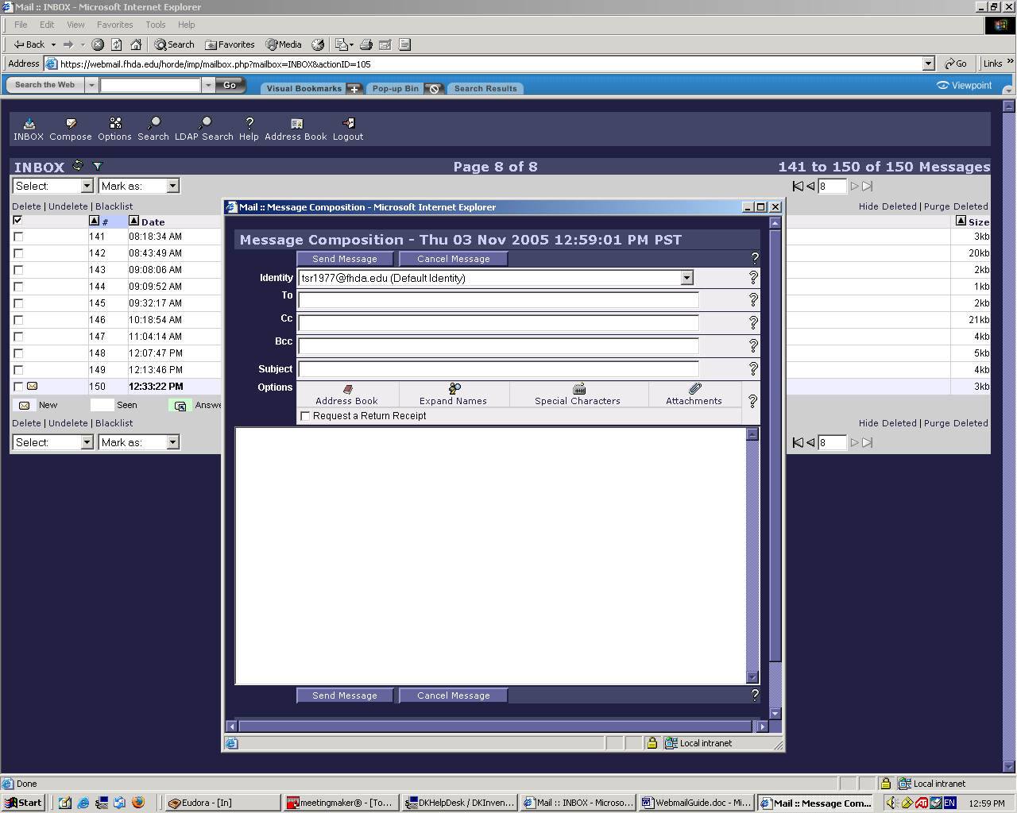
Webmail Message Composition Page

Enter Mailing & Message Information

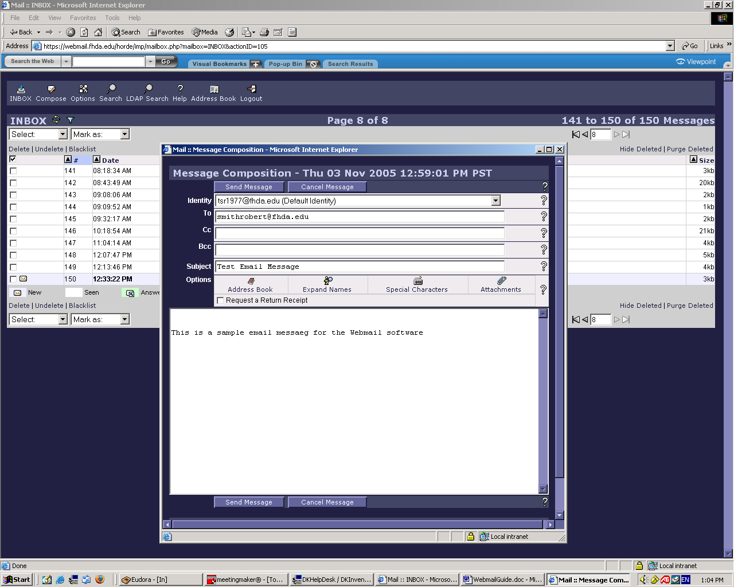

Click the Send Message Button to send email message
Webmail Options Page

Click each link and follow the instructions
for managing your Webmail client

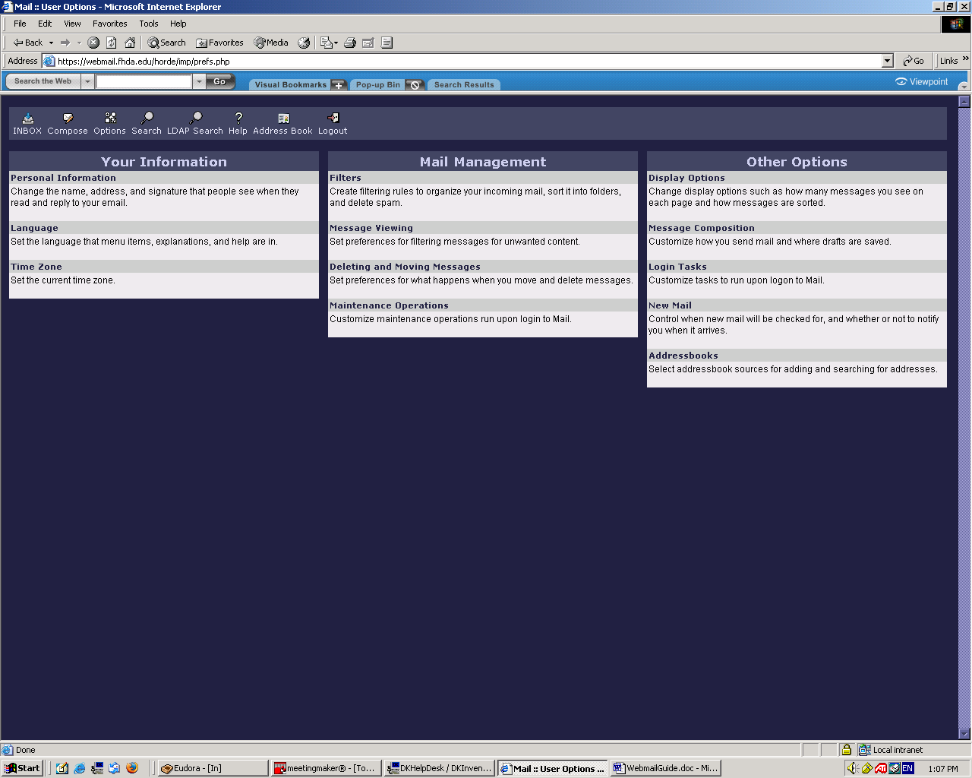
Webmail Message Search Page

Fill in the appropriate information to locate email messages in your InBox

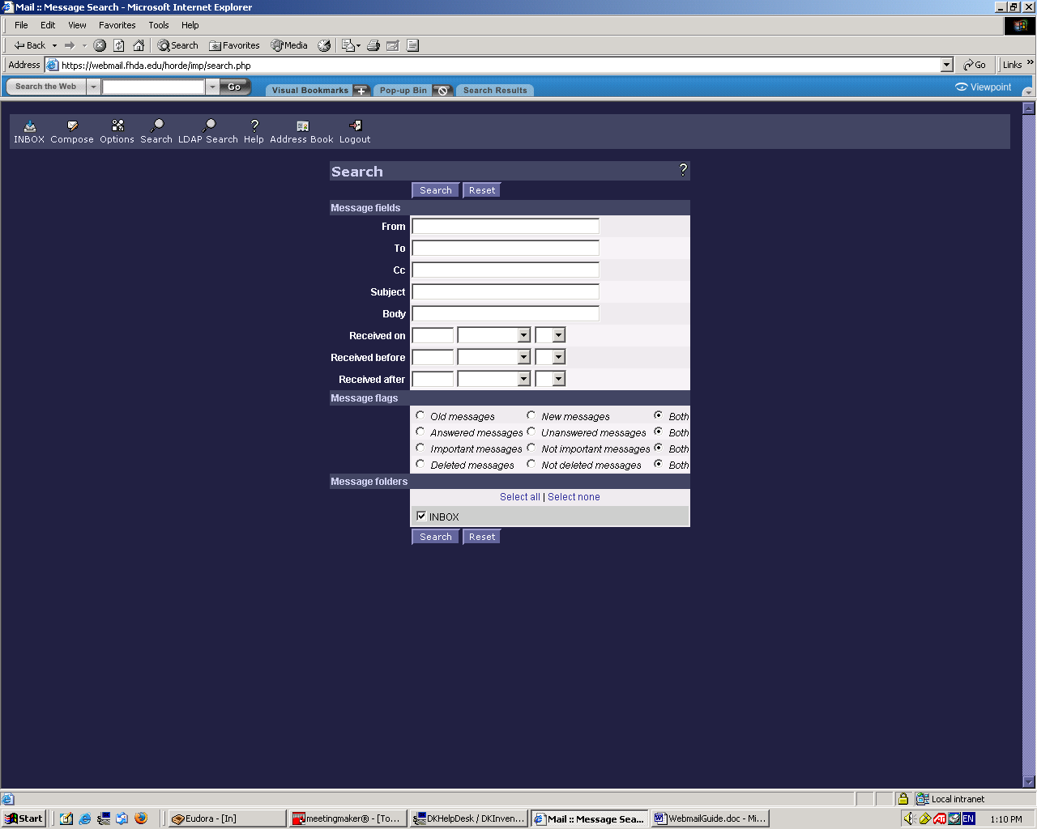

Click on the Search Button to locate messages
LDAP Name Search Page

Click on the LDAP Search link

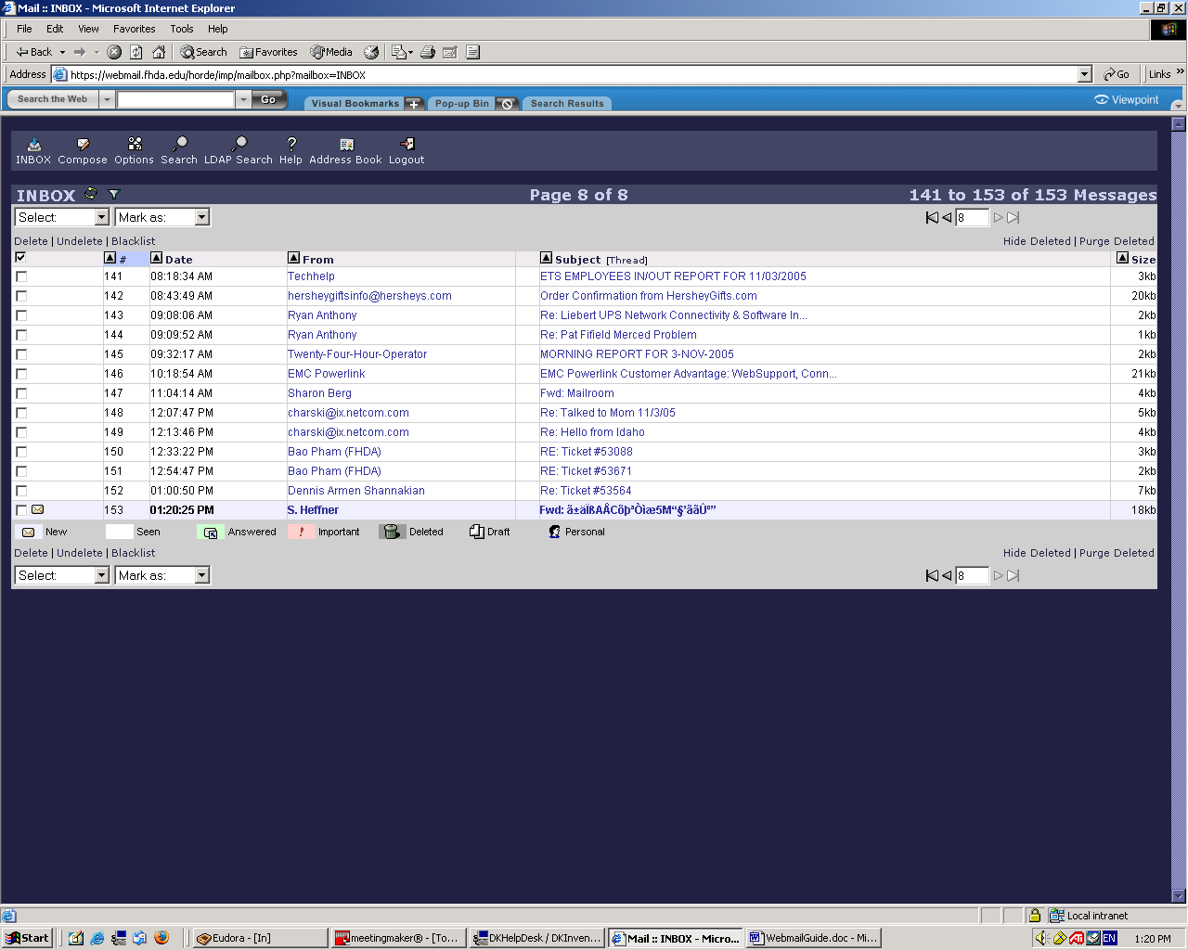
LDAP Name Search Page

Fill in the name to be searched
Click the Search Button

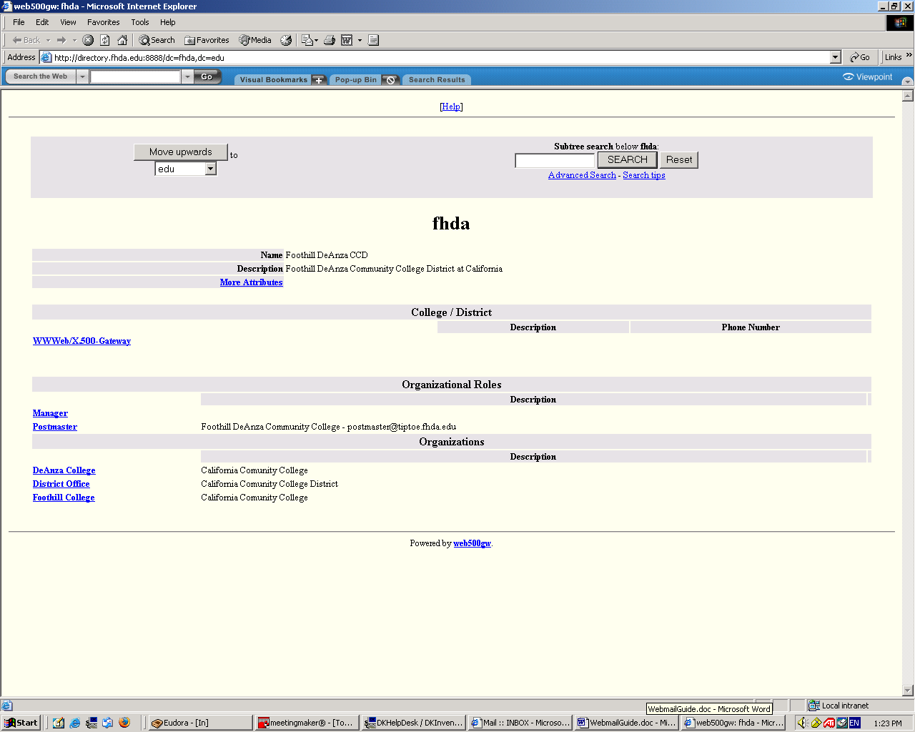
Email Address Search

Fill in the name to be searched
Click the Search Button

