Web Page URL: http://employeeid.fhda.edu

Type in email User Name (aka Uglyname)

Last 4-digits of Social Security Number
Birth Year

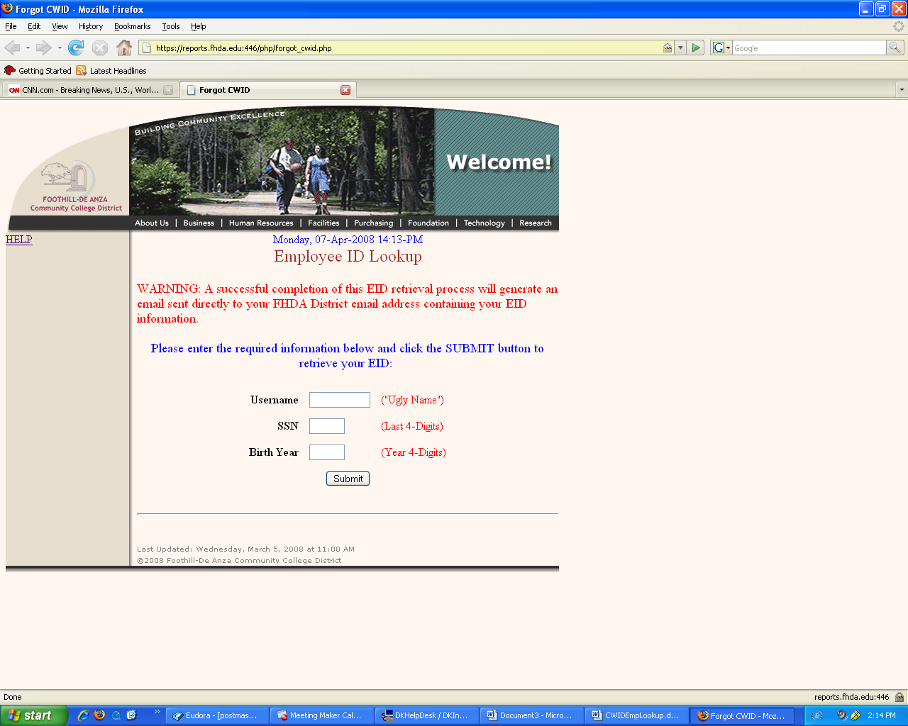

Click Submit button
If correct identity information is entered,
This page is displayed
If you need information on Email Accounts
Click on this link

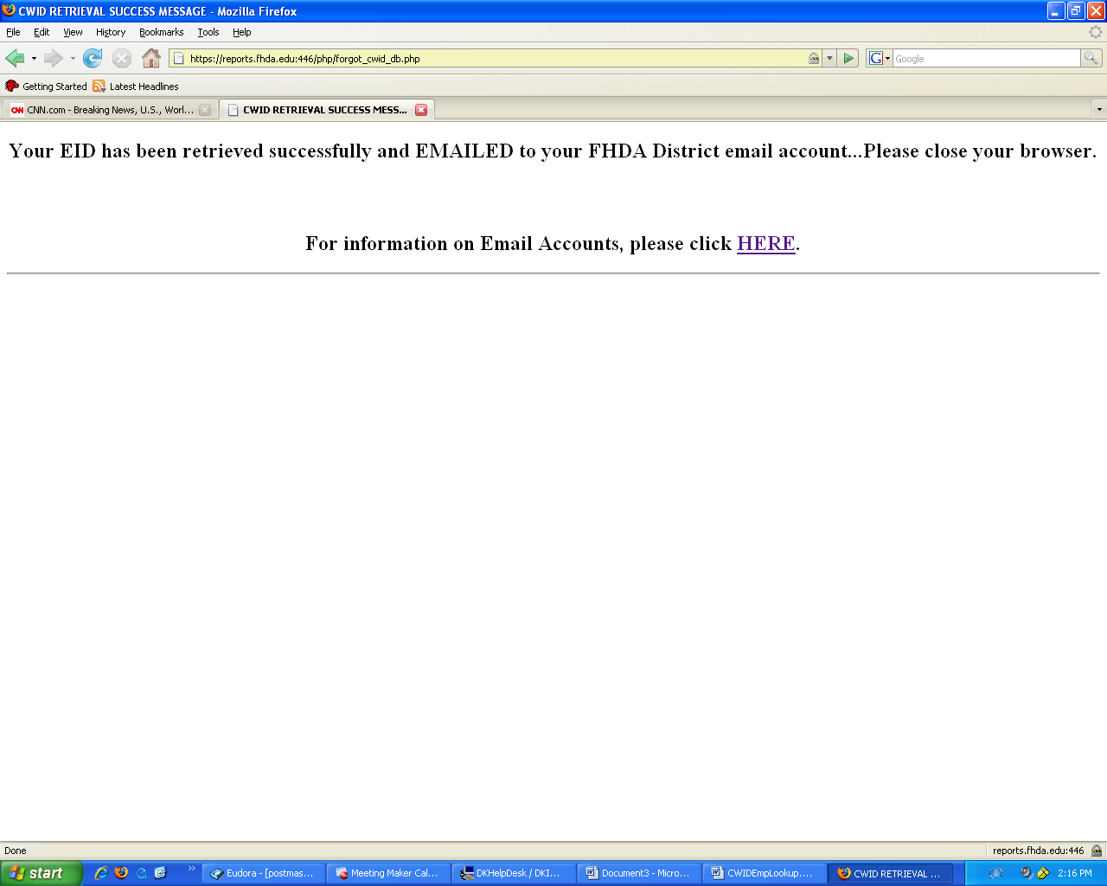

If any of the required data is not correct, the following page is displayed

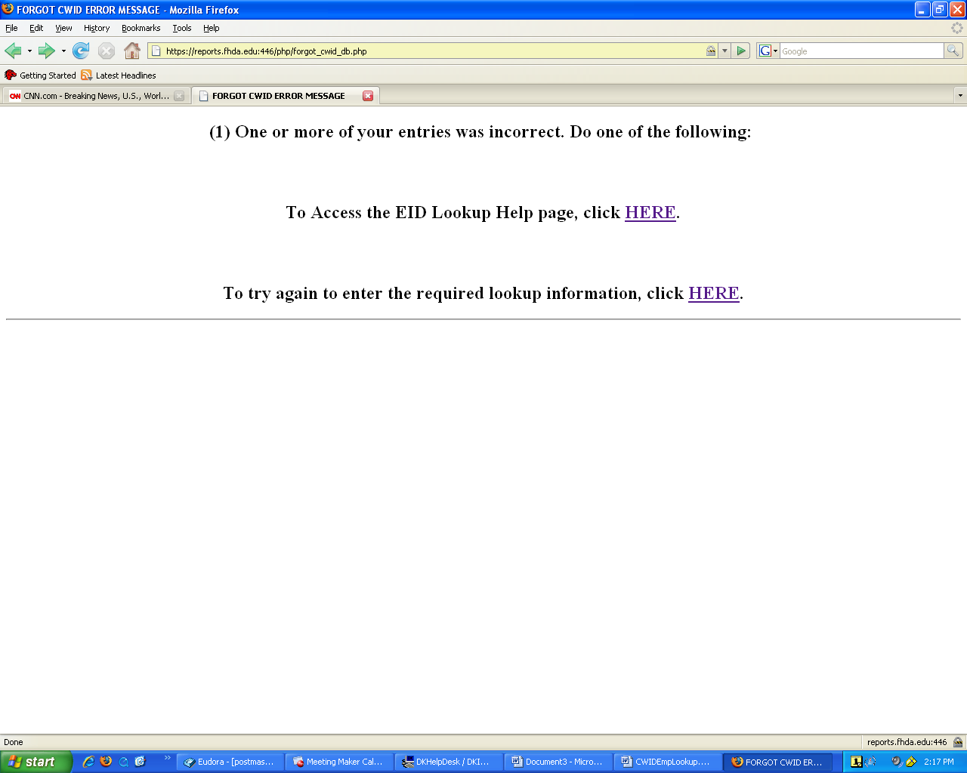

Example of email notification with Employee ID

Date: Mon, 7 Apr 2008 14:16:42 -0700
To: rozathomas@fhda.edu
X-ASG-Orig-Subj: Your Employee ID
Subject: Your Employee ID
From: postmaster@porky.fhda.edu

Hello, Your Employee ID is: 11111111
EMPLOYEE ID Lookup Online Help

