Use this application to retrieve the employee password (also known as PIN number) that was setup for you to access the District’s computing services using wireless communication devices. The URL is: http://employeepin.fhda.edu

Type in your email Username
(aka uglyname)
Type in the Last 4-digits of your
Social Security Number
Type in your Birth Year

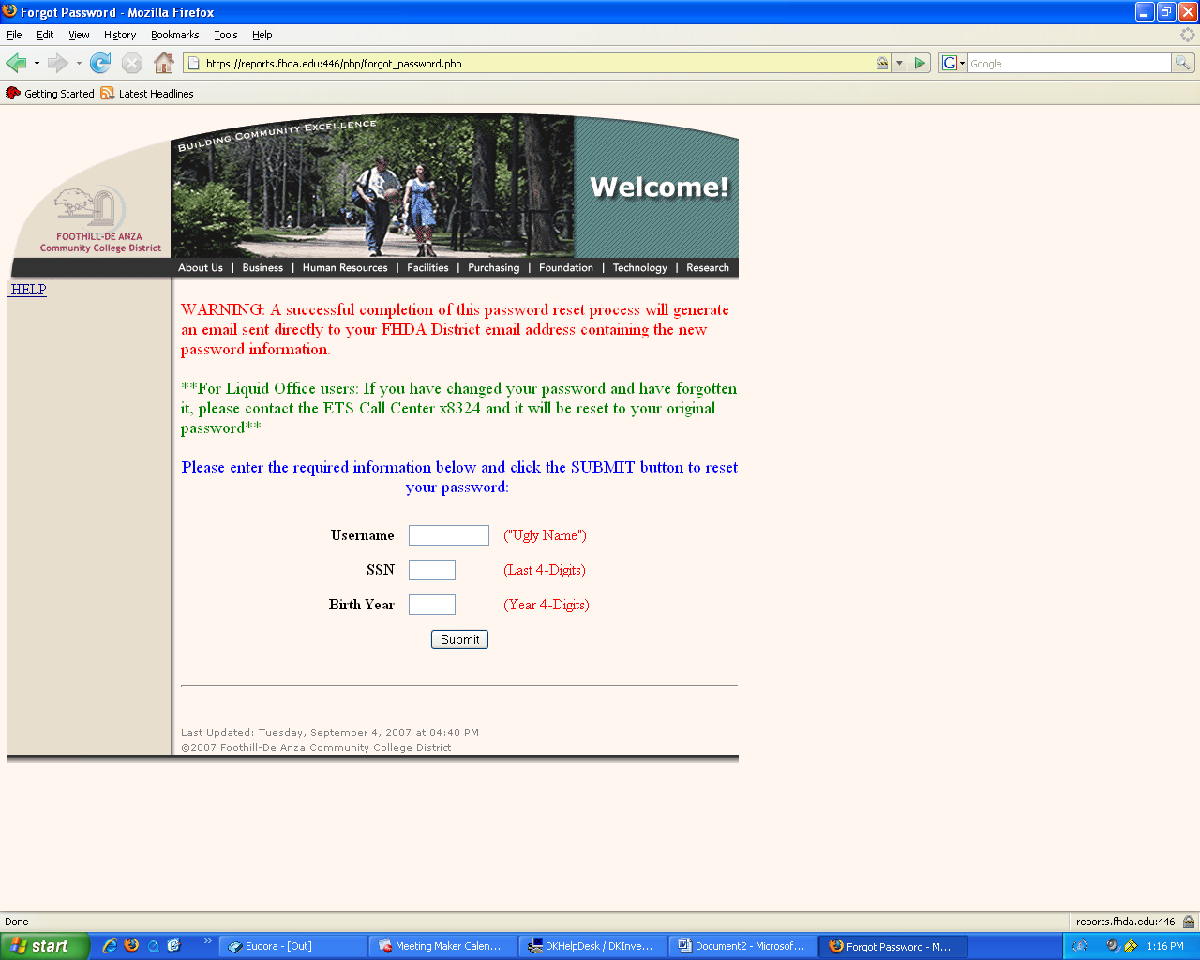

Click Submit Button
If correct identity information is entered,
This page is displayed
If you need information on Email Accounts
Click on this link

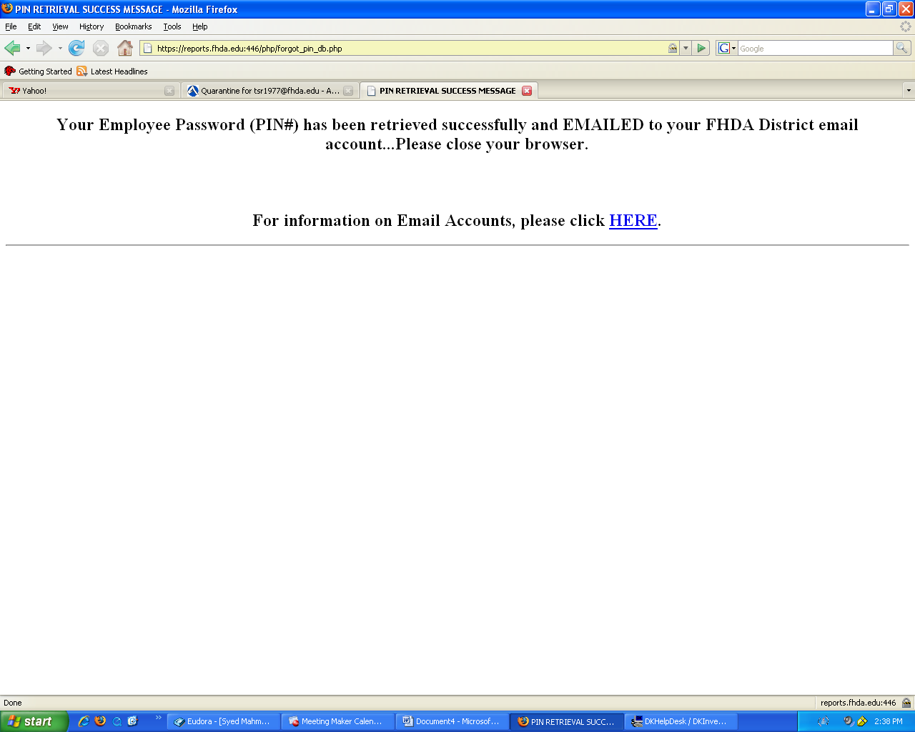

If any of the required data is not correct, the following page is displayed

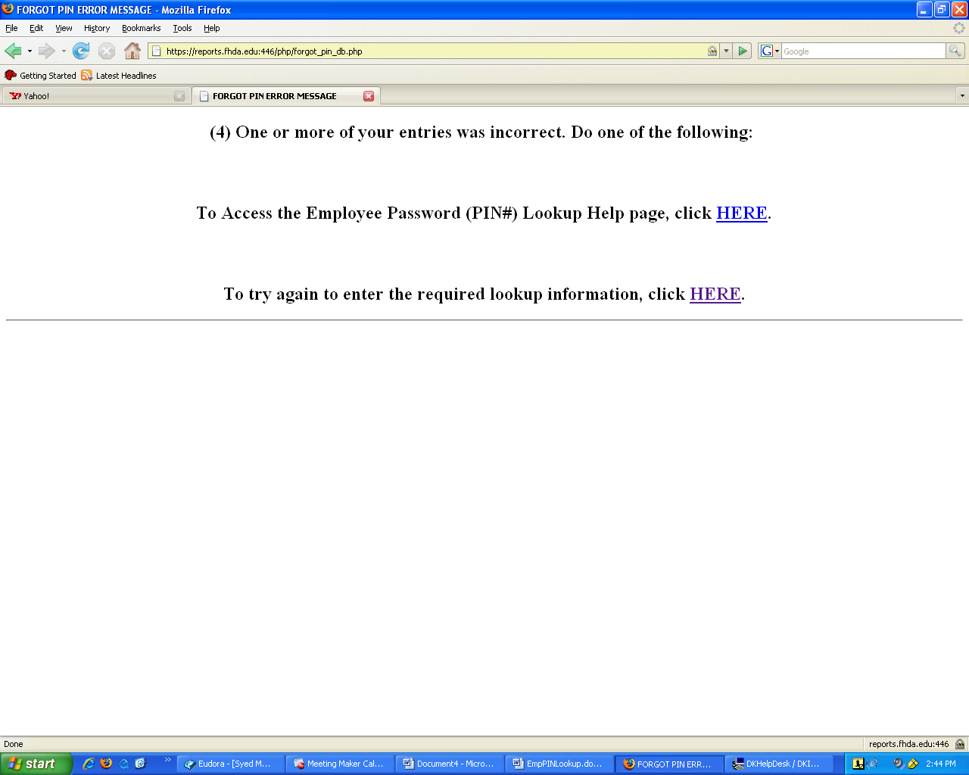

Example of email notification with Employee Password (PIN#)

Date: Mon, 12 May 2008 13:16:49 -0700
From: ETS Reports < Date: Tue, 13 May 2008 14:37:45 -0700
From: ETS Reports <etsreports@fhda.edu>
Subject: Your Employee Password (PIN#)
To: rozathomas@fhda.edu
X-Keywords:

Hello, Your Employee Password (PIN#) is: 111111

EMPLOYEE PIN Lookup Online Help

