We will take down the Banner Luminis (Portal) for maintenance Thursday July 16 at 6:00 pm and last throughout the day on Friday July 17. This will only affect the portal page, the Banner Self Service and Internet Native Banner will still be available.
For those individuals who need to access Self Service Banner (SSB) or Internet Native Banner (INB), please execute the following steps during the shut down period:
1-From any browser, enter the URL: http://banner.fhda.edu
2-The SunGard Higher Education Banner Links Page is displayed. Click on the Welcome to the Banner Finance Module (Click here to Enter) link
3-The MyPortal Page is displayed. Click on the appropriate link (See image display below) to access Banner:
Click here to access Self Service Banner
Click here to access Internet Native Banner
4-The SunGard/Banner login screen is displayed. Enter your current CWID and password and click the Connect button to log into Banner.
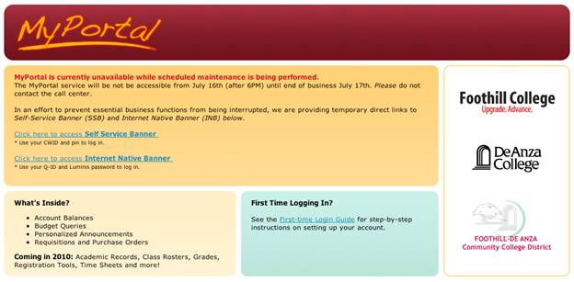
Forms modification request
Some of you request the modifications of the current forms (Check Request, Trip Voucher, Travel Advancement and Mileage) to fit to your local requirements, please contact Ellen Lyon lyonellen@fhda.edu (x6253) and submit your change request and form sample, Ellen will submit the request to the District form standard review committee, once the form passed the review, it will be posted for download and use.
Also, District ETS is working with Finance department to look into the options how we can automate the submission and processing of these forms on line, we will let you know when new information becomes available.
Thank you.
Chien Shih
Director, Information Systems and Operations
Foothill-De Anza Community College District
12345 El Monte Road
Los Altos Hills, CA 94022
voice(650)949-6139
e-mail: shihchien@fhda.edu
website: http://ets.fhda.edu/

