Banner Setup
1: STVTESC: Define Test Score Codes
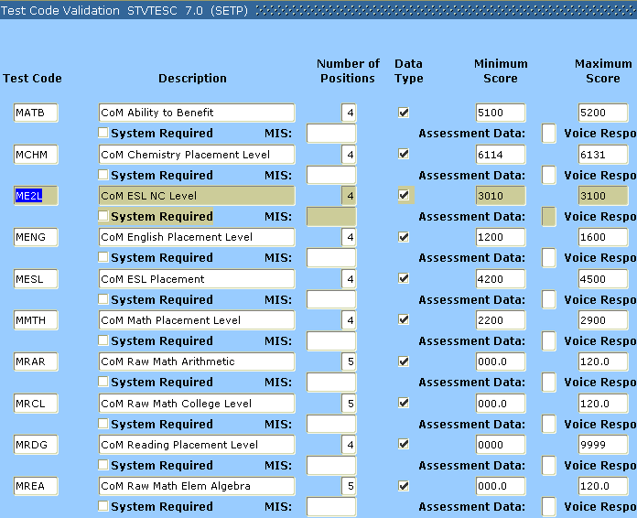
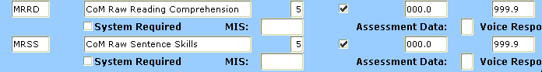

2: STVTAPE: Define ACCU code 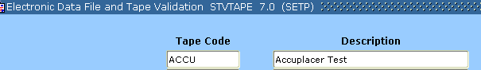

3: STVTSRC: Define ACC code


4: STVSBGI: Define ACCU code
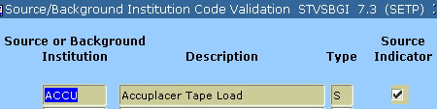

5: STVCTYP: Define T code


6: STVINFC: Define ACCU code
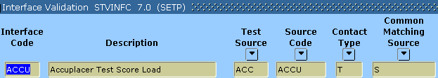

7: STVPREL: Define ACCU code
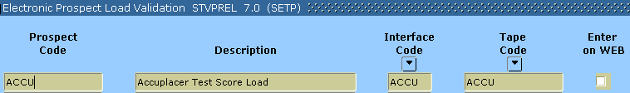

8: SRATPFD: Define Tape Positions
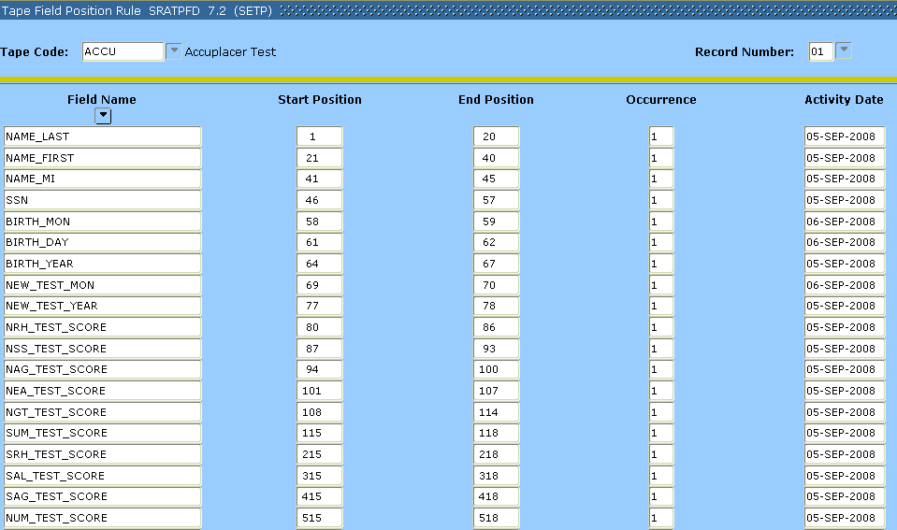
9: SOTCNVT: Define Conversion values
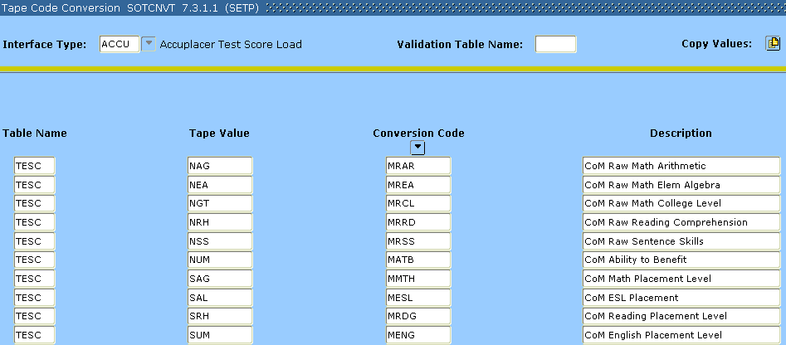

10: SRATPTS: Edit Test Score Date Origin to NEW for the value below
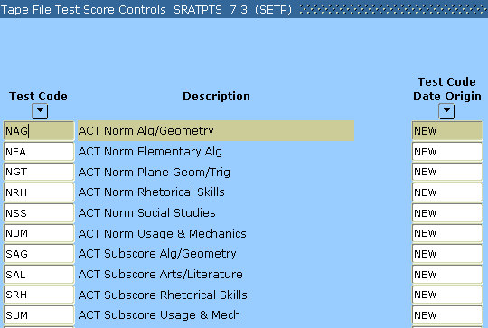

Banner Setup Complete
Accuplacer Setup
- Login to Accuplacer: www.accuplaceronline.com/accuplacer/do/userEdit
- Select Reports 
- Select Custom Reports
- At the bottom select New 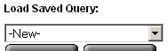
- On Step 1 select Basic information and use the “Move selected options to target list (>) button to add the Last Name, First Name, Middle Initial, Student ID, Birth Date and Test Date in that order.
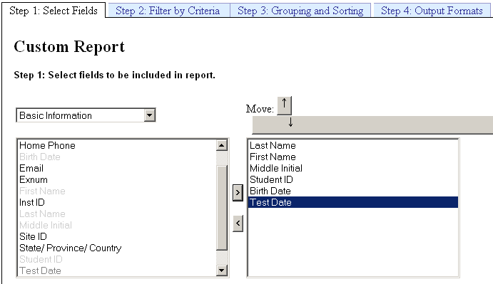
- Change the drop down to Test Scores and add Reading Comprehension, Sentence Skills, Arithmetic, Elementary Algebra, and College Level Math.
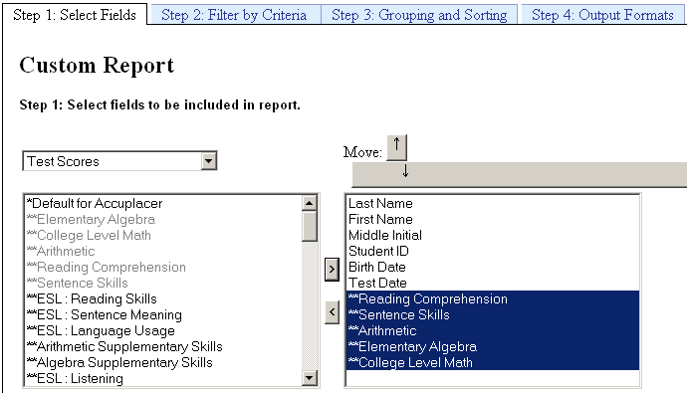
- Change the drop down to Placement Branches and add English, Reading, ESL, Math, and ATB.
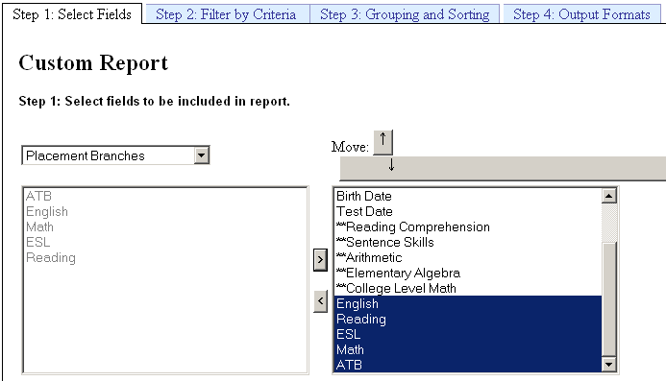
- Navigate to Step 4 and select Fix Length Fields (date format should default to MM/DD/YYYY)
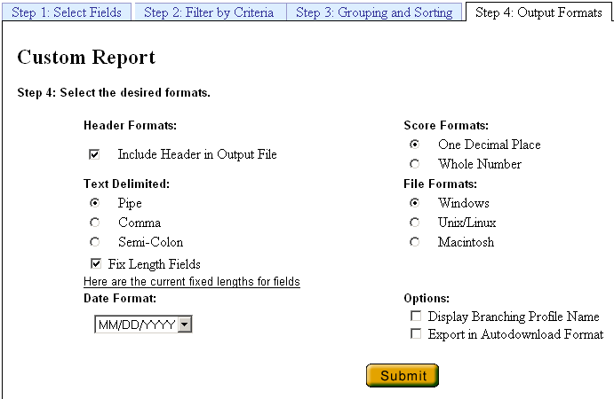

9. Name and Save the download format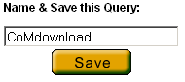

Accuplacer Set Up complete
Accuplacer Day to Day
- Login to Accuplacer: www.accuplaceronline.com/accuplacer/do/userEdit
- Select Reports
- Select Custom Reports
- Select CoMdownload from the drop down for Load Saved Query: 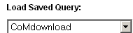
- Navigate to Step 2 and confirm date range for download 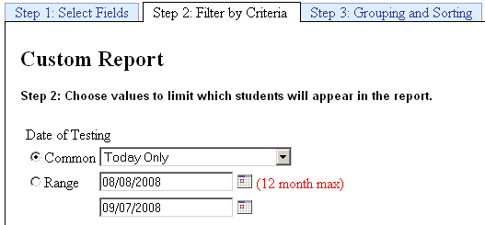
- Navigate to Step 4 and submit . The Submit button will change to 
- When finished the browser will convert to a report. Scroll down to the bottom and select Fix Lenghts
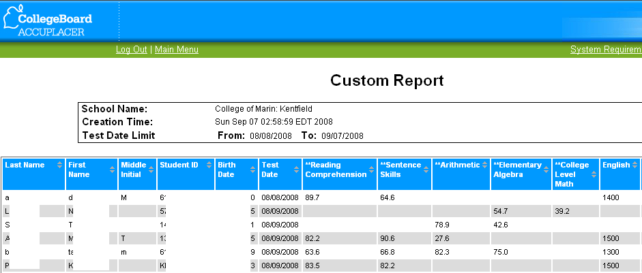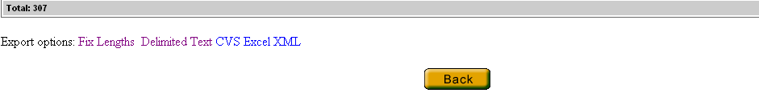
- Chose to save the File 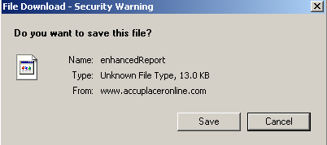
- Save the file in a designated Accuplacer folder and use a consistent naming convention 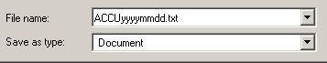
- Open the file and delete the header line then save.
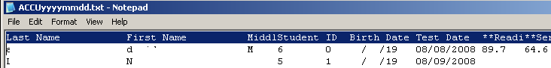
- Close the file and change the ending “txt” of the file name to “dat”. ACCUyymmdd.dat.
- Now the file needs to get transferred to the server in it’s designated folder. The file path name must not exceed 30 characters.
Banner Day to Day:
SRTLOAD-Electronic Prospect Load
This process uses a C program to load data from an input file to the search tape temporary tables. The process should always be run in audit mode first to determine which values are missing from Banner. SRTLOAD uses the values set up on SOTCNVT
Parm 1 will be updated each run with the new file name
Parm 22 should be used in A first to check for errors or bad data on the tape. Then U to load

The actual date of the test will not load. Banner will only load the month and year of the test. Banner will default the first of the month for the date.

SRRSRIN-Electronic Prospect Match
This process determines if a match exists between a record on the Search Tape View and Banner production data when loading tape records in mass. The process uses the interface code and the rules established on GORCMRL to determine if a record exists in Banner

SRIPREL-Electronic Prospect Inquiry Form

SRIPREL allows users to view records in the Search Tape View (SRVPREL). SRIPREL also allows users to view detailed search tape data for a person, determine if the person already exits in Banner and to create or update Banner records for a person.

SRRPREL-Migrate Electronic Prospect Process
This process is used to create or update Banner recruiting records from the records in the Search Tape View. The sources and contact codes identified as parameters on SRTLOAD are loaded to the new or updated recruiting records

SRTPURG-Prospect Purge Process
This process purges records from the temporary tables after the records have been loaded from the temporary tables to Banner

Functional users need access to the following Banner forms/jobs:
GJAPCTL
GJIREVO
GJAPDFT
SRTLOAD
SRRSRIN
SRIPREL
SRAPREL
SRRPREL
SRTPURG

