BLOCK REGISTRATION
STVBLCK/SSABLCK/SGASTDN/SFAMREG

BLOCK REGISTRATION: This is registration for a group of students who need to be enrolled in a special program (a core set of classes) each quarter

STVBLCK – In this screen you would create a code (name) for the registration you are doing. For example First Year Experience might be FYEX.
- Go to the Block Code column. Create a code to use for your block registration
- In the Description Column type in a description of the block registration. For example you would type in “First Year Experience” for that program.\
- Click on the Save icon (The gray disk in the upper left hand corner)
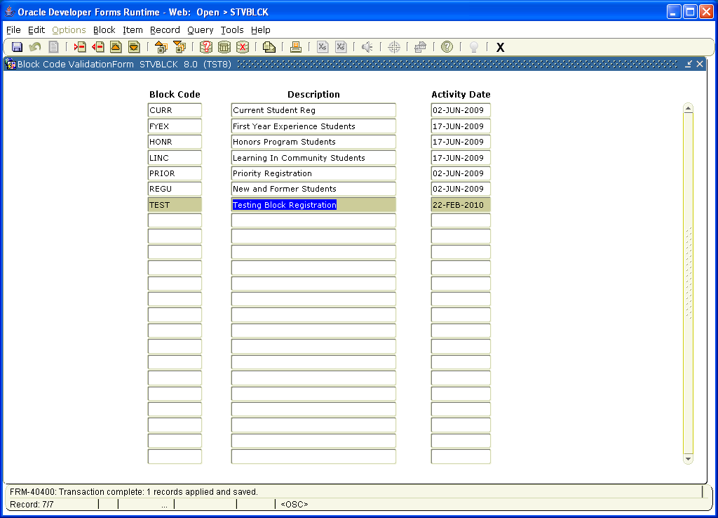

SSABLCK. – In this screen you would type in the call numbers to the classes that the students should be enrolled in.
- First block. Type in the Term and Code name for your block of registration
- Second block. Type in the call numbers for you block of registration. If it is more than two classes you will need to put your arrow on the word Record on the top of the page. This will bring up a menu and you must choose Record insert. This will bring up a blank line for you to type in more call numbers
- Click on the save icon.

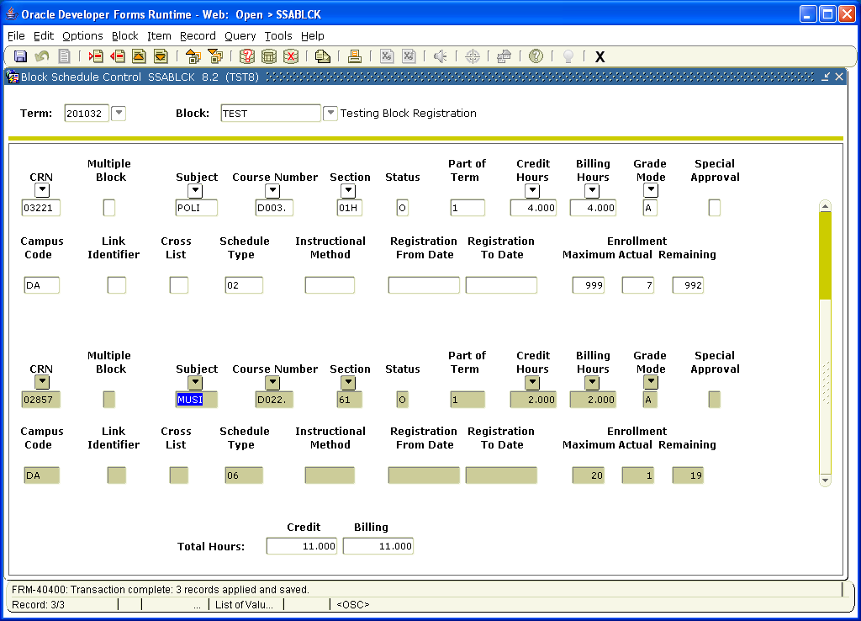

SGASTDN – Type in the code name for the block registration for each student.

- First block. Type in the student ID and the term.
- Second block. Go to the space next to the word BLOCK: (under Additional Information) and type in the code name for the block registration.
- Click on the save icon.

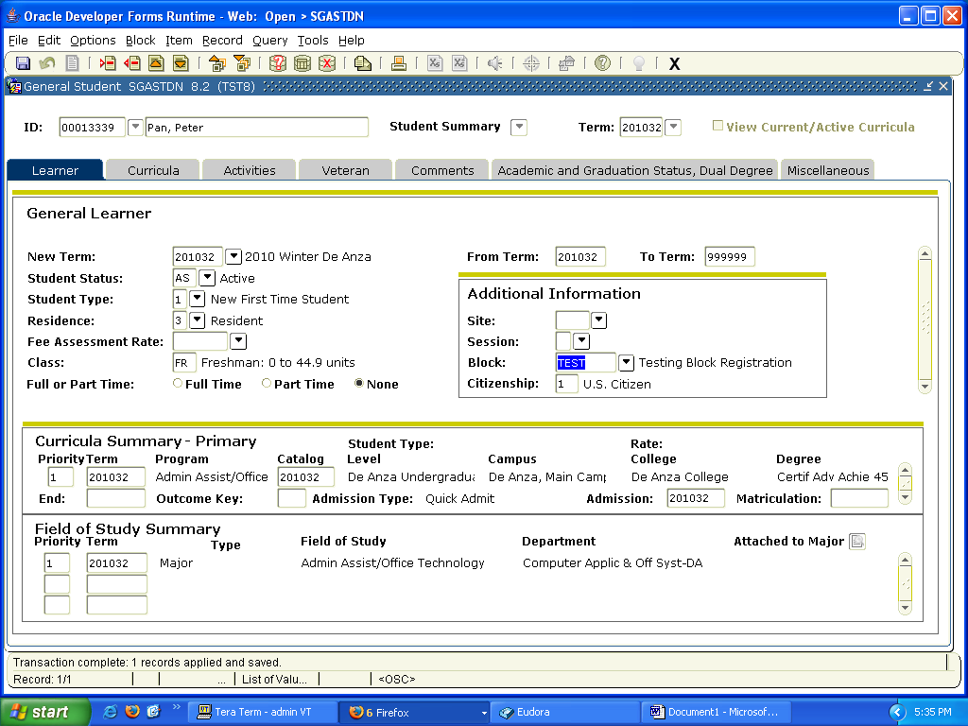

SFAMREG – This is were you will enroll the students (all at one time)

First block
- Type in the term
Second Block
2. Type in the Term (under Search Term)
- Type in the name of the block registration in the space next to the word Block.
- Click on the SAVE icon.
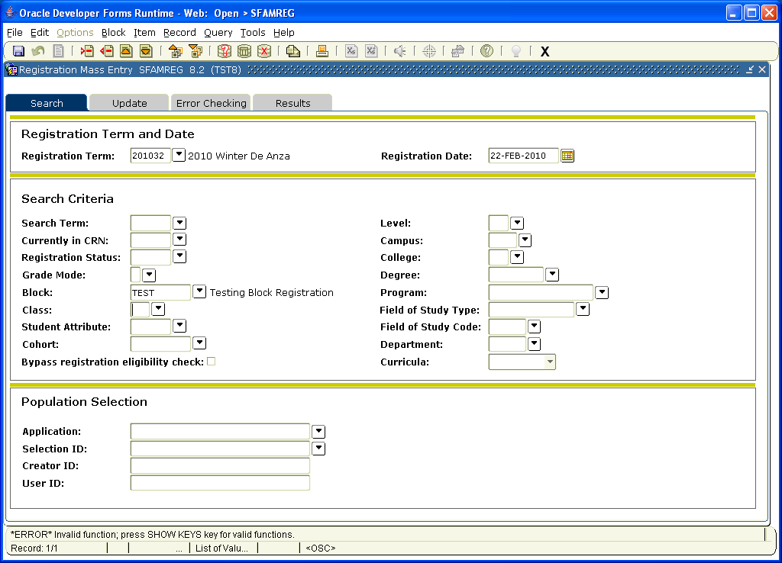

Click on the UPDATE tab
Second Block
- Type in the term
- Check the Mass Process Block
- Click on the Save Icon
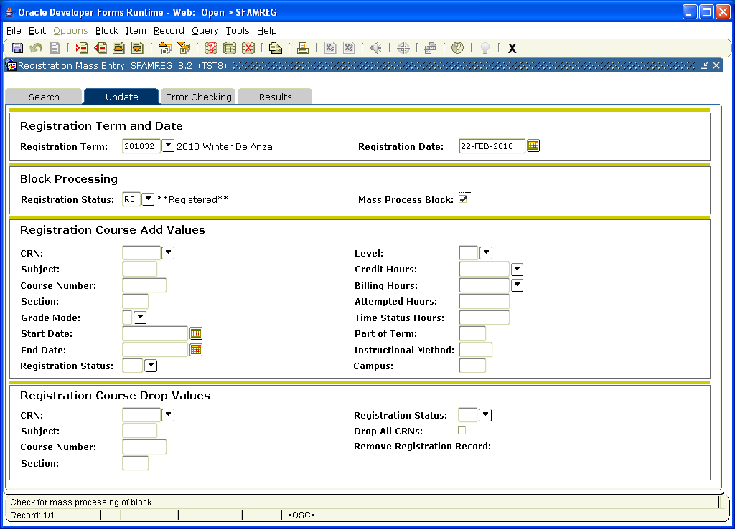
Click on the “RESULTS” tab
Second Block
- Check the box in front of the students you want added
Third Block
- Click on the Submit box.
- Click on the save icon.
- If the registration worked it should show in the second block as “Registration Processed” on the far right under MESSAGE. If it did not work it should give you an error message.

