Banner Review September 11, 2009

General Review:

To check if a person is already in the system, you will go to GOAMTCH and enter their last name and first name, and choose a common matching rule. We will choose the Admissions rule. You click on the duplicate check icon and the system will tell you if there is a match. If there is, click on select ID and the system will take you to SPAIDEN, the general person form.

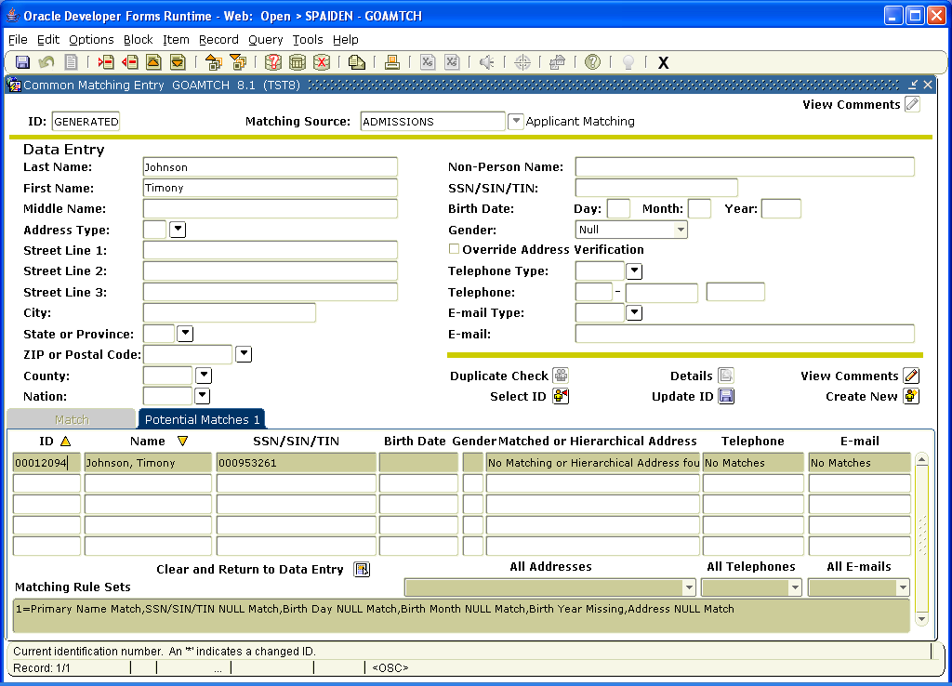

SPAIDEN is the general person form. You go to this form if you already know the person’s CWID and enter it in the ID form and hit enter.

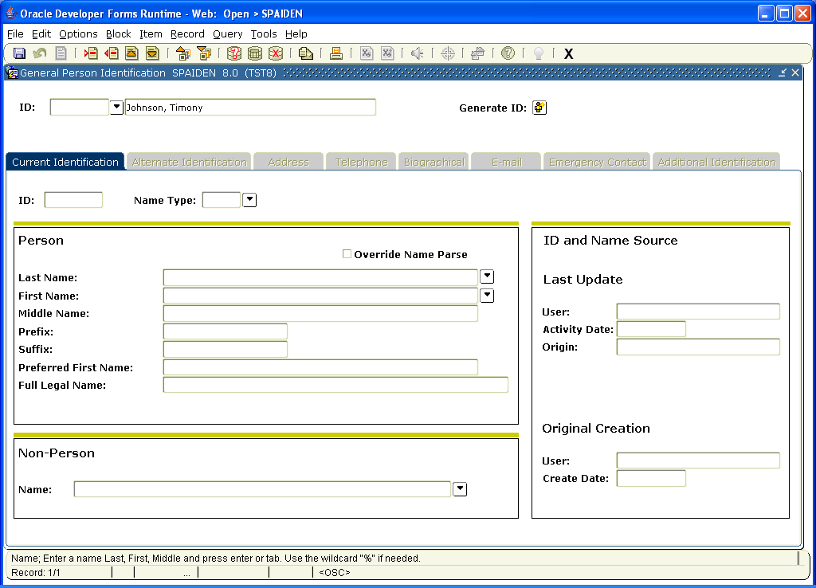

Once you know that this is the correct person, you put your cursor in the lower ID block and click, and the person’s name and other info already in the system will populate.

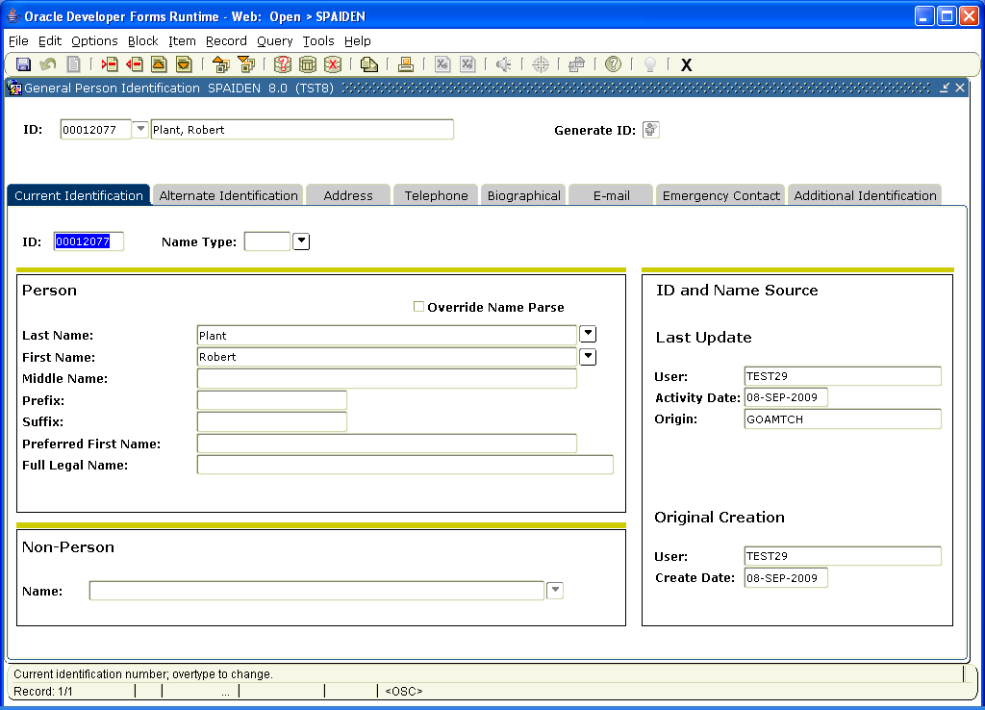

This group of forms holds the general person info and you click on the tabs to go to the next screen. This second tab will show you if the student has had more than one name or ID in the system that has been corrected.

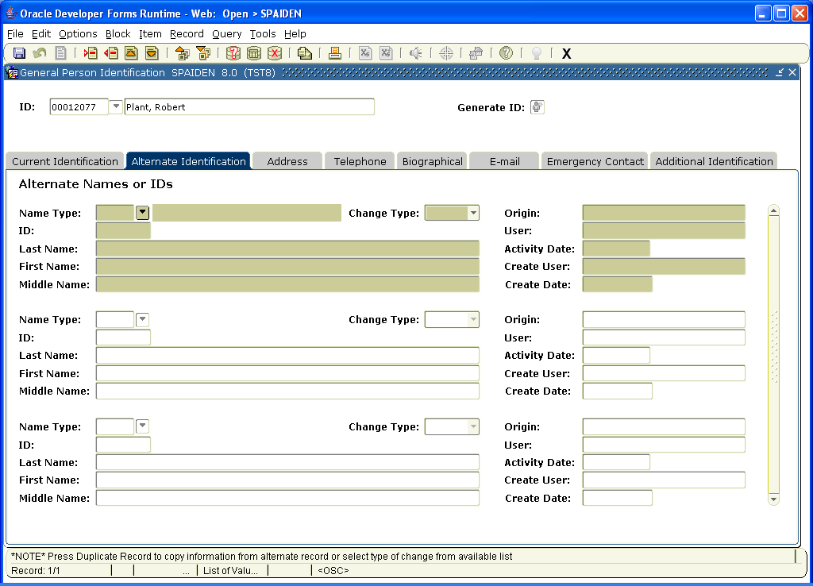

Address screen:

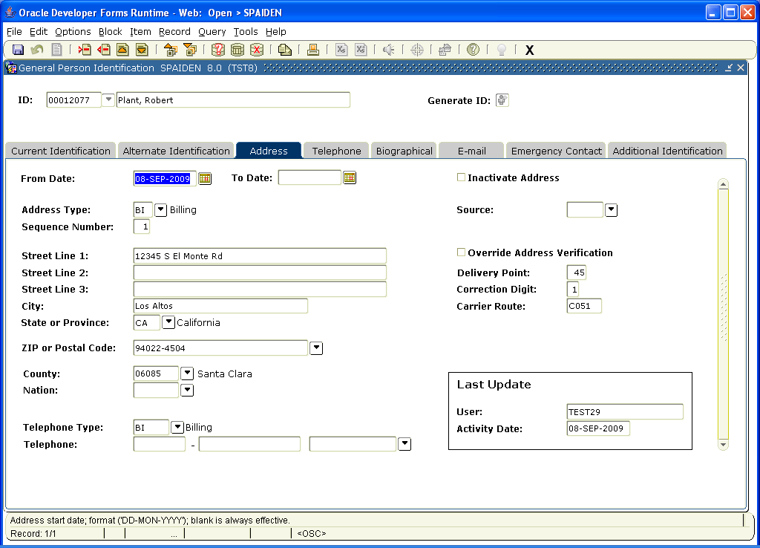

Telephone screen

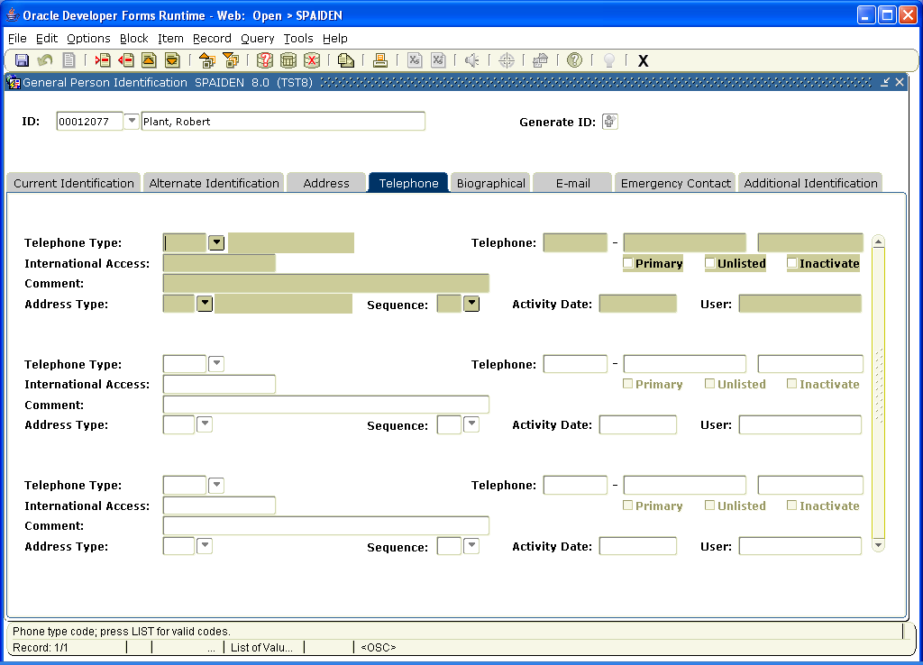

Biographical Information:

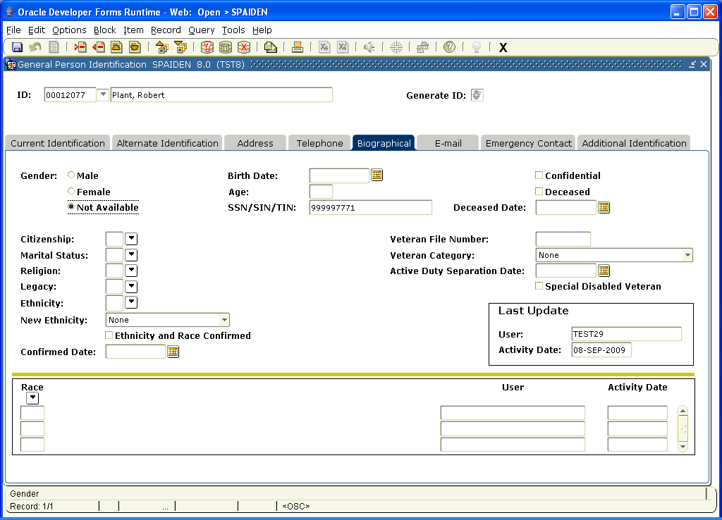

Email

Emergency Contact:
We are discussing a way to collect this information through the portal so we have the person’s emergency info if we need to do a campus-wide message.

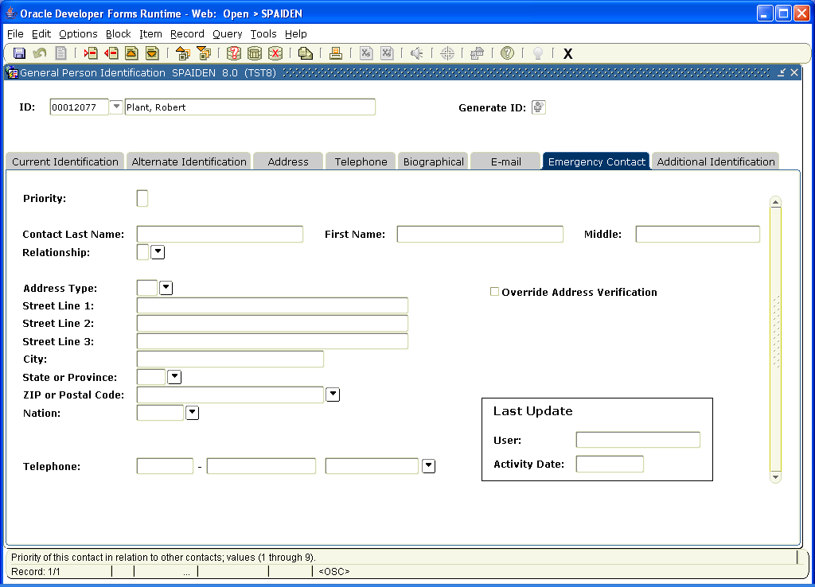

END OF GENERAL PERSON SCREEN

The Banner difference between a person and a student:

Students in Banner are not considered students until they go through the admissions process and are accepted. An ID and name could exist in Banner without that person being a student. They may have gotten into the system via a Financial Aid download, a recruitment card, etc. But until they are admitted, nothing else can be done with that record as far as registering them, etc.

You can see if a person is a student on SGASTDN - the General Student form. (You can see that Banner calls students “learners.”) The first screen has general information about the student, such as the term they were admitted, their residency status, etc.

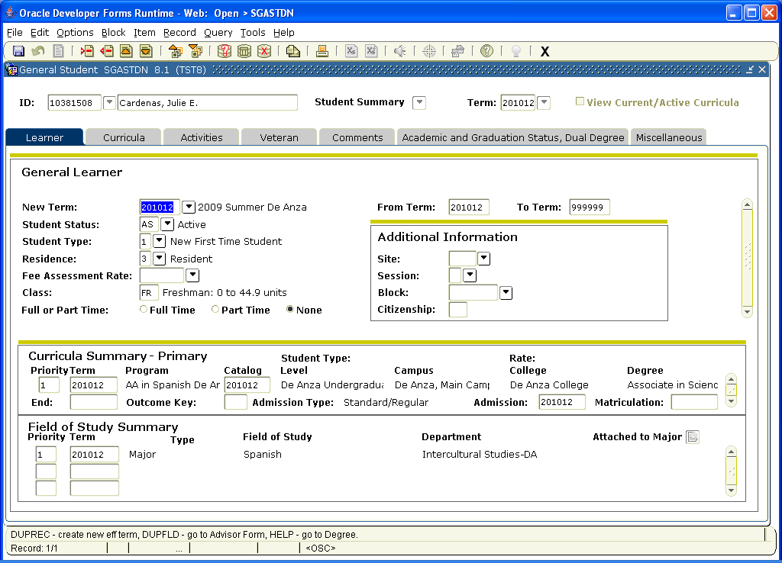

The Curriculum tab gives you more information about the student, including their college, etc, and the additional Field of Study tab has the different majors the student may have had.

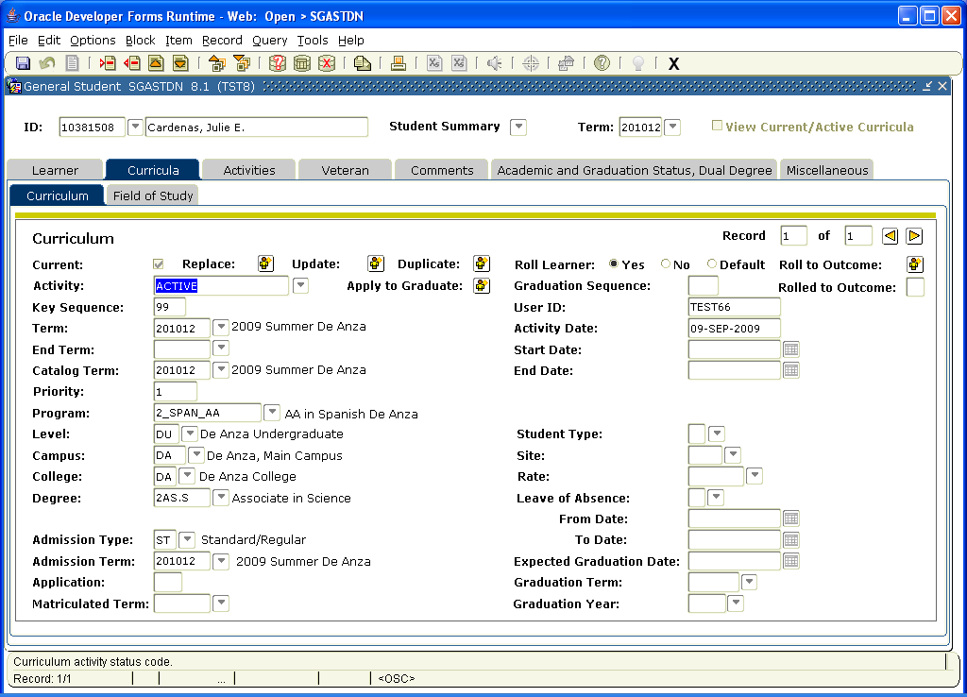

Field of Study Tab:

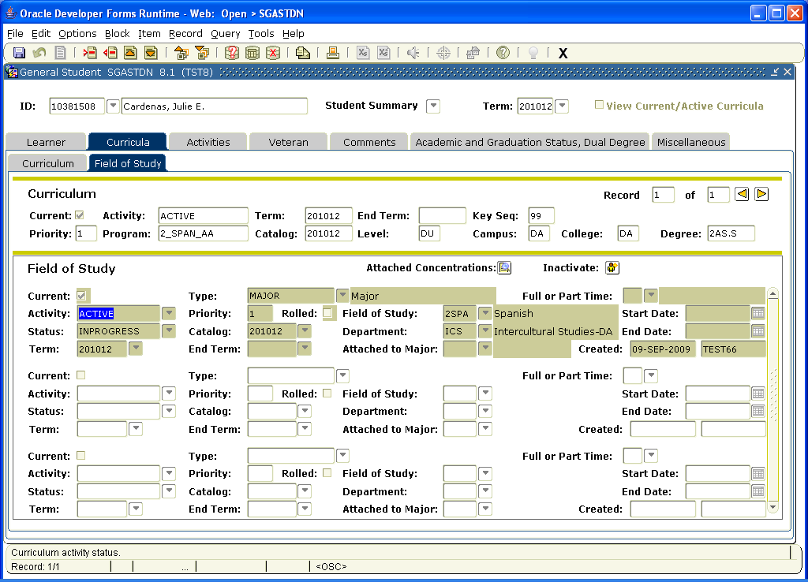

Going back to the regular SGASTDN form, if you click on Activities, it would show what activities the student might be in. We are not sure if we will collect this information. The next tab is the Veterans tab and would collect information as to whether the student was receiving benefits.

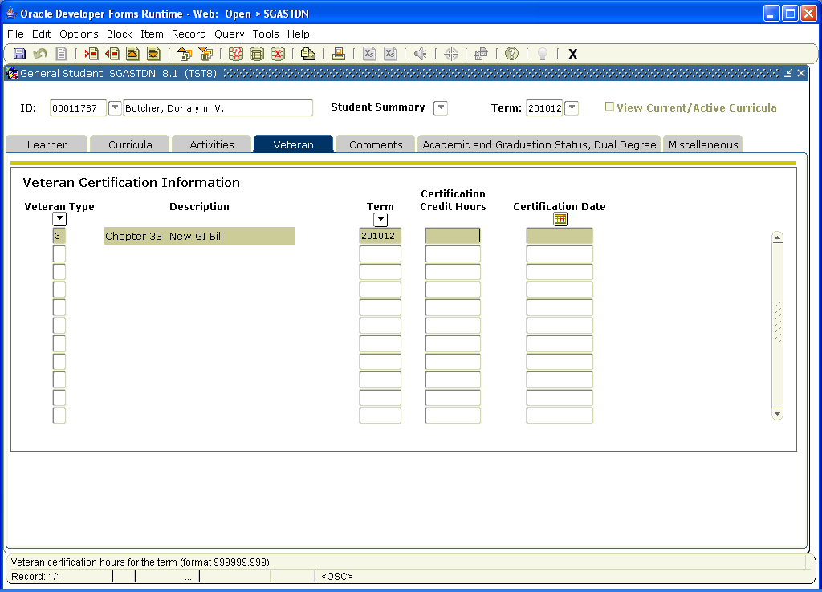

The Comments screen would hold any comments made by anyone who had access to that student’s record.

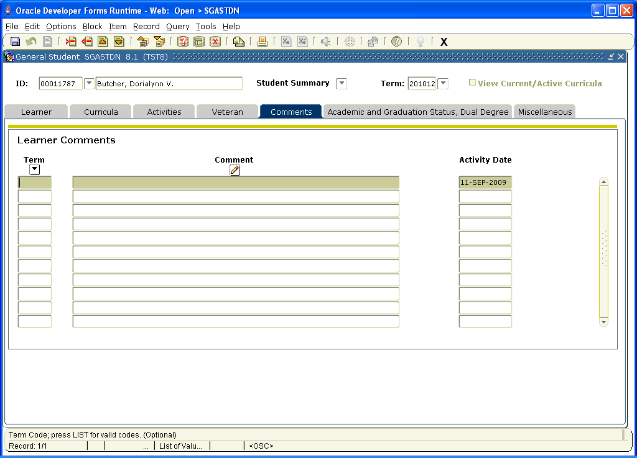

The Academic Status form lets us know if the student is on probation or if they have graduated, etc.

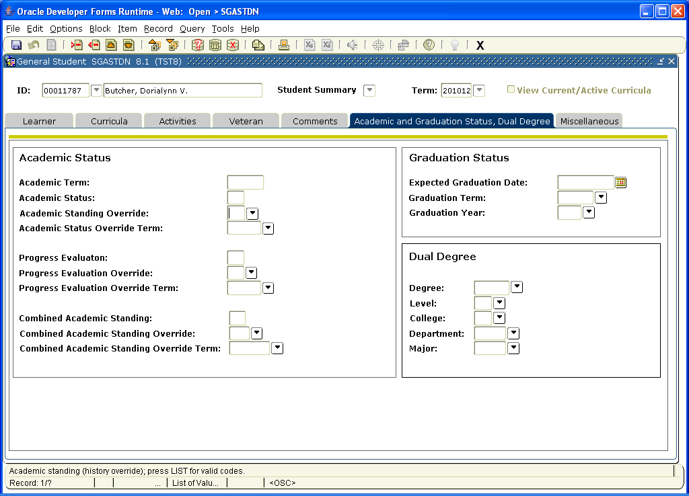

Finally, the last tab on SGASTDN is the MISC tab and it can collect more information about the student, such as transfer, vocational and other data.

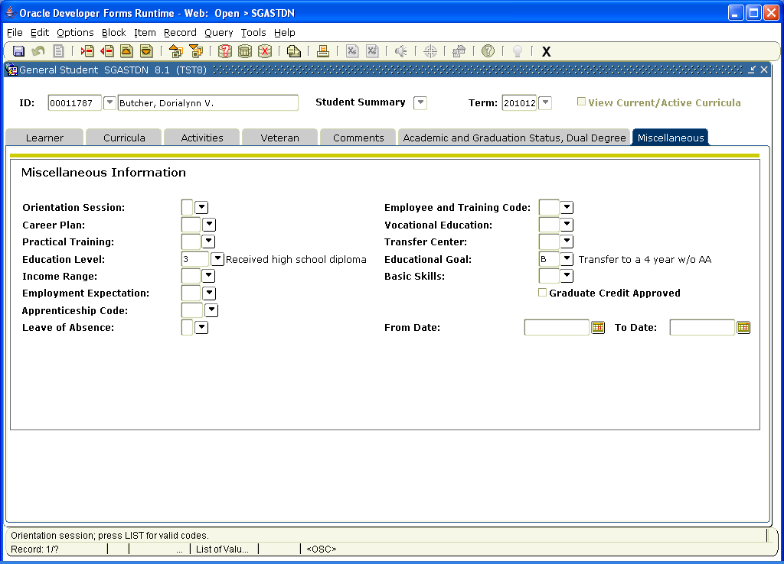

ADMISSIONS in Banner

We will be using a third party application called CCCApply. Most CA community colleges use this. It will require the student go to a link away from the college web site and complete the application there. The application data will be downloaded into Banner and populate most of the fields. We will set up the download to automatically accept students who don’t have any problems with their data, such as residency. International Students is looking into creating a different application that will connect directly to Banner.

The Admissions form is SAAADMS. It has a snapshot of all the admissions info you are recognize. All the little down arrows next to fields equal choices that the system chooses to populate those fields from already created tables.

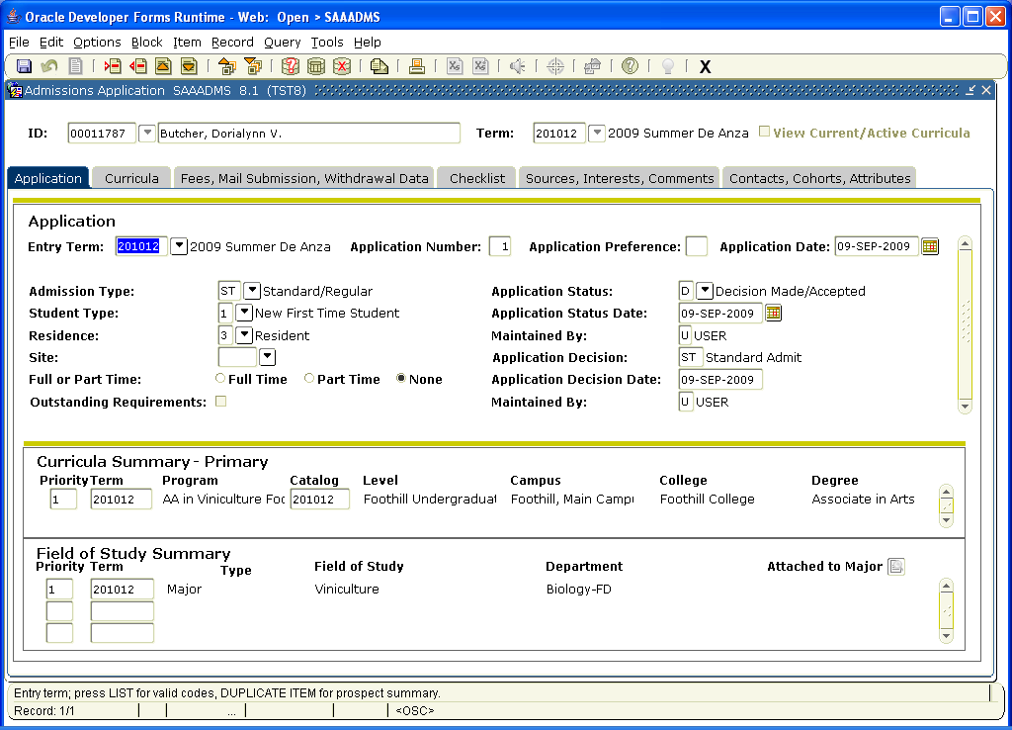

The Curriculum tab has the information we saw in SGASTDN about the students major, etc.

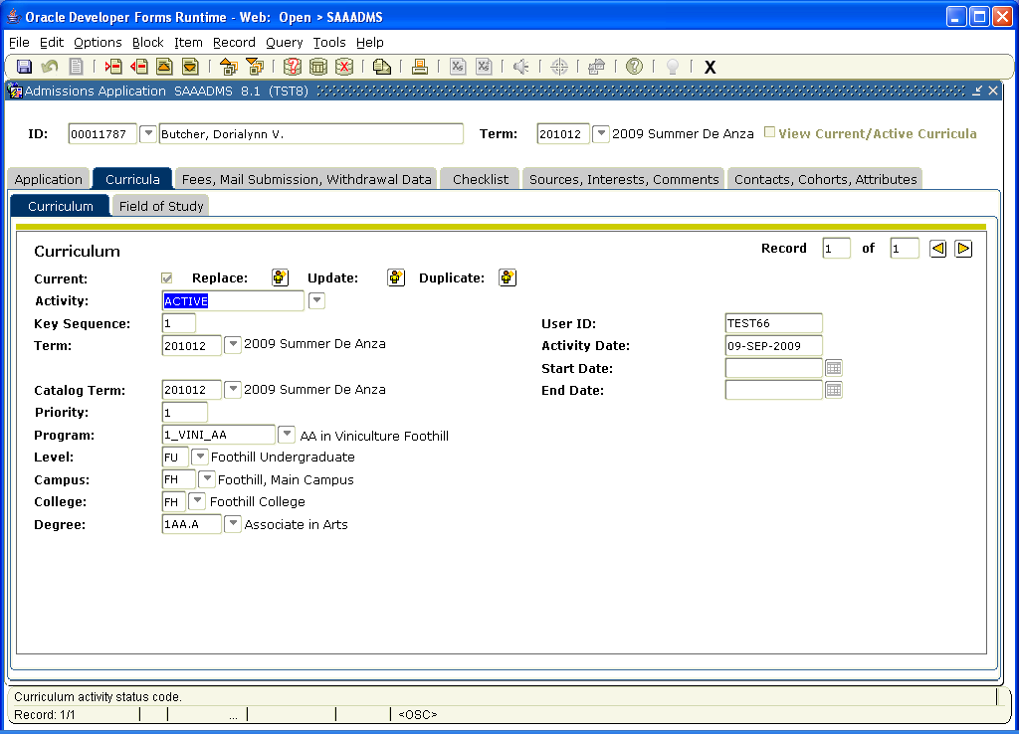

The Fees tab collects other information, such as if we had an application or other required admissions fees. It also shows if the student was recruited, etc.

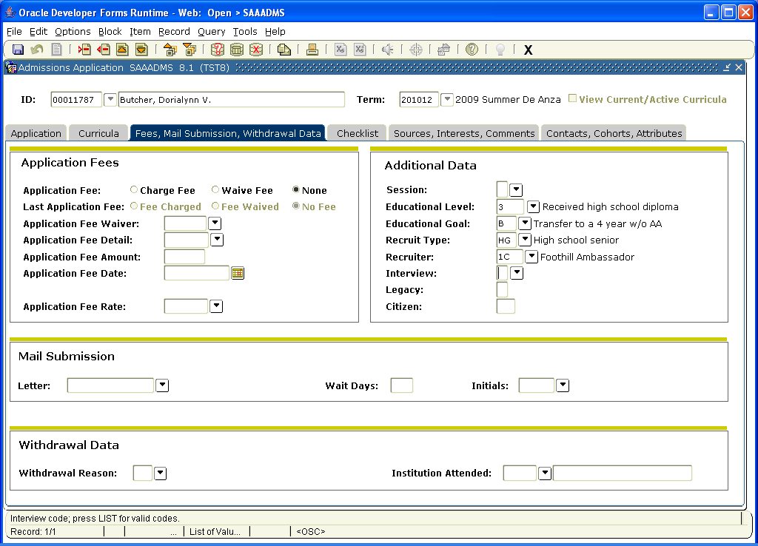

The Checklist screen lists the items the student needs to be activated as an admit. International Students offices will use this. We will also use it to keep track of HS permission forms, Veterans transcripts, etc.

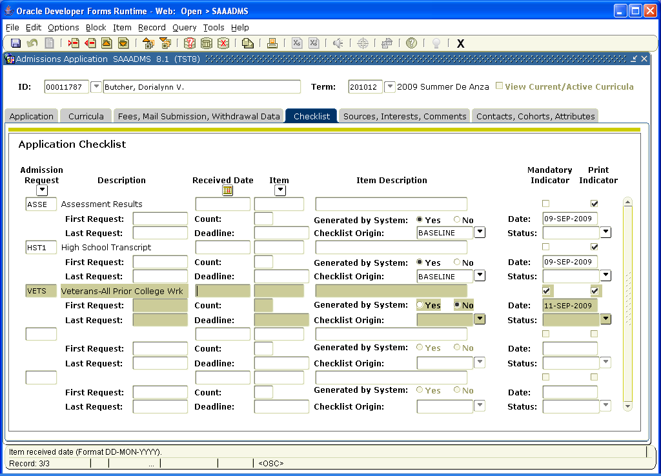

The Sources tab asks for additional information that we may or may not collect.

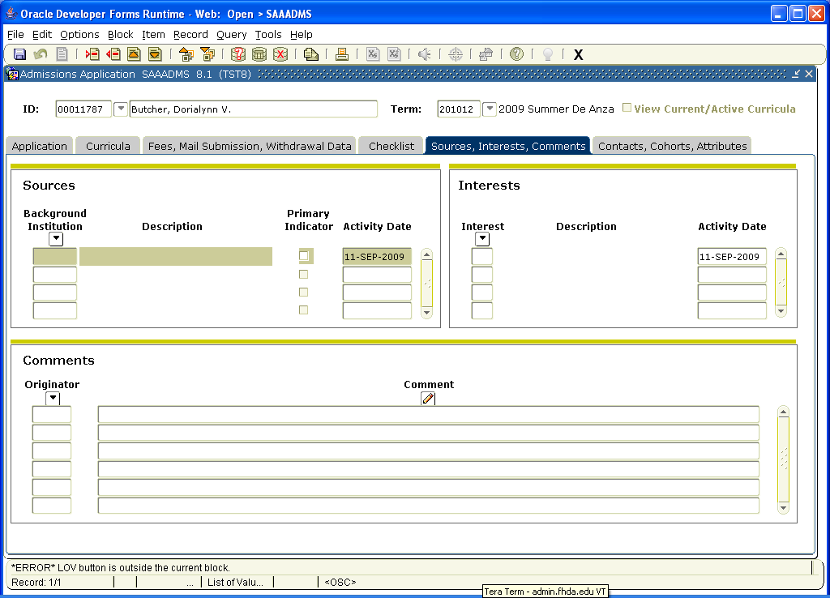

The Cohorts screen lists any special groups the student belongs to and can be used to help sort students in registration priorities, reporting, etc.

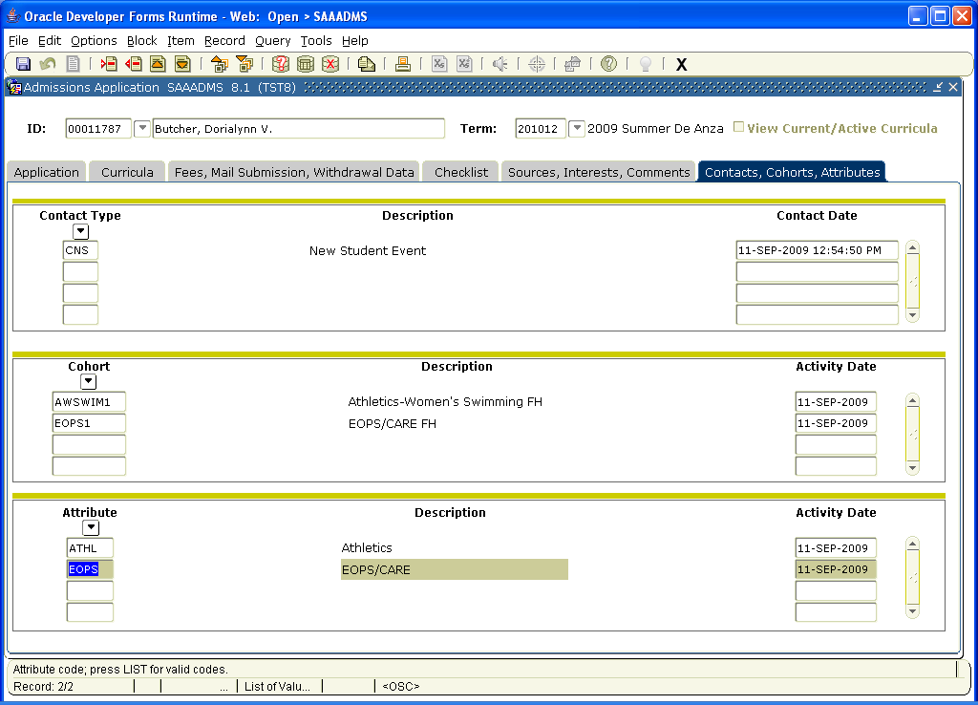

END OF SAAADMS

SFAREGS is the registration screen. On this screen it will show if a student has a hold, whether they are eligible to register, what courses they are already enrolled in, and where you can register them in person. It will also show if they have registration restrictions, so for example, a high school person would have a maximum number of 11 units already in that field.

Next blocking from the enrollment information will take you down to the Course Information block. Here you could enter a CRN (call number) if you had it, or look up classes to choose.

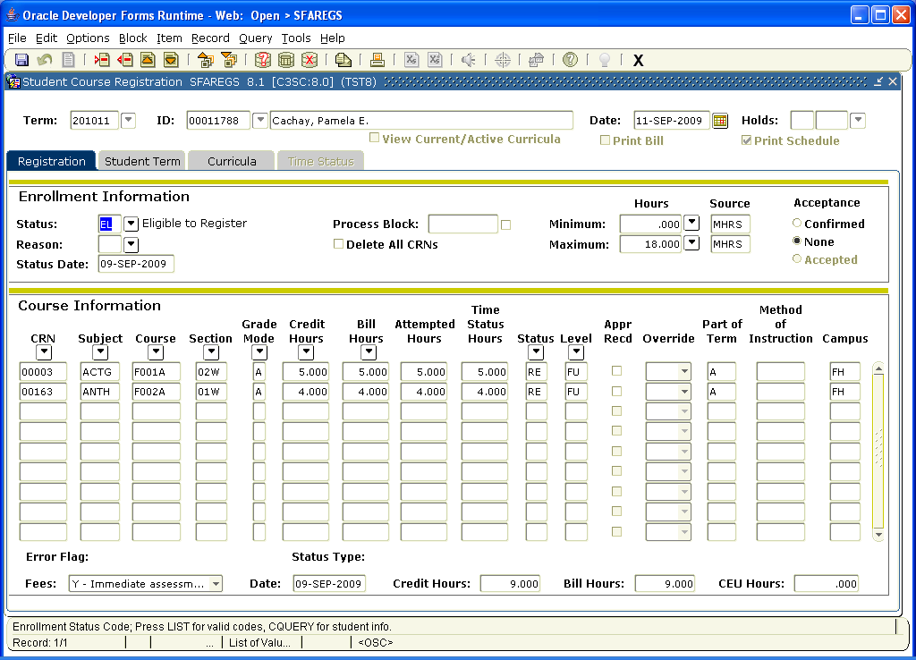

The next tab on SFAREGS is one you have seen in the SGASTDN. Curriculum is the next one:

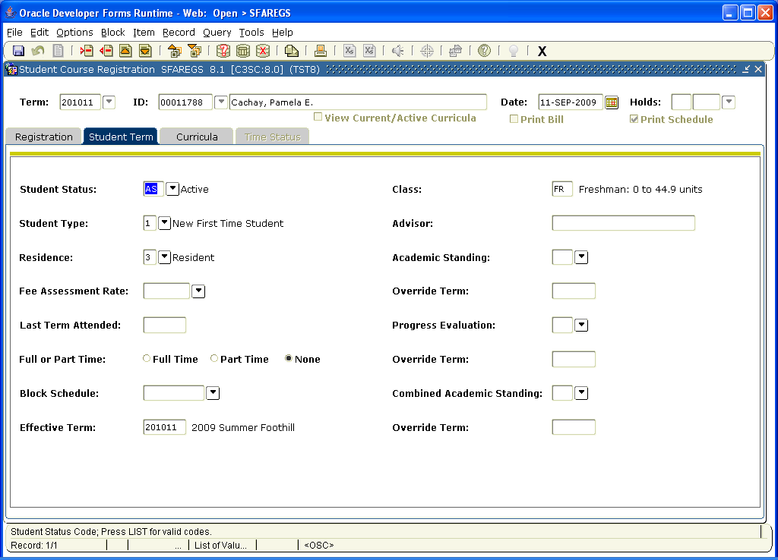

The last tab is Time Status and it will show the date to register.

