Canceling Classes in Banner
(Finding and dropping students from Cancelled classes)

SSASECQ (searching for Cancelled Sections)

Step 1. Go to SSASECQ
Step 2. Type in the term
Step 3. Go to section status and type X (this means cancelled)
Step 4. Go to the box next the word Actual in the Enrollment Maximum line and type >0. (This means classes with enrollment more than 0)
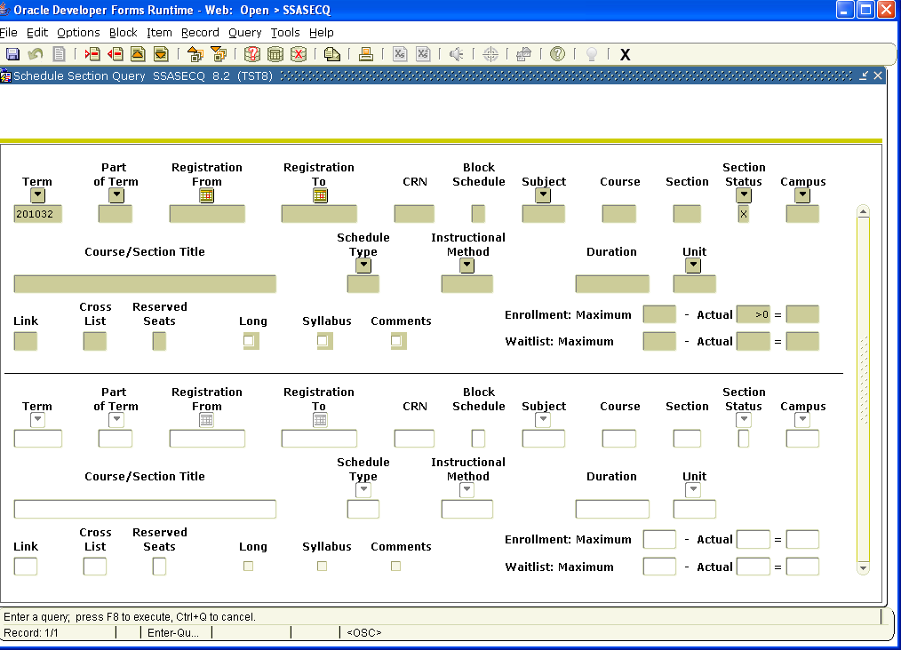

Step 5. Go to Query at the top of the page and choose Execute Query. This will bring up all the classes that have been cancelled that have enrollment.

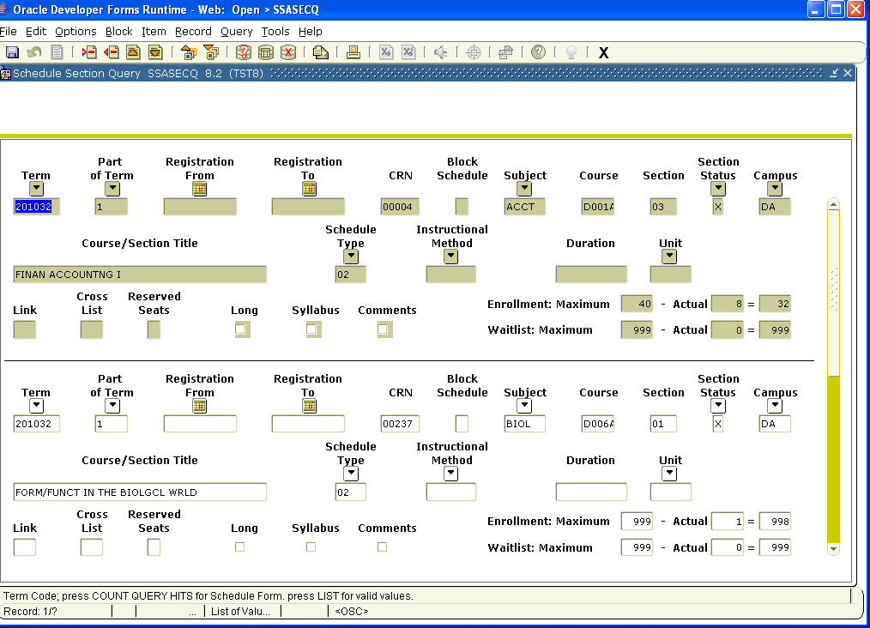

SFAMREG
(dropping students in the Mass Entry Form)

Step 1. Go to SFAMREG
Step 2. Put in the term in the first block
Step 3. Put the current date in the Registration Date box
Step 4. Go to next Block
Step 5. Put in the term in the Search Term Box
Step 6. Put the CRN in the Currently CRN Box

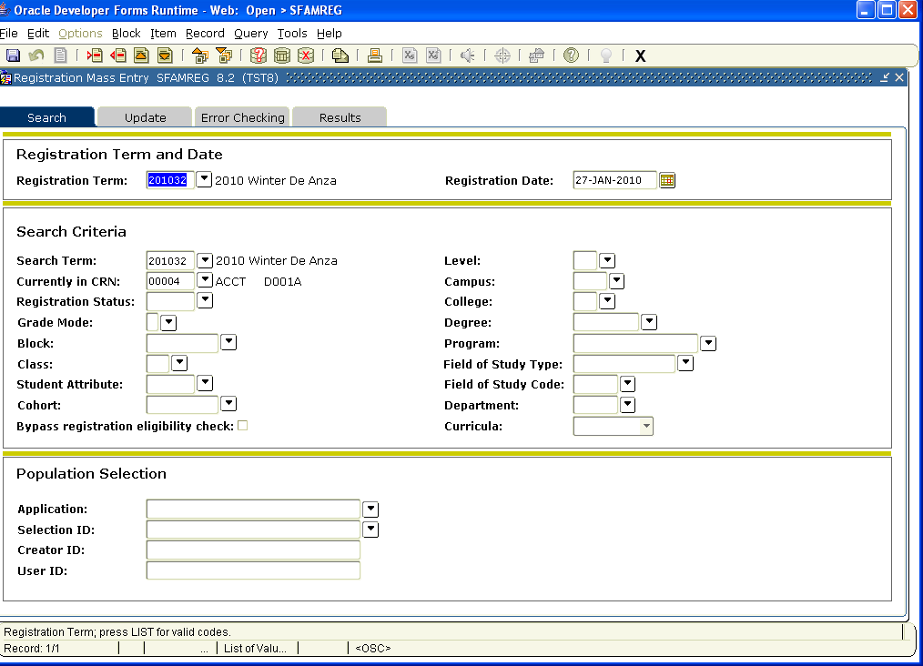

Step 7. Click on Update tab
Step 8. Go to the last block (fourth block)
Step 9. Type in the CRN
Step 10. Under registration status type in CC (for cancelled)
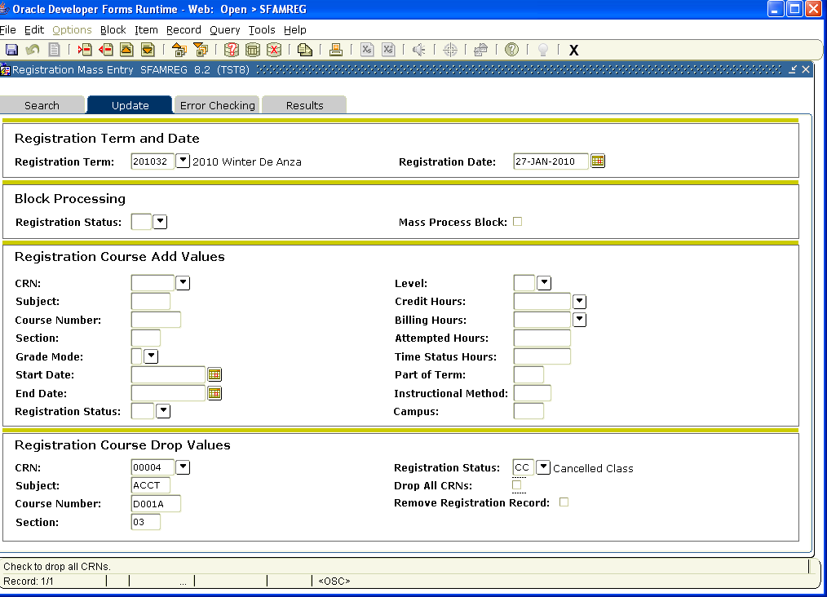

Step 11. Click on Results tab
Step 12. Click on Select All (to drop all the students from the section)
Step 13. Go to last block
Step 14. Click on Submit
Step 15. Save by clicking on the gray disk in upper left hand side of the page.
Step 16. Check the left hand side under Message. This will tell you if the drops were successful and if you had any problems. You can research to see why the drops may not have happened.
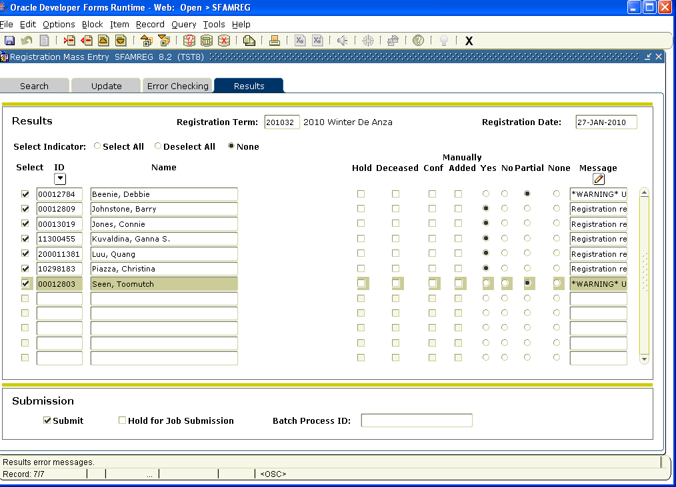

SOAMAUD
(audit trail of the Mass Entry Form SFAMREG)

- Go to SOAMAUD
- First block Type in the from and To Date
- Go to next block – This will show any activities you have done for that time period.
- Choose and click on the date that you performed the Cancellation
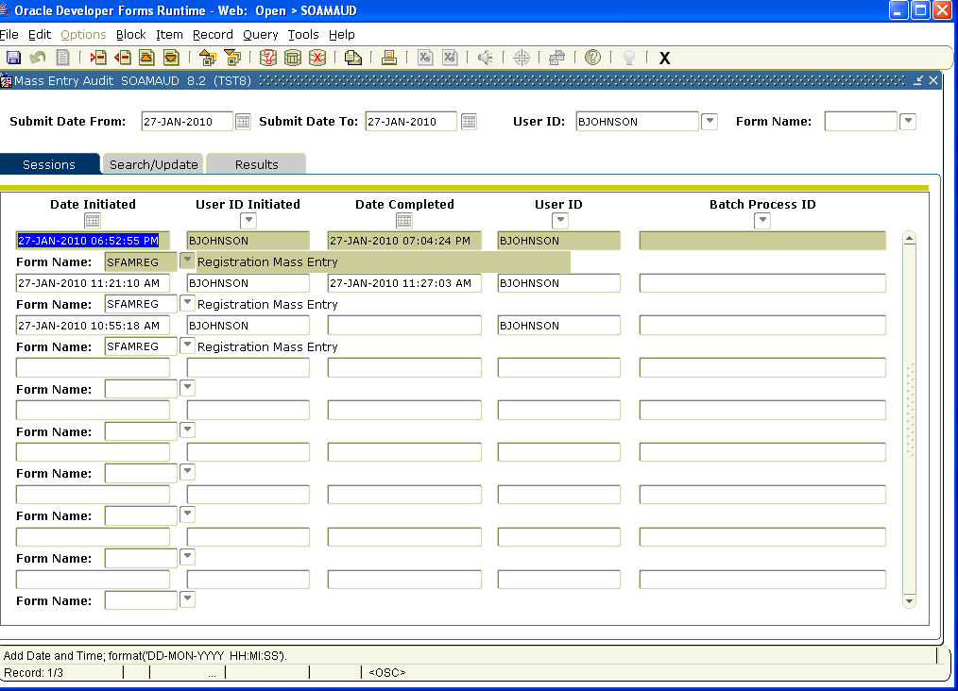

Step 5. Click on Search/Update – you will be able to view the CRN and Term and Transaction detail
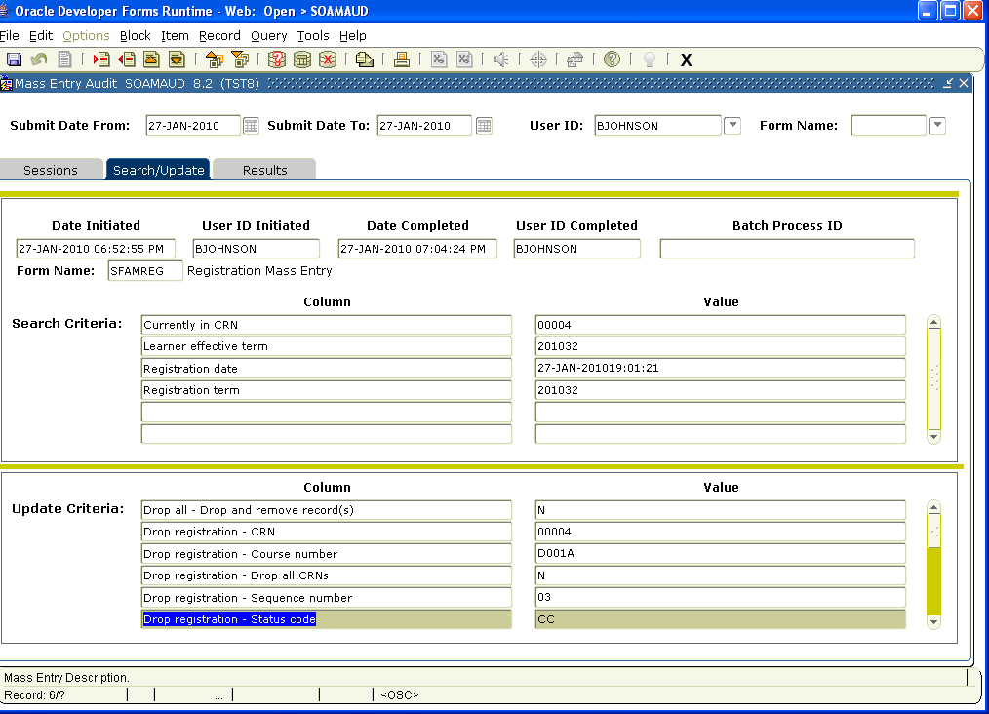

Step 6. Click on Results. You can view the students dropped and any problems that may have occurred. This will appear under the Message in the far right side of the screen.
