Appendix A

FERPA Statement by the Colleges

Appendix B

Searching for a Vendor by ID or Name Using FOAIDEN
The Identification Form in the Finance Module (FOAIDEN) displays vendor ID information. Use the Banner ID number (CWID in plus) or name to access records for this vendor in the General Entity module. Follow these steps, illustrated in Figure A.1.
- Open the identification form by either...
  - Typing ‘FOAIDEN’ and then hitting the [Enter] key , or
  - Double clicking on the form within the ‘Financial’ folder.
Figure A.1 Access to General Entity through Finance (FOAIDEN)
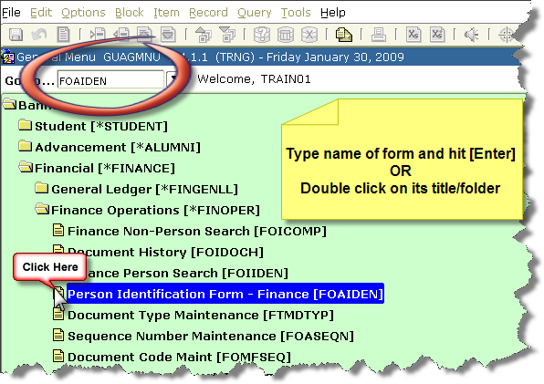

- Once in FOAIDEN, type the vendor Banner ID in the ‘ID’ field or box, or press the tab key to navigate to the Name field and type the name. (Banner is not case-sensitive; you can use upper or lower case characters). The name format on this field is Last Name, First Name. You can use any of the following steps to streamline your search if needed.
  - Type ‘Mar%’ to find vendor whose Legal Name or Last Names begin with Mar. (See Figure A.2)
Figure A.2 Searching by Using Initial Characters of a Legal Name
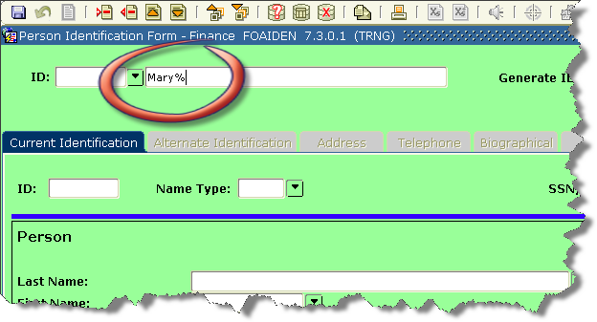
  - Type ‘Mar% , De%’ to find vendors whose Last Name begins with Mar and First Name begins Car. Do not use a prefix for this is stored in a different data field.

  - Click on the ‘pull down’ box to access form for ‘Extended Search.’ (See Figure A.3)

Figure A.3 Accessing Extended Search Forms in Finance Module
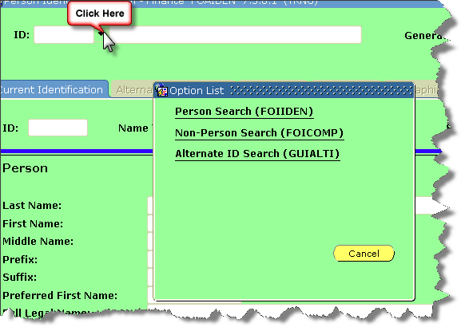

- To search for a person, click on Person Search (FOIIDEN). Use as many of the given data fields to search for the person, including searching under a Name Type. (See Figure A.4.)
Figure A.4 Searching a Person’s ID in Finance with FOIIDEN
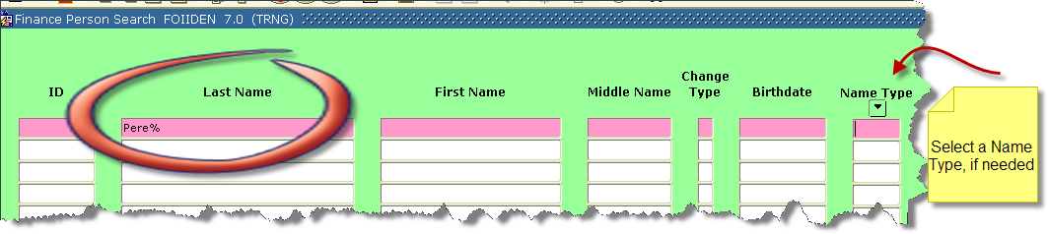

  - Execute your search by pressing the [F8] key, or clicking on ‘Query’ and then ‘Execute’ as shown on Figure A.5.

Figure A. 5 Executing Search
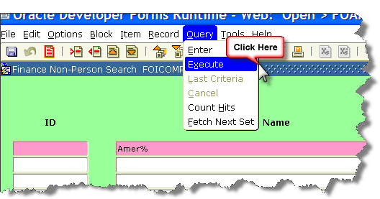

- To search for a Non-Person’s ID, select the form FOICOMP from the ‘Extended Search’ box. Use as many of the given data fields to search for the non-person entity, including Name Type. Then execute your query.
Figure A.5 Searching a Non-Person’s ID in Finance with FOICOMP
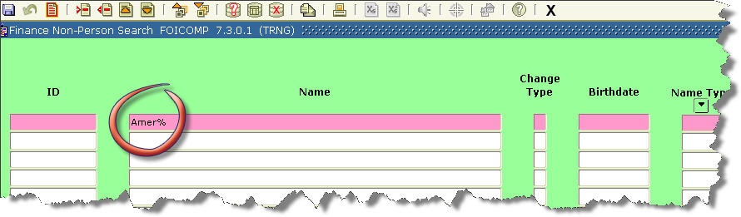

- To search for Alternate IDs, use GUIALTI. Notice that this form is part of the General Entity module and that it allows for a more general type of search, including the SSN/SIN/TIN number. For example, in Figure A.6, search results are shown for entries in the General Entity where the Entity equals ‘C’ or and Change Type equals ‘N.’

Figure A.6 Results for a Query within the Alternate ID Search Form (GUIALTI)
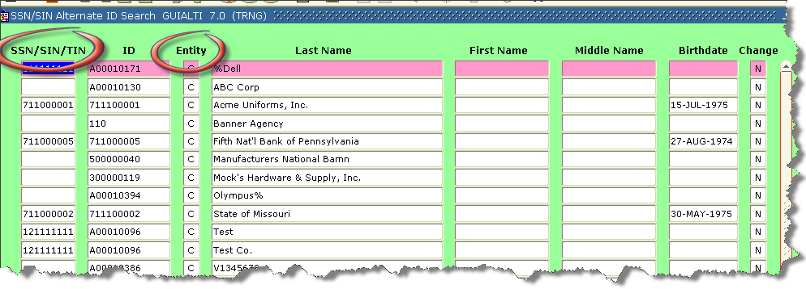

Appendix C

USPS Approved Street Abbreviations

Street Name | Street Common Name | USPS Accepted Abbreviation
ALLEY | ALLEE | ALY
ALLEY | ALLEY | ALY
ALLEY | ALLY | ALY
ALLEY | ALY | ALY
ANNEX | ANEX | ANX
ANNEX | ANNEX | ANX
ANNEX | ANNX | ANX
ANNEX | ANX | ANX
ARCADE | ARC | ARC
ARCADE | ARCADE | ARC
AVENUE | AV | AVE
AVENUE | AVE | AVE
AVENUE | AVEN | AVE
AVENUE | AVENU | AVE
AVENUE | AVENUE | AVE
AVENUE | AVN | AVE
AVENUE | AVNUE | AVE
BAYOO | BAYOO | BYU
BAYOO | BAYOU | BYU
BEACH | BCH | BCH
BEACH | BEACH | BCH
BEND | BEND | BND
BEND | BND | BND
BLUFF | BLF | BLF
BLUFF | BLUF | BLF
BLUFF | BLUFF | BLF
BLUFFS | BLUFFS | BLFS
BOTTOM | BOT | BTM
BOTTOM | BOTTM | BTM
BOTTOM | BOTTOM | BTM
BOTTOM | BTM | BTM
BOULEVARD | BLVD | BLVD
BOULEVARD | BOUL | BLVD
BOULEVARD | BOULEVARD | BLVD
BOULEVARD | BOULV | BLVD
BRANCH | BR | BR
BRANCH | BRANCH | BR
BRANCH | BRNCH | BR
BRIDGE | BRDGE | BRG
BRIDGE | BRG | BRG
BRIDGE | BRIDGE | BRG
BROOK | BRK | BRK
BROOK | BROOK | BRK
BROOKS | BROOKS | BRKS
BURG | BURG | BG
BURGS | BURGS | BGS
BYPASS | BYP | BYP
BYPASS | BYPA | BYP
BYPASS | BYPAS | BYP
BYPASS | BYPASS | BYP
BYPASS | BYPS | BYP
CAMP | CAMP | CP
CAMP | CMP | CP
CAMP | CP | CP
CANYON | CANYN | CYN
CANYON | CANYON | CYN
CANYON | CNYN | CYN
CANYON | CYN | CYN
CAPE | CAPE | CPE
CAPE | CPE | CPE
CAUSEWAY | CAUSEWAY | CSWY
CAUSEWAY | CAUSWAY | CSWY
CAUSEWAY | CSWY | CSWY
CENTER | CEN | CTR
CENTER | CENT | CTR
CENTER | CENTER | CTR
CENTER | CENTR | CTR
CENTER | CENTRE | CTR
CENTER | CNTER | CTR
CENTER | CNTR | CTR
CENTER | CTR | CTR
CENTERS | CENTERS | CTRS
CIRCLE | CIR | CIR
CIRCLE | CIRC | CIR
CIRCLE | CIRCL | CIR
CIRCLE | CIRCLE | CIR
CIRCLE | CRCL | CIR
CIRCLE | CRCLE | CIR
CIRCLES | CIRCLES | CIRS
CLIFF | CLF | CLF
CLIFF | CLIFF | CLF
CLIFFS | CLFS | CLFS
CLIFFS | CLIFFS | CLFS
CLUB | CLB | CLB
CLUB | CLUB | CLB
COMMON | COMMON | CMN
CORNER | COR | COR
CORNER | CORNER | COR
CORNERS | CORNERS | CORS
CORNERS | CORS | CORS
COURSE | COURSE | CRSE
COURSE | CRSE | CRSE
COURT | COURT | CT
COURT | CRT | CT
COURT | CT | CT
COURTS | COURTS | CTS
COURTS | CT | CTS
COVE | COVE | CV
COVE | CV | CV
COVES | COVES | CVS
CREEK | CK | CRK
CREEK | CR | CRK
CREEK | CREEK | CRK
CREEK | CRK | CRK
CRESCENT | CRECENT | CRES
CRESCENT | CRES | CRES
CRESCENT | CRESCENT | CRES
CRESCENT | CRESENT | CRES
CRESCENT | CRSCNT | CRES
CRESCENT | CRSENT | CRES
CRESCENT | CRSNT | CRES
CREST | CREST | CRST
CROSSING | CROSSING | XING
CROSSING | CRSSING | XING
CROSSING | CRSSNG | XING
CROSSING | XING | XING
CROSSROAD | CROSSROAD | XRD
CURVE | CURVE | CURV
DALE | DALE | DL
DALE | DL | DL
DAM | DAM | DM
DAM | DM | DM
DIVIDE | DIV | DV
DIVIDE | DIVIDE | DV
DIVIDE | DV | DV
DIVIDE | DVD | DV
DRIVE | DR | DR
DRIVE | DRIV | DR
DRIVE | DRIVE | DR
DRIVE | DRV | DR
DRIVES | DRIVES | DRS
ESTATE | EST | EST
ESTATE | ESTATE | EST
ESTATES | ESTATES | ESTS
ESTATES | ESTS | ESTS
EXPRESSWAY | EXP | EXPY
EXPRESSWAY | EXPR | EXPY
EXPRESSWAY | EXPRESS | EXPY
EXPRESSWAY | EXPRESSWAY | EXPY
EXPRESSWAY | EXPW | EXPY
EXPRESSWAY | EXPY | EXPY
EXTENSION | EXT | EXT
EXTENSION | EXTENSION | EXT
EXTENSION | EXTN | EXT
EXTENSION | EXTNSN | EXT
EXTENSIONS | EXTENSIONS | EXTS
EXTENSIONS | EXTS | EXTS
FALL | FALL | FALL
FALLS | FALLS | FLS
FALLS | FLS | FLS
FERRY | FERRY | FRY
FERRY | FRRY | FRY
FERRY | FRY | FRY
FIELD | FIELD | FLD
FIELD | FLD | FLD
FIELDS | FIELDS | FLDS
FIELDS | FLDS | FLDS
FLAT | FLAT | FLT
FLAT | FLT | FLT
FLATS | FLATS | FLTS
FLATS | FLTS | FLTS
FORD | FORD | FRD
FORD | FRD | FRD
FORDS | FORDS | FRDS
FOREST | FOREST | FRST
FOREST | FORESTS | FRST
FOREST | FRST | FRST
FORGE | FORG | FRG
FORGE | FORGE | FRG
FORGE | FRG | FRG
FORGES | FORGES | FRGS
FORK | FORK | FRK
FORK | FRK | FRK
FORKS | FORKS | FRKS
FORKS | FRKS | FRKS
FORT | FORT | FT
FORT | FRT | FT
FORT | FT | FT
FREEWAY | FREEWAY | FWY
FREEWAY | FREEWY | FWY
FREEWAY | FRWAY | FWY
FREEWAY | FRWY | FWY
FREEWAY | FWY | FWY
GARDEN | GARDEN | GDN
GARDEN | GARDN | GDN
GARDEN | GDN | GDN
GARDEN | GRDEN | GDN
GARDEN | GRDN | GDN
GARDENS | GARDENS | GDNS
GARDENS | GDNS | GDNS
GARDENS | GRDNS | GDNS
GATEWAY | GATEWAY | GTWY
GATEWAY | GATEWY | GTWY
GATEWAY | GATWAY | GTWY
GATEWAY | GTWAY | GTWY
GATEWAY | GTWY | GTWY
GLEN | GLEN | GLN
GLEN | GLN | GLN
GLENS | GLENS | GLNS
GREEN | GREEN | GRN
GREEN | GRN | GRN
GREENS | GREENS | GRNS
GROVE | GROV | GRV
GROVE | GROVE | GRV
GROVE | GRV | GRV
GROVES | GROVES | GRVS
HARBOR | HARB | HBR
HARBOR | HARBOR | HBR
HARBOR | HARBR | HBR
HARBOR | HBR | HBR
HARBOR | HRBOR | HBR
HARBORS | HARBORS | HBRS
HAVEN | HAVEN | HVN
HAVEN | HAVN | HVN
HAVEN | HVN | HVN
HEIGHTS | HEIGHT | HTS
HEIGHTS | HEIGHTS | HTS
HEIGHTS | HGTS | HTS
HEIGHTS | HT | HTS
HEIGHTS | HTS | HTS
HIGHWAY | HIGHWAY | HWY
HIGHWAY | HIGHWY | HWY
HIGHWAY | HIWAY | HWY
HIGHWAY | HIWY | HWY
HIGHWAY | HWAY | HWY
HIGHWAY | HWY | HWY
HILL | HILL | HL
HILL | HL | HL
HILLS | HILLS | HLS
HILLS | HLS | HLS
HOLLOW | HLLW | HOLW
HOLLOW | HOLLOW | HOLW
HOLLOW | HOLLOWS | HOLW
HOLLOW | HOLW | HOLW
HOLLOW | HOLWS | HOLW
INLET | INLET | INLT
INLET | INLT | INLT
ISLAND | IS | IS
ISLAND | ISLAND | IS
ISLAND | ISLND | IS
ISLANDS | ISLANDS | ISS
ISLANDS | ISLNDS | ISS
ISLANDS | ISS | ISS
ISLE | ISLE | ISLE
ISLE | ISLES | ISLE
JUNCTION | JCT | JCT
JUNCTION | JCTION | JCT
JUNCTION | JCTN | JCT
JUNCTION | JUNCTION | JCT
JUNCTION | JUNCTN | JCT
JUNCTION | JUNCTON | JCT
JUNCTIONS | JCTNS | JCTS
JUNCTIONS | JCTS | JCTS
JUNCTIONS | JUNCTIONS | JCTS
KEY | KEY | KY
KEY | KY | KY
KEYS | KEYS | KYS
KEYS | KYS | KYS
KNOLL | KNL | KNL
KNOLL | KNOL | KNL
KNOLL | KNOLL | KNL
KNOLLS | KNLS | KNLS
KNOLLS | KNOLLS | KNLS
LAKE | LAKE | LK
LAKE | LK | LK
LAKES | LAKES | LKS
LAKES | LKS | LKS
LAND | LAND | LAND
LANDING | LANDING | LNDG
LANDING | LNDG | LNDG
LANDING | LNDNG | LNDG
LANE | LA | LN
LANE | LANE | LN
LANE | LANES | LN
LANE | LN | LN
LIGHT | LGT | LGT
LIGHT | LIGHT | LGT
LIGHTS | LIGHTS | LGTS
LOAF | LF | LF
LOAF | LOAF | LF
LOCK | LCK | LCK
LOCK | LOCK | LCK
LOCKS | LCKS | LCKS
LOCKS | LOCKS | LCKS
LODGE | LDG | LDG
LODGE | LDGE | LDG
LODGE | LODG | LDG
LODGE | LODGE | LDG
LOOP | LOOP | LOOP
LOOP | LOOPS | LOOP
MALL | MALL | MALL
MANOR | MANOR | MNR
MANOR | MNR | MNR
MANORS | MANORS | MNRS
MANORS | MNRS | MNRS
MEADOW | MDW | MDW
MEADOW | MEADOW | MDW
MEADOWS | MDWS | MDWS
MEADOWS | MEADOWS | MDWS
MEADOWS | MEDOWS | MDWS
MEWS | MEWS | MEWS
MILL | MILL | ML
MILL | ML | ML
MILLS | MILLS | MLS
MILLS | MLS | MLS
MISSION | MISSION | MSN
MISSION | MISSN | MSN
MISSION | MSN | MSN
MISSION | MSSN | MSN
MOTORWAY | MOTORWAY | MTWY
MOUNT | MNT | MT
MOUNT | MOUNT | MT
MOUNT | MT | MT
MOUNTAIN | MNTAIN | MTN
MOUNTAIN | MNTN | MTN
MOUNTAIN | MOUNTAIN | MTN
MOUNTAIN | MOUNTIN | MTN
MOUNTAIN | MTIN | MTN
MOUNTAIN | MTN | MTN
MOUNTAINS | MNTNS | MTNS
MOUNTAINS | MOUNTAINS | MTNS
NECK | NCK | NCK
NECK | NECK | NCK
ORCHARD | ORCH | ORCH
ORCHARD | ORCHARD | ORCH
ORCHARD | ORCHRD | ORCH
OVAL | OVAL | OVAL
OVAL | OVL | OVAL
OVERPASS | OVERPASS | OPAS
PARK | PARK | PARK
PARK | PK | PARK
PARK | PRK | PARK
PARKS | PARKS | PARK
PARKWAY | PARKWAY | PKWY
PARKWAY | PARKWY | PKWY
PARKWAY | PKWAY | PKWY
PARKWAY | PKWY | PKWY
PARKWAY | PKY | PKWY
PARKWAYS | PARKWAYS | PKWY
PARKWAYS | PKWYS | PKWY
PASS | PASS | PASS
PASSAGE | PASSAGE | PSGE
PATH | PATH | PATH
PATH | PATHS | PATH
PIKE | PIKE | PIKE
PIKE | PIKES | PIKE
PINE | PINE | PNE
PINES | PINES | PNES
PINES | PNES | PNES
PLACE | PL | PL
PLACE | PLACE | PL
PLAIN | PLAIN | PLN
PLAIN | PLN | PLN
PLAINS | PLAINES | PLNS
PLAINS | PLAINS | PLNS
PLAINS | PLNS | PLNS
PLAZA | PLAZA | PLZ
PLAZA | PLZ | PLZ
PLAZA | PLZA | PLZ
POINT | POINT | PT
POINT | PT | PT
POINTS | POINTS | PTS
POINTS | PTS | PTS
PORT | PORT | PRT
PORT | PRT | PRT
PORTS | PORTS | PRTS
PORTS | PRTS | PRTS
PRAIRIE | PR | PR
PRAIRIE | PRAIRIE | PR
PRAIRIE | PRARIE | PR
PRAIRIE | PRR | PR
RADIAL | RAD | RADL
RADIAL | RADIAL | RADL
RADIAL | RADIEL | RADL
RADIAL | RADL | RADL
RAMP | RAMP | RAMP
RANCH | RANCH | RNCH
RANCH | RANCHES | RNCH
RANCH | RNCH | RNCH
RANCH | RNCHS | RNCH
RAPID | RAPID | RPD
RAPID | RPD | RPD
RAPIDS | RAPIDS | RPDS
RAPIDS | RPDS | RPDS
REST | REST | RST
REST | RST | RST
RIDGE | RDG | RDG
RIDGE | RDGE | RDG
RIDGE | RIDGE | RDG
RIDGES | RDGS | RDGS
RIDGES | RIDGES | RDGS
RIVER | RIV | RIV
RIVER | RIVER | RIV
RIVER | RIVR | RIV
RIVER | RVR | RIV
ROAD | RD | RD
ROAD | ROAD | RD
ROADS | RDS | RDS
ROADS | ROADS | RDS
ROUTE | ROUTE | RTE
ROW | ROW | ROW
RUE | RUE | RUE
RUN | RUN | RUN
SHOAL | SHL | SHL
SHOAL | SHOAL | SHL
SHOALS | SHLS | SHLS
SHOALS | SHOALS | SHLS
SHORE | SHOAR | SHR
SHORE | SHORE | SHR
SHORE | SHR | SHR
SHORES | SHOARS | SHRS
SHORES | SHORES | SHRS
SHORES | SHRS | SHRS
SKYWAY | SKYWAY | SKWY
SPRING | SPG | SPG
SPRING | SPNG | SPG
SPRING | SPRING | SPG
SPRING | SPRNG | SPG
SPRINGS | SPGS | SPGS
SPRINGS | SPNGS | SPGS
SPRINGS | SPRINGS | SPGS
SPRINGS | SPRNGS | SPGS
SPUR | SPUR | SPUR
SPURS | SPURS | SPUR
SQUARE | SQ | SQ
SQUARE | SQR | SQ
SQUARE | SQRE | SQ
SQUARE | SQU | SQ
SQUARE | SQUARE | SQ
SQUARES | SQRS | SQS
SQUARES | SQUARES | SQS
STATION | STA | STA
STATION | STATION | STA
STATION | STATN | STA
STATION | STN | STA
STRAVENUE | STRA | STRA
STRAVENUE | STRAV | STRA
STRAVENUE | STRAVE | STRA
STRAVENUE | STRAVEN | STRA
STRAVENUE | STRAVENUE | STRA
STRAVENUE | STRAVN | STRA
STRAVENUE | STRVN | STRA
STRAVENUE | STRVNUE | STRA
STREAM | STREAM | STRM
STREAM | STREME | STRM
STREAM | STRM | STRM
STREET | ST | ST
STREET | STR | ST
STREET | STREET | ST
STREET | STRT | ST
STREETS | STREETS | STS
SUMMIT | SMT | SMT
SUMMIT | SUMIT | SMT
SUMMIT | SUMITT | SMT
SUMMIT | SUMMIT | SMT
TERRACE | TER | TER
TERRACE | TERR | TER
TERRACE | TERRACE | TER
THROUGHWAY | THROUGHWAY | TRWY
TRACE | TRACE | TRCE
TRACE | TRACES | TRCE
TRACE | TRCE | TRCE
TRACK | TRACK | TRAK
TRACK | TRACKS | TRAK
TRACK | TRAK | TRAK
TRACK | TRK | TRAK
TRACK | TRKS | TRAK
TRAFFICWAY | TRAFFICWAY | TRFY
TRAFFICWAY | TRFY | TRFY
TRAIL | TR | TRL
TRAIL | TRAIL | TRL
TRAIL | TRAILS | TRL
TRAIL | TRL | TRL
TRAIL | TRLS | TRL
TUNNEL | TUNEL | TUNL
TUNNEL | TUNL | TUNL
TUNNEL | TUNLS | TUNL
TUNNEL | TUNNEL | TUNL
TUNNEL | TUNNELS | TUNL
TUNNEL | TUNNL | TUNL
TURNPIKE | TPK | TPKE
TURNPIKE | TPKE | TPKE
TURNPIKE | TRNPK | TPKE
TURNPIKE | TRPK | TPKE
TURNPIKE | TURNPIKE | TPKE
TURNPIKE | TURNPK | TPKE
UNDERPASS | UNDERPASS | UPAS
UNION | UN | UN
UNION | UNION | UN
UNIONS | UNIONS | UNS
VALLEY | VALLEY | VLY
VALLEY | VALLY | VLY
VALLEY | VLLY | VLY
VALLEY | VLY | VLY
VALLEYS | VALLEYS | VLYS
VALLEYS | VLYS | VLYS
VIADUCT | VDCT | VIA
VIADUCT | VIA | VIA
VIADUCT | VIADCT | VIA
VIADUCT | VIADUCT | VIA
VIEW | VIEW | VW
VIEW | VW | VW
VIEWS | VIEWS | VWS
VIEWS | VWS | VWS
VILLAGE | VILL | VLG
VILLAGE | VILLAG | VLG
VILLAGE | VILLAGE | VLG
VILLAGE | VILLG | VLG
VILLAGE | VILLIAGE | VLG
VILLAGE | VLG | VLG
VILLAGES | VILLAGES | VLGS
VILLAGES | VLGS | VLGS
VILLE | VILLE | VL
VILLE | VL | VL
VISTA | VIS | VIS
VISTA | VIST | VIS
VISTA | VISTA | VIS
VISTA | VST | VIS
VISTA | VSTA | VIS
WALK | WALK | WALK
WALKS | WALKS | WALK
WALL | WALL | WALL
WAY | WAY | WAY
WAY | WY | WAY
WAYS | WAYS | WAYS
WELL | WELL | WL
WELLS | WELLS | WLS
WELLS | WLS | WLS

Appendix D

USPS Approved Abbreviations for Secondary Unit Designators

Secondary Unit Designator | USPS Approved Abbreviation
APARTMENT | APT
BASEMENT | BSMT
BUILDING | BLDG
DEPARTMENT | DEPT
FLOOR | FL
FRONT | FRNT
HANGAR | HNGR
LOBBY | LBBY
LOT | LOT
LOWER | LOWR
OFFICE | OFC
PENTHOUSE | PH
PIER | PIER
REAR | REAR
ROOM | RM
SIDE | SIDE
SLIP | SLIP
SPACE | SPC
STOP | STOP
SUITE | STE
TRAILER | TRLR
UNIT | UNIT
UPPER | UPPR

Appendix E

USPS Standards for City Name
It is strongly recommended that addresses use only approved Last Line (city) names as described in the Postal Service City State file currently in effect.
City names with the City State Mailing Name indicator flag set to YES in the City State file are considered part of a complete and standardized address; city names with the flag set to NO in the City State file should not be used in a complete and standardized address. For a complete and standardized address, abbreviations for city or state names must be shown in the Postal Service City State file. If you are preparing pre-barcoded mail, city names set to NO for mailing name can be used.

Source: http://pe.usps.com/text/pub28/pub28c1_001.htm

More information: http://zip4.usps.com/zip4/citytown.jsp

Appendix F

FIPS 10-4 Country Codes and Descriptions

FIPS 10-4 Country Code | Description
AA | ARUBA
AC | ANTIGUA AND BARBUDA
AE | UNITED ARAB EMIRATES
AF | AFGHANISTAN
AG | ALGERIA
AJ | AZERBAIJAN
AL | ALBANIA
AM | ARMENIA
AN | ANDORRA
AO | ANGOLA
AQ | AMERICAN SAMOA
AR | ARGENTINA
AS | AUSTRALIA
AT | ASHMORE AND CARTIER ISLANDS
AU | AUSTRIA
AV | ANGUILLA
AY | ANTARCTICA
BA | BAHRAIN
BB | BARBADOS
BC | BOTSWANA
BD | BERMUDA
BE | BELGIUM
BF | BAHAMAS, THE
BG | BANGLADESH
BH | BELIZE
BK | BOSNIA AND HERZEGOVINA
BL | BOLIVIA
BM | BURMA
BN | BENIN
BO | BELARUS
BP | SOLOMON ISLANDS
BQ | NAVASSA ISLAND
BR | BRAZIL
BS | BASSAS DA INDIA
BT | BHUTAN
BU | BULGARIA
BV | BOUVET ISLAND
BX | BRUNEI
BY | BURUNDI
BZ | GERMANY, BERLIN
CA | CANADA
CB | CAMBODIA
CD | CHAD
CE | SRI LANKA
CF | CONGO
CG | CONGO, DEMOCRATIC REPUBLIC OF THE
CH | CHINA
CI | CHILE
CJ | CAYMAN ISLANDS
CK | COCOS (KEELING) ISLANDS
CL | CENTRAL AND SOUTHERN LINE ISLANDS
CM | CAMEROON
CN | COMOROS
CO | COLOMBIA
CQ | NORTHERN MARIANA ISLANDS
CR | CORAL SEA ISLANDS
CS | COSTA RICA
CT | CENTRAL AFRICAN REPUBLIC
CU | CUBA
CV | CAPE VERDE
CW | COOK ISLANDS
CY | CYPRUS
CZ | CZECHOSLOVAKIA
DA | DENMARK
DJ | DJIBOUTI
DO | DOMINICA
DQ | JARVIS ISLAND
DR | DOMINICAN REPUBLIC
EC | ECUADOR
EG | EGYPT
EI | IRELAND
EK | EQUATORIAL GUINEA
EN | ESTONIA
EQ | CANTON AND ENDERBURY
ER | ERITREA
ES | EL SALVADOR
ET | ETHIOPIA
EU | EUROPA ISLAND
EZ | CZECH REPUBLIC
FG | FRENCH GUIANA
FI | FINLAND
FJ | FIJI
FK | FALKLAND ISLANDS (ISLAS MALVINAS)
FM | MICRONESIA, FEDERATED STATES OF
FO | FAROE ISLANDS
FP | FRENCH POLYNESIA
FQ | BAKER ISLAND
FR | FRANCE
FS | FRENCH SOUTHERN AND ANTARCTIC LANDS
FT | FRENCH TERRITORY OF THE AFARS AND ISSAS
GA | GAMBIA, THE
GB | GABON
GC | GERMAN DEMOCRATIC REPUBLIC
GE | FEDERAL REPUBLIC OF GERMANY
GG | GEORGIA
GH | GHANA
GI | GIBRALTAR
GJ | GRENADA
GK | GUERNSEY
GL | GREENLAND
GM | GERMANY
GN | GILBERT AND ELLICE ISLANDS
GO | GLORIOSO ISLANDS
GP | GUADELOUPE
GQ | GUAM
GR | GREECE
GS | GILBERT ISLANDS
GT | GUATEMALA
GV | GUINEA
GY | GUYANA
GZ | GAZA STRIP
HA | HAITI
HK | HONG KONG
HM | HEARD ISLAND AND MCDONALD SLANDS
HO | HONDURAS
HQ | HOWLAND ISLAND
HR | CROATIA
HU | HUNGARY
IC | ICELAND
ID | INDONESIA
IM | ISLE OF MAN
IN | INDIA
IO | BRITISH INDIAN OCEAN TERRITORY
IP | CLIPPERTON ISLAND
IQ | UNITED STATES MISC. PACIFIC ISLANDS
IR | IRAN
IS | ISRAEL
IT | ITALY
IU | ISRAEL-SYRIA DEMILITARIZED ZONE
IV | COTE D IVOIRE
IW | ISRAEL-JORDAN DEMILITARIZED ZONE
IY | IRAQ-SAUDI ARABIA NEUTRAL ZONE
JA | N MAYEN
JO | JORDAN
JQ | JOHNSTON ATOLL
JS | SVALBARD AND JAN MAYEN
JU | JUAN DE NOVA ISLAND
KE | KENYA
KG | KYRGYZSTAN
KN | NORTH KOREA
KQ | KINGMAN REEF
KR | KIRIBATI
KS | SOUTH KOREA
KT | CHRISTMAS ISLAND
KU | KUWAIT
KZ | KAZAKHSTAN
LA | LAOS
LE | LEBANON
LG | LATVIA
LH | LITHUANIA
LI | LIBERIA
LO | SLOVAKIA
LQ | PALMYRA ATOLL
LS | LIECHTENSTEIN
LT | LESOTHO
LU | LUXEMBOURG
LY | LIBYA
MA | MADAGASCAR
MB | MARTINIQUE
MC | MACAU
MD | MOLDOVA
ME | SPANISH NORTH AFRICA
MF | MAYOTTE
MG | MONGOLIA
MH | MONTSERRAT
MI | MALAWI
MJ | MONTENEGRO
MK | MACEDONIA
ML | MALI
MN | MONACO
MO | MOROCCO
MP | MAURITIUS
MQ | MIDWAY ISLANDS
MR | MAURITANIA
MT | MALTA
MU | OMAN
MV | MALDIVES
MW | MONTENEGRO (prior to 2001)
MX | MEXICO
MY | MALAYSIA
MZ | MOZAMBIQUE
NC | NEW CALEDONIA
NE | NIUE
NF | NORFOLK ISLAND
NG | NIGER
NH | VANUATU
NI | NIGERIA
NL | NETHERLANDS
NO | NORWAY
NP | NEPAL
NR | NAURU
NS | SURINAME
NT | NETHERLANDS ANTILLES
NU | NICARAGUA
NZ | NEW ZEALAND
PA | PARAGUAY
PC | PITCAIRN ISLANDS
PE | PERU
PF | PARACEL ISLANDS
PG | SPRATLY ISLANDS
PK | PAKISTAN
PL | POLAND
PM | PANAMA
PO | PORTUGAL
PP | PAPUA NEW GUINEA
PQ | CANAL ZONE
PS | PALAU
PT | PORTUGUESE TIMOR
PU | GUINEA-BISSAU
QA | QATAR
RB | SERBIA
RE | REUNION
RH | SOUTHERN RHODESIA
RM | MARSHALL ISLANDS
RN | SAINT MARTIN
RO | ROMANIA
RP | PHILIPPINES
RQ | PUERTO RICO
RS | RUSSIA
RW | RWANDA
SA | SAUDI ARABIA
SB | SAINT PIERRE AND MIQUELON
SC | SAINT KITTS AND NEVIS
SE | SEYCHELLES
SF | SOUTH AFRICA
SG | SENEGAL
SH | SAINT HELENA
SI | SLOVENIA
SK | SIKKIM
SL | SIERRA LEONE
SM | SAN MARINO
SN | SINGAPORE
SO | SOMALIA
SP | SPAIN
SQ | SWAN ISLANDS
SR | SERBIA (prior to 2001)
SS | SPANISH SAHARA
ST | SAINT LUCIA
SU | SUDAN
SV | SVALBARD
SW | SWEDEN
SX | SOUTH GEORGIA AND THE SOUTH SANDWICH ISLANDS
SY | SYRIA
SZ | SWITZERLAND
TB | SAINT BARTHELEMY
TD | TRINIDAD AND TOBAGO
TE | TROMELIN ISLAND
TH | THAILAND
TI | TAJIKISTAN
TK | TURKS AND CAICOS ISLANDS
TL | TOKELAU
TN | TONGA
TO | TOGO
TP | SAO TOME AND PRINCIPE
TQ | TRUST TERRITORY OF THE PACIFIC ISLANDS
TS | TUNISIA
TT | TIMOR-LESTE
TU | TURKEY
TV | TUVALU
TW | TAIWAN
TX | TURKMENISTAN
TZ | TANZANIA
U2 | NEUTRAL ZONE
U3 | STATELESS
U5 | UNKNOWN
UG | UGANDA
UK | UNITED KINGDOM
UP | UKRAINE
UR | UNION OF SOVIET SOCIALIST REPUBLICS
US | UNITED STATES
UV | BURKINA FASO
UY | URUGUAY
UZ | UZBEKISTAN
VC | SAINT VINCENT AND THE GRENADINES
VE | VENEZUELA
VI | BRITISH VIRGIN ISLANDS
VM | VIETNAM
VN | DEMOCRATIC REPUBLIC OF VIET-NAM
VQ | VIRGIN ISLANDS
VS | REPUBLIC OF VIET-NAM
VT | VATICAN CITY
WA | NAMIBIA
WE | WEST BANK
WF | WALLIS AND FUTUNA
WI | WESTERN SAHARA
WQ | WAKE ATOLL
WS | SAMOA
WZ | SWAZILAND
YE | YEMAN (SANAA)
YI | SERBIA AND MONTENEGRO
YM | YEMEN
YO | YUGOSLAVIA
YQ | SOUTHERN RYUKYU ISLANDS
YS | YEMEN (ADEN)
ZA | ZAMBIA
ZI | ZIMBABWE

Appendix G

Current FHDA Visa Type Codes

Amd31 Student Visa Status | Amd31 Value Label
A1 | Dipl Srv/Fam
A2 | For Gvt Off
A3 | Emp A-1/A-2
AP | Approved Petitioner for Immigrant Visa,
ASY | Asylum
AY | Asylee
B1 | Bsn Visitor
B2 | Pls Visitor
C1 | Alien in Transit
C2 | Alien in Transit to U.N. Hdqtrs. District
C3 | Foreign Government Official
D1 | Alien Crewmember
D2 | Alien Crewmember
E1 | Trty Trd/Dep
E2 | Trty Inv/Dep
E3 | Australian national who will perform services in a specialty occupation
F1 | Acad Student
F2 | Dep Acad Stu
F3 | Com Acad Stu
FC | F1 student who has a completed status in SEVIS
FD | F1 student who is terminated
FG | F1 student who graduated
FN | F1 student with no show
FT | F1 student who transferred
FX | Student F1 (issued by other Institution)
FZ | Pending F1 Student (issued by Institution)
G1 | Prin-Int Org
G2 | Gov-Int Org
G3 | Oth-Int Org
G4 | Int Org Empl
G5 | Pers Empl-G
H | Very Distinguished Visitor
H1 | Temporary Worker of Distinguished Merit
H1B | Spclty Occ
H1C | Reg Nurse
H2 | Temporary Worker Performing Services
H2A | Temp Agric
H2B | Oth Temp Wkr
H3 | Trainee
H4 | Dep H Visa
I | For Med Rep
I3 | Filed I130 Alien Relative Petition
I4 | Filed I145 Application for Permanent Residency
IM | Immigration Card Holder
J1 | Exch Vistr
J2 | Dep Exch Vis
K1 | Fiance(e) US
K2 | Minor of K-1
K3 | Spouse-Life
K4 | Minor of K-3
L1 | Intracompany Transferee
L1A | Exec, Mangr
L1B | Spec Knwldge
L2 | Sp/Ch of L-1
M1 | Voc Student
M2 | Dep Voc Stu
M3 | Com Voc Stu
N | Non-U.S. Citizen, No Visa given
N8 | Parent SK-3
N9 | Parent SK-3
NT1 | NATO Pri Rep
NT2 | NATO St Rep
NT3 | NATO Clercl
NT4 | NATO Offic
NT5 | NATO Expert
NT6 | NATO Civ Stf
NT7 | NATO Per Emp
O1 | Extr Abilty
O2 | Staff of O-1
O3 | Dep O-1/O-2
OT | Other
P1 | Athl/Entrtn
P2 | Recip Ex Pgm
P3 | Cult Unique
P4 | Dep of P
PA | Parolee
PR | Permanent Resident
Q | International Cultural Exchange Program
Q1 | Cul Exch Vis
Q2 | Irish Peace
Q3 | Dep of Q
R | Religious Occupations
R1 | Religious Wk
R2 | Dep of R-1
RF | Refugee
S5 | Inf-Crim Org
S6 | Inf-Terr Ac
T1 | Vict Trfk
T2 | Sp Vict Trfk
T3 | Ch Vict Trfk
T4 | Par Vict Trfk
TC | Trade Commission (Treaty Trader) with Canada
TD | Dep of TN
TN | NAFTA Prof
TPS | Temp Protect
U1 | Vict Cer Crm
U2 | Sp Vict Crm
U3 | Ch Vict Crm
U4 | Par Vict Crm
V1 | Sp LPR Pet
V2 | Ch LPR Pet
V3 | Dep V-1/V-2
WT | 3-month Waiver, Tourist

Appendix H

Protocol for Identifying Deceased Person

Appendix I

FHDA Entity Names

SIS Name | New Name--Based on Standards
DACSB | De Anza Student Accounts
DE ANZA C/O | De Anza College
FHDA FOUNDATION/APALI,DE ANZA | FHDA Foundation
FHDACCD | FHDA Community College District
FHDCCDI | FHDA Community College District
FOOTHILL COLLEGE (COTOP) | Foothill College
DE ANZA APPLIANCE PARTS | De Anza Appliance Parts
DA BOOKSTORE | De Anza Bookstore
DE ANZA BOOK STORE | De Anza Bookstore
DA CASHIER | De Anza Cashier
DAC CASHIERS | De Anza Cashier
DE ANZA CAHIERS OFFICE | De Anza Cashier
DE ANZA CASHIER | De Anza Cashier
DE ANZA COLLEGE-CASHIER | De Anza Cashier
DA ANZA COLLEGE CLASSIFIED SEN | De Anza Classified Senate
DE ANZA COLLEGE CLASSIFIED SEN | De Anza Classified Senate
DE ANZA COLLEGE | De Anza College
DE ANZA COLLEGE EQUITY CONF | De Anza Equity Conference
DAC FINANCIAL AID | De Anza Financial Aid
DE ANZA COLLEGE FINANCIAL AID | De Anza Financial Aid
DA FOOD SERVICES | De Anza Food Services
DAC FOOD SERVICES | De Anza Food Services
DE ANZA COLLEGE DINING SERVICE | De Anza Food Services
DE ANZA COLLEGE FOOD SERVICES | De Anza Food Services
DAC FOUNDATION | De Anza Foundation
DE ANZA COLLEGE FOUNDATION | De Anza Foundation
DAC PARKING FUND | De Anza Parking
DE ANZA COLLEGE PARKING FUND | De Anza Parking
DE ANZA COLLEGE-CAMPUS SECURIT | De Anza Police
DAC CAMPUS SECURITY | De Anza Police
DE ANZA - PRINTING SERVICE | De Anza Printing Services
DE ANZA COLLEGE STUDENT ACCTS. | De Anza Student Accounts
DE ANZA COLLEGE TELEVISION CTR | De Anza Television Center
SIS Name | New Name--Based on Standards
DE ANZA COLLEGE TV CENTER | De Anza Television Center
FH DA COLLEGE DISTRICT | FHDA Community College District
FH DA COMMUNITY COLLEGE DISTRI | FHDA Community College District
FH DE ANZA COLLEGE DISTRICT | FHDA Community College District
FH DE ANZA COMMUNITY COLLEGE D | FHDA Community College District
FH-DA COLLEGE FOUNDATION | FHDA Foundation
FHDA FOUNDATION | FHDA Foundation
FHDACC FOUNDATION | FHDA Foundation
FOOTHILL COLLEGE FOUNDATION | FHDA Foundation
FHDA FOUNDATION PETTY CASH | FHDA Petty Cash
FHDA POLICE SERVICES | FHDA Police
FHDA IMPACT COMM ED. SHORT CRS | FHDA Short Courses
FH ADMISSIONS | Foothill Admissions & Records
FH ADMISSIONS & RECORDS | Foothill Admissions & Records
FH COLLEGE ADMISSIONS | Foothill Admissions & Records
FH COLLEGE ADMISSIONS & RECORD | Foothill Admissions & Records
FOOTHILL ADMISSION & RECORD | Foothill Admissions & Records
FOOTHILL ADMISSION & REGISTRAR | Foothill Admissions & Records
FOOTHILL COLLEGE ADMISSIONS | Foothill Admissions & Records
FOOTHILL COLLEGE- REGISTRAR | Foothill Admissions & Records
FOOTHILL COLLEGE-ADMISSIONS | Foothill Admissions & Records
FOOTHILL COLLEGE - PETTY FOOTHILL COLLEGE ADMISSIONS | Foothill Admissions & Records, Petty Cash
FH BOOKSTORE | Foothill Bookstore
FOOTHILL BOOKSTORE | Foothill Bookstore
FOOTHILL COLLEGE BOOKSTORE | Foothill Bookstore
FH CASHIER | Foothill Cashier
FOOTHILL CASHIER | Foothill Cashier
FOOTHILL CASHIER'S OFFICE | Foothill Cashier
FOOTHILL COLLEGE CASHIER | Foothill Cashier
FOOTHILL COLLEGE | Foothill College
FH FAC SEN | Foothill Faculty Senate
FH FACULTY SENATE | Foothill Faculty Senate
FOOTHILL COLL FINE ARTS FAC. | Foothill Fine Arts Faculty
FH CLLG FOUNDATION | Foothill Foundation
FH FOUNDATION | Foothill Foundation
FH COLL.-PETTY CASH | Foothill Petty Cash
FH PETTY CASH | Foothill Petty Cash
FH BOX OFFICE | Foothill Postal Office
SIS Name | New Name--Based on Standards
FOOTHILL BOX OFFICE | Foothill Postal Office
FH STUDENT ACCOUNTS | Foothill Student Accounts
FOOTHILL COLLEGE STUDENT ACCT. | Foothill Student Accounts

