What is an expert query?

Expert query is a way to execute more complicated queries within Banner using a simplified SQL language. In some forms, utilizing just the standard enter query/execute query commands, you are unable to tab into the field on which you wish to query, thereby limiting you in the queries you are able to execute. Using expert query, you are able to execute queries on any fields within the table being referenced by the form.

What do I need to know to do an expert query?
In order to execute some expert queries, you must know the field names. This information can be found in the form you are querying, by tabbing into the field in question and clicking on Help, Help. The field name will be displayed in the top line. Other basic expert queries will be able to be performed without knowing the field names.

You will follow these basic steps in order to execute an expert query:

- Be in a form that allows queries
- Enter Query (F7)
- Type a : (colon) in any field
- Execute Query (F8)
- A ‘Query/Where’ pop up window will be displayed where you can type in the expert query instructions
- Select OK to execute the query
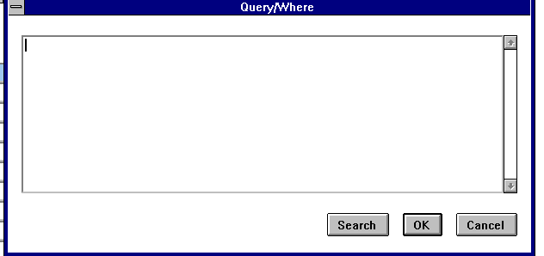

Expert Query Basic Commands:

You can use expert query for simple sorts by the fields you are able to tab into on the form, without needing to know the field name.

- Go into the form on which you wish to query
- Enter Query (F7)
- Tab into the field you wish to sort by and enter a : (colon)
- Execute Query (F8)
- The pop up window will be displayed.
- Type “order by :” (no quotes).

Select OK

The results of the query will be sorted by the field in which you placed the : (colon).

If you want these items sorted in descending order, type: Order by : desc

If you want these items sorted in ascending order, type: Order by : asc

If you know the Banner table field name (or several field names), you can use other SQL commands to limit or restrict your query results. You can use the % (percent sign) as a wild card in those commands. These commands would be typed in the pop up Query/Where window and some examples might include:

- field_name IS NOT NULL - When executed, the query will only return results where the specified field does not contain null values (the field is not empty).

- field_name LIKE ‘%ABC’ - When executed, the query will only return results where the ABC characters appear at the end of the specified field (example: Manufacturing ABC).

- field_name LIKE ‘%ABC%’ – When executed, the query will return results where the ABC characters appear consecutively anywhere in the specified field (example: ABC Trucking or South ABC Company).

- field_name_1 = 'XYZ' AND field_name_2 = 'ABC' - When executed, the query will only return results where the two field names contain the specified values as an exact match.

Note: the wild card % sign can be used in front of, behind, or both in front of and behind the values you want to include/exclude.

FAIINVL – Invoice/Credit Memo List Form

What if you wish to see transactions for one-time vendors? This information will not be displayed by using the normal enter query/execute query functions. You need to know the table being referenced by the form FAIINVL and the name of the field on which you wish to query.

FAIINVL references the FABINVH table.
The field name we wish to query on is ONE_TIME_VEND_NAME

To execute the expert query:
- Go to FAIINVL
- Select your desired option in the key block (Open, Paid, Suspense, Hold)
- Next Block
- Enter Query (F7)
- Enter : (colon) in the first field
- Execute Query (F8)
- In pop up box type: FABINVH_ONE_TIME_VEND_NAME is not null
- Select OK
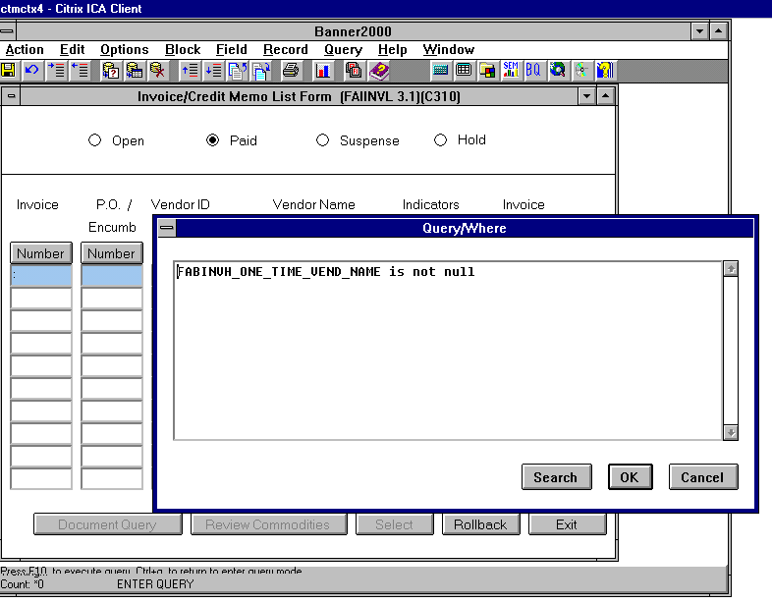
What if you wish to see all one-time vendors whose names begin with J?
- F7
- : (colon)
- F8
- In pop up box type: FABINVH_ONE_TIME_VEND_NAME like ‘J%’
- Select OK

FPAPOAS – Purchase Order Assignment Form

The form brings back information in Commodity Description order. What if you want to sort the lines by Requisition Document Number then by line item number?

- Go to FPAPOAS
- Enter the buyer code
- Next block
- F7
- : (colon)
- F8
- In pop up box type: order by FPRREQD_REQH_CODE, FPRREQD_ITEM

Select OK
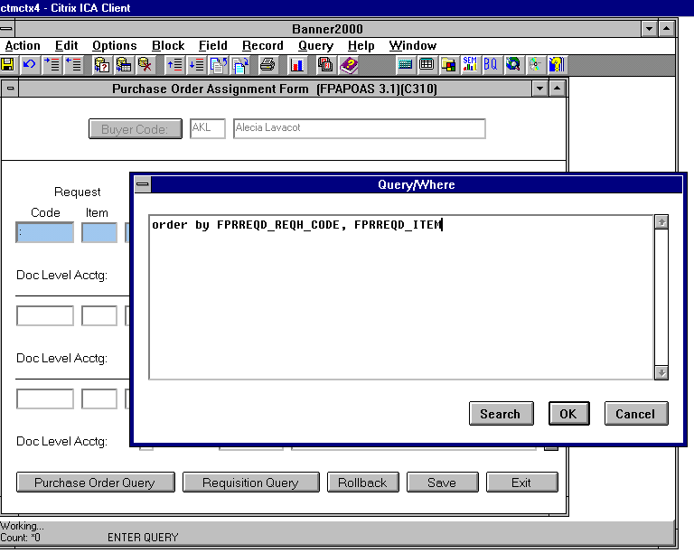

The requisitions assigned to this buyer are now sorted first by requisition number, then by the commodity item number.

FTICHKS – Check Number Validation Form

What if you want to see all the checks that have been marked ‘F’ for reconciled in Final Mode?

In pop up box type: FABCHKS_RECON_IND = 'F'

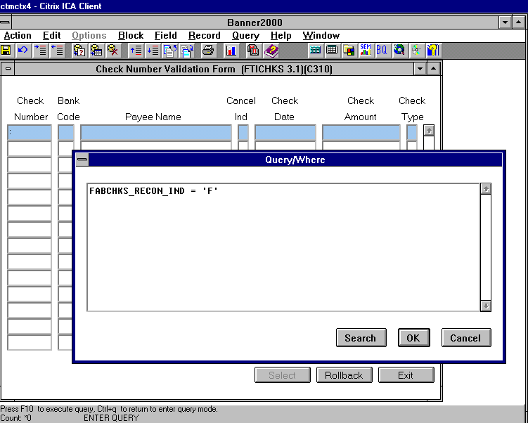

If you only wish to return these reconciled documents for a certain bank - in the pop up box type:

FABCHKS_RECON_IND = 'F' and FABCHKS_BANK_CODE = ‘XX’

Substitute XX for your Bank Code.

FFIFALV – Fixed Asset List Form

Want to see all OTAG records not converted to PTAGs?

- Enter Query (F7)
- Put a : (colon) in the Perm Tag Field
- Execute Query (F8)
- In pop up box type: : is null
order by FFBMAST_OTAG_CODE
- Select OK
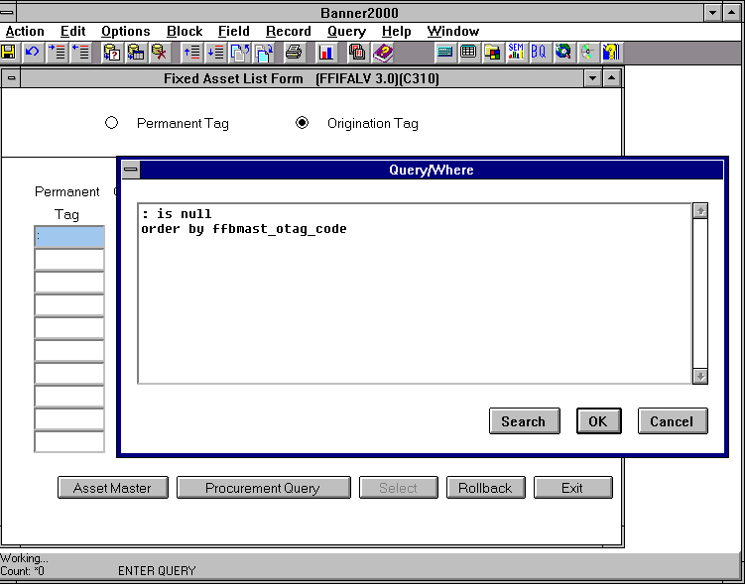

This query will return all the OTAG records not turned into PTAGs, sorted in OTAG number order.

