Payroll Process Training
Supplemental Training Document
Earn Codes

Author-Bruce Schermerhorn

Table of Contents

Earnings Code Rule Form - PTREARN 2
Regulatory Information Window 8
Rule Class Overrides Information Window 10
Earn Code Labor Distribution Override Window 12
More Notes on Earnings Codes 14
Definition of Earnings Types 15

Earnings Code Rule Form - PTREARN

The Earnings Code Rule Form enables you to create earnings codes and associate them with rules. The earnings code identifies the nature of the pay (for example, regular or holiday) and establishes the rules governing the time entry validation and processing of earnings represented by this code. This form can also be used to instruct the system to override labor distribution rules when it encounters this code.

Note: In order to build this form correctly, you must complete the following steps:

- Complete the form without entering values in the Leave Information fields.
- Complete the Leave Code Rule Form (PTRLEAV).
- Return to this form and enter the values you want in the Leave Information fields. You must define earnings codes with this form before completing the Employee Class Rule Form (PTRECLS).

The main window establishes most of the code's associated rules, including descriptions, calculation rule, multiplication factor, rate, affected leave code, and eligibility for shift differential.

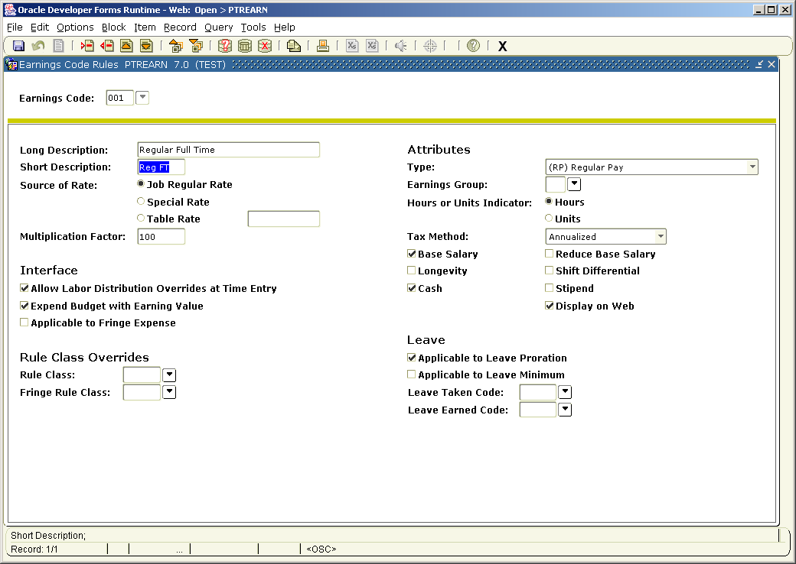

Self Service Field
Note: The field described below should be used only at sites that have installed the Banner Employee Self Service product on the Web. (See the Banner Employees Self Services Implementation Guide for further information on the Employees Self Service Application.)
You can utilize the Display on Web? field on the Earnings Code Rule Form to limit the types of earnings for which data can be displayed on the Web. For example, you can indicate that some earnings are not to be displayed on the Web. Instructions for using this field are given below.

Training and set up notes are in boxes.

Instructions
- At Earnings Code, enter a unique code to identify the earnings code rule you are defining or revising. To see a list of previously defined codes, click the Search button for the Earnings Code field. Move to the next block.

- At Long, enter a one- to thirty-character extended code description.

- At Short, enter a one- to eight-character description of the code you are defining.

This value appears on the employee’s paycheck.

- At the Source of Rate radio group, select the rate at which earnings in this category are calculated.
Job Regular Rate This earning code's rate will equal the regular pay rate (that is, the rate defaulted for the employee on NBAJOBS) times the value in the Multiplication Factor field.
Special Rate This earnings code will have a unique rate for each individual. You will then be able to enter the rate during payroll processing on the Online Time Entry Form (PHAHOUR).
Table Rate Table calculation rate. Earnings will be calculated according to the value you enter in the next field. Use this value primarily for group rates (for example, mileage allowance).

- If you selected Table Rate at Source of Rate, enter the calculation rate for this earnings code in the unlabeled Calculation Rate box at the right of the Table Rate radio button.
- If you selected Job Regular Rate at Source of Rate, enter the multiplication factor for this earnings code at the Multiplication Factor field. The multiplication factor is an automatic differential. Enter the factor as a percentage (for example, 150 for time and a half). The default factor is 100.

- Check the Allow LD Overrides at Time Entry checkbox if the labor distribution rules defined in the Employee Job Form (NBAJOBS) for this earnings code can be changed at time entry. Leave the checkbox unchecked if they cannot be changed.

- The Expend Budget with Earnings Value? checkbox indicates whether earnings in this category represent a budget expense and, if so, what budget should be expended. Select one of the following:

checked If this earnings code represents base pay, expend the position budget for regular salaries. If this earnings code represents premium earnings and has a premium earnings budget established on NBAPBUD, expend the premium earnings budget.
unchecked Do not expend either budget.
- Check the Applicable to Fringe Expense? checkbox if these earnings are used to compute the fringe charge back expense when PHPFEXP interfaces to your finance system. Leave it unchecked if they are not.

- Rule Class Overrides

The Rule Class Overrides Information window provides for the ability to override the Rule Class code at the
Earnings level. Access this window by selecting Rule Class Overrides Information from the Options menu.

- At Rule Class identify the earnings code rule class for this earnings type. The value for this field is used to process salary encumbrances and liquidations.
This field is usually left blank. When the field is blank, the system assumes the following value:
HGRS This earnings code will update the Encumbered field on the Position Salary Budgets window of NBAPBUD and liquidate the payroll encumbrance when expenditures are sent to Finance. If you do not enter a value in this field, the system assumes this value. (Note: Although it is the assumed value, it does not default into the field or appear on the form.)
If you do not want to encumber or liquidate using the earn code being described, select an alternate rule class such as HGNL. To view a list of defined rule classes, double click in the Rule Class field.

Use HGNL to identify earnings that are not planned events, which have been previously established in NBAJOBS and are events that are typically entered at payroll time, that is, overtime or bonus payments.
The Rules Maintenance Form (FTMRUCL) is delivered to you with HGRS and HGNL predefined.

- At Fringe Class Rule identify the earnings code rule class for this earnings type. The value for this field is used to process fringe chargeback encumbrances and liquidations.
This field is usually left blank. When the field is blank, the system assumes the following value:
HFRD This earnings code will update the Encumbered field on the Position Salary Budgets – Fringe Benefits Information window of NBAPBUD and liquidate the fringe benefit encumbrance when expenditures are sent to Finance. If you do not enter a value in this field, the system assumes this value. (Note: Although it is the assumed value, it does not default into the field or appear on the form.)
If you do not want to encumber or liquidate fringe chargeback benefits applicable to the earn code being described, select an alternate nonliquidating rule class such as HFNL. To view a list of defined rule classes, double click in the Fringe Rule Class field.

Use HFNL to identify fringe chargeback benefits applicable on earnings that are not planned events, which have been previously established in NBAJOBS and are events that are typically entered at payroll time, that is, overtime or bonus payments.
The Rules Maintenance Form (FTMRUCL) is delivered to you with HFRD and HFNL predefined

- At Type, indicate the nature of the earnings represented by this earnings code. Select one of the following:
AP Advance pay
AR Advance recovery
DA Deferred amount
DK Dock pay
DO Deferred pay out
FA FLSA accrual non-cash earnings
FC FLSA cash earnings
FP Leave with full pay and full benefits
HP Holiday pay
LB Leave with benefits and without pay
LO Leave without benefits and without pay
OV Pay at FLSA specified overtime rate
PP Leave with partial pay and full benefits
PR Premium pay
RO Retroactive pay for previous fiscal year
RP Regular pay
RT Retroactive pay for current fiscal year
(None) No earn type

There can be only one instance of each type for an employee class.

- At Earnings Group, enter the code identifying the earnings group to which the earnings code being defined belongs. The code you enter must be predefined on the Earnings Group Code Validation Form (PTVERGR).
To view a list of defined earnings group codes and their associated descriptions, double click in the Earnings Group field. You can then select the required earnings group code from this list.
Note: Earnings group data is optional.

- At the Hours/Units radio group, select Hours if this earnings code represents payment calculated according to hours worked. Select Units if payment is calculated by unit.

If the Source of rate is Special – this should be Units.
If the Source of Rate is Job Regular Rate – this should be hours.

- At Tax Method, indicate the method of deducting taxes from earnings in this category. Select one of the following:
- Annualized
- One Time
- Supplemental Rate
Refer to the section on PXATXCD in Chapter 16, Time Entry and Payroll Processing, for detailed information on these tax methods.

PXATXCD, Chapter 16

Annualize The system uses the straight annualizing method. This method annualizes only the current period's earnings (that is, it multiplies the current pay amount by the number of pays per year). It does not consider year-to-date gross.

Cumulative The system uses the cumulative annualizing method. This method considers year-to-date gross when it calculates tax withholding amounts.

Note that the annualization method you select affects the tax calculation of supplemental and one-time earnings:

Supplemental earnings are taxed at the rate specified in the Supplemental Percent field. If you use the cumulative annualization method (that is, if you enter Cumulative at the Annualization Method prompt), these earnings are considered when subsequent payrolls are processed. This increases the accuracy of the annual withholding. If you use the straight annualization method (that is, if you enter Annualize at Annualization Method), these earnings are not considered when subsequent payrolls are processed.

One-time earnings are taxed as one-time payments and added to the annualized gross. As with supplemental earnings, they are considered when subsequent payrolls are processed only if you entered Cumulative at the Annualization Method prompt. If you entered Annualize, the one-time earnings will correctly be included in the pay period in which they occur, but will not be considered in subsequent payrolls. Therefore, combining the straight annualizing method with one-time earnings may result in under withholding. Because the average pay (and therefore the projected yearly earnings) changes with each pay event following a rate change, the cumulative method adjusts the tax calculation rate with each subsequent pay. Although this results in withholding amounts that vary from one pay to the next, it also produces a more accurate yearly withholding amount.

- Check the Base Salary checkbox if this earnings code represents base salary. Leave it unchecked if it does not.

- Check the Reduce Base Salary checkbox if earnings in this category should be subtracted from base salary. Leave it unchecked if they should be added to base salary.

This should be checked for earnings that will reduce salaried employee’s base pay – for example, the earnings codes for vacation and sick leave would reduce (or replace) the base pay, not add to it.

- Check the Longevity checkbox if this earnings code is eligible for longevity premium calculation. Leave it unchecked if this earnings code is not eligible.

- Check the Shift Differential checkbox if earnings in this category are eligible for shift differential. Leave it unchecked if they are not.

- Check the Cash checkbox if the code represents cash earnings. Leave it unchecked if the earnings are non-cash.

Any pay with the following earnings type should be non-cash:
AR Advance recovery
DA Deferred amount
DK Dock pay
FA FLSA accrual non-cash earnings
LB Leave with benefits and without pay
LO Leave without benefits and without pay
Any ‘pay’ that is created to appear in the employee’s earnings for tax purposes only should be non-cash. For example, if the school picks up rent for the Provost, the value of the rent may be entered on her pay records for tax purposes only.

A non-cash earnings may also be created to reduce a salaried employee’s pay.
Non-cash earnings are not included in the gross amounts in PHRPREG. They only show up in applicable gross for deductions if the earn code is not excluded on PTRBDCA.

- Check the Stipend checkbox if the code represents stipend earnings.

This is a memo field for reporting purposes.

- Check the Display on Web checkbox if information is to be displayed for the current earnings type. Leave this checkbox unchecked if information is not to be supplied for this earnings type. Note that this field affects only Earnings History on the Web. It does not affect what is displayed on the Pay Stub on the Web.
Note: Complete this field only if you have installed the Banner Employee Self Service product on the Web.

- Check the Applicable to Leave Proration? checkbox if earnings in this category are counted when leave accrual is calculated. Leave it unchecked if they are not.

This field works in conjunction with the Leave Category form (PTRLCAT). All earnings with this box checked are totaled in the leave proration calculation.

- Check the Applicable to Leave Minimum? checkbox if time in this earnings category is included when calculating accrued leave.

This field works in conjunction with the Leave Category form (PTRLCAT). All earnings with this box checked are totaled in looking at the minimum hours reported before leave accruals will occur.

- If the earnings code you are defining represents leave to be deducted, enter the appropriate leave code at the Leave Taken Code field. The code you enter must be predefined on the Leave Code Rule Form (PTRLEAV). To view a list of defined leave codes, click the Search button for the Leave Taken Code field.

This field links the leave codes defined on the Leave Code form (PTVLCAT) to an earnings code. If you enter a leave code in this field, whenever this earnings code is processed on the Time Entry Form (PHAHOUR), the leave balance for the employee on the Employee Form (PEAEMPL) will be reduced.

- If the earnings code you are defining identifies a specific leave type accrual, enter the leave code at the Leave Earned Code field. The code you enter indicates the specific leave balance that should be increased when this earnings code is used. To view a list of currently defined leave codes, click the Search button for the Leave Earned Code field.
Note: This field works in conjunction with the value you entered at the Multiplication Factor field in Step 6. For example, if the value of Multiplication Factor is 150 (that is, 150%, or time and a half), using this leave code will cause the leave balance to increase by one and one-half times the number of hours entered.

This field links the leave codes defined on the Leave Code form (PTVLCAT) to an earnings code. If you enter a leave code in this field, whenever this earnings code is processed on the Time Entry Form (PHAHOUR), the leave balance for the employee on the Employee Form (PEAEMPL) will be increased.

- Perform the Save function or go to the Regulatory Information window (described below).

Regulatory Information Window

The Regulatory Information window collects FLSA and 1099 data for this earnings code. Access this window by selecting Regulatory Information from the Options menu.

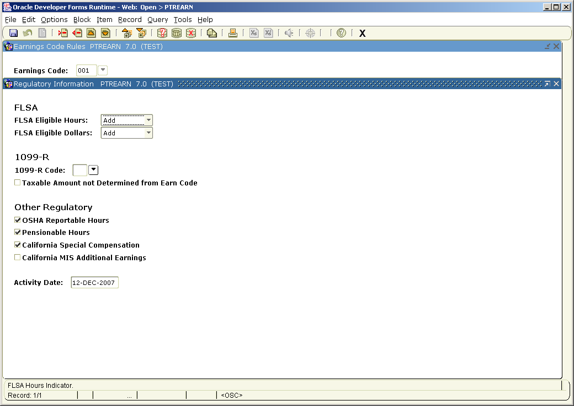
Instructions
- At FLSA Eligible Hours, indicate the effect of earnings in this category on the total number of hours worked in the FLSA work period. The value selected here is used in the automatic calculation of overtime pay as dictated by the Fair Labor Standards Act. Enter one of the following: For additional information, refer to the FLSA (Overtime) Compensation section of Chapter 6, Processing.
Add Add to total number of FLSA-eligible hours. Select this value if this earnings code's hours qualify as Hours Worked as defined by the FLSA. If you enter this value, time associated with these earnings will be included in determining whether the employee has reached the overtime hour threshold.
Reduce Reduce FLSA-eligible hours by the number of hours associated with this earnings code.
No Effect Neither add to nor reduce FLSA-eligible hours. Select this value if this earnings code's hours have no effect on the total number of hours worked in the FLSA work period.

Complete this field only if you are using FLSA processing.

- At FLSA Eligible Dollars, indicate the effect of earnings in this category on the dollar amount used to determine average hourly rate. The value selected here is used in the automatic calculation of overtime pay as dictated by the Fair Labor Standards Act.

For additional information, refer to the FLSA (Overtime) Compensation section of
Chapter 6, Processing.

Select one of the following:

Add Add to total number of FLSA-eligible dollars for use in calculating overtime pay. Select this value if these earnings are to be added to the dollar amount used by PHPCALC to determine the FLSA hourly average rate. This rate (also called the regular rate by the FLSA) is computed by dividing the employee's FLSA-eligible gross income by the number of FLSA-eligible hours (as defined on PTREARN) in the work period.

Reduce Reduce FLSA-eligible dollars by the number of dollars associated with this earnings code.

No Effect Select this value if these earnings have no effect on the dollar amount used by PHPCALC to determine average hourly rate. These earnings will be not be included in the employee's FLSA-eligible income when the FLSA average rate (also called the regular rate by the FLSA) is calculated.

Complete this field only if you are using FLSA processing.

- If you are defining an earnings code that requires 1099-R reporting, enter the 1099-R distribution code associated with this earnings code at the 1099-R Code field. The value you enter must be predefined on the 1099 Code Validation Form (PTV1099). To view a list of defined values, double click in the 1099-R Code field.

- Checking the Taxable Amount Not Determined from Earn Code indicator for a particular earnings code designates it as income for which the taxable amount is not determined when processing 1099-Rs. This includes IRA distributions except for the Roth IRA and the Ed IRA.

- Mark the OSHA Reportable Hours check box if you wish to associate the hours with a specific earn code and include it in the calculation of the Total hours worked by all the employees last year field on Form 300A.

- Check the Pensionable Hours? checkbox if the hours for the earn code being defined are to be tagged as pensionable hours. Otherwise, leave this checkbox blank. . This is used for California STRS/PERS.
- The California Special Compensation checkbox is related to California STRS/ PERS processing. Please refer to Appendix C, California STRS/PERS, for further information.

- CA-MIS Additional Earnings check box field has been added to the Regulatory Information window of PTREARN to identify the earn codes that are to be included in the calculation of the annual salary by the PEPCSAL process.

Longevity, shift differential and other earn codes that are not defined as stipends on PTREARN can also be included in the calculation of the annual salary.

Note: If shift differential is not set up as a premium pay it will not be added for the calculation of the annual salary. However, you can indicate this earn code as an additional earning by selecting this check box.

The PEPCSAL process has now been modified to calculate the annual salary by including any additional earnings for primary and secondary jobs.

- Perform the Save function or move to the Rule Class Override window (described below).

Earn Code Labor Distribution Override Window

The Earn Code Labor Distribution Override window allows you to define an accounting distribution to be used for this specific earnings code. For example, you can define an accounting distribution for overtime expenses that is different from that used for regular salary expenses. New values are entered by employee class. To access this window, select Employee Class Labor Dist Overrides from the Options menu.

To view the Locn, Project Type, and Cost Type fields, move the horizontal scroll box below Prog or use the Next Field function.

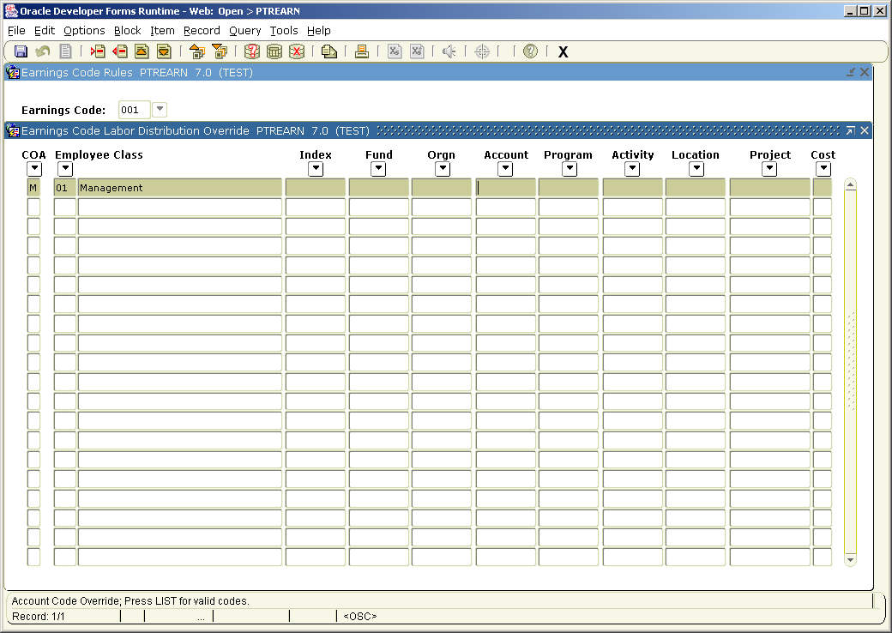

Instructions
- At COA, enter the code of the Chart of Accounts to which this earnings code/ employee class combination should be charged. The code you enter must be predefined on the Chart of Accounts Validation Form (FTMCOAS). To view a list of defined values, click in Search button for the COA field.

- At Employee Class Code, enter the code of the employee class whose labor distribution you are defining. The employee class code you enter must be predefined on the Employee Class Rule Table (PTRECLS). (To view a list of defined codes, click the Search button for the Employee Class Code field.) The system displays the employee class description for the employee class code.

- Enter labor distribution data at the following fields: To view a list of defined codes for any of the fields above, click the Search button for that field.
Index Account Index code (FTMACCI)
Fund Fund code (FTMFUND)
Orgn Organization code (FTMORGN)
Acct Account code (FTMACCT)
Prog Program code (FTMPROG)
Actv Activity code (FTMACTV)
Locn Location code (FTMLOCN)
Project Type Project code (FTMPROJ)
Cost Type Cost Type code (FTMCTYP)

- To define labor distribution data for another employee class, perform the Next Record function and return to Step 1. If your rule definition is complete, perform the Save function. The system enters the current date in the Activity Date field and saves your new or revised data to the database

Once the first employee class has been entered, you can use the following functions to reduce the amount of entry:

Do the next record function (this key stroke is usually a down arrow or F6
Do a record duplicate function (this can be done by F4 or using the pull down menu)
Override the employee class and any other values.
Continue.

More Notes on Earnings Codes

To create a new earnings code:
- Create the new code on the Earnings Code Rule form (PTREARN).
- Add the new earnings code to the appropriate employee classes on the Employee Class Rule form (PTRECLS).
- Add the new earnings code to the included/excluded section to the Benefits/Deductions Rule form (PTRBDCA) where appropriate.
- If the new earnings code involves leave accruals, update the Leave Code Rule form (PTRLEAV) and the Leave Category form (PTRLCAT) as required.
- If you are using the Banner system to calculate shift pay using the Shift Premium Rule form, update PTRSHFT as required.
- If you are using the Banner system to calculate premium payments using the Premium Pay Code Rule form, update PTRPPAY as needed.

Definition of Earnings Types

Advance pay: Enter this value if the earnings code will be used in the advance pay processing as the advance payment.

Advance Recovery: Enter this value if the earnings code will be used in the advance pay processing as the recovery of the advance payment.

Deferred Amount: Enter this value for the earnings code that will be used in deferred pay calculations as the amount saved as a liability within the employees record to be paid out during the deferred pay-out pay periods on PTRDFPR. This earnings code will appear on the employee’s check with one unit and the value of the deferred pay.

Deferred Pay Out: Assign this code to the earnings code that will be system generated when the employee is paid from the deferred pay during deferred pay out periods defined on PTRDFPR.

Dock Pay: Enter this value for the earnings code that will be used to reduce an employee’s pay. The ‘reduce base salary’ flag should also be checked. The ‘reduce regular hours’ flag should be check on PTRECLS eligible earnings. There can only be one earnings code with this type assigned to an employee class.

FLSA accrual non-cash earnings: This earnings type is used in FLSA processing. These FLSA earnings will be used to calculate accrual compensation (for example: comp time) for overtime hours. Note: If you enter FA at Type, you must also enter a value in the Leave Earned Code field.

FLSA cash earnings: This earnings type is used in FLSA processing. These FLSA earnings will be used to calculate cash compensation for overtime hours.

Holiday pay: Use this value for the holiday earnings code that will default to PHAHOUR. The earnings code will default only for employee classes with default earnings.

Leave with benefits and without pay: The earnings code with this type will default instead of regular pay for employee classes that have the default earnings flag checked on PTRECLS and when the status on NBAJOBS is ‘Leave with benefits and without pay’. There can only be one earnings code with this type assigned to an employee class.

Leave with full pay and full benefits: The earnings code with this type will default instead of regular pay for employee classes that have the default earnings flag checked on PTRECLS and when the status on NBAJOBS is ‘Leave with full pay and full benefits’. There can only be one earnings code with this type assigned to an employee class.

Leave with partial pay and full benefits: The earnings code with this type will default instead of regular pay for employee classes that have the default earnings flag checked on PTRECLS and when the status on NBAJOBS is ‘Leave with partial pay and full benefits’. There can only be one earnings code with this type assigned to an employee class.

No earn type This is the default. If no other earnings type applies, use this value. The majority of earnings codes created will use this value.

Overtime pay: This earnings type is used in FLSA processing. Enter this value only if your site intends to allow manual entry of overtime in addition to automated FLSA calculation. Note that all OT type earnings reduce the amount of FC or FA earnings generated by PHPCALC.

Premium pay: Enter this value if the earnings code will be used in premium pay calculations. This earnings type will reference the calculation rules on the Premium Pay Category form (PTRPCAT).

Regular Pay: Enter this code against the earnings that will be the base, or regular, earnings for an employee class. . Each employee class can have only one regular pay earnings code. If an employee class is set to default hours, the earnings code with the regular pay type will default. On the employee class, earnings codes can be set to reduce regular pay hours. These earnings codes will reduce the hours entered against the earnings code with a regular pay type.

Retroactive pay for current fiscal year: Use this value for earnings that will be used in the Retroactive Pay Process (PHPRETO) for current fiscal year earnings.

Retroactive pay for previous fiscal year Use this value for earnings that will be used in the Retroactive Pay Process (PHPRETO) for previous fiscal year earnings.

