Foothill De Anza Community College District

Follow-up Report for Feb 23-25, 2010
Banner Advancement Training Session 2
Individual/Organization Processing and Student to Advancement Interface

March 8, 2010

Account Information
Project name: | Foothill De Anza Community College District
Prepared by: | Noelle Hylton
 | Senior Banner Advancement Functional Consultant
 | Noelle.Hylton@sungardhe.com
 | 510.368.4086

Distribution
SunGard Higher Education | Senior Project Manager | Debra Treacy
SunGard Higher Education | Senior Technical Consultant | Lee Millen
Foothill De Anza Foundation | Executive Director | Marie Fox Ellison
Foothill De Anza Foundation | Assistant Director | Robin Lyssenko

Objectives
Advancement Individual and Organization Processing
- Create Persons and Non-Persons in Banner
- Enter pertinent information on Banner entities
- Make Banner entities Advancement Individuals and Organizations
- Add/maintain biographical, demographic, academic and business information on Advancement Individuals
- Geographic Regions

Interface to Student System
- The Student System concepts needed to make students/graduates constituents
- Setting up and running the feed from the Banner Student system
- Review associated reports and processes

Introduction of Campaigns and Designations
- What is a campaign-best practices for campaign
- What is a designation-best practices for designations

Progress Report

Accomplishments
Advancement Individual and Organization Processing
- We successfully reviewed how to create Persons and Non-Persons in Banner
- We successfully reviewed how to enter pertinent information on Banner entities
- We successfully reviewed how to make Banner entities Advancement Individuals and Organizations
- We successfully reviewed how to add/maintain biographical, demographic, academic and business information on Advancement Individuals
- We successfully reviewed Geographic Regions, we will need to revisit during our next training session if time permits. If not, we will address during our Consulting session in May.
Set up needed for entry of Banner entities
- We successfully reviewed Shared Validation Tables
- We successfully reviewed Advancement Individual and Organization Validation Tables
- We successfully reviewed the Advancement Control Form (AGACTRL)
Notes:

Validation Tables: Robin and I spent Thursday afternoon reviewing the Validation spreadsheet for items covered to date. A copy was e-mailed to Robin on 3/2/2010.

Salutations: While we were reviewing how to process Salutations, the team voiced their concerns on how the Salutations are manually populated in Banner. We discussed, that scripts could be created to generate salutations once a record is created and this could be run nightly. I also advised Robin that other schools are doing this, so she can also look on the Listserv. Additionally, salutations code is being used on APPSTDI, so this code could be copied into a script and tweaked.

Householding: We set up householding for spouses for changing address information, we reviewed that this is not automated, the end user has to select if the address needs to be updated. In cases of business and other address types that aren’t shared, I stressed to the group that they shouldn’t opt to household these addresses. The team liked this functionality and will practice address changes.

Spouse Records: While we were reviewing how to create a spouse records, one of the participants linked a spouse record to a General Person record opposed to an Advancement Constituent. We noted that this functionality doesn’t apply cross-referencing on both records, unless both records are constituents. We discussed that as a best practice, all spouse records that have an ID in Banner should be created as an Advancement Constituent. We also reviewed how to fix if this does occur:

- On the Advancement Constituent Spouse Record/go to APACONS and Remove the Spouse Information from the Spouse Tab.
- Go to APACONS and make the Spouse Record an Advancement Constituent
- Determine who will be the primary Spouse and have ID on the key block/go to APACONS and Search on the Spouse Name or Enter the ID and create a cross reference as SPS

Quick Flows: We successfully reviewed how to create Quick Flows via GTVQUIK and GUAQUIK. We created several test Quick Flows and the team will use for practice purposes and tweak accordingly. The following Quick Flows were created:

IACNCO- Inst Adv Create New Const Org
IACNCI - Inst Adv Create New Const Ind
IACNA- Inst Adv Create New Activities
IADR- Inst Adv Decease Records
IAMAA-Inst Adv Mergers/Acquisitions
IAEMP- Inst Adv Employment Info
IAADI- Inst Adv Address Info
IACOM- Inst Adv Comments
IACON- Inst Adv Contacts
IAITR- Inst Adv Interest Tracking
IAEOR- Inst Adv Estate of Record

My Banner: We successfully reviewed how to set up My Banner via GUAPMNU. In addition, I also reviewed with the group how to copy my Banner from one user to another via GUTPMNU. The following users were set up with My Banner for topics covered to date Test141-146 and 160.

Interface to Student System
- We successfully reviewed the Student System concepts needed to make students/graduates constituents; we met with Kathleen and Pat from the Student team from DeAnza.
- We successfully reviewed how to set up and run the feed from the Banner Student to Advancement.
- We successfully reviewed associated reports and processes (APPSTDI) as well as reports and processes that are run in the Student module.
- When we initially ran the process APPSTDI we didn’t get any data, I later fixed some of the addresses and the process worked. I reviewed with Robin and the team that the process worked. The following parameters were reviewed:

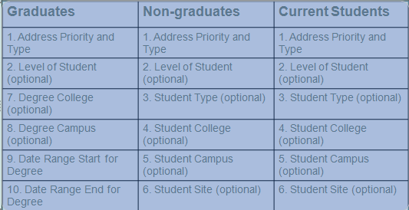
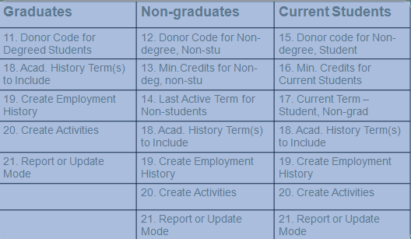
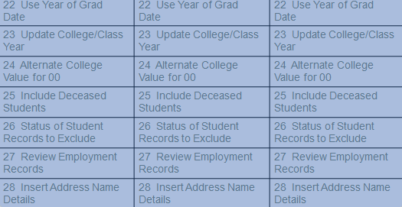
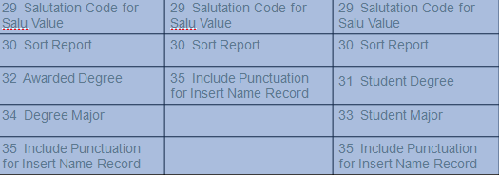

Notes:

Confidential Indicator- We discussed that a record that has a confidential flag will also be rolled over as confidential through this process. I discussed with the group that other schools ask students if they would like to have their records remain confidential as well as explain that this may exclude their records from Self-Service and other Social Networks.

Deceased Records: We discussed that we can roll this process to include deceased records. FHDA, will determine if they want to roll decease records. We discussed that other schools use this as an opportunity for creating scholarships/endowments.

Name Types: We discussed how name types can be used to store Diploma, Legal and Advancement name types. The team will need to discuss further at the Core Meeting, in addition a supplemental document was sent out reviewing how to use name type functionality for reprinting transcripts and diplomas.

Address Types: We discussed the various name types that are used in the Student module this is used in Parameter 1 of APPSTDI process. In addition, we discussed once this process is run Advancement will have a need to copy the address from Student to the Advancement address type. We discussed that some scripts will need to be built to address or we can also see if another school can share a script.

Graduation/Commencement Process:

Foothill-Robin will get in touch with Shauna to discuss their graduation dates and process.

DeAnza- There is 1 commencement ceremony in June and four graduation dates in:

- December
- March
- June
- August

The Registrar takes 4-6 weeks to process graduation verification.

Introduction of Campaigns and Designations
- We successfully reviewed best practices for campaigns.
- We successfully reviewed best practices for designations.

Notes:

Campaigns- We discussed that campaigns are required for conversion as well as going forward for pledge and gift entry in Banner. We discussed the pros and cons of setting campaigns year specific vs. cumulative. We will discuss during our next session, but we reviewed that we could use the gift date to determine what campaign to use for each fiscal year for conversion.

Designations- We discussed how designations are set up in Banner and how they are linked to a campaign. We also discussed how this is tied to Finance’s FOAPAL and Financial Aid’s Fund Codes. We will revisit this during our session in March in greater detail. We also discussed that we may want to create a suspense FOAPAL account (s) for designations that are no longer being used, this way if someone uses the wrong designation, it will go to suspense and can be easily identified.

General Consulting

GPSYNCH- We discussed that GPSYNCH will be used for conversion to identify potential duplicate records. We also discussed that each time a record is created in DonorWorks it should be cross-walked to the current Banner ID.

Address Types – During the Core Meeting, it was determined that Advancement will have their own address types, since they don’t plan on formatting addresses like other departments. Additionally, Robin would like to have a report or process that identifies addresses that have been changed to ensure that each area has the most up to date information.

Name Types – We discussed the need to use Diploma, Legal and Advancement name types, we will continue to discuss as the Core team needs to take and make further decisions.

Parent Information – FHDA will not be storing parent information. Documentation was provided in case this is used in the future, but for go-live this will not be implemented.

Progress Report

Decisions Made and/or Actions Taken

Salutations
- We will need to revisit if FHDA can create scripts internally to automate salutations, if not Robin will look on the Listserv to see what other schools are doing.
- We also discussed that the APPSTDI process has a Salutation script built for individual salutations, so FHDA could use some of the code that already exist.

Validation Tables/Processing
- Robin will review and update the Validation spreadsheet for items covered to date.
- The team will continue practicing all items covered to date and they will also review the Quick Flows that were created and give feedback during our session in March.
- Need to revisit how Board of Trustees will be stored via Donor Category or Activity or both.

Student to Alumni Interface
- APPSTDI will be run for the 4 graduations that are used by DeAnza.
- Robin, will get in touch with Shauna to discuss what parameters should be used for Foothill. Robin will also discuss what information they are converting prior to our session in March.
- As a best practice, APPSTDI will be run for each graduation as well as being run from the beginning of time (first graduation) through the current graduation on a continual basis to ensure that records don’t slip through the cracks.
- We will need to make a decision on Name Types: Diploma, Legal and Advancement.
- Foothill and DeAnza will meet to test the Student Roll Process and document any issues or concerns. The goal is to have this done in May, once Student is live. We also discussed, that we could use the session in May to address any outstanding items.
- APPSTDI can also be used to roll graduates for conversion, Robin and the team will discuss further and we will revisit during my sessions in March and May.
- DeAnza is only converting academic history from 2004 and forward.

Campaigns and Designations
- We will continue to discuss during our session in March.
- We will revisit the use of having year specific campaigns and how this can be converted, since campaigns aren’t being used in DonorWorks.
- During our next session we will be reviewing the interfaces between Advancement, Finance and Financial Aid. A representative for all offices should plan on attending this session.
- Designation Statement of Purpose will be store in the Designation Comment and Subject Code will need to be created via GTVSUBJ,so that it can be tracked easily.

Action Items and/or Assignments for SunGard Higher Education
Date Assigned | Description | Owner | Critical Date for Completion | Status
2/26/2010 | Trip Report | Noelle Hylton | ASAP | Completed
2/26/2010 | Report Template | Noelle Hylton | ASAP | Completed- attached
2/28/2010 | Discuss Donor Works Conversion Data Functional and Technical | Noelle Hylton | ASAP | Completed- Discussed on 3/8/2010
3/1/2010 | Validation Spreadsheet | Noelle Hylton | ASAP | Completed-Sent Robin e-mail.
3/8/2010 | E-mail Correspondence:  APASPUR  Milestone Review  Agenda for week of March 30th  ATVSALU  ATVSICC | Noelle Hylton | ASAP | Completed-Sent Robin e-mail.
2/05/2010 | Trip Report | Noelle Hylton | ASAP | Completed
2/05/2010 | Evaluation | Noelle Hylton | ASAP | Completed
2/05/2010 | Common Matching Doc | Noelle Hylton | ASAP | Completed
2/05/2010 | Reporting Template | Noelle Hylton | ASAP | Completed
2/05/2010 | SURLOAD | Noelle Hylton | ASAP | Completed- send supplemental document
2/05/2010 | Name Types | Noelle Hylton | ASAP | Completed- Sent supplemental document
2/05/2010 | Parent Rollover Script | Noelle Hylton | ASAP | Completed
2/05/2010 | Validation table spreadsheet | Noelle Hylton | ASAP | Completed- Distributed while on-site.
2/05/2010 | GPSYNCH | Noelle Hylton | ASAP | Deferred to Debra Treacy
2/05/2010 | Endowment Management | Noelle Hylton | ASAP | Deferred to Debra Treacy
Status: New, Open, Completed, Cancelled, Deferred

Action Items and/or Assignments for Foothill De Anza Community College District
Date Assigned | Description | Owner | Critical Date for Completion | Status
2/26/2010 | Discuss with Shauna from Foothill graduation process and dates. | Robin Lyssenko | 3/29/2010 | New
2/26/2010 | Review Quick Flows create to date and Practice. Be prepared to give feedback during our session in March. | Banner Advancement Implementation Team | 3/29/2010 | New
2/26/2010 | Review and update validation tables covered to date for Individual and Organization Processing | Banner Implementation Team | 3/29/2010 | New
2/26/2010 | Identify reports needed for go-live and determine if Banner Canned report can be used or if a custom report is needed. | Banner Implementation Team | On-going | New
2/26/2010 | APPSTDI certificate testing. Ensure that the roll picks up certificate degrees. | Banner Advancement Implementation Team | 5/01/2010 | New
2/05/2010 | Review Current Policies and Procedures as it relates to Shared Data Topics:  Name Type  Address  Phone  Email | Banner Advancement Implementation Team | 2/22/2010 | Open
2/05/2010 | Spend time navigating in Banner before 2/23/2010 training session. | Banner Advancement Implementation Team | 2/22/2010 | Completed
Status: New, Open, Completed, Cancelled, Deferred

Concerns / Decisions to be made
Description | Owner | Target Date for Closure | Action Plan
N/A

Supplemental Documents
Report Template

Upcoming Session

March 30-April 1, 2010
Campaign Module
- Understanding Campaign structures
- Building Campaigns
- Associating Designations and Solicitation data with Campaigns

Designation Module
- Definition of a Designation
- Working with Designation Supervisors and adjustments
- Using the Stewardship Financial Aid link
- Designation Finance System Data

Gift and Pledge Modules
- Posting Pledges in Banner
- Using the Pledge/Gift Default Form
- Using the Pledge Mass Entry Form
- Posting Gifts in Banner
- Balancing, Closing, and Finalizing Cashiering Sessions
- Using Banner query forms to view gift and pledge information

Interface to Finance System/Financial Aid
- Advancement Control Form
- Gift and Pledge Rule Classes
- Designation Finance and Financial Aid Data
- Posting Gifts and Pledges
- Finalizing Cashiering Sessions
- Run the Pledge feed and Gift feed processes

Hours Billed
Preparation | 2.0
Travel | 2.5
On-Site Consulting | 24
Off-Site Consulting | 3.0
Follow-Up | 2.0
TOTAL | 34

