ADVANCEMENT RULE EXAMPLE FOR PERSON MATCHING

 | Column | Element | Length | Match on Null Data
Priority 1
 | SPRIDEN_SEARCH_LAST_NAME | LAST NAME/NON-PERSON NAME | 60 | Yes
 | SPRIDEN_SEARCH_FIRST_NAME | FIRST NAME | 5 | Yes
Priority 2
 | SPRIDEN_SEARCH_LAST_NAME | LAST NAME/NON-PERSON NAME | 20 | Yes
 | SPRIDEN_SEARCH_FIRST_NAME | FIRST NAME | 5 | Yes
Priority 3
 | SPRIDEN_SEARCH_LAST_NAME | LAST NAME/NON-PERSON NAME | 10 | Yes
 | SPRADDR_STREET_LINE1 | STREET LINE 1 | 15 | Yes
 | SPRADDR_CITY | CITY | 10 | Yes
Priority 4
 | SPRIDEN_SEARCH_LAST_NAME | LAST NAME/NON-PERSON NAME | 10 | Yes
 | SPRADDR_CITY | CITY | 10 | Yes
 | SPRTELE_PHONE_NUMBER | TELEPHONE NUMBER | 7 | Yes
Priority 5
 | SPRIDEN_SEARCH_LAST_NAME | LAST NAME/NON-PERSON NAME | 10 | Yes
 | SPRADDR_CITY | CITY | 10 | Yes
 | SPRTELE_PHONE_AREA | TELEPHONE AREA CODE | 3 | Yes

Additional Rule Settings as optional (may affect performance) that are suggested:
- Add comments for your rule to better assist users in selection for match process (on GORCMRL)
- Check Transpose First/Last Name (Under Options on GORCMSC) to allow search to look for name entered matches in either first or last name Note: If entering only one part of the name, enter the details in the last name field and the search process will look for a match in both the first and last name fields.
- Check Allow Alias Wildcard use (Under Options on GORCMSC) to allow search to use user defined alias values (as specified in GORNAME) in search match selection
- Check Allow Length Override (Under Options on GORCMSC) to allow the search process to use the number of characters entered for selection even if less are entered than defined on the rule (on GORCMRL)
- Check Prevent ID Creation on API Failure (Under Options on GORCMSC) to avoid creating a record in error when missing required data fields are not populated on GOAMTCH (requires complete Address, Telephone and/or E-mail details in order to create a new ID)
- Consider defining a hierarchy for address display (Under Hierarchy of Display on GORCMSC) which results in the display of existing addresses based the (? Is something missing) hierarchy defined even if the existing address does not match the search criteria entered. You can use this feature for telephone and e-mail as well.
Person Examples:
The match process follows the rule priority order and searching stops when a potential match is found. Define the priority details to begin with the most restrictive details and then broaden the search details in higher numbered priorities.

Existing Data in Banner
First Name | Last Name | Street 1 | City | Telephone
Margaret | Chillicothsoniannism | 222 Spruce Street | Malvern | 610-777-9999
Mary | Jones | 222 Spruceset Court | Galveston | 711-888-4444
John | Smith | 1 Fort Way | Atlanta | 451-844-5555

Case #1 | Entered Data to Match | Element | Length | Match on Null Data
 |  | Priority 1
 | Chillicothsoniannism | LAST NAME/NON-PERSON NAME | 60 | Yes
 | Margaret | FIRST NAME | 5 | Yes
Results | Match on priority 1 rule – exact match on first and last name.  Stopped after first priority rule based on match status

Case#2 | Entered Data to Match | Element | Length | Match on Null Data
 |  | Priority 1
 | Chillicothsoniannisms | LAST NAME/NON-PERSON NAME | 60 | Yes
 | Margaret | FIRST NAME | 5 | Yes
Results | No match on priority 1 rule – different name
 |  | Priority 2
 | Chillicothsoniannisms | LAST NAME/NON-PERSON NAME | 20 | Yes
 | Margaret | FIRST NAME | 5 | Yes
Results | Match on priority 2 rule – match on first and last name (based on length)  Stopped after second priority rule based on match status

Case#3 | Entered Data to Match | Element | Length | Match on Null Data
 |  | Priority 1
 | Chillicothsonianisms | LAST NAME/NON-PERSON NAME | 60 | Yes
 | Margaret | FIRST NAME | 5 | Yes
Results | No match on priority 1 rule – different name
 |  | Priority 2
 | Chillicothsonianisms | LAST NAME/NON-PERSON NAME | 20 | Yes
 | Margaret | FIRST NAME | 5 | Yes
Results | No match on priority 2 rule – different name
 |  | Priority 3
 | Chillicothsonianisms | LAST NAME/NON-PERSON NAME | 10 | Yes
 | 222 Spruce Street | STREET LINE 1 | 15 | Yes
 | Malvern | CITY | 10 | Yes
Results | Match on priority 3 rule – match on last name (based on length), street and city  Stopped after third priority rule based on match status

Case#4 | Entered Data to Match | Element | Length | Match on Null Data
 |  | Priority 1
 | Chillicothsonianisms | LAST NAME/NON-PERSON NAME | 60 | Yes
 | Margaret | FIRST NAME | 5 | Yes
Results | No match on priority 1 rule - name different
 |  | Priority 2
 | Chillicothsonianisms | LAST NAME/NON-PERSON NAME | 20 | Yes
 | Margaret | FIRST NAME | 5 | Yes
Results | No match on priority 2 rule - name different
 |  | Priority 3
 | Chillicothsonianisms | LAST NAME/NON-PERSON NAME | 10 | Yes
 | 22 Spruce Street | STREET LINE 1 | 15 | Yes
 | Malvern | CITY | 10 | Yes
Results | No match on priority 3 rule - street is a no match
 |  | Priority 4
 | Chillicothsonianisms | LAST NAME/NON-PERSON NAME | 10 | Yes
 | Malvern | CITY | 10 | Yes
 | 610-777-9999 | TELEPHONE NUMBER | 7 | Yes
Results | Match on priority 4 rule – match on last name (based on length), city and phone  Stopped after fourth priority rule based on match status

Case#5 | Entered Data to Match | Element | Length | Match on Null Data
 |  | Priority 1
 | Chillicothsonianisms | LAST NAME/NON-PERSON NAME | 60 | Yes
 | Margaret | FIRST NAME | 5 | Yes
Results | No match on priority 1 rule - name different
 |  | Priority 2
 | Chillicothsonianisms | LAST NAME/NON-PERSON NAME | 20 | Yes
 | Margaret | FIRST NAME | 5 | Yes
Results | No match on priority 2 rule - name different
 |  | Priority 3
 | Chillicothsonianisms | LAST NAME/NON-PERSON NAME | 10 | Yes
 | 22 Spruce Street | STREET LINE 1 | 15 | Yes
 | Malvern | CITY | 10 | Yes
Results | No match on priority 3 rule - street is a no match
 |  | Priority 4
 | Margaret | LAST NAME/NON-PERSON NAME | 10 | Yes
 | Malvern | CITY | 10 | Yes
 | 610-777-9998 | TELEPHONE NUMBER | 7 | Yes
Results | No match on priority 4 rule - telephone is a no match
 |  | Priority 5
 | Chillicothsonianisms | LAST NAME/NON-PERSON NAME | 10 | Yes
 | Malvern | CITY | 10 | Yes
 | 610 | TELEPHONE AREA CODE | 3 | Yes
Results | Match on priority 5 rule – match on last name (based on length), city and area code  Stopped after fifth priority rule based on match status

Example of Settings on GORCMSC for Person Matching Rule

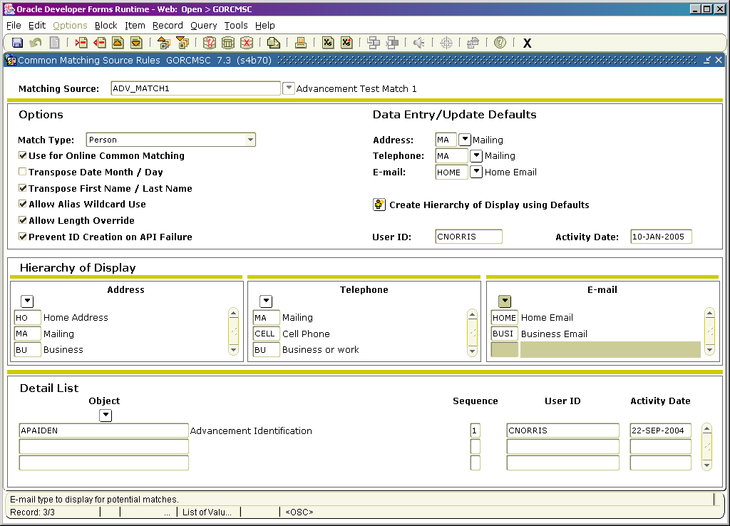
ADVANCEMENT RULE EXAMPLE FOR NON-PERSON MATCHING

 | Column | Element | Length | Match on Null Data
Priority 1
 | SPRIDEN_SEARCH_LAST_NAME | LAST NAME/NON-PERSON NAME | 60 | Yes
Priority 2
 | SPRIDEN_SEARCH_LAST_NAME | LAST NAME/NON-PERSON NAME | 20 | Yes
 | SPRADDR_STREET_LINE1 | STREET LINE 1 | 15 | Yes
 | SPRADDR_CITY | CITY | 10 | Yes
Priority 3
 | SPRIDEN_SEARCH_LAST_NAME | LAST NAME/NON-PERSON NAME | 10 | Yes
 | SPRADDR_CITY | CITY | 10 | Yes
 | SPRTELE_PHONE_NUMBER | TELEPHONE NUMBER | 7 | Yes
Priority 4
 | SPRIDEN_SEARCH_LAST_NAME | LAST NAME/NON-PERSON NAME | 10 | Yes
 | SPRADDR_CITY | CITY | 10 | Yes
 | SPRTELE_PHONE_AREA | TELEPHONE AREA CODE | 3 | Yes

Additional Rule Settings as optional (may affect performance) that are suggested:
- Add comments for your rule to better assist users in selection for match process (on GORCMRL)
- Check Allow Alias Wildcard use (Under Options on GORCMSC) to allow search to use user defined alias values (on GORNPNM) in search match selection
- Check Allow Length Override (Under Options on GORCMSC) to allow the search process to use the number of characters entered for selection even if less are entered than defined on the rule (on GORCMRL)
- Check Prevent ID Creation on API Failure (Under Options on GORCMSC) to avoid creating a record in error when missing required data fields are not populated on GOAMTCH (requires complete Address, Telephone and/or E-mail details in order to create a new ID)
- Consider defining a hierarchy for address display (Under Hierarchy of Display on GORCMSC) which results in the display of existing addresses based the hierarchy defined even if the existing address does not match the search criteria entered. You can use this feature for telephone and e-mail as well.
Non-Person Examples:
The match process follows the rule priority order and searching stops when a potential match is found. Define the priority details to begin with the most restrictive details and then broaden the search details in higher numbered priorities.

Existing Data in Banner
Name | Street 1 | City | Telephone
Michael Tire | 444 Tires Street | Malvern | 610-444-9999
Scott Oil | 14 Summer Court | Galveston | 711-777-4444
Peterson Book Binders | 17 Reading Road | Atlanta | 451-944-5555

Case #1 | Entered Data to Match | Element | Length | Match on Null Data
 |  | Priority 1
 | Michael Tire | LAST NAME/NON-PERSON NAME | 60 | Yes
Results | Match on priority 1 rule – exact match on name.  Stopped after first priority rule based on match status

Case#2 | Entered Data to Match | Element | Length | Match on Null Data
 |  | Priority 1
 | Peterson Book Binders Inc | LAST NAME/NON-PERSON NAME | 60 | Yes
Results | No match on priority 1 rule – different name
 |  | Priority 2
 | Peterson Book Binders Inc | LAST NAME/NON-PERSON NAME | 20 | Yes
 | 17 Reading Road | STREET_LINE1 | 15 | Yes
 | Atlanta | CITY | 10 | Yes
Results | Match on priority 2 rule – match on name (based on length), street and city  Stopped after second priority rule based on match status

Case#3 | Entered Data to Match | Element | Length | Match on Null Data
 |  | Priority 1
 | Peterson Books Binders Inc | LAST NAME/NON-PERSON NAME | 60 | Yes
Results | No match on priority 1 rule – different name
 |  | Priority 2
 | Peterson Books Binders Inc | LAST NAME/NON-PERSON NAME | 20 | Yes
 | 17 Reading Road | STREET_LINE1 | 15 | Yes
 | Atlanta | CITY | 10 | Yes
Results | No match on priority 2 rule – different name
 |  | Priority 3
 | Peterson Books Binders Inc | LAST NAME/NON-PERSON NAME | 10 | Yes
 | Atlanta | CITY | 10 | Yes
 | 944-5555 | TELEPHONE | 7 | Yes
Results | Match on priority 3 rule – match on name (based on length), city and telephone  Stopped after third priority rule based on match status

Case#4 | Entered Data to Match | Element | Length | Match on Null Data
 |  | Priority 1
 | Peterson Books Binders Inc | LAST NAME/NON-PERSON NAME | 60 | Yes
Results | No match on priority 1 rule - name different
 |  | Priority 2
 | Peterson Books Binders Inc | LAST NAME/NON-PERSON NAME | 20 | Yes
 | 17 Reading Road | STREET_LINE1 | 15 | Yes
 | Atlanta | CITY | 10 | Yes
Results | No match on priority 2 rule - name different
 |  | Priority 3
 | Peterson Books Binders Inc | LAST NAME/NON-PERSON NAME | 10 | Yes
 | Atlanta | CITY | 10 | Yes
 | 945-5555 | TELEPHONE | 7 | Yes
Results | No match on priority 3 rule – telephone is no match (one wrong number)
 |  | Priority 4
 | Peterson Books Binders Inc | LAST NAME/NON-PERSON NAME | 10 | Yes
 | Malvern | CITY | 10 | Yes
 | 451 | TELEPHONE AREA CODE | 3 | Yes
Results | Match on priority 4 rule – match on last name (based on length), city and area code  Stopped after fourth priority rule based on match status

Example of Settings on GORCMSC for Non-Person Matching Rule

