Foothill-De Anza Community
College District

Guidelines for Data Standards, Data Integrity, and Data Security

March 23, 2009
(Draft)

This document is based on the data standard and guidelines developed by the Virginia State University, ARIES Project, and the University of Carolina.
Table of Contents
Introduction 1
A. Document Review and Maintenance 2
Data Integrity, Access and Security 3
B. Purpose 3
C. Administrative Responsibility 3
D. FERPA and the Release of Student Records 4
E. Employee Access to District Data (Need Chien to provide final proposal on how data access will be granted or monitor in the District. ) 5
F. Information Access Definitions 6
G. Secured Access to Data 6
H. Requests for Confidential Information (*** Discuss the possibility of developing a form—Institutional Research?) 6
I. Data Ownership 6
J. Data Owners 8
K. Data Custodianship 8
L. Data Change/Update Rules 10
M. Rules for Clean and Accurate Records 13
1. Entering new records 13
2. Updating records 13
GENERAL ENTITY CRITERIA 14
A. General Notes 14
B. Entity Dimensions 14
1. Constituent: 14
C. Identification Number Standards 15
D. Banner Identification Number/GE Unique Number 16
E. Oracle Username (Need confirmation from Chien) 16
F. Third Party ID (Need confirmation from Chien) 16
G. Luminis ID (To be decided) 16
H. Social Security Number/Tax ID Number 16
I. Alternate IDs 16
J. Person Name Standards 17
1. Name Type 18
2. Last Name 19
3. First Name 19
4. Middle Name 19
5. Prefixes 20
6. Suffixes 21
7. Preferred First Name 21
8. Legal Name 21
K. Non-Person Name/Vendor Name Standards 22
1. Acronyms 22
2. Abbreviations 22
3. Names of FHDA Entities 23
L. Address Standards 24
1. Street Standards 25
2. Unit Numbers such as Apartment, Building, Suite, etc. 26
3. City Standards 26
4. State and Canadian Province Standards 27
5. ZIP Code Standards 27
6. Nation Codes 28
7. Military Addresses (Overseas) 28
8. Rural Route Addresses 29
9. Post Office Boxes 29
10. Campus Mailing Address Standards (internal mail) 29
11. Inactivate Address 29
12. Source Code 30
M. Address Types and Custodianship 31
N. Telephone Numbers 33
O. Email 35
P. Date Standards 37
1. Birth Date Standards 37
Q. Confidential Information Indicator Standards 38
1. Students 38
2. Employees 39
R. Citizenship Type Standards 40
S. Visa Type Standards 40
T. Gender Code Standards 41
U. Ethnic Code Standards 42
V. Relationship Code Standards 45
W. Marital Code Standards 46
X. Veteran Information 47
Y. Deceased Person Information 47

Introduction

Banner is the new administrative system purchased from SunGard Higher Education and tailored for Foothill-De Anza Community College District (FHDA), which will replace the non-integrated systems (SIS, FRS, HRS) the District is currently using under the SIS-Plus system. Banner offers the FHDA an increase in the quantity and quality of data it can maintain, as well as increased data access, enhanced data security, and compatibility across functional areas.

Banner is a modular administrative (made up of parts or modules) on which every module addresses a separate functional or main work area. At FHDA, the modules or products to be implemented include Student Information (e.g., Admissions, Registration, Institutional Research), Advancement, Finance, Human Resources, Financial Aid, Accounts Receivable, and the General module which allows the administrative system to integrate all of the functional modules altogether. For example, a person’s ID number, name, and address are contained within the General module so that any data related to that person across the different modules can linked.

In Banner, the data itself is stored in tables residing in an Oracle database-- a relational database, where tables can be linked together by means of an internal identification number. Because data for a given entity (person/non person) is stored in a single well-defined structure, data redundancy and/or inconsistencies in this database system. There are over 3,000 tables in the Banner system, which can be linked through key data fields, such as student ID and a course ID.

Banner also provides a collection of forms with imbedded instructions to allow authorized users to enter, modify, delete, and query data. Each form is assigned a seven character code in which the first character indicates the primary module/owner of the form, such as "G" for General. (See Table 1 for details.)

Table 1. Initial Character on Banner Form ID by Module

Initial Character Code/ID for Standard Banner Form | Module Owner
A | Advancement
F | Finance/Budget
G | General—Shared across modules
N/P | Human Resources /Payroll
R | Financial Aid
S | Student Information
T | Accounts Receivable

Luminis is the Sungard Higher Education’s portal product purchased by the District. Luminis integrates with Banner to give authorized users personalized access to information and associated technology services through a single sign-on. Luminis portal feature is expected to provide a customized online environment to all system users, including students and District employees.

This manual has been developed to document good practices to improve and maintain data validity, as a function of improving employee’s data maintenance functions, particularly as the District moves toward the implementation of a new information system or EIS. The standards published here are not final and they should be reviewed on a regular basis to meet the current and future data needs of the District.

Table 2. Data Standard Committee Members: 2008-09

Committee Member | Department
Patricia Fifield | Associate Registrar, Admission and Records, De Anza College
Shawna Aced | Registrar, Foothill College
Cindy Castillo | Financial Aid Director, De Anza College
Hector Quinonez | Controller, Central Services
Kim Chief Elk | Director of Human Resources Central Services
Chien Shih | Director of Information Systems and Operations,  Central Services
Joe Lampo | Applications Programming Supervisor, Central Services
Lourdes del Rio-Parent | Sr. Res Analyst/Data Warehouse Coordinator, Central Services

Document Review and Maintenance

Data Standard Committee (DSC) members should meet at least once a year to review data related policies and standards for data entry in Banner, as required by upgrades to the system and/or reporting requirements. Updates to this document will be posted on the District’s website.

Data Integrity, Access and Security

Purpose

These guidelines provide recommendations for protecting, accessing, and using Foothill-De Anza Community College District (FHDA) data that are electronically maintained on the FHDA’s Enterprise Information System (EIS) system, including legacy data migrated into the EIS system. The EIS system includes the four Banner administrative systems (i.e., Finance, Human Resources, Student, and Financial Aid) Advancement? as well as a number of other SunGard/SCT systems (i.e., Luminis, ODS, and Data Warehouse) and third party systems (e.g., SARS, Touch Net payment gateway) implemented as part of this project. These guidelines also define the responsibilities of users who have access to the data in any of these systems.

Divisions/Departments may have additional guidelines that supplement these guidelines, but do not replace or supersede them. Data entrusted to FHDA by other organizations (e.g., Foundations and Governmental agencies) is governed by terms and conditions agreed upon with those organizations. Specific issues not governed by such agreed terms shall be governed by the guidelines set forth in this document.

These guidelines are also set to ensure database integrity and the goals of easy, professional, cost-effective communication for FHDA employees who work with these systems by:

- Avoiding creation of duplicate records for a single entity,
- Providing complete name/address information in a timely manner, with an audit trail of changes, and established guidelines as to what constitutes an appropriate entry (such as legal name)
- Using standard entry to facilitate consistent reports and searches,
- Sharing effective processing discoveries and problem-resolution tasks with other team members,
- Using Postal Services recommended mailing address setup and procedures, and
- Taking advantage of the database capabilities and workflow analysis.

Administrative Responsibility

Electronic data is a vital asset to the District. All institutional data, whether maintained in the central database or copied into other data systems, including microcomputers, is property of the District. Access to institutional data is not approved for use outside of an individual’s official job responsibility in the District. Data, institutional computing services, and facilities shall be used only as required in the performance of job functions at the District or only for the legitimate business of the FHDA. Data attached to persons through a unique identifier should not be stored or maintained on laptops or other less secured hardware except under approved conditions determined by District policy.

All levels of management shall ensure their areas of accountability, and each information system user must know his/her responsibilities. Employees must adhere to any applicable federal and state laws covering storage, retention, use, release, and destruction of data.

Supervising administrators shall ensure a secure office environment with regard to all institutional information systems. Administrators shall validate the access requirements of their staff according to job functions before submitting requests for the provision of data access.

As a general principle of access, District data (regardless of who collects or maintains it) shall be shared among those employees whose work can be done more effectively by knowledge of such information. Although the District must protect the security and confidentiality of data, the procedures to allow access to data must not unduly interfere with the efficient conduct of District business.

All information systems owned by FHDA shall be constructed to assure that:

- All data is input correctly.
- All system contents are accurately maintained during storage and processing.
- System capabilities can be re-established within an appropriate time after loss or damage by accident, malfunction, breach of security, or natural disaster.
- Actual or attempted breaches of security can be detected promptly and controlled.
- Data reports are accurate.

FERPA and the Release of Student Records

FERPA regulations restrict the release of this information only to the students themselves, with proper identification. Any other entity or person, including parents, will need proper written consent from the student to have access to the student’s educational records. The District may only disclose educational records without students’ consent under the following conditions (34 CFR § 99.31): ( See reference to the adoption of FERPA rules by the District/Colleges in Appendix A.)

- School officials with legitimate educational interest;
- Other schools to which a student is transferring;
- Specified officials for audit or evaluation purposes;
- Appropriate parties in connection with financial aid to a student;
- Organizations conducting certain studies for or on behalf of the school;
- Accrediting organizations;
- To comply with a judicial order or lawfully issued subpoena;
- Appropriate officials in cases of health and safety emergencies; and
- State and local authorities, within a juvenile justice system, pursuant to specific State law.

Employee Access to District Data (Need Chien to provide final proposal on how data access will be granted or monitor in the District. )

The following outlines the requirements and limitations for District departments/divisions to follow in obtaining permission for inquiry and update access to the District’s official records. Data security is everyone’s responsibility and must be impressed upon all employees.

Access will be awarded only after appropriate tailored training is received, as documented by the employees’ supervisor. Entries to Banner general entity (person or non-person) tables affect the overall integrity of the database used by all Banner modules. Failure to abide by the guidelines outlined in this manual for creating and maintaining general entity records will result in removal of access.

Employees/Users must protect all District data files from unauthorized use, disclosure, alteration, or destruction. Users are responsible for the security, privacy, and control of data to which they have access as authorized users of the EIS system. All users are responsible for all transactions occurring during the use of their username and password. Users are not to loan or share access codes with anyone. If it is found that a user inappropriately loans or shares their access codes, that user is subject to disciplinary action, which in some cases may include termination.

The EIS system tracks changes by user username and date. Offices hiring temporary or part-time employees should request an appropriate username for use by each individual who is to be granted access to the system. All employees with access to the EIS system, including student workers and temporary workers, will have a unique username and password to access the system. Update capability should be carefully considered and approved by the division/department head and the Data Custodian will follow established policies and procedures for granting access to EIS system data.

Temporary employees and students will not be given update capability for Financial, Human Resources, and Payroll transactions, nor will they be permitted access to validation tables and transactions that directly affect the student transcript, such as grades. Exceptions may be authorized at the discretion of the Data Custodian. This includes functions that create financial transactions. Temporary employees and students may be given update capability for holds and comments. It is the department/division manager’s responsibility to ensure that system access is cancelled for employees and students who no longer work in their area.

Students will not be given update capability to Student records, including grades, grade changes, or other secured data. A student or temporary staff who is found to have accessed and modified secured data will be terminated and subject to disciplinary or other action.

Departments/divisions should take steps to ensure that they have an alternate person assigned as backup for each office function, and that this individual has access to the system functions required to provide backup support. Every department/division will maintain a current list of primary and secondary users for the various module functions, a copy of which will be made available to the appropriate system manager.

Information Access Definitions

“Display” or “view” access enables the user to view or analyze, but not change EIS data. This may also be referred to as inquiry or query access. Downloaded data must be used and represented responsibly and accurately, and it must be stored in a manner that is consistent with the sensitivity of the contents of the data downloaded.

“Update” access provides both display and add/change capabilities. This may also be referred to as maintenance access. Update capability is generally limited to users directly responsible for the collection and maintenance of the data, as identified by the associated Data Custodian.

Secured Access to Data

EIS system access will be established based on job function (e.g., clerical, faculty, cashier, etc.) and will be referred to as a classification. Specific access will be assigned to each classification. For example, a registration clerk might have update access to registration, but only display access to academic history. Each user will be assigned one or more classifications, depending on his or her particular needs, as established by their division/department head and approved by the Data Custodian(s).

Specific classifications and associated access privileges will be developed at a later date and included in future versions of this document. (***Specifics to be provided by Chien, Manager of Information Systems and Operations on February.)

Requests for Confidential Information (*** Discuss the possibility of developing a form—Institutional Research?)

Current FHDA faculty and staff who wish to request confidential information in any form (i.e., lists, labels, electronic documents) from the FHDA EIS system (data to which they do not already have access to) must make a formal request of the appropriate Data Custodian(s) according to established policies and procedures. Adequate lead time should be allowed.

The Data Custodian will review the request to determine if the request meets FERPA and other appropriate rules/guidelines. If questions arise, the requester may be asked to provide additional information regarding the data requested. If necessary, procedures for appealing decisions made by the Data Custodian concerning requests for confidential information will be developed and included in future versions of this document

Data Ownership

Data Owners are the directors or department supervisors with the authority for acquiring, creating, and maintaining information systems within their assigned areas of control. Data
Owners are responsible for:

- Managing the information for which they have been assigned Data Ownership on behalf of the entire institution. This includes ensuring that all users who need access to that information to perform their job duties are given such access based on the principle of least privilege (e.g., a user will be given no more privilege than necessary to perform a job) as confirmed by the appropriate request approved by department heads;

- Categorizing the information for which they have been assigned Data Ownership using classifications defined in the Data Standards Document;

- Defining the validation rules used to verify the correctness and acceptability of input data;

- Ensuring that a sufficient level of training takes place for people entering or modifying data in the system;

- Assisting in contingency planning efforts by identifying through formal documentation the sensitivity of the information for which they have been assigned ownership. This includes documenting critical information on the specific application support systems that process information under their responsibility;

- Making decisions about the permissible uses of information for which they have been assigned ownership in a way that reflects both the business requirements of the institution and requirements regarding data integrity and security;

- Understanding the uses and risks associated with the information for which Data Owners are accountable for, and being responsible for taking immediate and appropriate actions in the event of improper disclosure, insufficient maintenance, inaccurate classification labeling, and other security related control deficiencies pertaining to the information for which they are assigned ownership; and,

- Proposing and seeking timely approval for changes to data standards necessary to accommodate changes to information systems, changes in regulations or reporting requirements, or other mandated changes related to the information for which they have been assigned ownership.

When a system has more than one Data Owner's information residing on the system or commingled, the Data Owners shall ensure that the system will meet the highest level of security of the information needing protection.

When more than one functional area of the institution has authority to perform the above tasks, a single Data Owner will be designated to act on behalf of all such functional areas. That designation will be made by the Process Team Leaders and affirmed based on the following considerations:

- Legal, statutory, or policy mandate for ownership by a particular functional area within the institution;

- Expertise in the standards, classifications, and validation rules that structure the information and its use and maintenance;

- The volume of use of the information by the functional area the Data Owner represents;

- The volume of changes to information by the functional area the Data Owner represents.

Data Owners

Data Owners for application-specific tables are determined within the area of expertise of each functional area by the Data Custodian for that area. In the event that no such determination has been made or documented, the Data Custodian her/himself shall serve as the Data Owner for application-specific data. See the “Data Custodians” section below for Data Custodian assignments.

Data Custodianship

A Data Custodian is the manager or senior supervisor of a FHDA office or major division, within the colleges or District that is charged with the primary responsibility of maintaining a module of the EIS system data. The Data Custodian may make EIS system forms (similar to data screens in SIS-Plus) within his/her charge available to authorized personnel for the use and support of the office or department’s functions.

Data Custodianship and Ownership will, by their very nature, overlap, and Data Custodians and Data Owners in a given functional area will often be the same individual. Data Custodians represent a broader functional view that typically corresponds to form or report level access to a system, whereas Data Owners represent a table/form level perspective of the system. While the Data Owners bear all of the responsibilities outlined in the “Data Ownership” section above, Data Custodians bear additional responsibility for the contextual use of data that goes above and beyond any responsibilities they may also bear as Data Owners.

Before granting access to EIS system forms and data, the Data Custodian must be satisfied those protection requirements have been implemented and that a “need to know” is clearly demonstrated. By approving user access to FHDA EIS system data and forms, the Data Custodian consents to the use of that data within the normal business functions of administrative and academic offices or departments. All provisions of the Family Educational Rights and Privacy Act (FERPA) and relevant FHDA policies and procedures will be upheld by Data Custodians with authority over student data. These Data Custodians will be responsible for ensuring awareness and understanding of the provisions of FERPA and will make user training on this topic available if needed.

Data Custodians are the only individuals who can grant access to EIS system data. Users who are granted access to EIS system data do not have the right to share or redistribute those data or to use them for purposes other than those for which access was specifically granted.

Data Custodians are responsible for the accuracy and completeness of data files in their areas. Misuse or inappropriate use by individuals will result in revocation of the user’s access privileges.

Table 3. Data Custodians

Area of Responsibility | Data Custodian
Student System:
Admissions Application/ Registration/Academic Records | Dean of Admissions and Records/Registrar or Associate Registrar at each college
Course Inventory/Transfer & Articulation | VP Instruction/VP Instruction & Institutional Research at each college
Catalog/Room Scheduling/Faculty Assignments | VP Education Resources & College Operations/VP Educational Resources & Instruction at each college
Student Financial Aid | Director of Financial Aid at each college
Finance System | Controller
Human Resources System | Director of Human Resources

Data Change/Update Rules

The following rules establish which office makes changes to General Entity (Person/Non-Person) data for students, employees, financial aid recipients, or vendors in the EIS system.

Only trained and authorized personnel, within key departments, will be authorized to make changes to the General Entity. These employees will be trained and certified, though a formal assessment, as being qualified to take this responsibility. Changes to General Entity will be monitored and documented in the Person Comment Form (SPACMNT) using the following codes:

Table 4. Codes to Document Changes to Key General Entity Data Fields (GTVCMTT)

Code | Description of Change/Update
GAD | Address Change
GBD | Birth Date Change or Update
GDE | Decease Data Change or Update
GID | CWID Change or Update
GNM | Any Change or Update to a Name
GSN | SSN ID Change or Update

In changing General Entity data for a person that has multiple roles at FHDA (e.g., student, employee, vendor), the same data standards will be followed by departments that have update capability for that data element. Notification of any change or update to the other divisions (e.g., Human Resources, Admissions and Records) is generally not necessary when it follows rules as stated in Table 5. Otherwise, the key or sharing divisions should be notified through email. For example, changes to a student who is also an employee by the Admission and Records should be documented and notified to Human Resources.

At minimum, General Entity data should include Legal Name as the default, and all key field changes or updates (in Table 4) will require appropriate documentation. (See Table 5 for details.)

Table 5. Rules for Data Updates

If the person is a (an) … | Then changes will be made or notified to…
Employee, Retiree or Employment Applicant Only | Division of Human Resources.  To change names, SSN, or birth date changes require a copy of social security card or a letter from the Social Security Administration (SSA)
Prospective Student

Student Recruit or Student Applicant Only | Admissions and Records  Admissions and records can change nicknames to legal names without authorization, at their discretion.  Other name or birth date changes can be made with picture ID, comparable to a driver’s license.  For SSN changes, a copy of SS card or a letter from SSA.
Financial Aid Applicant Only | Financial Aid Office  Changes to name or SSN will require a SS card, SSA letter or passport (foreign students).  Other name or birth date changes can be made with picture ID, comparable to a driver’s license.
Financial Aid Applicant and Student Applicant | Admissions and Records, Financial Aid  Changes to name or SSN will require a SS card, SSA letter or passport (foreign students).  Other name or birth date changes can be made with picture ID, comparable to a CA driver’s license.
Matriculated Student

Matriculated Student Only | Admissions and Records  Name changes will require one of the following: marriage certificate, divorce decree, court order, or a picture ID comparable to a CA driver’s license.  SSN changes will require a copy of SS card or a letter from the SSA.  Birth date changes will require copy of birth certificate or passport; and, or a picture ID comparable to a CA driver’s license.
Matriculated Student and Financial Aid Recipient | Admissions and Records, Financial Aid  Documentation for updates, same as for matriculated student only.
Matriculated Student, Financial Aid Recipient, and Vendor (person) | Admissions and Records, Financial Aid  Documentation for updates, same as for matriculated student only.
Matriculated Student, Employee or Vendor (person) | Admissions and Records, Division of Human Resources  Documentation for updates, same as for matriculated student only.
Vendor Only | Only Accounts Payable and Purchasing can create and make changes to vendors that are paid for goods or services, with appropriate documentation, such as invoices.
Donor | Advancement/Foundation  Only the Advancement/Foundation should make changes to Donors.
Alumni*****Discuss | Advancement/Foundation, Admissions and Records  Documentation for updates, same as for matriculated student only.

Rules for Clean and Accurate Records

Entering new records

Search first. Before creating a new record for a person or organization, one MUST conduct a thorough search to make sure that person or organization has not already been entered in the EIS system database. Each user in every office MUST conduct a thorough search to prevent entering a duplicate record. This includes using multiple identifiers to search for records.

Updating records

When updating records, always follow procedures established by the Data Custodian of the data. Remember, data fields may have specific data entry rules. (***Discuss constraints)

GENERAL ENTITY CRITERIA

General Notes

The pound sign (#) will not be used in any field, excluding the data field ‘purchase order text.’ The @ symbol will not be used in any data field, excluding email addresses. Other special characters not be used in any data field are the dollar sign ($), percent sign (%), asterisk (*), double quotation marks (“), single quotation mark (‘), semi-colon, and the colon (;).

Any changes to the any name, ID, social security number, birth date, or deceased data need to be documented (SPACMNT—See Table 4.). If the division updating or changing the information is NOT the entity’s main data custodian, or the custodianship is shared by more than one division, the corresponding data custodian needs to be notified through email so that it can have the opportunity to review the changes.

At the time, it is being proposed to train and certify a group of employees from different divisions to have the exclusive privilege to enter/update data for the General Entity (person/non-person). The performance of this selected group of employees will be assessed and monitored for data quality purposes.

Regarding data access privileges, at this time it is proposed to create a table to identify access privileges by employee and role. Similar to the system used by the FHDA Data Warehouse system, the table will include the employee ID and assigned role (access privileges). Data custodians will identify the requirements needed for assigning a role to an employee (i.e., training, signing forms) and that the employee has met these requirements. Then, the Data Custodian will make the request to the appropriate ETS department maintaining the table with access privileges information.

Entity Dimensions

Constituent:

Student, alumnus, parent of student, parent of alumnus, friend of FHDA (person and non-person entity), board member, community member, donor, prospective donor, vendor, employee, retiree, or affiliate. The main entity dimensions, which will later be further defined for Luminis, include:

Employee:

Classified employee, faculty, adjunct, administrator, hourly employee, student-employee, retiree, board member, and former employee

Student:

Former or current person enrolled at FHDA, applicant, recruit, financial aid applicant

Vendor:

Company/Corporation/Foundation, current and/or former employee, former or current student, individual

Entity dimensions are not exclusive because a person/non-person may fall under more than one of the dimensions mentioned above (i.e., same data access through different forms). To protect these key pieces of data in the EIS system, a selected group of employees will be trained, assessed, and certified as having exclusive access to person/non-person identification forms.

Figure 1. Access to Person Identification Through Different Forms: SPAIDEN, PPAIDEN

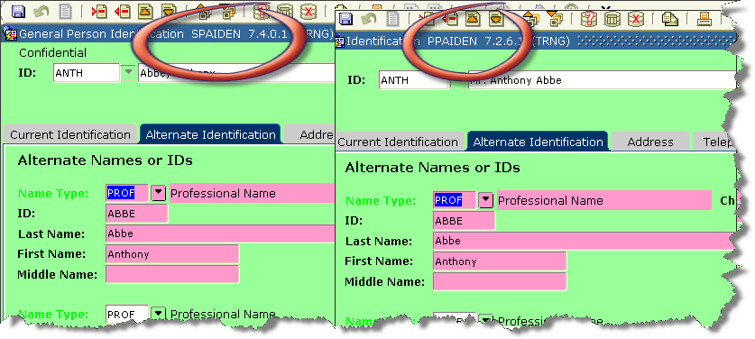

Identification Number Standards

An entity in the EIS system can be either a “person” or a “non-person.” A person is an instance of the general entity that is an individual (e.g., a student, prospect, faculty, staff, affiliate, donor, etc.); a non-person is an instance of the general entity that is not an individual (e.g., a vendor, governmental body, foundation, or sponsor).

Before creating a new entity in the EIS system, a thorough search must be performed to ensure that the person or non-person does not already exist in the EIS system. Any situations where multiple identities (e.g., PIDMs) are created in the EIS system for the same person or non-person require significant efforts to resolve; administrative office procedures must vigilantly guard against these occurrences. Banner accommodates person searches by name, date of birth, gender, address and social security number. (See procedures in Appendix B.)

Banner Identification Number/GE Unique Number

The Banner Identification Number (ID) is used in the EIS system to uniquely identify persons and non-person entities. This is not the person’s Social Security Number or the non-person entity’s federal Taxpayer Identification Number.

In order to protect student privacy and confidentiality, the legacy SIS-Plus system identifies students with a Student Number (campus-wide identification, “CWID”) that is 8 digits in length. To facilitate the transition of student information from that system to the EIS system, the CWID for students and employees will be the Banner ID for students already in the legacy system. Once the EIS system is in place, Banner ID numbers will be generated only after conducting ID and Name searches to verify that the person/non-person does not have this unique identifier. (See Appendix B for information on search procedures.)

All CWIDs in SIS Plus have a ‘1’ in the initial position. By contrats, new ID numbers created in Banner will have a ‘0’ for vendors, and a ‘2’ for all other constituents in the initial position of the ID. This scheme will allow to identify IDs created prior and after the data migration.

Oracle Username (Need confirmation from Chien)

The Oracle User Name (Oracle process user) will consist of the letter ‘Q’ plus the CWID/Banner (nine character data field).

Third Party ID (Need confirmation from Chien)

The Third party ID (to interact with other systems) will be the ‘ugly name’ or universal ID already used by FHDA employees to access systems such as email and Liquid Office.

Luminis ID (To be decided)

Social Security Number/Tax ID Number

The Social Security Number (SSN) and federal Taxpayer Identification Number (TIN) will be collected and recorded in the EIS system consistent with established District policies and federal reporting requirements. It is anticipated that the SSN/TIN will be used in appropriately controlled circumstances to ensure the accuracy and integrity of official records in the EIS system in a manner consistent with university policies. [****Discuss checking on valid SSNs?]

Alternate IDs

Nothing in this standard precludes the use of an alternate ID for the purposes of referencing electronic records within the EIS system, so long as such use does not refer to sensitive or privileged information in an unprotected manner or contradict District policies and procedures or state or federal law. The main purpose of the Alternate ID is to facilitate searches to avoid generating a second Banner ID to the same person/non-person.

Person Name Standards

Before creating a new record, always conduct an ID and/or name search to make sure that the person has not been entered in the system. If the person already exists, make and document any updates or changes. Make sure you follow procedures for changes and updates. (See section on ‘Data Change/Update Rules’ and Table 5 in this document for details.)

Names should be entered using legal spelling as provided by the student or employee. Enter first, middle and last name in title-case format (standard combination of upper and lower case letters). Hyphens and apostrophes are allowed as needed, but there should be no space before or after either a hyphen or an apostrophe. Single spaces are otherwise permitted as needed. Non-English characters should not be entered. Last Name and First Name are mandatory fields. Middle Name, Preferred First Name, and Prefix and Suffix are optional.

If a person has only one name (not a last and a first name), enter that name in the Last Name field and only a period (.) in the First Name field. Leave the preferred first name field blank.

Figure 2. Relationship between Banner Unique ID and Name Types

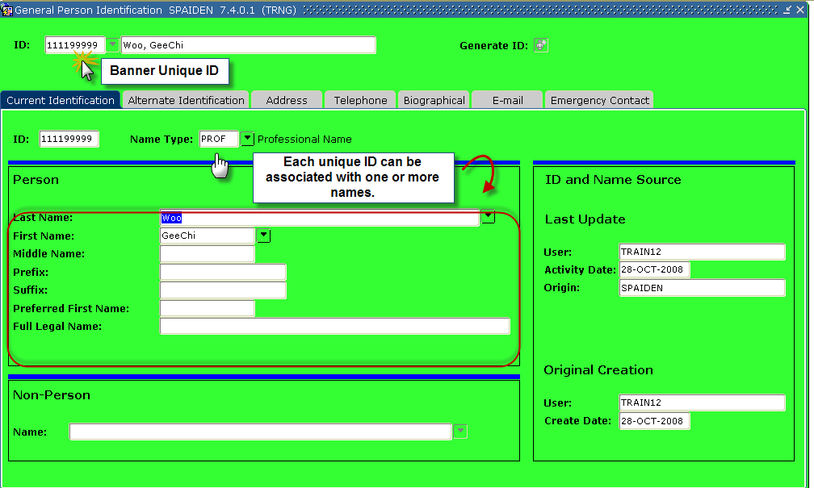

Name Type

Persons/Non-Persons can be identified by different name types (names and IDs), which are shown in the ‘Alternate Identification’ tag in the SPAIDEN form shown below in Figure 3. When creating Alternate ID for the non-persons, take into account search key words that may be used to identify the entity and avoid creating duplicate records, such as the use acronyms or short names (e.g., PG&E, Pacific Gas and Electric Company, PGE). There could be multiple entries under a Name Type (e.g., two entries under ‘AKWN’ or ‘also known as.’) Assigning a code to Name Type is not necessary, but strongly encouraged.

Figure 3. Alternate Identification and Name Types

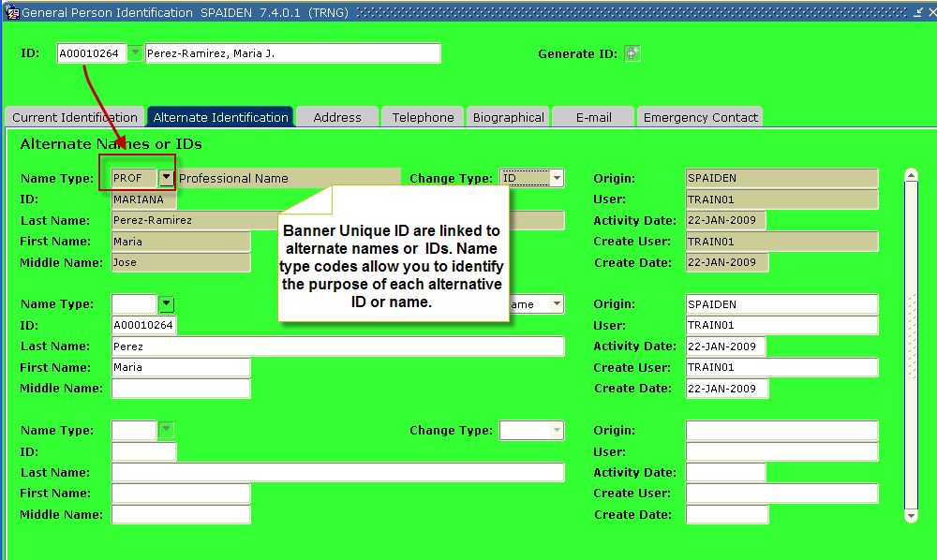

To help identify the source or purpose of the different name or ID use Name Type or ID Type codes in Table 6.

Table 6. Name Type and ID Codes and Descriptions (GTVNTYP)

Name Type Code | Description
AKWN | ‘Also known as’ alternate name—Mainly used for organizations with acronyms
APPL | Name as entered by student or employee on application.
LEGA | Name as shown by the SSN card. If SNN not available, then as shown by other legal documents (as approved by Human Resources). For non-persons, name as shown on official documents, such as invoices.
PRNA | To help identify previous name or ID.
MIGR | ‘Migration Bucket,’ when other codes do not apply.

Last Name

Enter the last name as provided by the person or stated in the approved documentation, when applicable. No titles or suffixes in the last name field (MD or III). If the person has only one name (not a last or a first name), enter the name in the Last Name field and only a period (.) in the First Name field.

First Name

Enter the first name as provided by the person or stated in the approved documentation, when applicable. If the person has only one name (not a last or a first name), enter the name in the Last Name field and a period (.) in the First Name field. To the extent possible, nicknames should not be used as first names (Megan not Meg or Robert not Bob). No periods after single character first name (J Bernard Smith). No prefixes in the first name field (Ms or Dr). For compound first names (e.g., Mary Jane), enter the complete first name, as provided by the person, in the First Name field.

Middle Name

This data field of Middle Name can include the person’s middle name, middle initial, maiden name or no middle name (blank). No periods should be entered after middle initial. If given, use the complete middle name; do not change it to an initial. Leave blank if no middle name. See examples of valid name on Table 7.

Table 7. Example of Valid Names
First Name | Middle Name/Initial | Last Name
Edward | Luis | Martinez
James | G | McKenzie
Susan | L | Bennett-Adams
Stephanie | M | St John
Colleen | G | O’Leary
Mary-Jo |  | Staples
Mary Jo |  | Smith
J | Albert | Edwards
Maria | Garcia | Thorndike

Note: Name as provided by the person or documentation (vendors). Apostrophe, space, and hyphen are allowed.

Prefixes

This is an optional data field. Enter it as reported by the person. Enter prefix in title-case format (standard combination of upper and lower case letters). Do not enter periods after prefix, and do not include the prefix in the First Name field. If the Data Standard Committee deems it necessary, the list of acceptable prefixes will be updated in future versions of this document. (See examples of Valid Prefixes in Table 8.)

Table 8. Examples of Valid Prefixes

Prefix | Description
Miss | Single woman
Ms | Widow or woman of unknown marital status
Mr | Man
Mrs | Married woman
Dr | Doctor
Sgt | Sergeant
Capt | Captain
Lt | Lieutenant

Suffixes

Enter the suffix in title-case format (standard combination of upper and lower case letters). No periods after suffix. Do not enter suffix in the Last Name field. Degree designations (e.g., PhD, MD, and DDS) should not be entered in the suffix field. (See examples of valid suffixes in Table 9.)

Table 9. Examples of Valid Suffixes

Suffix | Description
Sr | Senior
Jr | Junior
II | The Second
III | The Third
IV | The Fourth

Preferred First Name

This is an optional field, and it is entered as reported by the person. Leave it blank if no preferred first name is provided. See examples on the use of Legal Name versus Preferred Name in Table 10. This field is not included in the standard search/query of names.

Table 10. Examples for the use of Legal Name versus Preferred Name

Legal Name | Preferred Name
Julius Bernard Smith | Bernard
William L Thomas | Bill
Suzanne P Wilkinson | Sue

Legal Name

For employees and financial aid applicants, write the name as it shows on their Social Security card. For non-persons, enter the official name as it is shown on official letterhead or other official documents, such as invoices.

Non-Person Name/Vendor Name Standards

Prior to creating a new record, always conduct an ID and Name search. All name information for non-person vendors should be entered using title-case format (standard combination of upper and lower case letters). Acronyms are an exception. See the acronym section below. Enter the vendor’s name as supplied by the vendor.

Hyphens, apostrophes, and spaces are allowed if they are included in the legal spelling and format of the name.

The ampersand (&) can be used only when part of a formal name (e.g., PG&E). Use ‘and’ in all other cases.

The period is not used unless it is part of a web name (e.g., Amazon.com).

The pound sign (#) and percent sign (%) must not be used in any data field.

Acronyms

When companies are recognized by their acronyms, their names should be entered using their acronym (e.g., IBM, SCT, and ITT) as well as their full names in the Alternate Name field (e.g., AKWN). Do not use space or punctuation between the letters of an acronym. (See Table 11.)

Table 11. Use of Acronyms in Name Fields

Name of Company* | Name in Alternate Identification
IBM | International Business Machines
PG&E | Pacific Gas and Electric Company
California Community Colleges System Office | CCCSO
*Name or acronym by which the organization is best known

Abbreviations

Abbreviations are allowed for Co, Corp, Ltd or Inc when used after the name of a corporate entity. All other forms of abbreviations should not be used for the corporate entity name, unless abbreviations are necessary due to line length constraints or if abbreviations are used as a part of the legal name as supplied by the vendor. When abbreviations are used, they should NOT be followed by a period. (See Table 12.)

Table 12. Valid Abbreviations; Use ONLY when there are Length Limitations

Word in Official Non-Person Entity Name | Abbreviation to use in Banner
Association | Assn
Associate | Assoc
Associates | Assocs
Company | Co
Corporation | Corp
Department | Dept
Incorporated | Inc
International | Intl
Limited | Ltd
Limited Liability Corporation | LLC
Power of Attorney | PA
Private Corporation | PC
Society | Soc
Saint | St
University | Univ
Foothill-De Anza | FHDA
California | Calif

Government offices (e.g., city, county, departments and agencies) should be entered with the name as given on invoices and documents. The invoice, document, and letterhead should also be used when deciding on the use of initials, space, and punctuation marks. For examples, see Table 13.

Table 13. Use of Initials, Space, and Punctuation Marks on Names

Invoice Name | Rule Description
RJ Paving | No space between initials
T M Automotive | Space between initials
JCPenny Inc | No space between or after initials

Names of FHDA Entities

Use title-case format (standard combination of upper and lower case letters) and only use meaningful and non-redundant words to allow proper identification. (Unless needed, avoid the use of words such as ‘Office,’ ‘Account,’ or ‘Fund.’ Use the formal name of the college (e.g., Foothill College, De Anza College) only when referring to the college itself. When part of a title or name for an entity related to the college, use Foothill or De Anza (e.g., De Anza Police; Foothill Police). For the District, use FHDA when part of a district entity. When referring to the District, use ‘FHDA Community College District’ (e.g., FHDA Police, FHDA Foundation). See other examples below. (See Appendix I for details.)

Address Standards

Multiple addresses can be entered for a person or vendor using different address types, similar to alternate name and IDs. Address standards have been established cooperatively so that address types are used consistently. Use the appropriate address type code from the Address Type Code Validation Form (STVATYP), which are available through pull-down menu.

All address standards assume that the appropriate functionality exists and will be available to convert from address data stored in title-case format to addresses formatted in upper case as specified in USPS standards. Student address types must include a physical/permanent address as well as mailing address when a Post Office Box is listed.

Every address is linked to an address type and a sequence to allow keeping trail of address changes. (For more information, see section “Address Types and Custodianship.”) See Figure 4 for details.

The District has purchased CLEAN_Address software from Runner Technologies for validating addresses. Based on postal regulations or standards (CASS/CERP), the software corrects street misspellings, identifies undeliverable addresses with error codes, and corrects cities, states, and postal codes. This telephone verification component verifies and updates area codes based on the zip code and can correct area code splits and data entry errors. The use of the software will help prevent fraud and reduce time due to typos in address information. Changes made to address by the CLEAN program will be documented in the source code. (See details on Table 15.)

Figure 4. Address Information in SPAIDEN

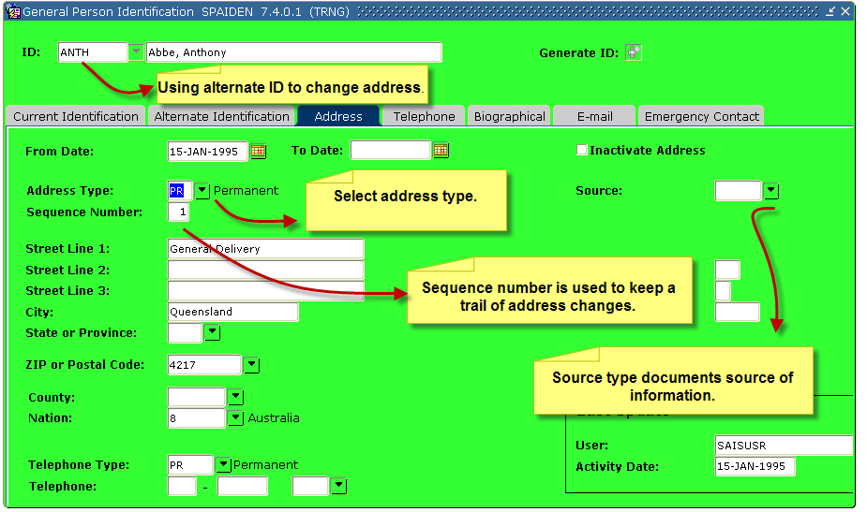

Street Standards

All information should be entered using title-case format (upper and lower case letters), with the exception of standard directional abbreviations, below, which will be entered with the given one- or two-character abbreviation, as shown in Table 14.

Table 14. Abbreviations for Directional Designations

Directional | Abbreviation
North | N
East | E
South | S
West | W
Northeast | NE
Southeast | SE
Northwest | NW
Southwest | SW

No punctuation is allowed in the street field except for a slash when used to designate “in care of” (“c/o”) or a fractional street address (“33 1/2 West Elm Street”). Hyphens should be replaced by a space. The pound sign (#) and percent sign (%) must not be used in any data field. (See Appendix C for a list of USPS acceptable street suffix abbreviations.) See below for standards related to post office boxes and rural route addresses.

Unit Numbers such as Apartment, Building, Suite, etc.

Enter unit number in title-case format (standard combination of upper and lower case letters). Use USPS Postal Addressing Standards for abbreviations. (See Appendix D for USPS approved abbreviations for secondary units.) Do not us punctuation marks, including periods. The pound sign (#) and percent sign (%) must not be used in any data field

City Standards

The ZIP code will automatically populate the City and State fields in EIS system forms using the ZIP code table delivered with the EIS system. The preferred method for data entry is to enter the ZIP code (not the City and State) and allow these fields to be automatically populated with the correct USPS spelling for City and State. Use USPS Postal Addressing Standards.
When done manually, enter the city name in title-case format (standard combination of upper and lower case letters). Spaces are allowed, if part of proper spelling. Do not use city abbreviations, unless the city name is longer than the 20 characters allowed within the EIS system or the abbreviation is part of the common spelling of city name (e.g., “St Louis”). City abbreviations must follow USPS addressing standards, and should not include any periods. (See Appendix E for details.) Do not enter a comma after city (e.g., “Richmond,”)

State and Canadian Province Standards

The ZIP code will automatically populate the City and State fields in the EIS system forms using the ZIP code table delivered with the EIS system. The preferred method for data entry is to enter the ZIP code (not the City and State) and allow these fields to be automatically populated with the correct USPS spelling for City and State. If you do a manual data entry, use USPS Postal Addressing Standards, including two-letter state abbreviation, upper case with no punctuation (e.g., CA, no California or Ca). This field will also include the abbreviation for the Canadian provinces.

ZIP Code Standards

United States Addresses

The ZIP code will automatically populate the City and State fields in EIS system forms using the ZIP code table delivered with the EIS system. The preferred method for data entry is to enter the ZIP code (not the City and State) and allow these fields to be automatically populated with the correct USPS spelling for City and State. Use USPS Postal Addressing Standards.
When entering a 9-digit ZIP code, place a hyphen (“-“) between the first digits and the last 4 digits

Canadian Addresses

Enter the six-character postal code with one space between the first three and last three characters, e.g., K1A 0B1. An example of a correct foreign address follows:

MS. HELEN SAUNDERS
1010 CLEAR STREET
OTTAWA ON K1A 081
CANADA

International Postal Code

Enter the international address as supplied to you by the student. The bottom line of the address should show only the COUNTRY name, written in full (no abbreviations) and preferably in capital letters. Do not place the postal codes (ZIP Codes) of foreign country designations on the last line of the address. Do not underline the COUNTRY name. An example of a correct foreign address follows:

INGE DIETRIC-FICHER
HART MANNSTRASSE 7
5300 BONN 1
GERMANY

Nation Codes

The nation code will be a two-digit alphanumeric value with all letters entered in uppercase. When entered, nation codes will automatically populate the country name using the nation description from STVNATN. Leave the nation code blank for US addresses, otherwise the EIS system will include “United States” on letters and mailing labels, resulting in additional postage costs. (See nation codes on Appendix F.)

Nation Descriptions

The STVNATN table in Banner contains a nation code and nation description field. Banner restricts the nation description field to 30 alphanumeric characters; therefore, official nation names may need to be abbreviated. No punctuation should be entered in the nation description, including periods and commas; however parentheses and the forward slash are allowed. The pound sign (#) and percent sign (%) must not be used in any data field. For historical purposes, the STVNATN table will need to contain codes and names for countries that are no longer officially recognized or in existence. Since these countries should not need to be utilized in routine data entry tasks, such non-existing countries will have the preface ‘Zz-’ as the first 3 characters of their description. This will force them to sort to the bottom of the list of nation descriptions and will keep them distinct from current, officially recognized countries.
(See nation codes on Appendix F.)

Military Addresses (Overseas)

Enter address in tile-case format (standard combination of upper- and lowercase letters). Use USPS Postal Addressing Standards Guidelines:

- Must contain APO (Army Post Office) or FPO (Fleet Post Office) –entered in City field; in upper case.
- Must include one of the following 2 alpha character location designation (entered in State field; upper case):
  - AE = Europe, Middle East, Africa or Canada
  - AP = Pacific
  - AA = Americas
- Must include zip code or zip + 4 code
- No punctuation (including periods or commas) except hyphen in 9 digit zip code

Example:
Sgt Cheryl Reed
Unit 250 Box 4190
APO AP 96522-1215

Rural Route Addresses

Format is RR <route number> Box <box number>. “RR” must be entered in upper case – do not spell out RURAL ROUTE. No punctuation marks should be entered, including periods and commas. The pound sign (#) and percent sign (%) must not be used in any data field.

Example:
RR 66 Box 81

Post Office Boxes

Format is PO Box <box number>. “PO” must be entered and it should be in upper case; “Box” is entered in title-case format (standard combination of upper- lower-case letters). There should be no periods between or after PO.

Example:
PO Box 1234

Do NOT use: P.O. BOX 1234, PO 1234, or BOX 1234

Campus Mailing Address Standards (internal mail)

Follow FHDA Mail Service standards. On-campus addressed must have a department name and room number. Enter address using title-case format (standard combination of upper and lower case letters). The pound sign (#) and percent sign (%) must not be used in any data field.

Example:
Stephen Hubbard
Human Resources
District Office

Inactivate Address

The ‘Inactive Address’ feature must be selected when an address is not longer active, and the source code feature must be updated to reflect the reason for the change. (STVASRC) For details see Figure 5.

Source Code

For any address type and sequence change, the source code must be identified with a four alphanumeric code. The default source code will be ‘APPL’ (Online or paper and pencil application).’ For data migration, ‘MIGR’ (Data Migration). (Table STVASRC.) For details, see Table 15.

Table 15. D Source Code and Description (STVASRC)

Code for Addresses Data Source | Description
APPL | Online or paper application
DOCU | Verified through documentation, such as utility bill
EMAL | Email communication with person
PHON | Phone communication with person
INPE | In person
RELA | Through a relative
MIGR | Migrated from SIS-Plus
CLEA | Use of CLEAN address, software
FAFS | FAFSA (Free Application Student Financial Aid)
SELF | Self-Service On-line System
W9 | W-9 Form (IRS Tax Identificaiton Number Form)

Figure 5. Updating Person/Non-Person Address

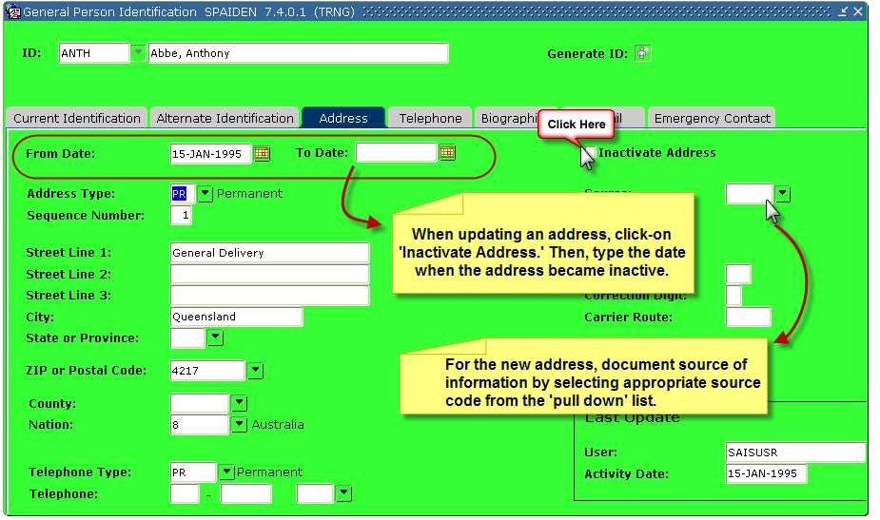

  - Address Types and Custodianship

Any changes to the address need to be documented and notified to Address Custodian. (Discuss with foundation what address type they would need****)

Table 16. Description of Address Types (STVATYP)

Code | Description | Address Use | Address Custodian
AP | Accounts Payable |  | Finance
BI | Billing  (SIS = ‘B’)  System required for sample data purposes | Billing address of student if different from MA or PA | Bursar
BU | Business  System required for sample data purposes | Donors: | Advancement, Foundation
BU | Business  System required for sample data purposes | Employees: | Human Resources
BU | Business  System required for sample data purposes | Students: | Admissions/ Registrar
MA | Mailing Address  (SIS = ‘L’?)  “System required for tape load processing, used by the Banner Advancement System for Student Loading process” | Donor: | Advancement/Foundation
MA |  | Employees: | Human Resources
MA |  | Students: | Admissions/ Registrar
PA | Parent Address  Original system-required value. | Mailing address of parent/guardian if different from MA | Admissions/Registrar
PO | Purchasing | Purchase Order | Finance
PR | Permanent  (SIS= P) | Students: permanent or physical address, as reported by student | Admissions/Registrar
SB | Corporate Subsidiary |  | Advancement/Foundation
TE | Temporary  (SIS= M) |  | Advancement/Foundation Admissions/Registrar/Human Resources

Code | Description | Address Use | Address Custodian
FA | Financial Aid payments |  | Financial Aid Office
VA | SEVIS US Address  (SIS = ‘A’) |  | Admissions/Registrar  International Stu Office
VD | SEVIS Dependent |  | Admissions/Registrar  International Stu Office
VF | SEVIS Foreign Address  (SIS = ‘F’) |  | Admissions/Registrar  International Stu Office
MR | Migration | To identify values migrated from SIS, which the address type cannot be documented. | ETS
XX | Accounts Payable  System maintained | Reserved for use by the Accounting Feed Process  TGRFEED | None

Note: Emergency contact address is included on a separate area of the General Entity Form.

Telephone Numbers

One primary telephone number must be indicated per address type. Additional phone numbers can be attached to each address type as long as these numbers are not checked as primary. For inactive or unlisted phone numbers, their respective buttons need to be selected. (See Figure 6.)

Enter area code with no parentheses. The phone number is entered as a 7-digit number with no hyphen. Extensions are entered into the separate “Phone Ext” field and can be up to 4 digits long.

Figure 6. Key Attributes for Telephone Numbers

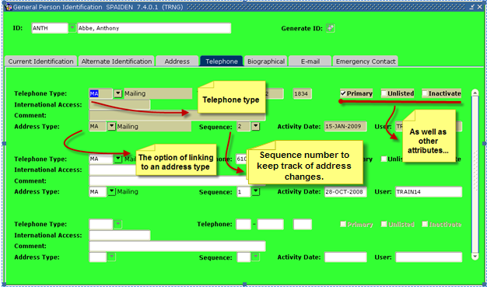

More than one phone number and phone type can be entered. Use codes in Table 17 to identify the type or purpose of the phone number.

Table 17. Telephone Type Codes and Descriptions (STVTELE)

Telephone Type Code | Description
AP | Accounts Payable
BI | Billing
BU | Business or work phone number
CELL | Cell Phone
FA | Financial Aid
FHDA | District number (including cell phones supplied by the District)
HQ | Corporate Headquarters
PA | Parent or Custodian
PO | Purchasing
POC | Purchasing contact
PR | Personal or home phone number
TE | Temporary
FOR | Foreign home phone

Email

An entity (person or non-person) may have multiple email addresses within the Banner system.
If an email address is stored, then the preferred indicator must be checked to indicate the preferred email address. (See Figure 7.) If the preferred indicator is not checked then the email address may be omitted from reporting and other communications.

Figure 7. Email Data on SPAIDEN

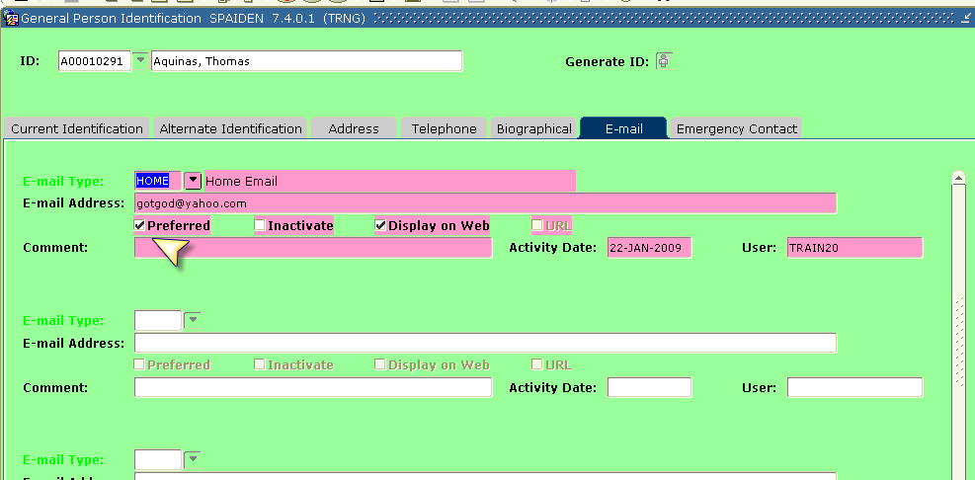

Table 18. Email Type Codes and Descriptions (GTVEMAL)

Email Type Code | Description
BU | Business or work email (Not FHDA)
HQ | Corporate Headquarters
PA | Parent or Custodian
PE | Personal or home email
AP | Accounts Payable
PO | Purchasing
FHDA | District email
WEB | Web Page
FAFS | FAFSA

Date Standards

Dates can be entered in different formats in Banner or selected from a calendar. However, they will be displayed in dd-MMM-yyyy format. The current date will show by typing ‘T’ and hitting the ‘Enter’ key.

Table 19. Date Entry and Display Formats

Entry | Displayed as
Jan 12 1968 | 12-JAN-1968
12022005 | 02-DEC-2005
*NOTE: When dates are entered in this format, the century is inferred based on a setting for all Banner systems.

Birth Date Standards

Enter the date of birth according to the Date Standards. Birth dates are required for all employees and financial aid recipients.

Confidential Information Indicator Standards

Students

This field will be left blank unless a student requests the Registrar to not release any Directory Information (see “Rights of Students under the Family Educational Rights and Privacy Act,” Appendix A of this document), at which time this box will be checked. If checked, no Directory Information will be released, with the exception of information that is necessary to be made available to university personnel who have a legitimate academic interest, such as academic advisors. Confidential information indicators do not apply to State and Federal reports (e.g., MIS, IPEDS).

According to the US Department of Education, Directory Information, which is information that is generally not considered harmful or an invasion of privacy, if released, can be disclosed to outside organizations without a parent's or student’s prior written consent, unless parents or the student has advised the District that they do not want their student's information disclosed. Directory Information usually includes:
- Student's name
- Participation in officially recognized activities and sports
- Address
- Telephone listing
- Weight and height of members of athletic teams
- Electronic mail address
- Photograph
- Degrees, honors, and awards received
- Date and place of birth
- Major field of study
- Dates of attendance
- Grade level
- The most recent educational agency or institution attended

The Confidential Information Indicator is recorded on the General Person Form (e.g., SPAPERS, SPAIDEN). If the checkbox is checked, the message “CONFIDENTIAL” displays on any forms with the ID in the Key Information Block. (See Figure 8.)

Figure 8. Confidential Information Block: SPAIDEN

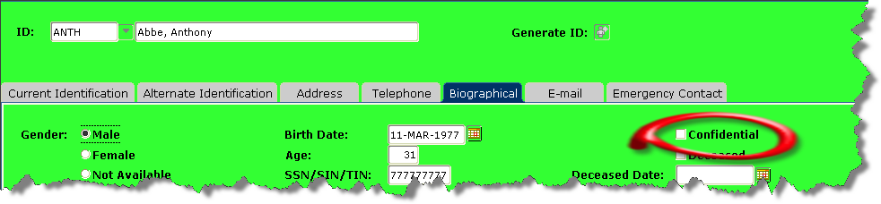

Employees
All employee information is considered confidential unless disclosure is permissible by policy or law. Certain personal information (i.e., Directory Information) must be disclosed to third parties upon request and may be disclosed without the knowledge and consent of the subject employee.
Directory Information includes:

Employee's position title,
Employee's job classification title,
Dates of employment, and
Annual salary, official salary or rate of pay, if such pay exceeds $10,000 per Year.???***

In addition, Human Resources will disclose information available in the public domain such as office phone number, which is available on the Districts’ web site. All other employee information is considered to be confidential regardless of whether or not the “CONFIDENTIAL” message displays on any forms with the ID in the Key Information Block.

Citizenship Type Standards

The citizenship will be a one digit alphanumeric value entered in uppercase.

Table 20. Code and Description for Citizenship Type (STVCITZ)

Student Citizenship Status | Description
A | Resident Alien
N | Not a US Citizen
Y | US Citizen

Visa Type Standards

The visa code will be a one or two digit alphanumeric value with all letters entered in uppercase (current FHDA Codes in AMD31-- Appendix G) as identified in, plus an additional code to identify AB 540 students. When not applicable, enter ’99.’ Identify PORT OF ENTRY in STVPENT Form. (STVVTYP)

Gender Code Standards

Gender is self-reported by students/employees. If gender is not reported for an employee, the Human Resource Division will contact the associated department personnel administrator in to obtain this information. Human Resource Division must know gender for all employees for state reporting purposes. (See Table 21.)

Table 21. Gender Codes and Descriptions (SPAPERS)

Gender Code | Description
X  (Only applicable to students/recruits/applicants) | Unknown/not specified
F | Female
M | Male

Ethnic Code Standards

Per United States Department of Education guidelines, educational institutions will be required to collect racial and ethnic data using a two-part question. The first question is whether the person is Hispanic/Latino. The second question is whether the person is from one or more races/ethnic groups. FHDA’s version of the ethnicity items includes one data field for identifying whether the person is Hispanic (‘Y’ for yes; ‘N’ for no; ‘X’ for unknown/unreported) and 21 data additional data fields for identifying the person’s racial background (‘N’ is for no, which is also the default, and ‘Y’ for yes). (See Figure 9.)

The key data field of this section is the one that identifies whether a person is of Hispanic or Latino(a) heritage. (For MIS reporting, when this data field is left blank, no other ethnic group can be reported.) From the ‘New Ethnicity’ list, indicate whether the person is Latino/Hispanic. Then, from the ‘Race’ list, enter one or more of Table 22.

Table 22. Race Codes and Descriptions (STVETHN)
Race Code | Description
HM | Mexican, Mexican American, or Chicano
HR | Central American
HS | South American
HX | Other Hispanic
AI | Asian Indian
AM | Cambodian
AC | Chinese
F | Filipino
AJ | Japanese
AK | Korean
AL | Laotian
AV | Vietnamese
AX | Other Asian
B | Black or African American
N | American Indian or Alaskan Native
PG | Guamanian
PH | Hawaiian
PS | Samoan
PX | Other Pacific Islander
W | White or Caucasian
WM | Middle Easterner

Figure 9. Multiple Ethnicities Coding in SPAIDEN

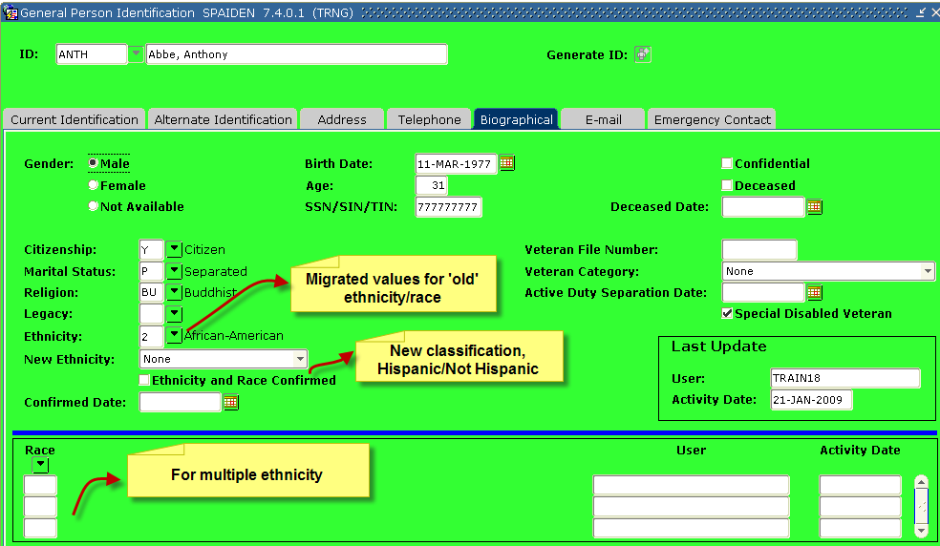

Relationship Code Standards

The relationship codes in Table 23 will be used with an employee or student emergency contact. (See Figure 10 for more details.)

Table 23. Relationship Codes and Descriptions (STVRELT)

Code Relationship | Description
A | Aunt or Uncle
B | Brother or Sister
C | Child or Children
D | Domestic Partner
E | Embassy
F | Father
G | Grandfather or Grandmother
M | Mother
P | Mother and Father
S | Spouse
U | Guardian
V | Advisor or Sponsor
X | Other
(Blank or Null) | Unknown/Unreported

Figure 10. Emergency Contact in SPAIDEN

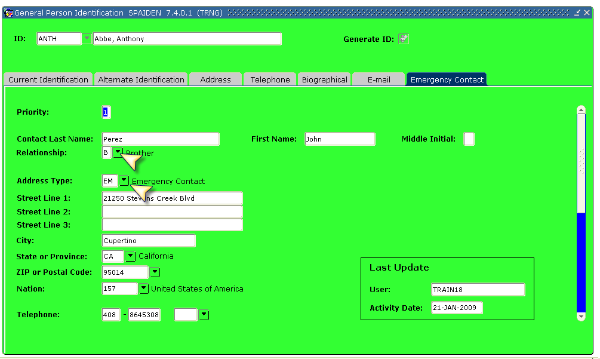

Marital Code Standards

Marital codes are self-reported by the person.

Table 24. Marital Codes and Descriptions (STVMRTL)

Code | Description | Explanation
D | Divorced | Once married, but now legally divorced
L | Living Partner | Not married, but living together
M | Married | Legally married
N | Not known | Information not available
P | Separated | Legally married, but not living together
S | Single | Never legally married.
W | Widowed | Legally married and spouse is deceased
X | Not Applicable | Not applicable

Veteran Information

In Banner, veteran information collected includes Veteran File Number (ID's Vietnam file number), Veteran Category, and Active Duty Separation Date (date the person was separated from active duty—entered in DD-MON-YYYY). If the person is associated with one of the categories in the pull down list of the ‘Veteran Category,’ they may be eligible for Veteran-related programs, if applicable. This field is also used in Banner Human Resources VETS-100 reporting. For details, see Table 25.

Table 25. Veteran Category and Descriptions

Veteran Category from pull down menu | Description
None | Non-veteran
Other Protected Veteran Only | Other protected veterans who did not serve in Vietnam
Vietnam Veteran Only | Vietnam veterans who do not meet the criterion for other protected veteran only
Both Vietnam and Other Eligible Veteran | Vietnam veterans who meet the criterion for other protected veteran only???

Deceased Person Information

Enter ‘Y’ if the employee/student is deceased. Update the date of death, if known.
Deceased information should be maintained using the same guidelines as name changes.
Refer to the Data Change Rules section of this document for determining which offices are allowed to update deceased information. (For a protocol for documenting the death of a person, see Appendix H. )

The Family Educational Rights and Privacy Act (FERPA) (20 U.S.C. § 1232g; 34 CFR Part 99) is a Federal law that protects the privacy of student education records. The law applies to all schools that receive funds under an applicable program of the U.S. Department of Education. FERPA gives parents certain rights with respect to their children's education records. These rights transfer to the student when he or she reaches the age of 18 or attends a school beyond the high school level. Students to whom the rights have transferred are "eligible students."
A job description is not a reliable indicator for assigning access privileges, especially in the handling of confidential data.
Questions/Items must not be framed as being ‘optional,’ however no controls can exist to disallow a student/employee from simply not responding. If the student/employee does not answer the first part, bring it to their attention attention—just a friendly reminder, but do not force an answer. For the first part of question 1, the default is ‘X’ (no response), ‘No’ will be coded as ‘N’ and ‘Yes’ will be coded as ‘Y.’ For the second part of this question and the following question, ‘N’ (No) will be used as the default value and ‘Y’ will be used for indicting students’ selection or ‘Yes.’

