

What can we help you achieve?
HIGHER EDUCATION
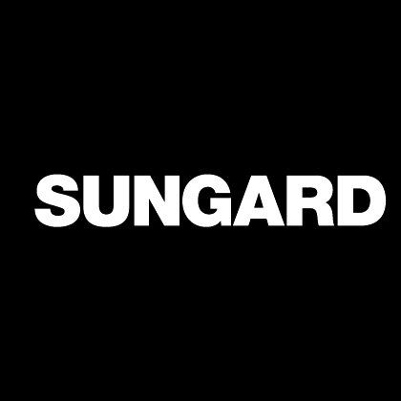
Banner Financial Aid
Progress Assessment Report
Foothill-DeAnza Community College District

June 8, 2009

Confidential Business Information
----------------------------------------------------------------------------------------------------------------------------------------------------------------------

This documentation is proprietary information of SunGard and is not to be copied, reproduced, lent or disposed of, nor used for any purpose other than that for which it is specifically provided without the written permission of SunGard.

Prepared By: SunGard
4 Country View Road
Malvern, Pennsylvania 19355
United States of America

© SunGard 2004-2005. All rights reserved. The unauthorized possession, use, reproduction, distribution, display, or disclosure of this material or the information contained herein is prohibited.

In preparing and providing this publication, SunGard is not rendering legal, accounting, or other similar professional services. SunGard makes no claims that an institution's use of this publication or the software for which it is provided will insure compliance with applicable federal or state laws, rules, or regulations. Each organization should seek legal, accounting and other similar professional services from competent providers of the organization's own choosing.

SunGard, the SunGard logo, , the logo, and Banner, Campus Pipeline, Luminis, PowerCAMPUS, Matrix, Plus, OnSite and PocketRecruiter are trademarks or registered trademarks of SunGard Data Systems Inc. or its subsidiaries in the U.S. and other countries. All other trade names are trademarks or registered trademarks of their respective holders.

Account Information
Project name: | Foothill-DeAnza Community College District
Prepared by: | Cheryl Marcotte
Prepared by: | Principal Financial Aid Functional Consultant & Team Manager
Prepared by: | Cheryl.Marcotte@sungardhe.com
Prepared by: | 608.358.1533

Distribution
SunGard Higher Education | Rob Bailey | Project Manager  Rob.Bailey@sungardhe.com
SunGard Higher Education | Debra Treacy | Project Manager  Debra.Treacy@sungardhe.com
SunGard Higher Education | Linda Wooden | Functional Project Manager  Linda.Wooden@sungardhe.com
SunGard Higher Education | Carol Linsley | FA Functional Consultant  Carol.Linsley@sungardhe.com
Foothill-DeAnza CCD | Cindy Castillo | FA Director/FA Team Co-Lead  castillocindy@fhda.edu
Foothill-DeAnza CCD | Kevin Harral | FA Director/FA Team Co-Lead  harralkevin@fhda.edu

Objectives

The objectives of the progress assessment is to assess the client’s progress, offer solutions for issues encountered by both the client and the consultant and to provide a forum to discuss issues that may inhibit a successful implementation.

Progress Report

This progress of the Financial Aid implementation at Foothill-DeAnza Community College District appears to be right on target. We did not identify any issues at this point that should hinder success. This report summarizes the information that was discussed during this call along with any possible solutions and/or recommendations.

Communication between SunGard and FHDA Community College District | The FHDA Financial Aid Team is very satisfied with the communication between SunGard and the College. All questions are being addressed and answered in a very timely manner. Agendas, training materials and follow-up reports also being delivered in a very timely manner. Financial Aid is very happy with Carol’s knowledge and delivery style indicating that Carol has the right combination of forcing FA to think differently but also accommodating the way they currently do business.  FHDA has mentioned one concern regarding the communication between SunGard consultants. Cindy and Kevin gave a few examples of where decisions were made in one area and the other consultants in the other affected areas were not aware of these decisions. Part of the preparation for each client visit is to read prior trip reports from other consultants to be aware of the progress and interactions between the systems. In some cases as visits are close together and the trip reports are not yet available the communication may be missed. In addition, I will bring this concern up with Project Management to determine additional actions that can be taken to ensure proper communication is taking place within the SunGard implementation team.

Communication within FHDA Community College District | Communication within the College appears to be satisfactory. Understanding the interfaces between the systems is always important in any implementation and can be a bit more challenging in an implementation of a Multi-Institutional environment. FA will continue to work with Admissions, Registration and AR to communicate what and when specific tables are needed in TEST for FA build and testing. Since all of these areas are still in the implementation phase, I would also recommend that a system be put in place to notify FA of any changes to the tables used by FA. This type of communication will also be necessary when in Production as new values are added to specific tables. I have included a document, which Carol also shared earlier, listing the common student tables that are often used by FA. This document can be shared with your student team as well.  See FA Student Integration in the Supplemental Documents attached section of this report.

Leadership | Strong leadership is important to a successful implementation and it appears that FHDA has two strong leaders in charge and who work well together. Cindy and Kevin are committed to the project and are skilled and excellent leaders. Decisions are being made in a timely manner as to not hold up progress. Homework assignments are also being completed on time. Both institutions have agreed to work with common philosophies, although separate codes and rules will be needed. The leadership and cooperation of the teams should lead to a very successful FA implementation!

Multi-Institution Specifics | FHDA is running the Banner system as a Multi-Institutional system with both colleges in one Banner database without VPD. Carol has been working hard with Financial Aid on documenting procedures and decisions that will affect the processing for each institution. Although this adds some additional challenges, at this time there do not appear to be any issues and the FA Team will continue to monitor and test all setup and processes in the Multi-Institutional environment.

Databases | The decisions to which database to be building in has been discussed. At this point training in being done in a TRNG database as it is the only database that contains SEED data. However, the issue is that TRNG is on Version 7.x and TEST is on Version 8x and FHDA will be going live in Version 8.x. It is important that the TRNG database be upgraded to 7.x as soon as possible to allow for proper training. Cindy intended to bring up this issue in the CORE meeting Monday afternoon. In addition, Carol Linsley was going to bring this up to Linda Wooden. Hopefully this will be resolved prior to the next FA training visit.  A TEST database is available to FA and it does not contain any seed data. This is a clean instance to allow FA to build their validation and rule tables and load in Financial Aid records to test the setup. This process appears to be working well for FHDA.

Moving Tables between Instances | As of now, all validation and rule tables will be built and tested in the TEST database. FHDA will want to formulate a plan and timeframe regarding how and when data is going to be moved from one instance to another. Although FA is not ready to move data into a PPRD or PROD database at this point a plan should be put in place to determine what will be moved by the technical staff and what will need to be rebuilt by the functional staff. If necessary, we can discuss this further in one of our future Progress Assessment calls.

Technical Training | FHDA anticipates needed additional FA Technical Consulting assistance for the writing of SAP rules. SAP has not yet been trained but SAP rules are often the most complex and may be even more complex at FHDA due to the multi-institution environment. I recommend that FHDA SAP policy be provided to Carol to have her determine if technical assistance is needed. If so, FHDA and project management can work on determining the best way to accomplish this.  In addition, the FA leads feel the functional users have a basic understanding of SQL to accomplish what needs to be done with simple rules and population selections. However, they did express some possible concern with the technical staff having the proper training and skills to have the advanced SQL knowledge that may be required to assist with more technical issues. FHDA should assess and determine if more SQL training is necessary.

Utilizing SunGard Documentation | Workbooks: The workbooks are available and are used during the implementation. FHDA Financial Aid staff should continue referring to the appropriate workbook while setting up, testing and processing specific areas.  User Manual: The User Manual is available and should also be accessible as FA continues through building and testing each module.  Task Log: FHDA has the task log and this document will prove to be very useful when determining what forms are needed for setup in each area. Carol is working with FHDA to encourage them to keep the task log up to date.  Test Plan: FHDA also has the Test Plan and this document is very beneficial for use when testing each module. Once you have used the Task Log to verify you have an area setup completely, and then use the Test Plan for that area to run the appropriate processes and verify things are working as desired.  Trip Reports: SunGard provides a trip report following all training and consulting sessions. In these reports documentation of what was covered, discussed and decisions made should be documented. In addition, staff should have notes from each visit. As you move along in the testing of each module, please refer back to the appropriate trip reports and internal session notes for additional information.  Progress Assessment Report: This report will also provide to be useful in specific areas as I have included some training information where appropriate. All staff members who are responsible for building and/or testing should have access to this report as well.

FHDA Process Flow Documentation | FHDA has begun documenting their procedures and are keeping these updated as changes are made throughout testing. Although things are not finalized at this time in the implementation, I still highly recommend that FHDA continue to document their procedures at this time during the implementation and not wait until all decisions have been made and finalized. It will prove to be very useful in your testing and training throughout the implementation. Carol has provided the FA implementation team with a sample Process Flow document that can is being used as a starting point for documenting FHDA specific procedures.

Student Data Conversion | Student data conversion is often needed in the TEST database for complete testing. Cindy indicated that FHDA is currently working on conversion of General Person, Admissions, and HR data and there is some confusion as to who is responsible for the verification and clean-up of this data. This topic was to be discussed in the migration meeting Monday afternoon and hopefully procedures will be outlined.  Prior to FA go-live, specific student data must be converted into PROD. FHDA FA implementation team has not been directly involved in the discussions regarding a timeline for these conversions that will work with all systems. It is important that this planning is done early on so it does not hinder FA Go-Live.  I have attached a Sample Conversion Timing Guideline document addressing timelines of when information is needed for Financial Aid.  See Conversion Timing Guidelines in the Supplemental Documents Attached Section.

FTP Software Access | Financial Aid will be very dependent on moving files to and from the Banner server. Although the FA Team Leads do not have access to FTP, it is believed that the staff working with EdConnect and responsible for the Data Load does have some FTP capabilities from the office. This FTP access should be verified. In addition, if any other staff is responsible for importing files to or exporting files from Banner, those staff members will also need an FTP solution.

Banner Security | Financial Aid is doing their build in TEST and has run into some security access issues. At this point it appears that FA has access to all R% forms and processes but did not get access to some of the necessary student forms. As these forms are identified, FA has to go to the appropriate IT staff to have the access granted. Since this access is not immediate, FA would like to have Carol identify any non-FA forms or processes that they will need prior to each visit to make sure FA can request the proper access. I will pass this information along to Carol, especially in the BOG Waiver area; but also Carol provided a couple documents earlier in the implementation that I will again attach to this report that will help you determine what forms are needed for each area prior to each visit.  The first document is a FA Student Integration Document. This document lists the student forms that will contain information that may be needed for that module. If you refer to this document prior to training, you can verify you have access to the proper forms.  See FA Student Integration in Supplemental Documents Attached section.  The second document is the Security Spreadsheet. This is just a list of all FA forms and recommended Student, AR, General and HR tables that may be needed by FA. This is listed by topic but should be helpful when developing additional security. In addition, since this spreadsheet does not assume FA will be creating personnel records in HR, the complete list of forms are not listed for these purposes. I recommend that FA contact the HR team and consultant to identify the necessary security needed for that process.  See Sample Standard FA Security in Supplemental Documents Attached section.

Luminis and Financial Aid | The Financial Aid implementation is moving along well but Financial Aid is concerned at this point about Luminis and how it will work with Financial Aid. As they build Banner tables, they are concerned about how items will display in Luminis and if the descriptions will display correctly, etc. In addition, they are interested in the Luminis email communication process and how it relates to Banner or if both Banner and Luminis need to be used to send email.  My first recommendation would be to have a meeting with the Luminis consultant to get these types of questions answered so FA can continue through their implementation; especially regarding the email communication as in my research I have done regarding Luminis, I have not been able to answers to how the Luminis Email communication or targeted messages work.  David Douglas, Luminis Consultant, did indicate the following about Targeted Messages in Luminis:  I do not believe Luminis Targeted Messages are logged in Banner anywhere. Luminis does log messages in the database that are delivered to the Targeted Announcements channels, but there is no interface to view the messages or see who viewed them. Targeted Messages can also be delivered as email in addition to being posted to the channels. Depending on what email system is being used in conjunction with the portal there may be a way to track delivery of the message, however much less likely that you will be able to track who viewed the message.  You may want to continue using ROREMAL to send emails to students in that it logs the email communication in RUAMAIL.  I have confirmed David Douglas, Luminis Consultant, will be on-site the week of June 30-July 2 and would be willing to meet with the FA Staff that week to go over any questions they may have. Please coordinate with him and Carol Linsley to arrange the meeting.  In reviewing the Luminis Portal, documentation, and information I received from David, I was able to find information on the delivered channels and how items display in Luminis as well as the link into FA Self-Service. This information should allow FA to make decisions on fund code descriptions, etc.  The following screenshots are of my test database which has the three delivered FA Luminis Channels (which I highlighted in yellow)  - Financial Aid Requirements  - Student Work Study Balance  - Financial Aid Awards  The links and message icons (noted with red arrows) are links that bring a student directly to a specific spot in the Financial Aid Self-Service product. For example, if a student clicks on Financial Aid Status at the bottom of the Requirements Channel, it will bring them to the Status Page in FA Self-Service and if a student clicks on Award Package or Financial Aid Awards, it will bring them to the award area in FA Self Service (both pictured below the Luminis picture.)  At this point, FHDA indicated they do not have a Luminis environment available to them for testing or viewing and would like to get moving on this as soon as possible so they can develop their processes as it relates to student communication.  See Luminis and FA Self-Service Screen Shots on following pages.

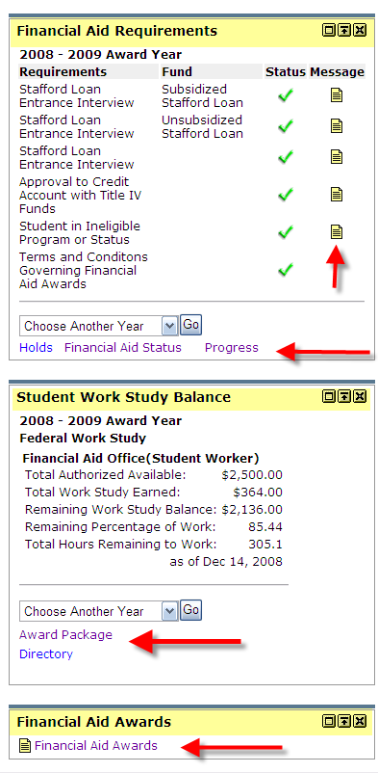
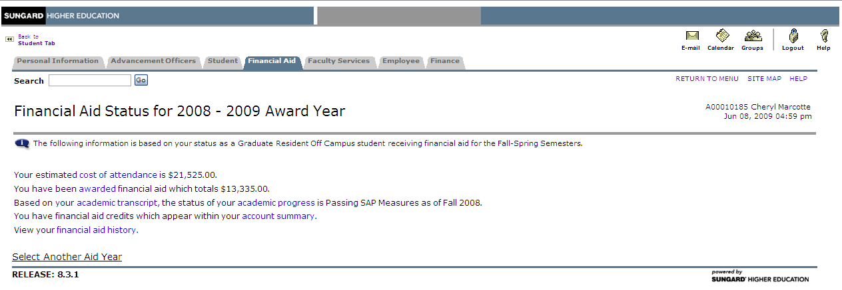

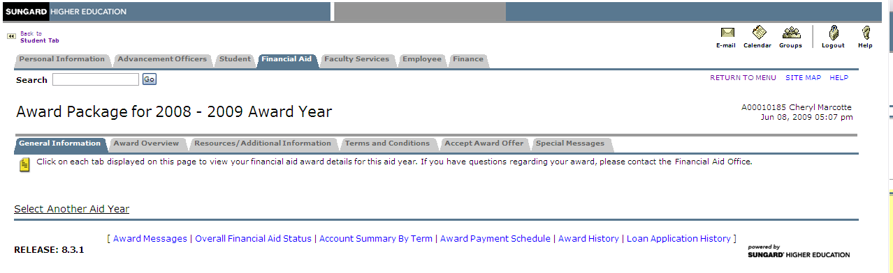

UC4 (AppWorx) | FHDA has purchased the scheduling tool but has not yet done much with implementing this for Financial Aid. We discussed that it is good for FA to be completely comfortable with a process before moving it to a scheduling tool. Most often the first process schools like to schedule will be the disbursement process including all FA, AR, and Finance processes. This will allow this process to run nightly or on any other type of schedule the institution defines.  Once FHDA is ready to begin implementing UC4 (AppWorx), it may be beneficial to post a request to BFINAID to obtain sample chains from other clients to use as a starting point.

Progress of Training | Training is on target according to the implementation plan and is going very well. FHDA is very happy with the quality of training they are receiving in the Financial Aid area.  See specifics under each module in the following report.

Progress of Build | Banner setup has begun and progressing well. Financial Aid and all other areas are building information in the TEST database. This will be good for testing interfaces and FA rules once that point in the implementation is reached.  See specifics under each module in the following report.

Record Creation/Data Load | Training has been completed and Common Matching rules have been built. FHDA should continue to run and test this process throughout their training as it is important to get these procedures down to prevent multiple PIDM issues. In addition, with FHDA having two institutions in the same database they have also been testing to verify the campus code is working correctly. At this time, there does not seem to be any issues in the Data Load process or the campus code process.

Needs Analysis | Although training has been completed and EDE files have been loaded in, FHDA has not done much testing in this area. This area has several forms with a lot of information and the only way to learn where all information is stored is to spend time viewing each form in the Needs Analysis menu. This area does not require much setup or testing, but instead requires much practice to become familiar with the information. Some clients like to develop a ‘cheat sheet’ for end users to know what each form contains. I am attaching an example this type of document. Feel free to using this information in developing your own documentation.  See Needs Analysis Training Outline in Supplemental Documents Attached section.

EDE Corrections | Training on EDE corrections has been completed. This included making correction in the Banner forms, logging the corrections, viewing corrections on REACORR and creating an extract file using REBCDxx. FHDA does not plan to utilize this functionality out of Banner at this time as they can continue their current procedures and have counselors make corrections on FAA Access.  It is recommended that FHDA consider using this functionality in the future. The main advantage to using this functionality in Banner is that your counselors can make the correction on RNANAxx, run Calculate Need and have an updated valid EFC immediately to continue processing. FA can schedule the extract process to run nightly to send off corrections via batch. In addition to the real time EFC calculation, there is no need to go into any other program to make the changes.  Here is a visual process flow document that may be useful to follow when practicing the EDE Correction process:  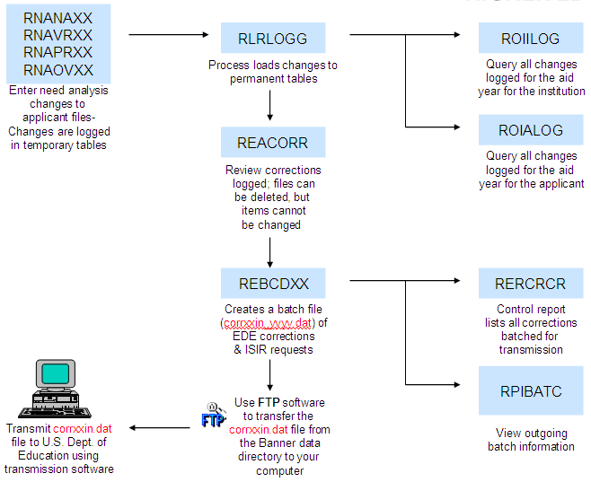

Requirements Tracking | Training went well and FHDA is pretty comfortable with this area. Most of the setup has been completed and tested but not finalized at this point. FA will continue to test and document this process.

Applicant Budgeting | Training has been completed, budget groups have been built and rules have been built. FHDA has begun testing but will need to continue to test to finalize the accuracy of the setup.

Population Selection | Population Selection training has been completed and some basic population selections have been identified and built. This will continue to be an on-going process throughout the implementation and after go-live. Kevin seems to have a good understanding of population selections and will continue to work on these as the need arises. If at some point more technical assistance is needed, FHDA will want to work with a SunGard technical consultant or internally with IT.

Letter Generation/Email Communication | Training on Letter Generation and the ROREMAL email process has been completed. FHDA plans to continue communicating to their students via email and would like to be able to communicate via Luminis as well. Further research and discussion with the Luminis Team and Consultant will be needed to determine how Luminis email and targeted messages can meet the needs of Financial Aid.  FHDA indicated that at this point they only communicate to the student one time regarding unsatisfied documents and encourage them to check the web often about additional requirements. This will be the process they plan to use at this point in Banner as well but may considered sending additional email communications as new documents are assigned or after so many days have passed. Initially I suggested they look into the sample population selection delivered as TRACK1 that looks for students who haven’t had a letter sent since a specified date. However, this selection may not work for FHDA as they plan to have a different letter code on GTVLETR for initial letters and reminder letters. I recommended that as time allows addressing this with Carol during a consulting visit.

Batch Posting | FHDA went through the training for Batch Posting for comment codes. This involves the process of setting up a population selection of who should have comment codes reviewed and indicating what comment codes should cause additional requirements to be assigned. Carol encouraged them to develop a Generic User ID for the batch posting process and the FHDA Team Leads have access to this User ID already.  There are also several other uses for Batch Posting and FHDA will most likely continue to find additional uses throughout testing and while processing in production each year. Population selections (GLRLSCT) may need to be define and rules setup (RORPOST). Great detail about the different batch posting types can be found in the Banner 8.3 FA User Guide, Chapter 2 (Processing), Common Functions section on Batch Posting (approximately pages 2-201 to 2-211).

Funds Management | FHDA just had training on Funds Management last week and is beginning to think through their fund codes. There was some concern regarding how the funds would display on Luminis and in my research at this point it appears that they would display as they do on FA Self-Service. The entire description from RFRBASE is displayed on FA Self-Service so you should not have to be worried about the length of your description.  As you set up the rules on RFRMGMT for your funds, keep in mind that there are a lot of flags that control packaging and disbursements and some of these flags interact with others. It is sometimes hard to tell what will result in setting a specific flag. This is a challenge for clients and as consultants we can explain the purpose of each field and discuss with you how you want packaging and disbursement to happen and guide you in the best setup for those procedures. Unfortunately, until you thoroughly test the packaging and disbursement process it is sometimes not known if they will produce your actual desired results.  Also refer to the Funds Management Workbook for additional information as well as the field information for RFRMGMT. This WB should have been shared during training and is also available on the Customer Support site. Funds Management can be discussed during one of the future consulting visits, if necessary.

Packaging | Financial Aid recently completed training on packaging in Banner. FHDA has not had an opportunity to work on this module yet as they are first focusing on Funds Management.

Perkins MPN | Training for Perkins MPN has been completed. At this point the FA Team indicated that they have not been utilizing the multi-year MPN for Perkins. I agree with Carol’s recommendation that moving to Banner will be a perfect time to being implementing the multi-year MPN for Perkins as Banner has the functionality built in to manage this process very well. It would benefit FHDA to plan a future consulting session with the staff involved with Perkins Loans at both institutions. I have included a document regarding the setup, processing of Perkins MPN that may be useful. Although this document also discusses conversion, no conversion of MPN’s would be necessary at FHDA since they are not multi-year. You may decide to convert these is as normal tracking requirements.  See Perkins MPN Information document in Supplemental Documents Attached section.

Disbursement | Disbursement has not been tested yet but will be in the next couple months after funds management and packaging have been completed. Accounts Receivable training on detail codes will be this week and it will be important for FA to follow-up with AR on the need for the completion of detail codes for FA disbursement testing.

Attendance
Name | E-Mail Address
Cindy Castillo | castillocindy@deanza.edu
Kevin Harral | harralkevin@foothill.edu
Cheryl Marcotte | Cheryl.Marcotte@sungardhe.com

Supplemental Documents Provided

Hours Billed
Preparation | 1 hours
Conference Call | 1 hour
Follow-Up | 2 hours
TOTAL | 4 hours

