GJAPCTL

The GJAPCTL screen is used for running reports and processes.
First Key block:
Type in the report if you know it in space after Process. If you are not sure you can click on the down arrow next to the word Process.

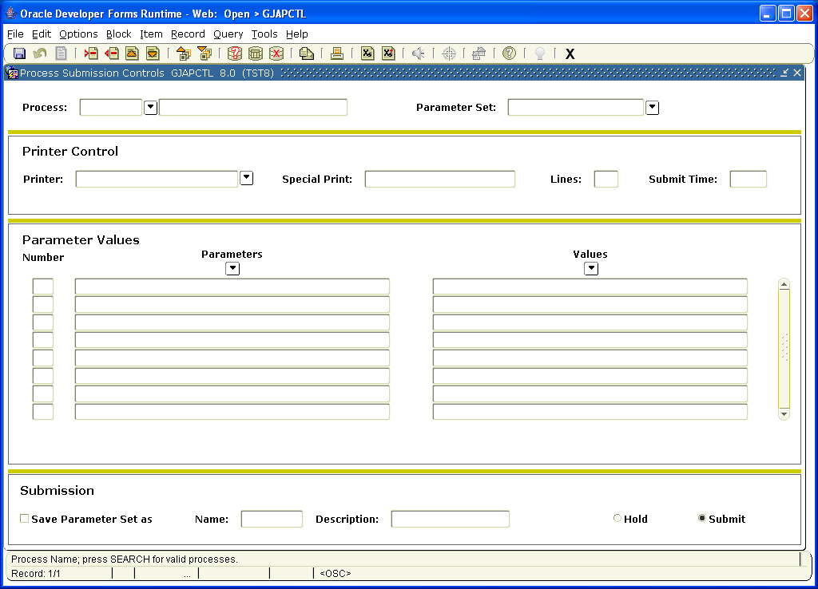

This will bring up GJAJOBS. This is a screen you can query to find all jobs. You need to narrow down the search otherwise this will bring up hundreds of jobs. To do that you would go to the Process block and type some of the letters that specify the process. In general all processes are seven letters long.

The first letter is either:
S (for Student)
T(for Accounts Receivable)

The second letter would be the following:
A (Admissions), C (Catalogue), S (Schedule), R (Recruiting), F (Registration), V (Cal-B Specific), H (Academic History)
You need to choose at least the first two letters and then use a % (as a wildcard) to access the area you are interested in to narrow down your search. For example if you are looking for registration reports you would type SF% in the space after Process. Then click on Query (at top of the page) and then choose Query Execute. The jobs would then populate and you can use the side bar to slide the page up and down to view all the jobs available. You would then double click on the job you want to bring it into GJAPCTL..
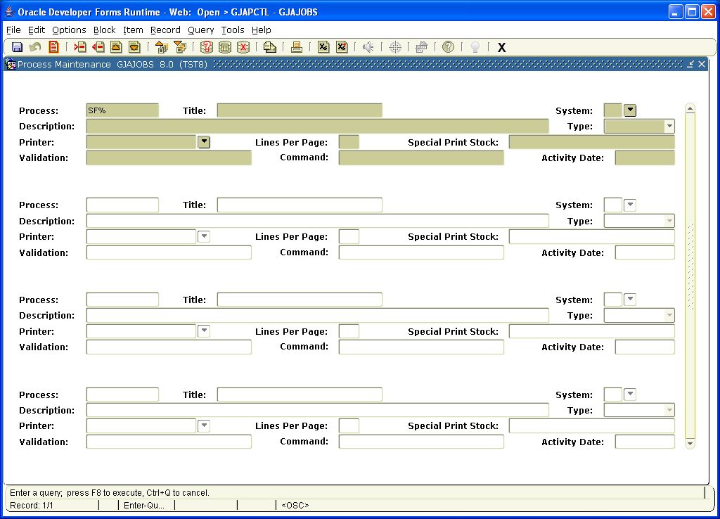

Back in GJAPCTL the job you had chosen would appear in the space after Process.
You would then click on the next block to go to the Second Block:
Second Block:
In the space after Printer you can choose the printer you want or type in Database. You would do this if you do not want a printout and wish to view the report in Banner.
Go to next block:
Third Block:
All the Parameters for the job you choose will automatically populate. You need to look at each of the values and determine what to enter. In the Parameter itself will sometimes be directions on what to choose. For example a Parameter of Report may have an R for report or U for update. This means you can run a report to view or run the report as an Update to perform the process.
As you go through each Parameter a message will appear on the bottom of the block giving you directions as to how to proceed. It will say O/R for Optional or Required. If the word required appears after this you will know you need to fill in a value for that Parameter. If if says Optional then you can leave that space blank if you wish and the job should still run.
Another message that appears is M/S. The M stands for Multiple the S stands for Single. If Multiple appears after M/S that means you can add more than one value. To do this you would go to Record (at the top of the page) click and Choose Record Insert. This will give you a blank line. You would type in the same information from the number and Parameters space that you are doing the Multiple for (which is the parameter directly above the blank line). In the values space you would type the value you want to include in the job.
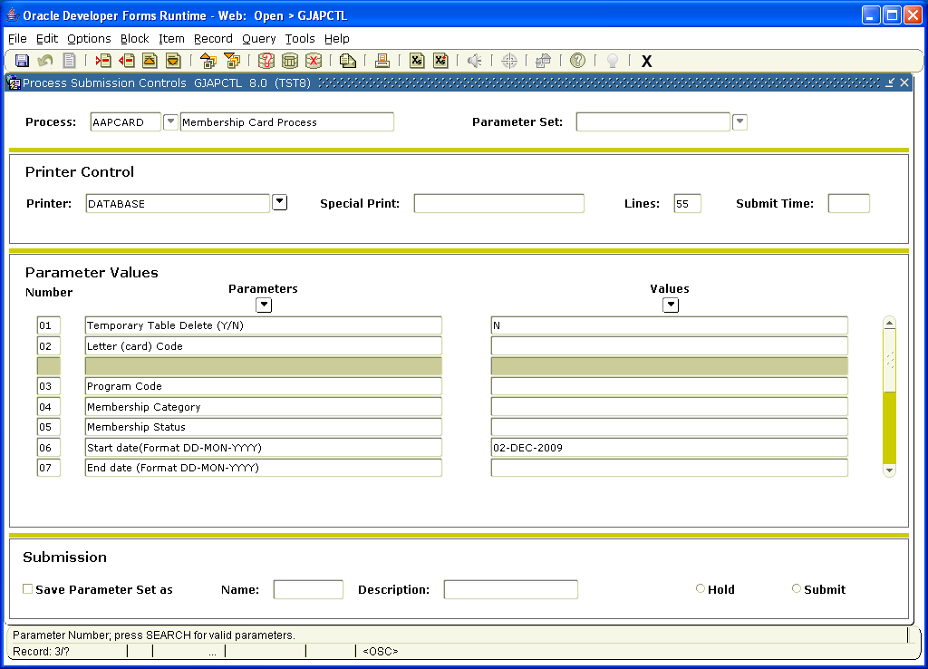

Once you have filled out all the Values you would click on next block.
Third Block:
The third block is where you would run the process or report. You can click on the Save icon (the gray disk in the upper left hand corner of the page) to run the report. If successful a message would appear on the bottom of the page. The message will be Logfile (with numbers) and List file (with numbers). If you want to save the whole report with the parameters you have chosen (some jobs have many) you can click on the box by Save Parameter Set. You also need to make a name in the space after Name and a Description in the space after Description before you save and run the job. In the future you can pull up the job with those specific parameters if you type in the Name you chose in the Parameter Set in the first block along with the process.
Once you have saved and run the job it will print if you have chosen a printer. If you used DATABASE in the printer you can view the output in banner. You would go to the top of the page to menu and click on Options. Then choose Review output.
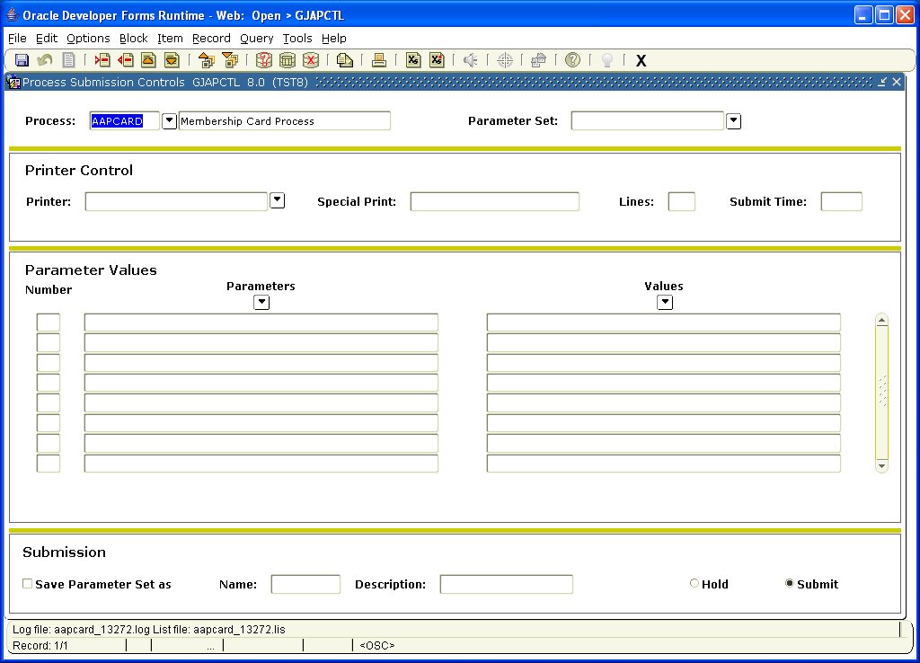

Once you have chosen Review output from the options menu the Output Review GJIREVO screen will appear. To view the report you go the space after File name and click twice. This will bring up the report. There are two files one ending in lis and one ending in log. You choose the lis to view the report. If the report was not successful you would look at the log and this should help you find out why it did not run.

