HOW TO CHECK FOR AN ACTIVE APPLICATION IN BANNER

If a student is unable to register, s/he might not have a current application or a current curriculum.

To check if a student has an active application, the quickest form is SAADCRV. Type in the student ID and term. Click your mouse in the next block and the form should populate.

In the Decision Data block at the bottom of the page, it should have a decision code and other information. The first example is for an application that came through CCCApply. You can also see on the form what student type the student has. For example, the student below is a HS student, which is designated under Admission Type and Student Type in the first block.

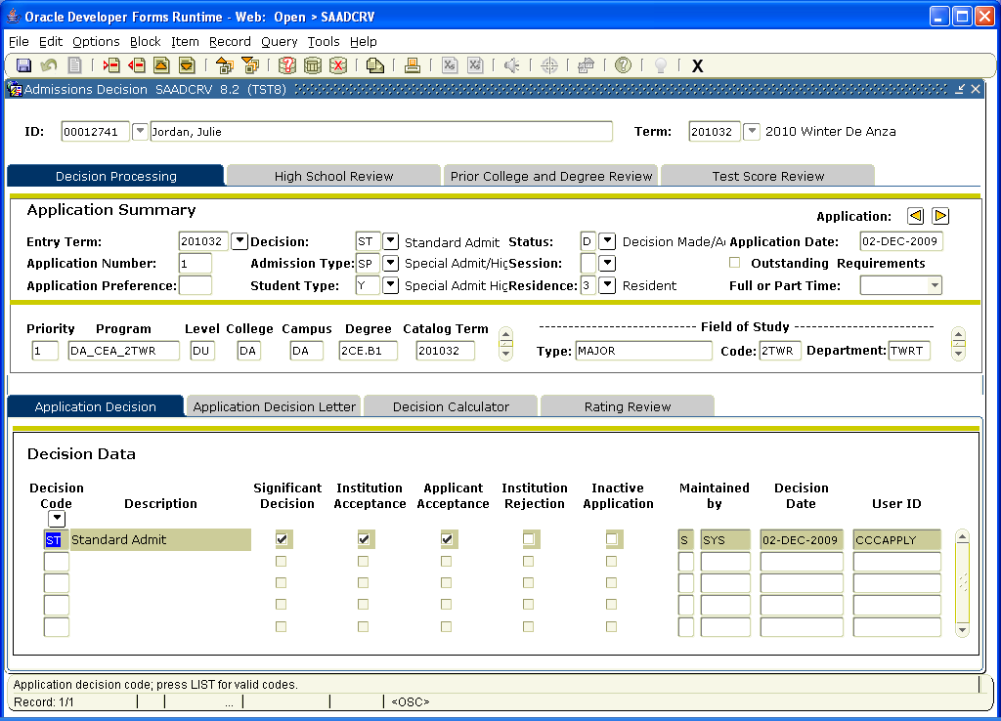

The next example is for an admissions application that was processed in person (via paper app). International, noncredit and other programs will still be using some paper apps.
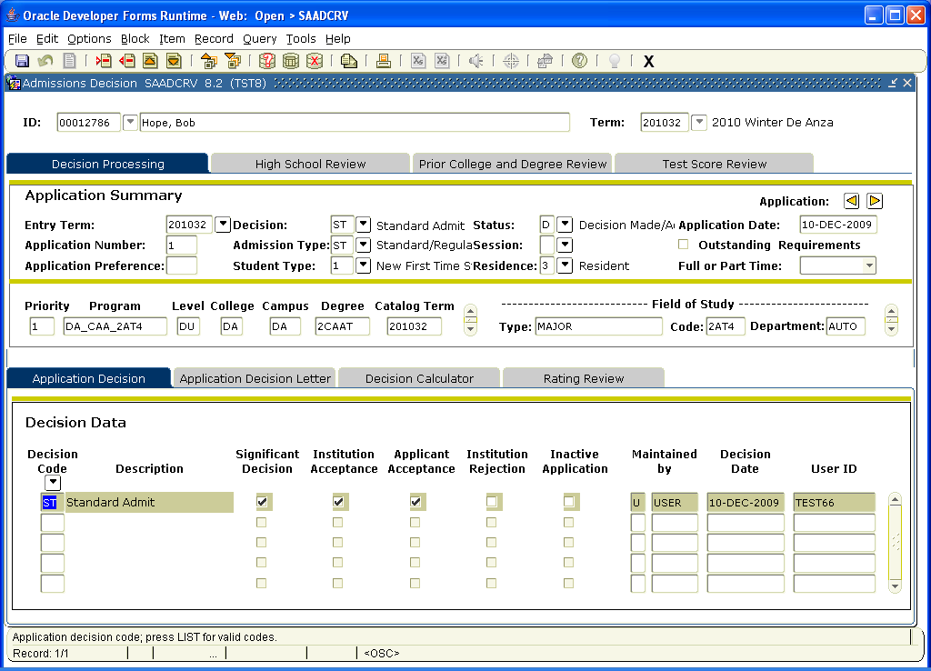

If the student does not have any Decision data, then s/he will not be able to register because s/he is not officially a student yet.

To add the decision information, review the information in the second block and add the appropriate Decision Code and save. If Banner will not allow you to save the form, there is likely registration or curriculum problems that need to be reviewed.

