HOW TO CREATE A REG OVERRIDE IN BANNER- set up details included.

1. Make sure that the type of override code exists in STVROVR.

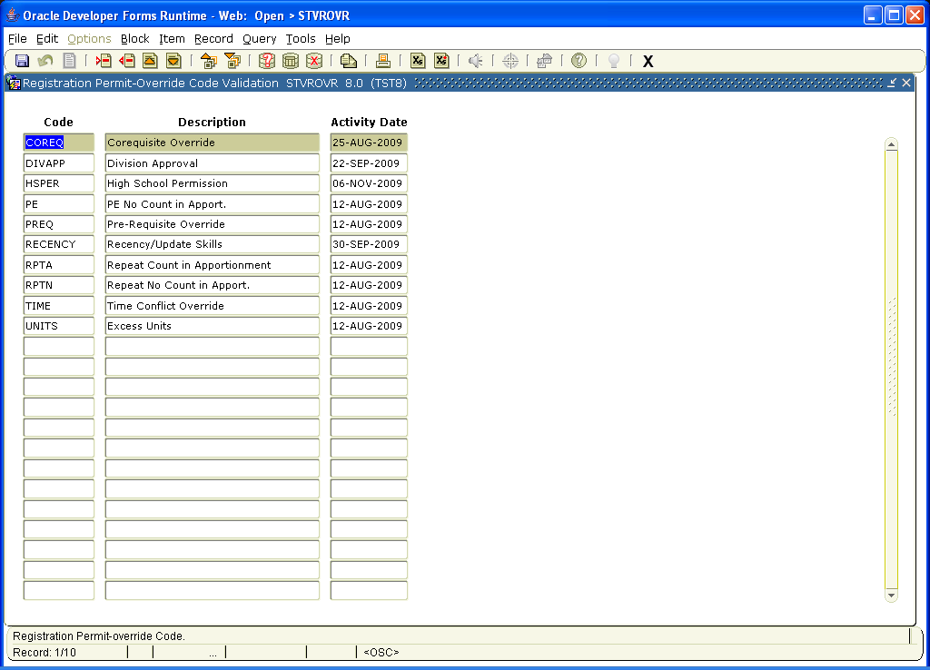

2. Make sure that this code and other override codes are active for the quarter on SFAROVR. If 1 or 2 are not correct, notify your Admissions Office.

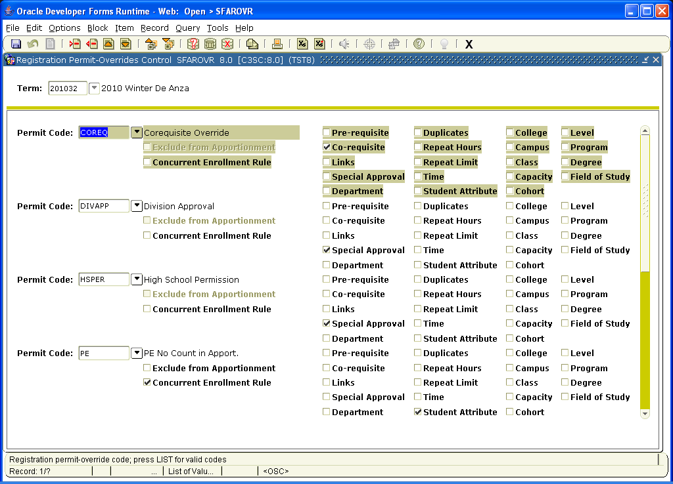

3. Go to SFARSPO and enter the CWID or student’s name.

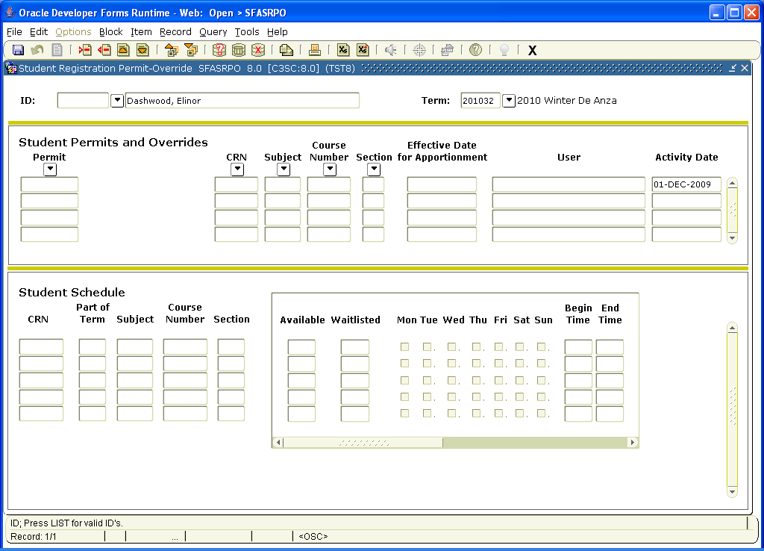

If you do not have the CWID, you will need to do a person search.
Click on the down arrow next to the ID field. It will take you to the query form (below). Enter the Last name/First name and hit the Execute Query button (between the ? and the X in the middle toolbar). This will find the CWID.
Double click on the ID number and you will return to the first screen.
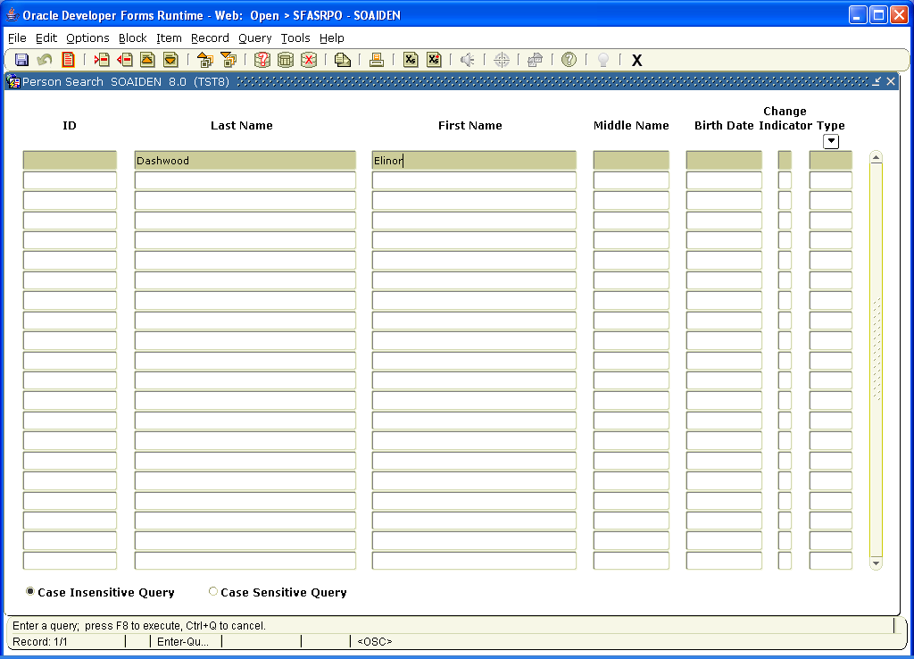

Enter the correct term. 201032 in example = year 09-10; term =3 or winter; 2 = college or DA. 201031 = same year and term, but for FH.

4. Click on the second block under the Permit arrow. Choose the correct override code from the drop down arrow. Enter the CRN for the specific course/section for which you are permitting the override, or enter the Subject and Course Number if the student may enroll in any section of that course. (Use the drop down to search all courses if you do not know the appropriate codes. Make sure you choose the correct college: D=DA and F=FH at the beginning of the Course Number). Save.

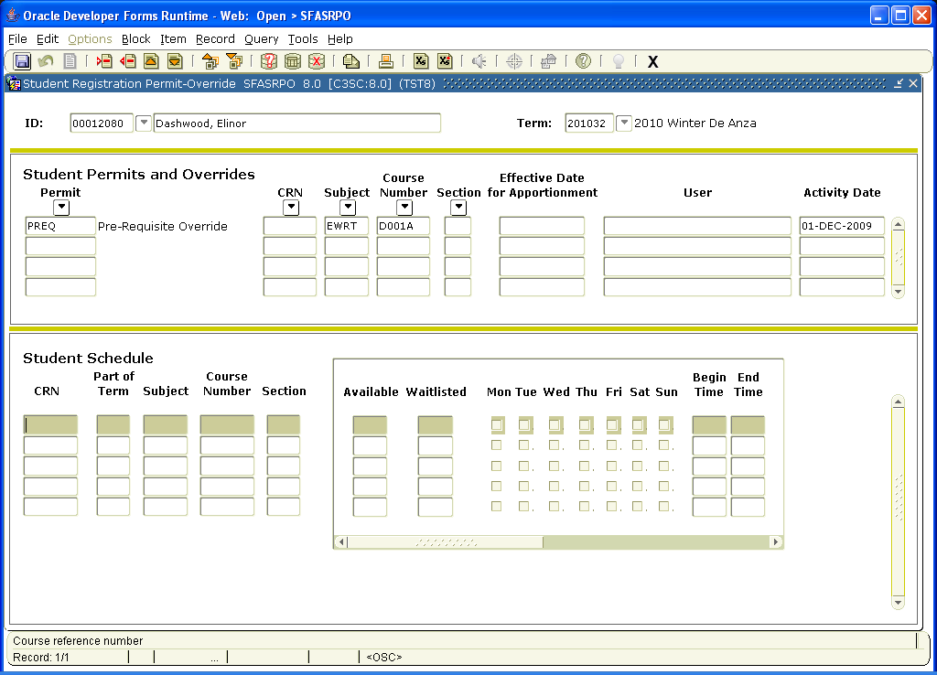

You do not need to register the student in any course in the next block (Student Schedule).

5. Go to SGASTDN and enter the CWID. Click in the next block area under new term. When the fields have populated, tab over to the Comments screen.

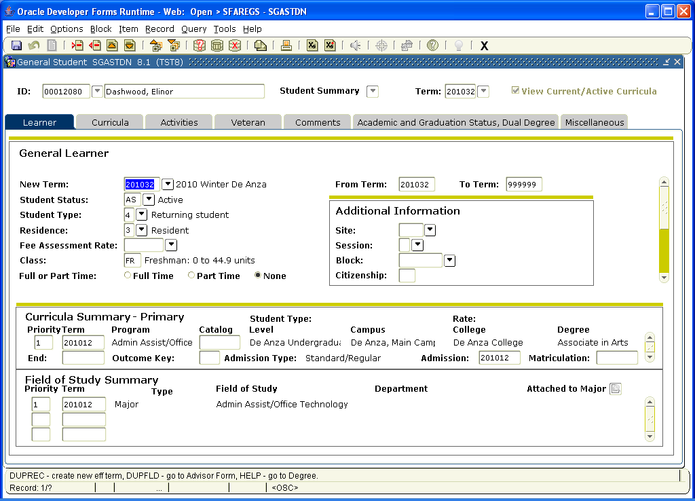

6. In the Comments form, go to the next open line and add a comment about the prereq override you entered and Save.
