HOW TO GIVE HS PERMISSION TO ENROLL

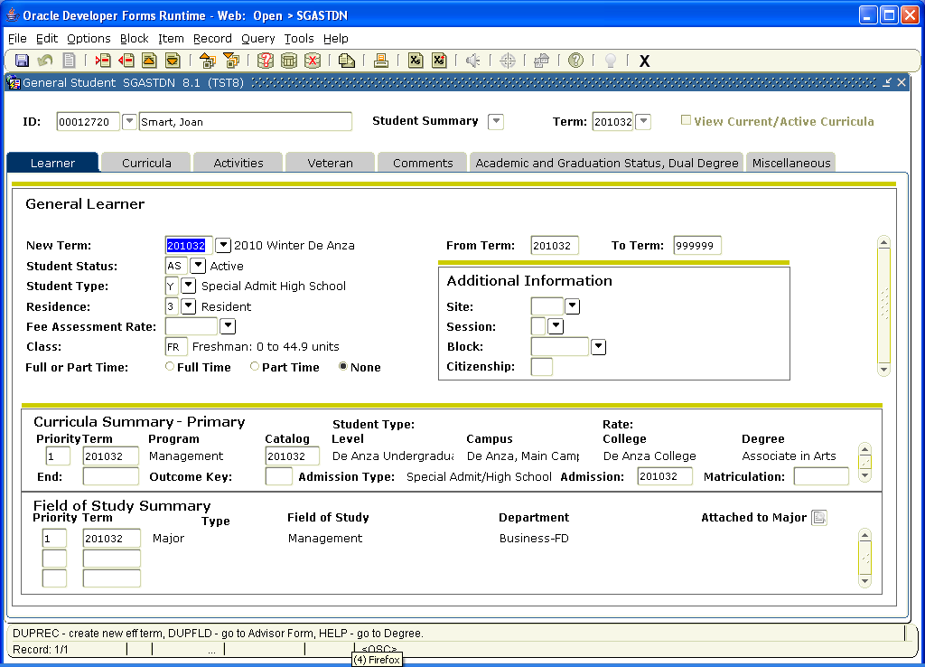
If you have received a high school permission form, go to SGASTDN to make sure the student has a current application. Make sure that the Student Type is Y for Special Admit High School.

Then Go to the Comments Tab and enter the term and the note Special Admit Permission Reviewed. Save and Exit.
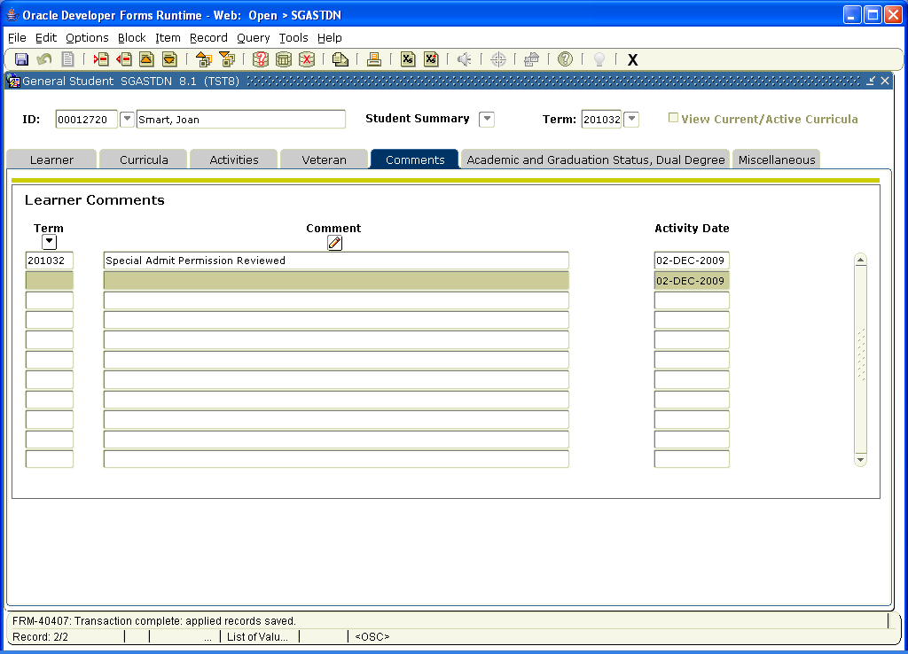

Then go to the HOLD screen SOAHOLD. The student should have a HOLD placed automatically when they apply via CCCApply. Click the Release Indicator so the student will be able to register. Save and Exit.
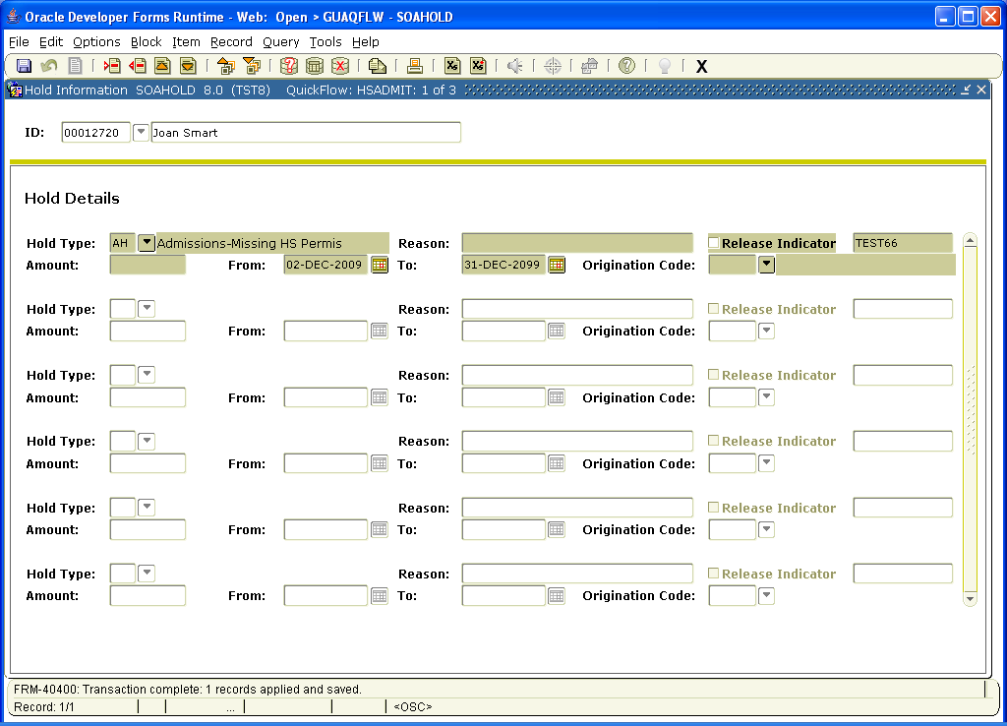

Go to SGASADD and in the second block, add the Student Attribute SPHS to identify the student as a HS student. Save and Exit.

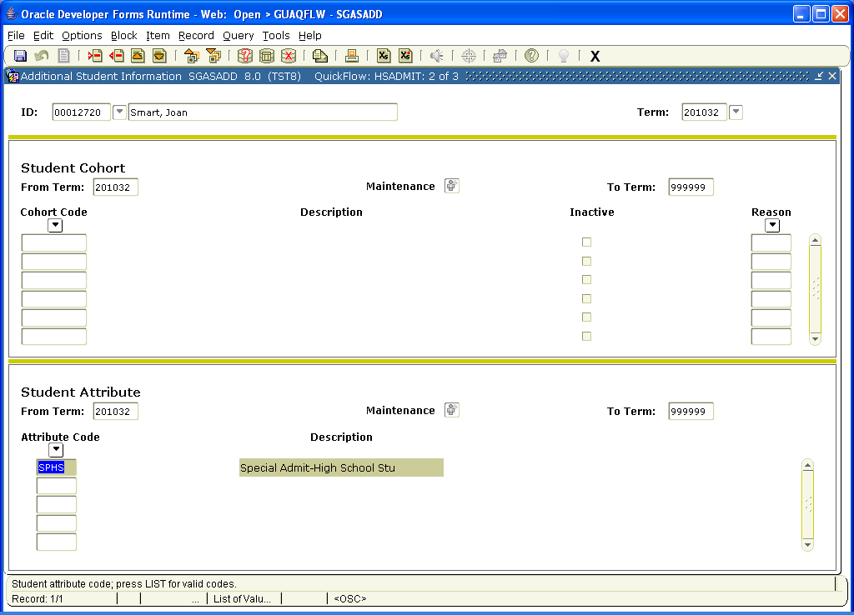

Then go to SFASRPO to include the courses that have been approved on the High School permission form. Remember NO ESL, 200 level or courses without prereq will be approved.

Enter the HSPER code in the Permit Block, and then enter the SUBJ and Course number in the fields If you do not know the Banner code, use the drop down menu for all subjects and course numbers. Be sure to choose the right college. Save and Exit.

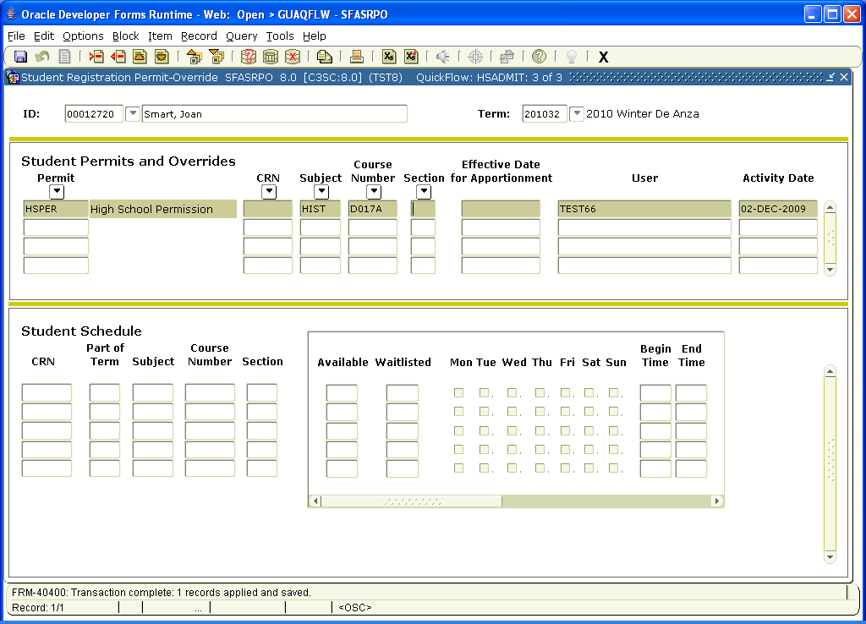

Students will need to have their individual approved courses approved like this every term. All other classes will be blocked to them.

