CHANGING RESIDENCY IN BANNER

To change residency in Banner you would go to one of two screens.

If the student has not registered for classes you would go to SGASTDN.

First Block
1.Type in the student ID or name.
1.Type in the term

Second Block
- Go to the Residence and choose the correct status by click on the down arrow.
- Go to the save icon (gray disk icon in the upper left hand side of the screen).
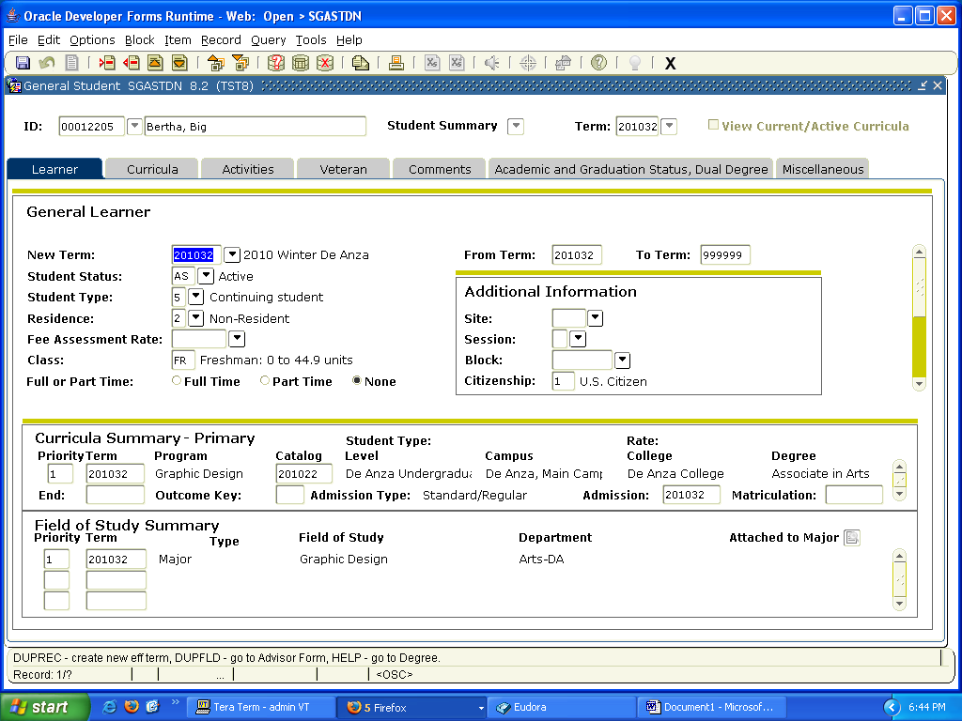

If the student has already registered for classes you would go to SFAREGS

First Block
- Type in the student ID or name.

Second Block
- You would just go to next block to enter the second block. Then you would click on “Student Term” which is the second gray tab directly above the words Enrollment Information. This will bring up the Student Term screen.
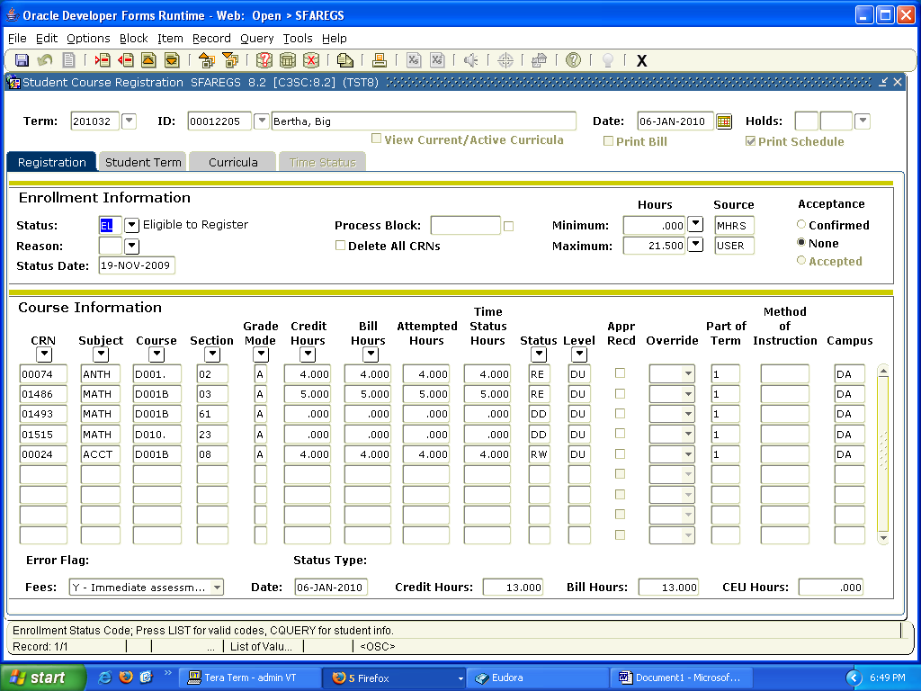

In the Student Term screen
- Click on the down arrow in the Residence Box and choose the appropriate status.
- Save the change by clicking on the save icon (the gray disk icon in the upper left hand side of the screen).
- Click on the large black X in the upper right hand side of the screen to exit the screen and go back to the Registration screen on SFAREGS.
- Once back in SFAREGS click on the Save Icon twice to calculate the fees.
