Notes from Banner Registration Training Aug 11-13

The workbook for this session can be found at http://fhdafiles.fhda.edu/downloads/eis/STRegistration81WB.pdf. If you can’t access it that way, it can also be found through http://www.fhda.edu/eis/student and choosing which workbook you would like to review.

GUAUPRF is the general set up link. If you want the 7-digit forms name box on your page, this needs to be checked on the set up.

Some programs are still going to want to use paper applications and not CCCApply when we go live with Banner. They may also want to develop a self-service app (Noncredit, for example). Charlie McKellar will check with other Banner colleges to get samples of paper apps they may already use.

We also asked if any colleges used a paper app they Scantronned into Banner. Dottie was not aware of this. USF has an app they have created an interface for, according to another Banner consultant.

Admissions training will need to be scheduled for all staff who will be processing paper applications in Banner.

SGASTDN- general student screen. (Banner calls students “learners”)

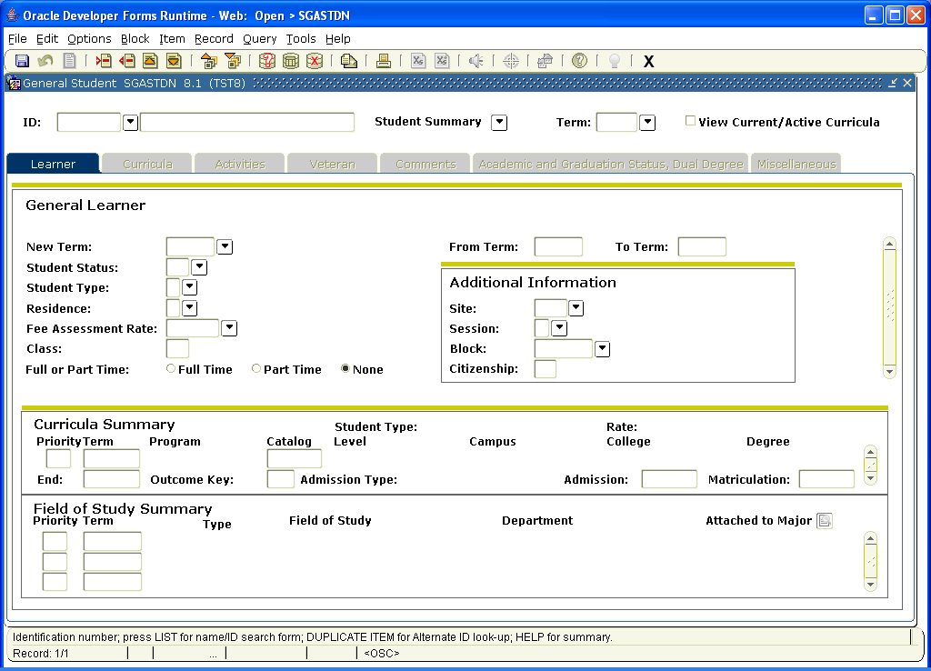
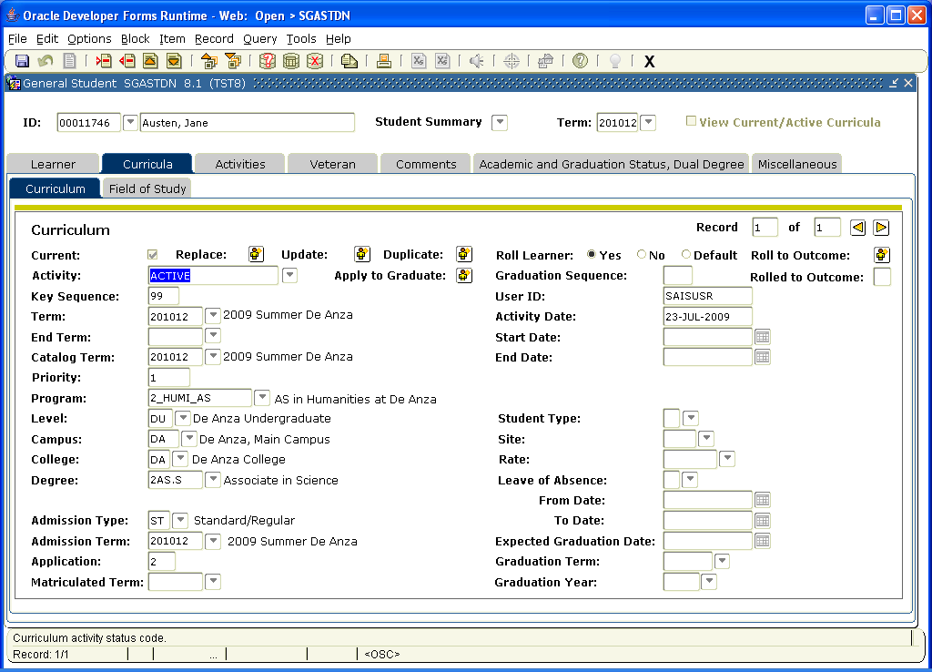
This is where Curriculum info is collected and where majors are changed, etc.

Certain Activities that students may be involved in can also be captured here, but Dottie suggested there may be a better way in the “committee forms” located elsewhere in Banner. Veterans and comments are also listed here on different tabs

Graduation status is another tab on this form. We can assign an anticipated grad date for all applicants or not; if we do, we need to decide what our general time line would be -- 2 years, or more??

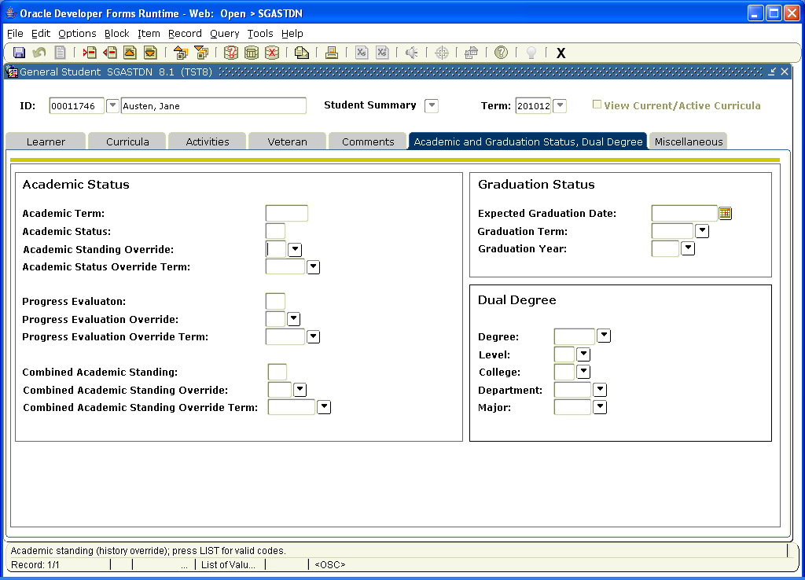

Other miscellaneous info is also collected on this form, including apprenticeship, vocational, basic skills, and other data.
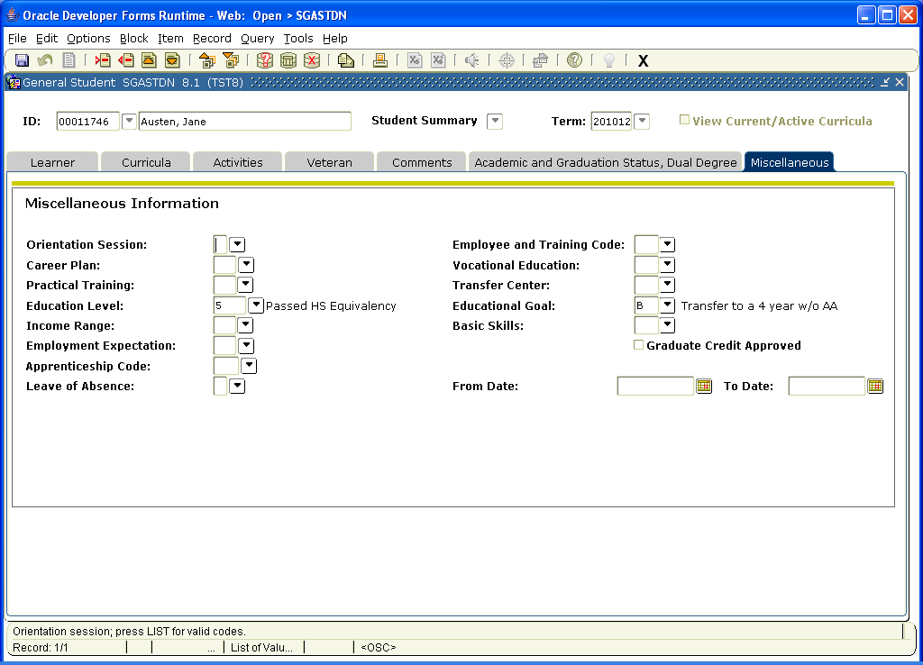

Course registration and refund dates need to be built in SFARSTS. Nancy Chao and Shawna Aced will be creating these. Target is early Sept after the detail codes have been created.

Validation tables for Apprenticeship (STVAPRN), Vocational Ed (STVVOED) and Transfer (STVTRCN) need to be created. We are asking Lourdes to do the first review.

General changes to the student record occur on SGASTDQ, the student summary form.

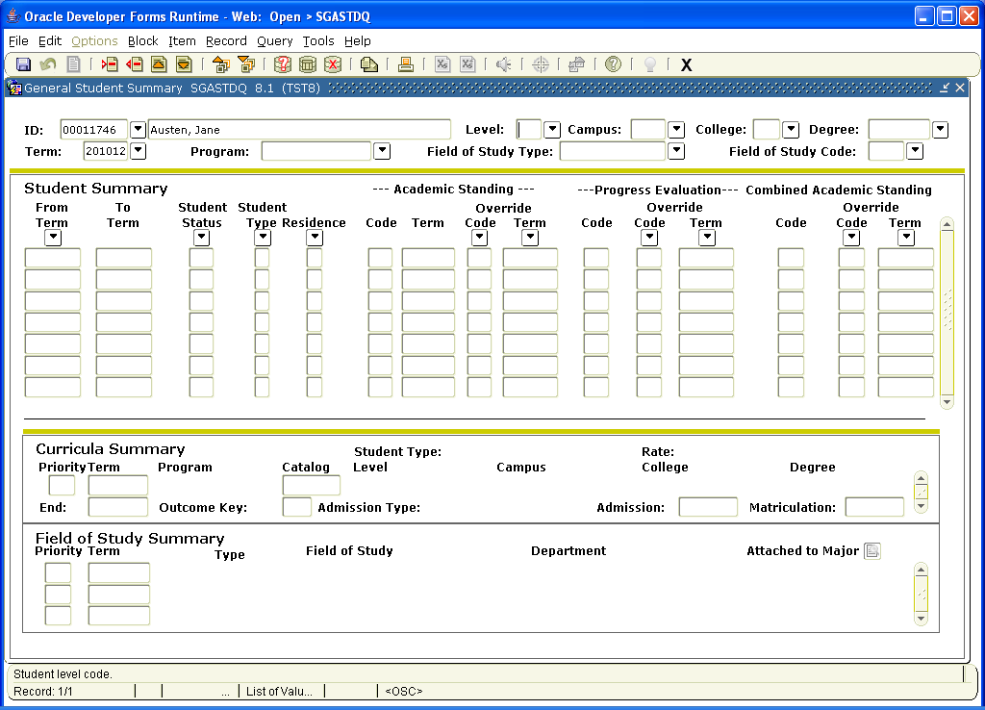

Specific counselors assigned to specific students, such as in EOPS, can be listed on SGAADVR.

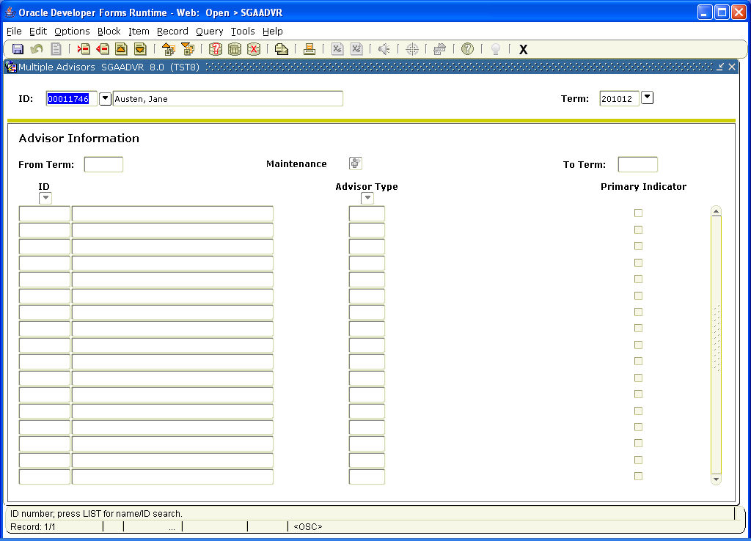

COOP: Forms are SGACOOP and STVEMPL.

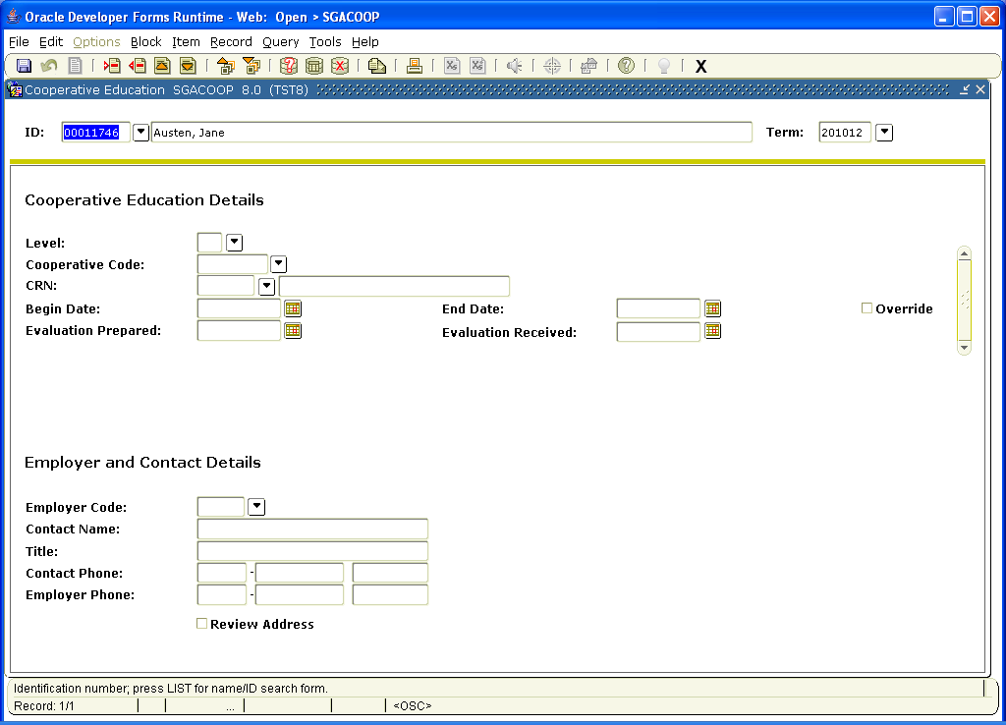

Employers who COOP works with can be added to STVEMPL.

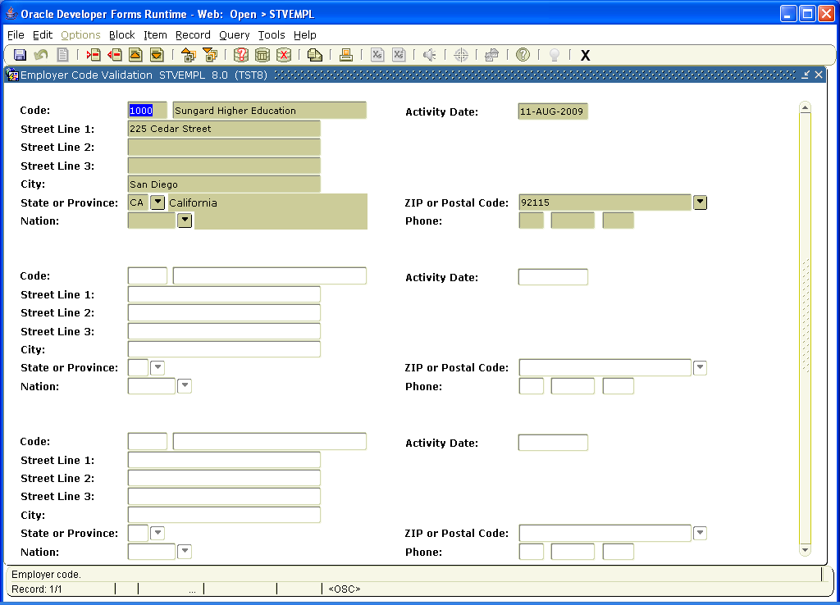

EOPS forms:

SGAEOPS
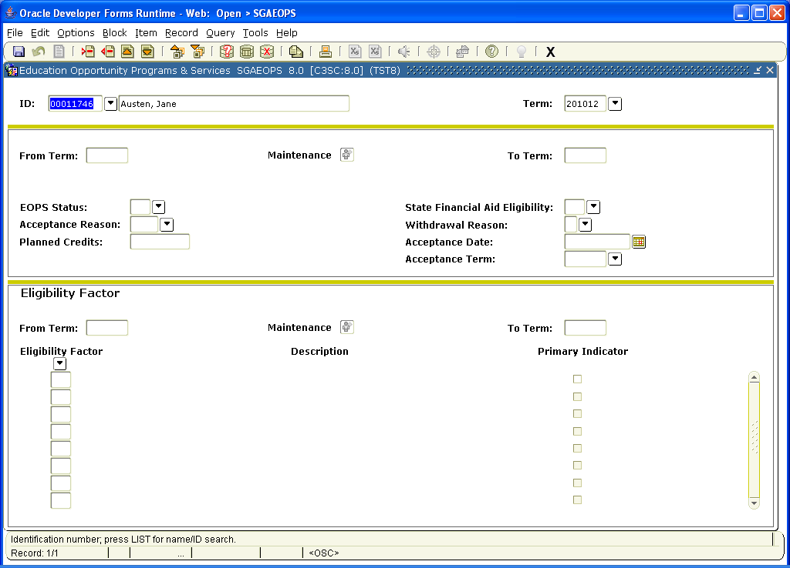

Athletics eligibility is tracked on SGASPRT. There are several tabs on this form.

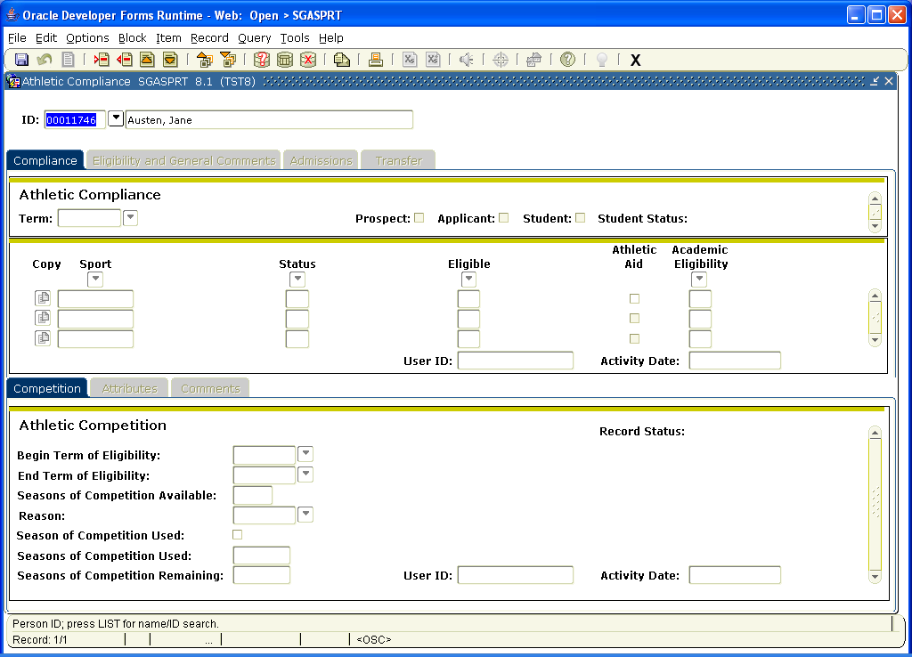

There is a comments screen:

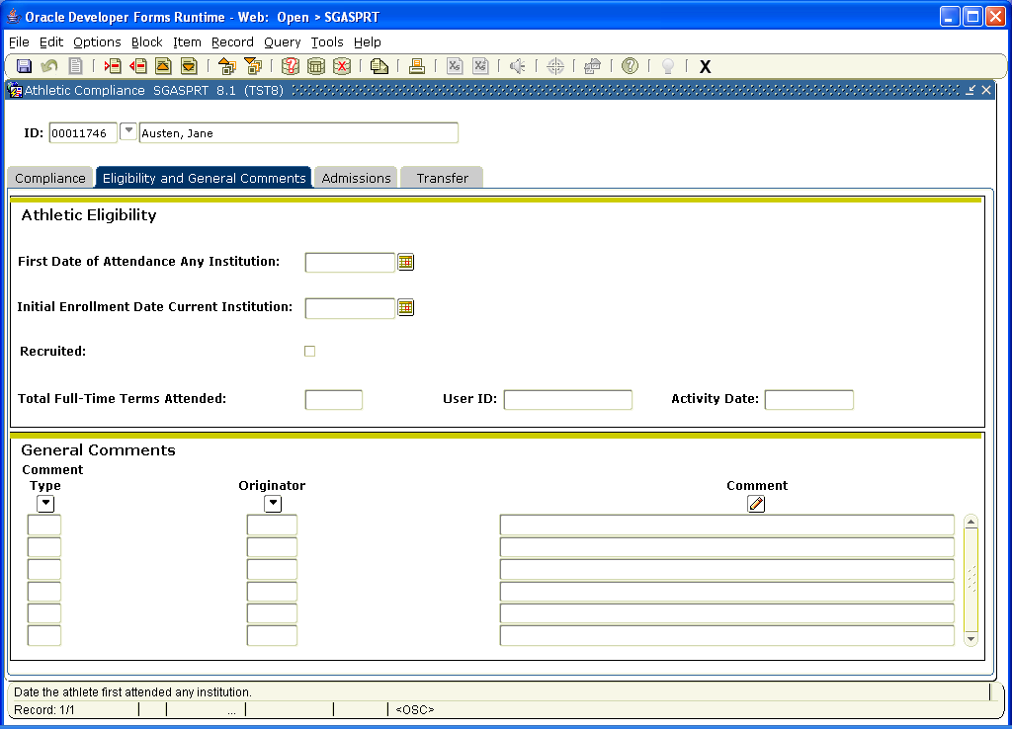

Admissions info is also summarized here:

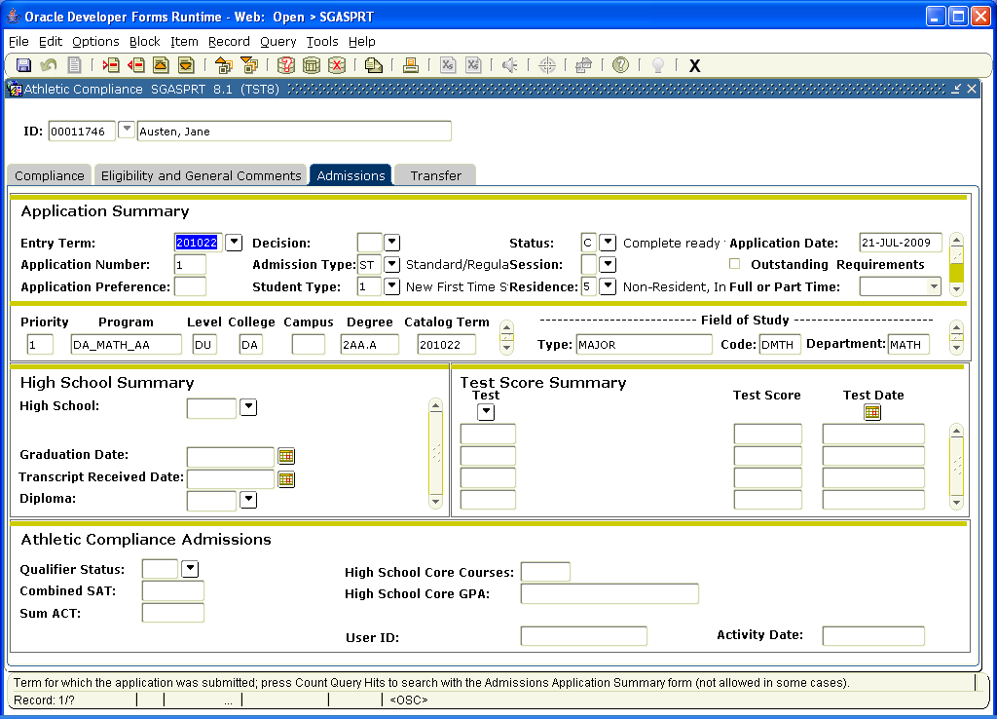

\

Transfer credit info is also collected here:

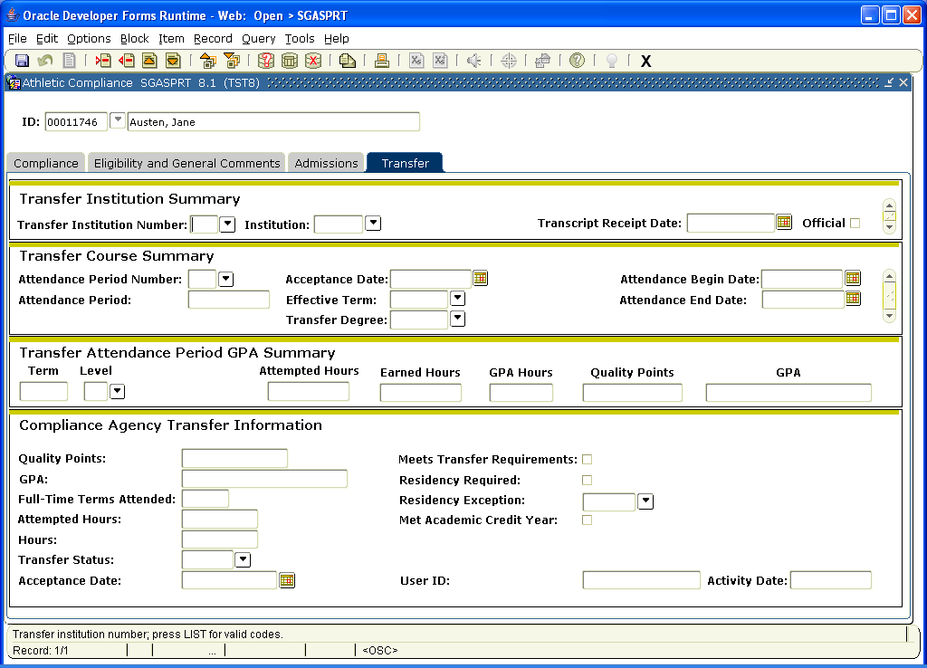

SGASADD -is the form where programs will add students who are part of a cohort or have certain attributes. This would be for Puente, Honors, FYE, etc. Departments will have to decide who will do this data entry.

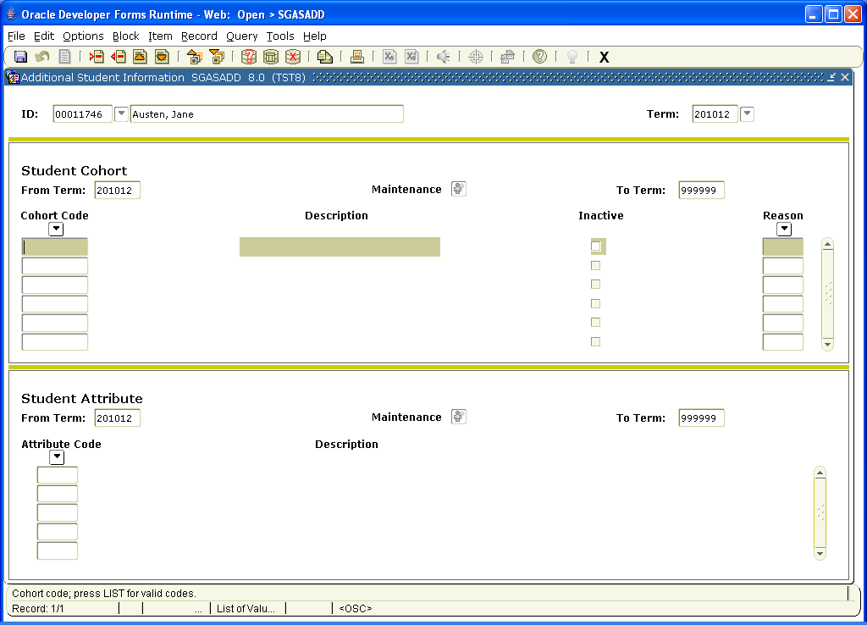

VTEA - STVSUDA-STVSUDAH

We have asked Lourdes to review these.

CalWorks:

There are many forms in Banner for CalWorks.

The validation tables are complete. Lourdes needs to review. (SVVSMSV, SVVELST, SVVOTHS, SVVSCST, SVVSFST, SVVSWAS)

SVACWSD

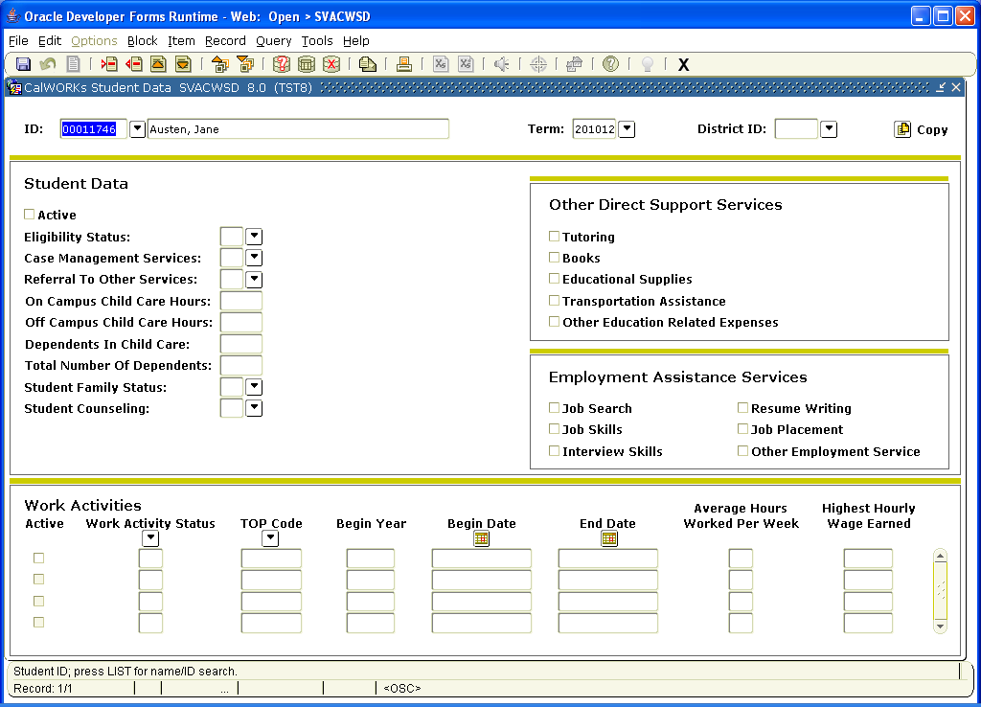

SOATERM - This is the HUGE form for registration set up and other reg-related functions.

There are many different forms that are not already tabbed, so you have to go to Options at the top of the form to access the other choices.

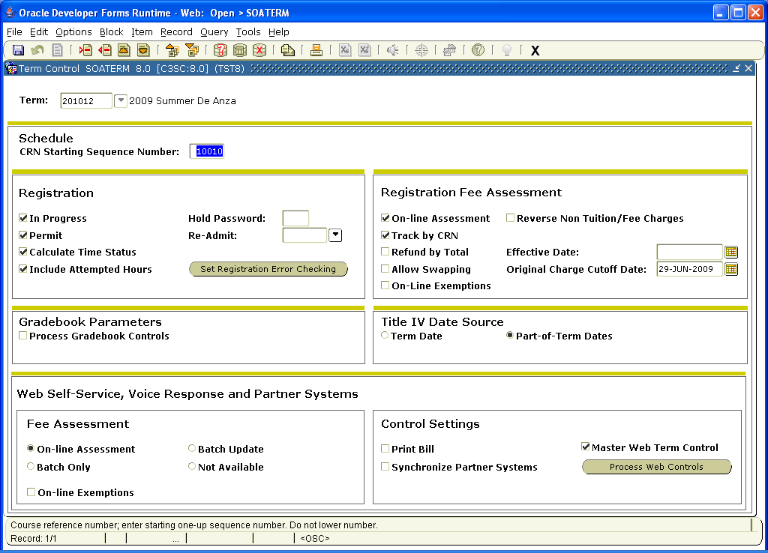

“In progress” checked = OK to register for classes where student is currently enrolled in prereq.
“Permit” checked = registration is OK
“Calculate time status” = used in National Student Clearinghouse reporting
“Inc Attempted Hours” = using these units as totals for registration unit loads
“Hold password” = ability to override
“Re-Admit” = last term they need to be enrolled in to be considered continuing

Registration Error Checking shows the different ways Banner searches for problems:

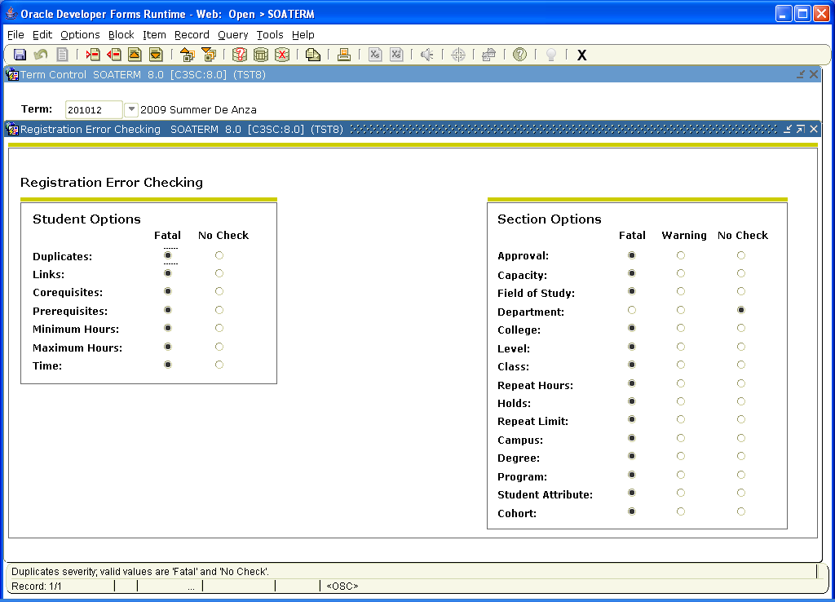

Web Processing Controls show the set up for the self-service:

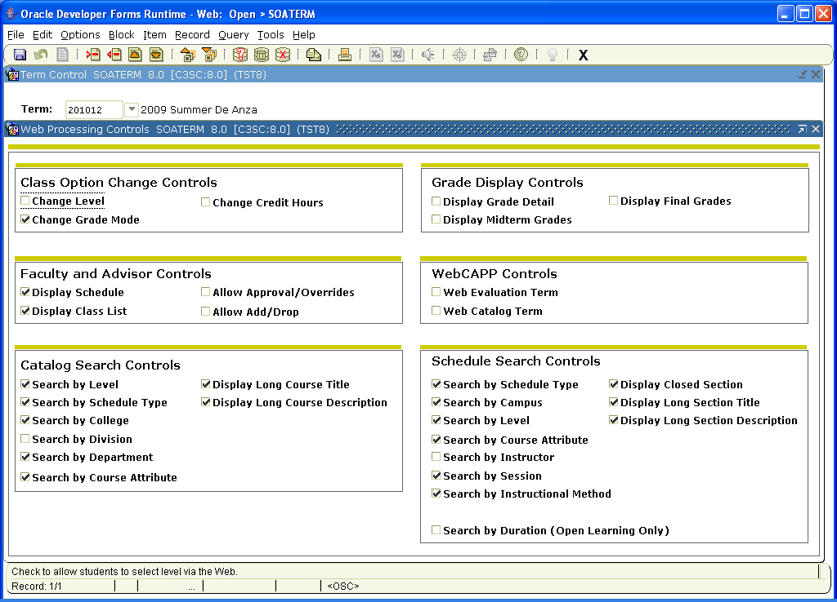

Registration processing controls:

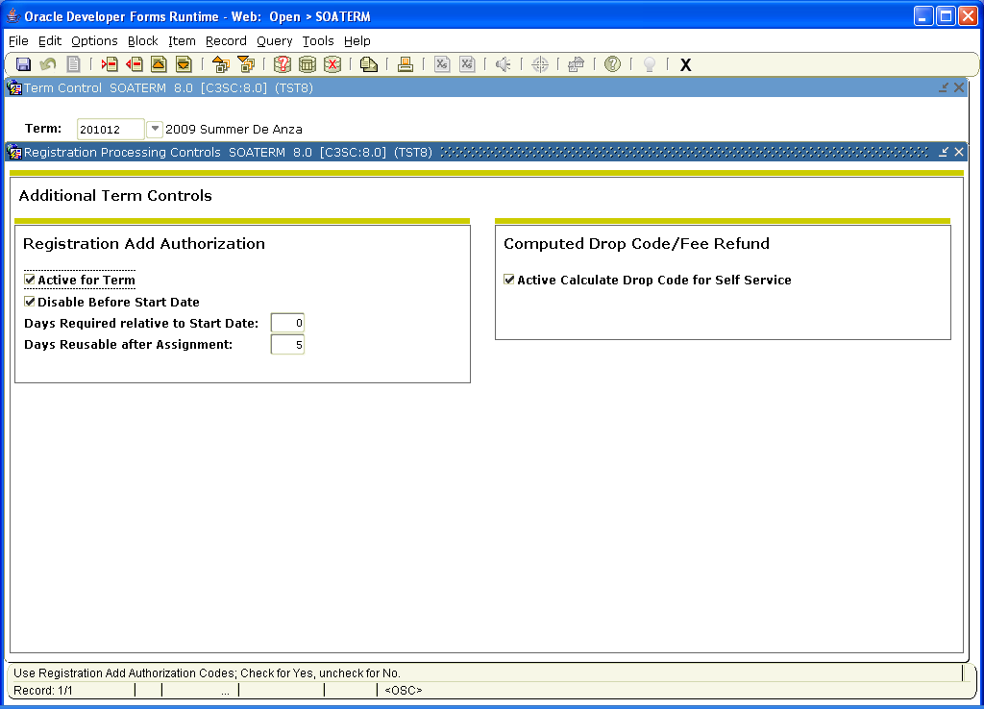

SFAREGS is the form that collects the student’s registration information. It shows whether the student is eligible to register, how many units s/he is approved to take, holds status, etc.

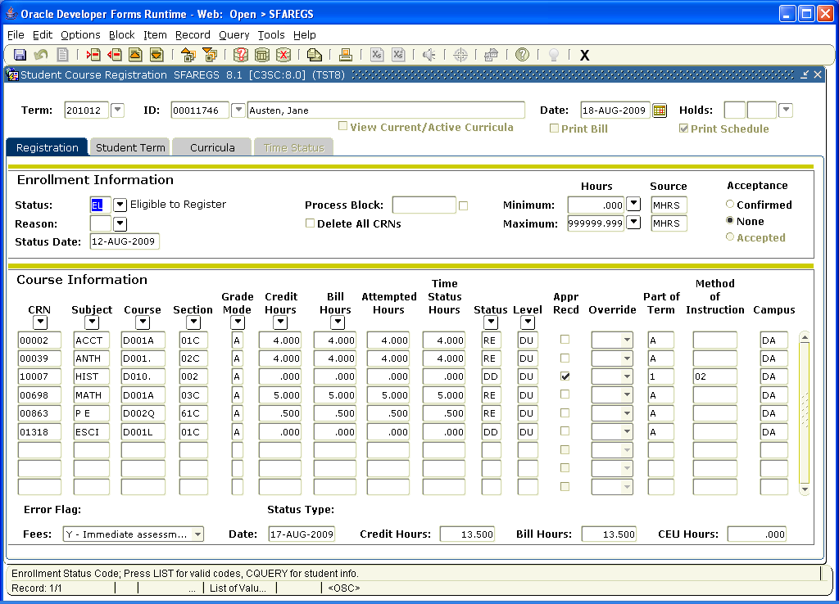

Accounts Receivable Term Control:

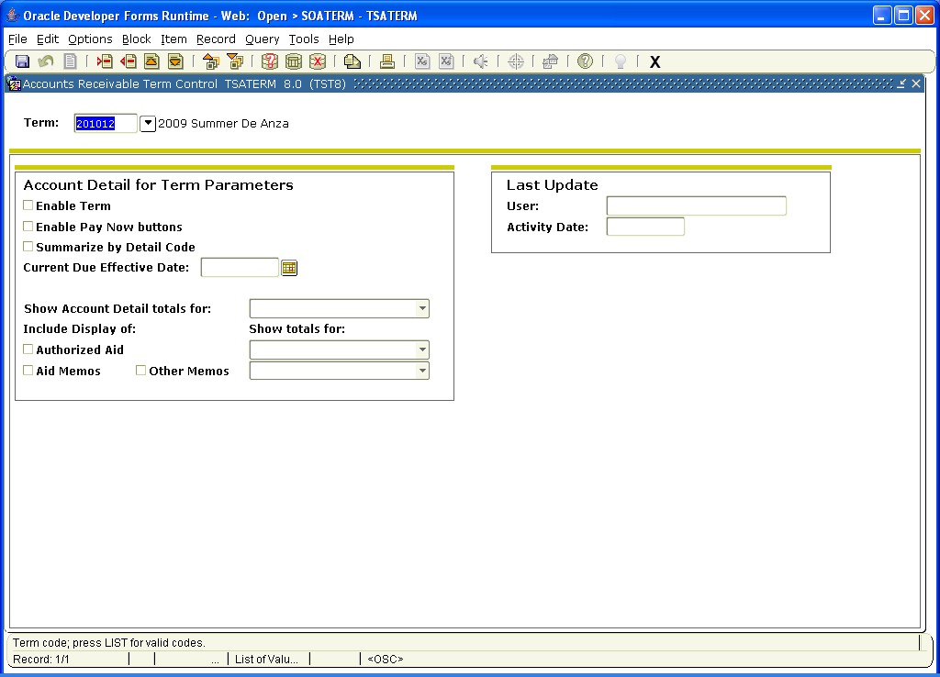

SFAESTS: Enrollment status Control Forms - in person reg dates, etc. The registration portion will be completed by Admissions registration staff and the refund portion by Cashiering.

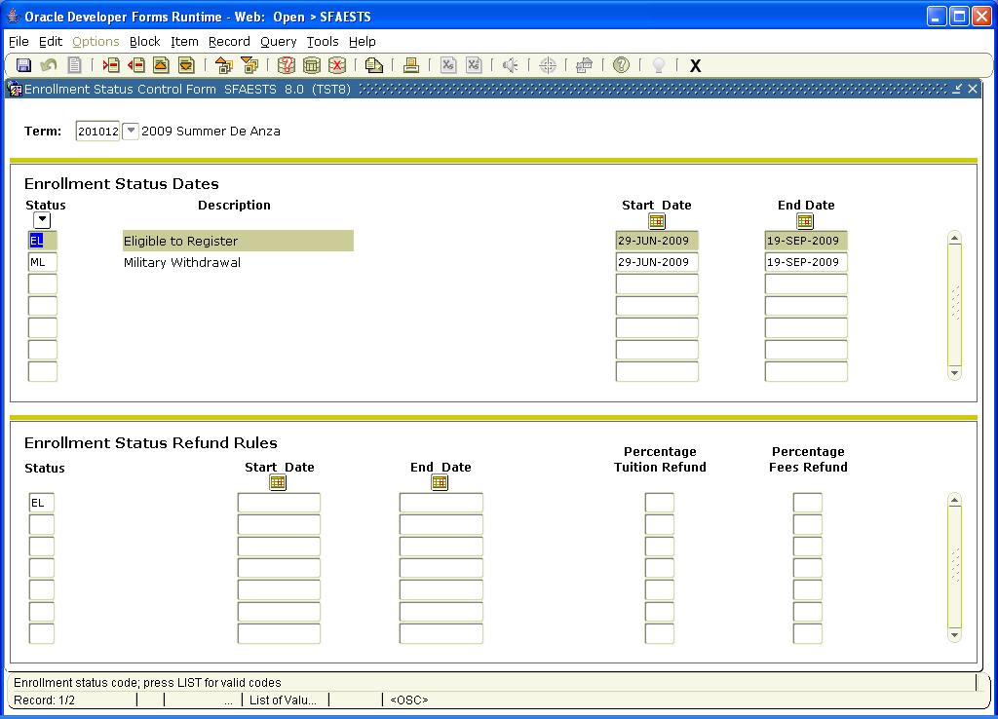

SFARSTS- Course Registration Status Form:

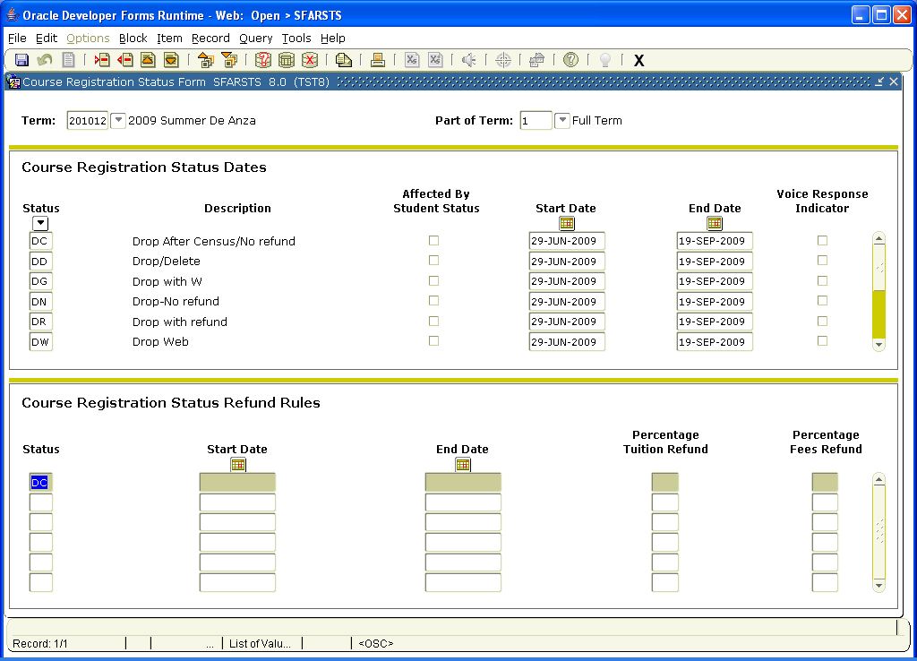

This form must be built for reg dates for each term and part of term. The registration portion will be built by the Schedule/Admissions staff and the Refund Rules by Cashiering.

SSAACCL- The general calendar form. You can run a query by section using the call number (CRN).

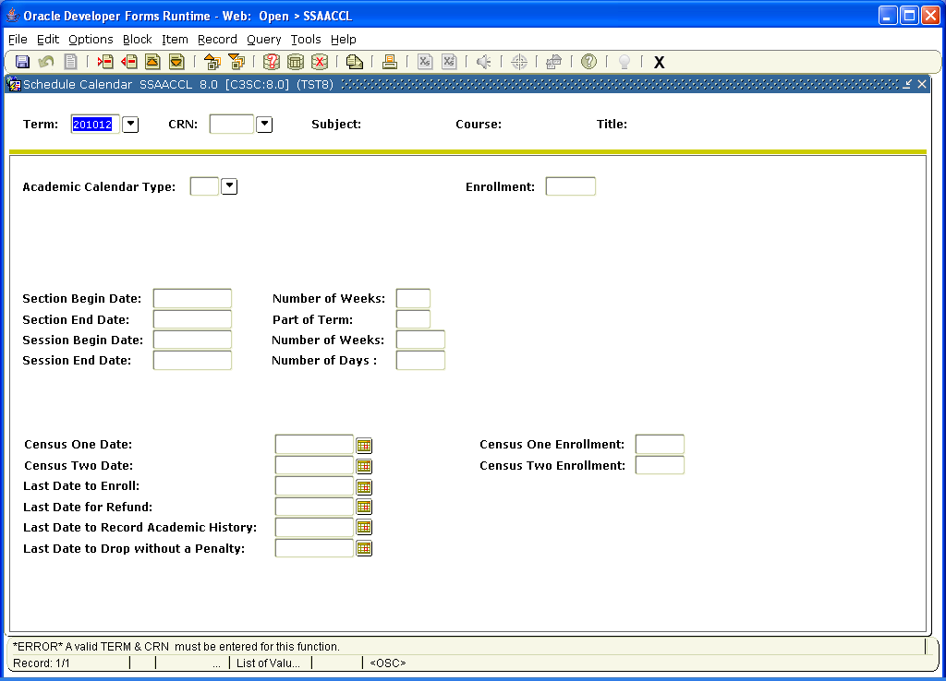

Registration error checks look for duplicate enrollment, linked courses, co-reqs, prereqs, min/max hours, and time conflicts.

We would also like to set up registration restrictions at the section level for 200 level courses prohibiting high school students from enrolling in these courses per Title V. We are requesting the Scheduling offices to complete this task.

TSATERM- Accounts Receivable

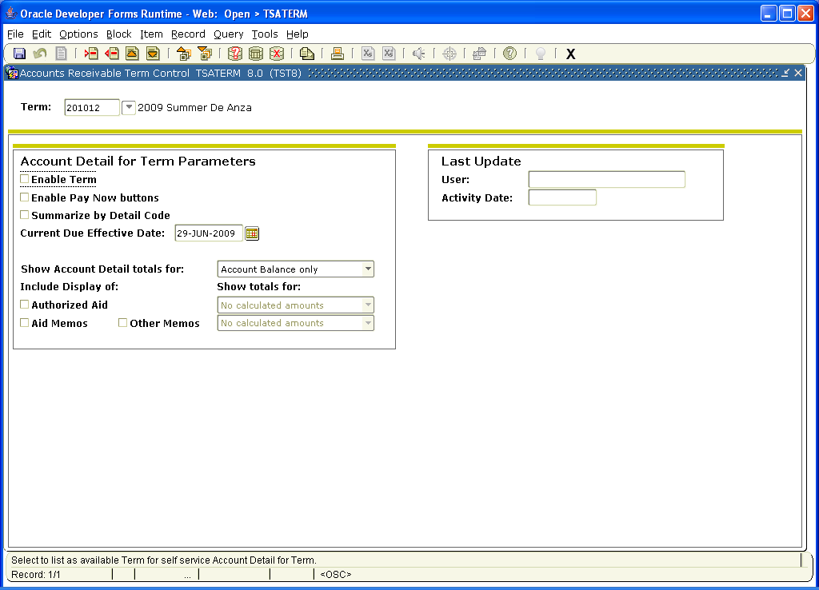

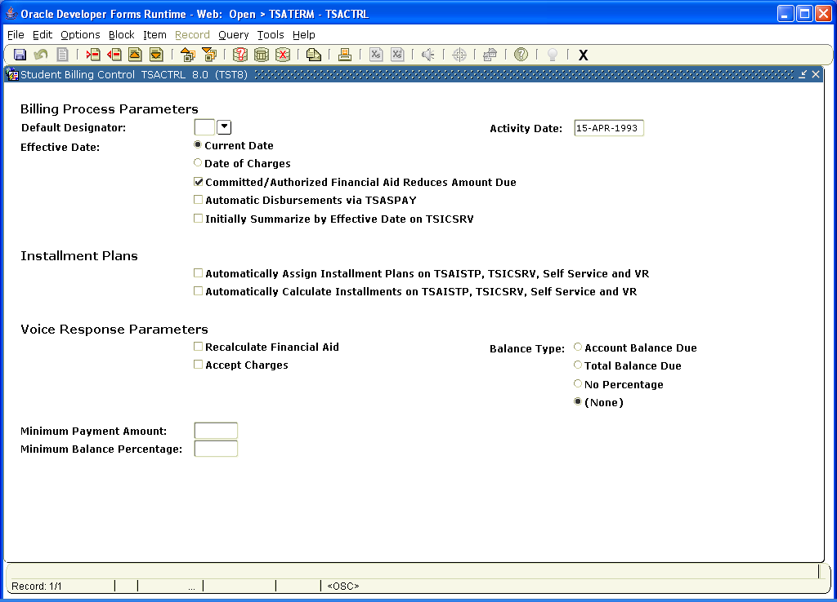

Base parts of term show the calendar dates for the term sessions and registration dates.

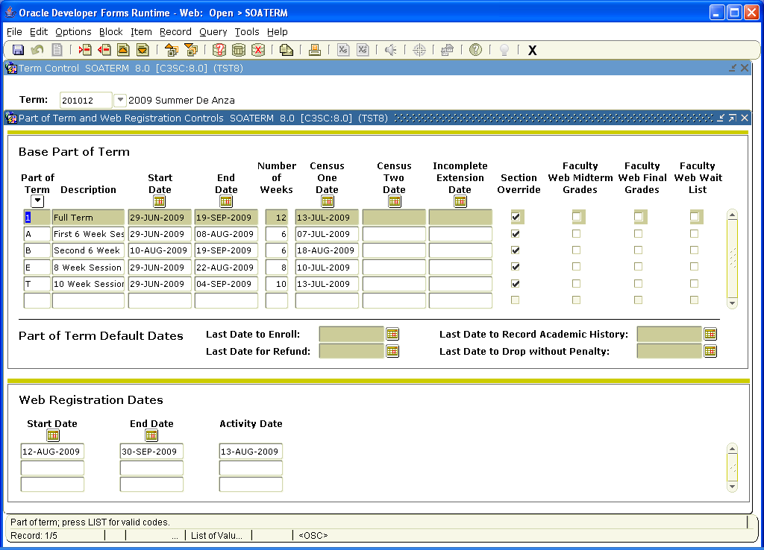

SFAMHRS - Registration min/max hours by student type/cohort/attribute

This has been partially built and is awaiting more info from different groups.

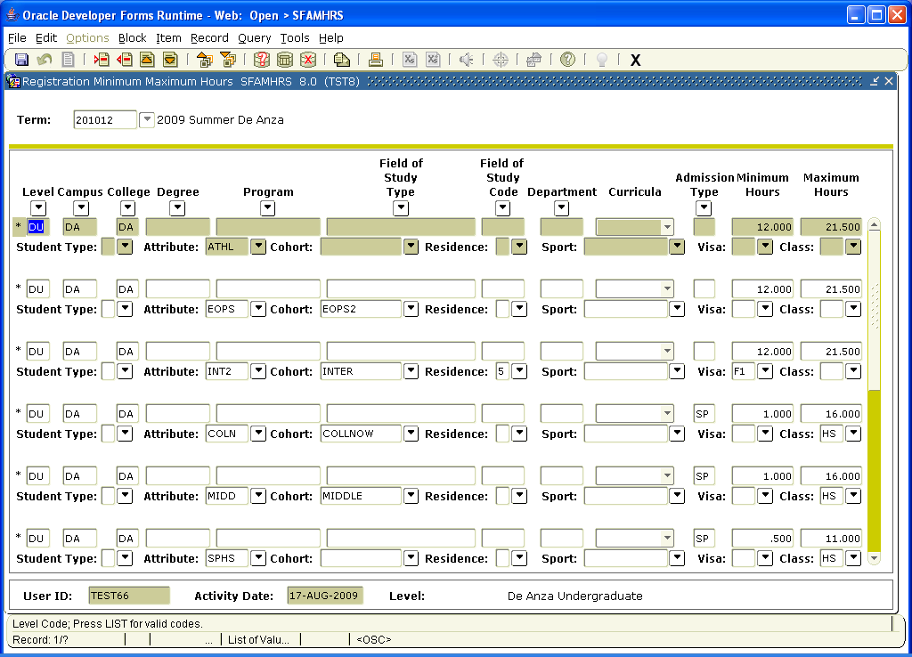

STVESTS - Enrollment Status Codes

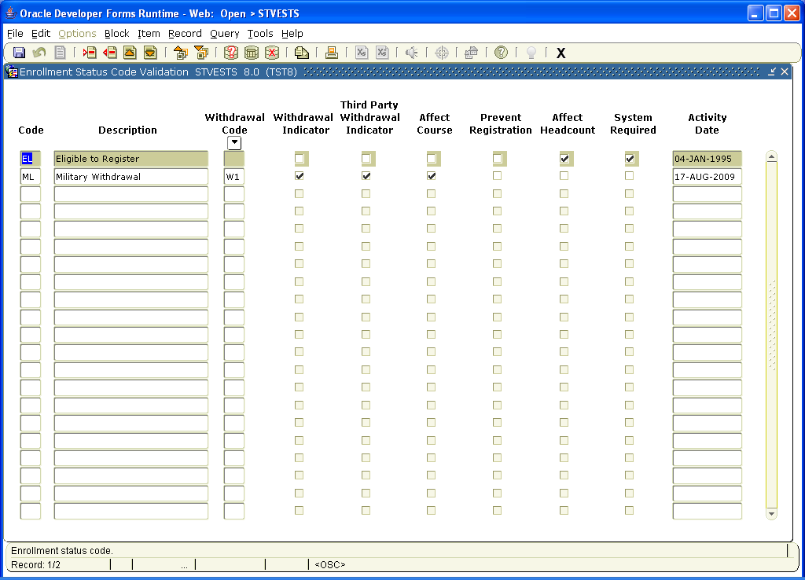

We have a discussion regarding the “enrolled” vs “withdrawn” status for students who drop all their courses. There is a partial manual process for changing the status of students who have dropped all their courses. Our decision impacts Financial Aid. Further discussion between Financial Aid and Student will occur in a special meeting with both consultants the week of Sept 7.

SFAALST- Class roster

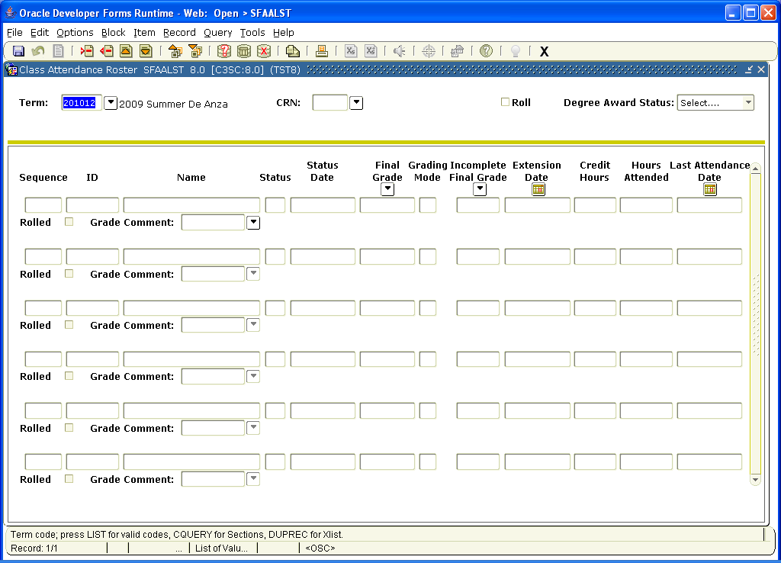

SFASTCA- Student Registration Audit. This form shows all courses for the student per term.

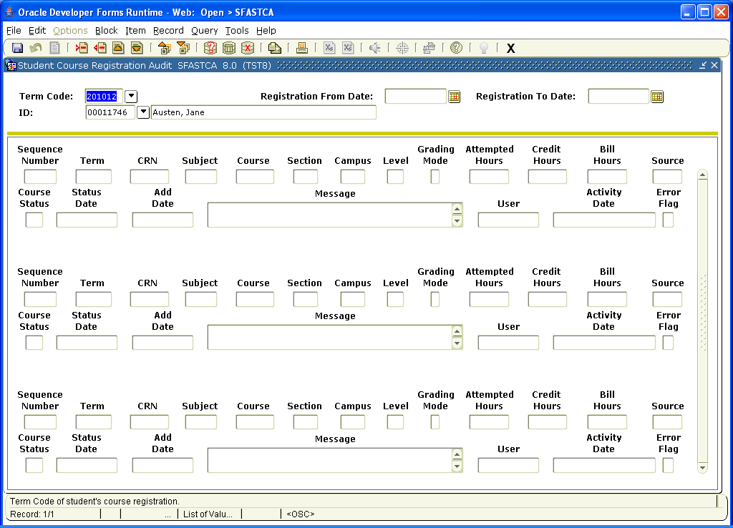

SFAOVR- registration override codes
Shawna and Pat to forward current list of codes used in SIS.

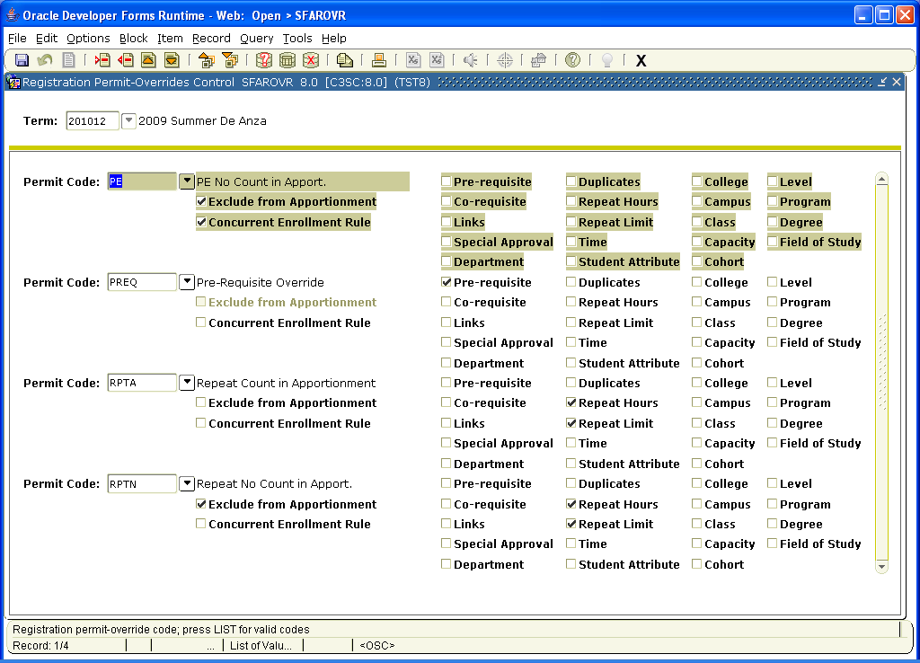

SFASRPO - permit override is used to add prereq permission for registration. This form will be used by Assessment for transfer students taking summer courses (vs regular students).
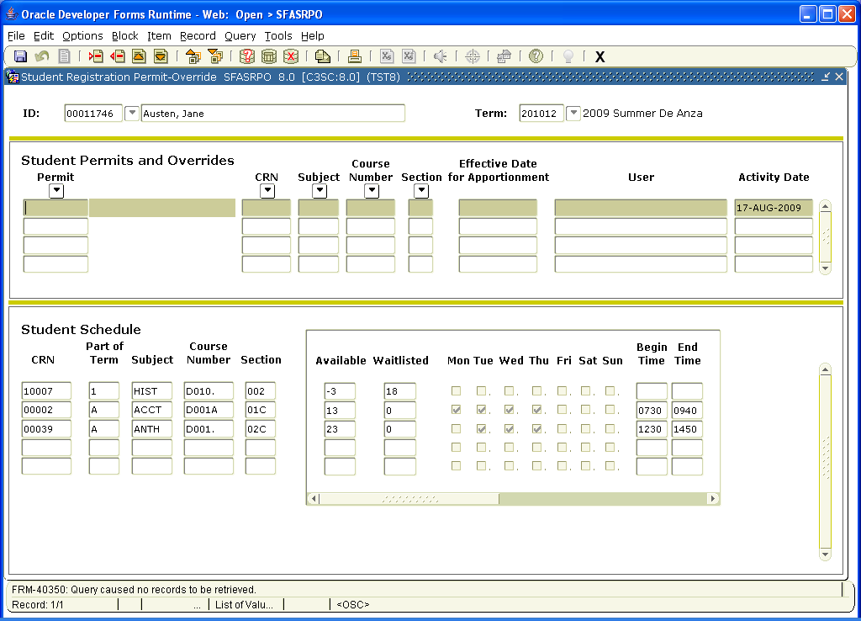

SVAAUTC - Add Authorization Codes; creates on demand codes per section
GJAPCTL is the job for running batch add authorization codes using eprint. These codes can also be sent to faculty via the portal and not printed, which is our preference.
A list of all codes can be run from SVPAUTL

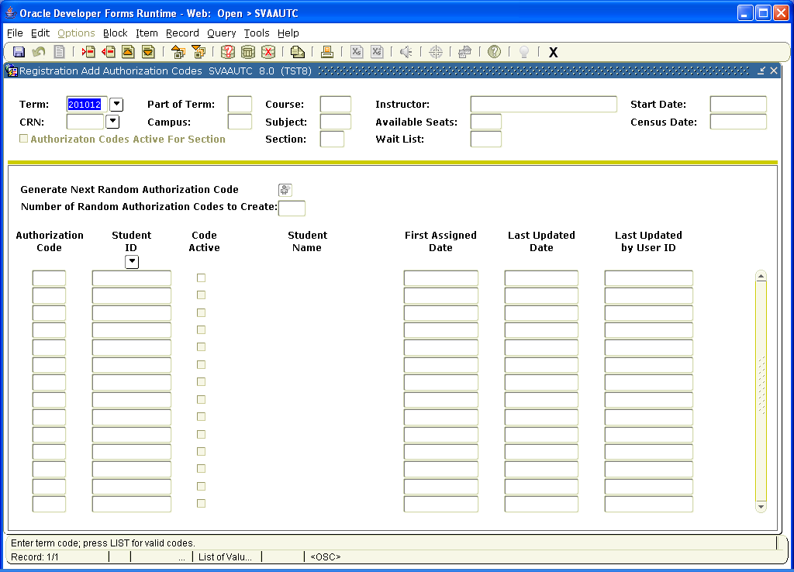

Waitlists:

The Scheduling staff enable waitlists at the section level. Students who are eligible for a course from the waitlist are notified via email (based on communication plan set up by Admissions staff) that they have a certain number of hours to register for the course or lose their slot. If they do not register, the next person on the waitlist is notified.

**A custom report needs to be created to batch run the waitlists and push them to the portal so faculty can see them on the first day of classes. Waitlists and add authorization codes cannot be active at the same time, so waitlists that are inactivated before the first day of class are lost unless the batch report or hard copy printing occurs.

The email notice to students is created on SOAWLTC.

SSAWLSC-controls for waitlist notification

