SFAREGS – First block Options Menu

From the SFAREGS screen if you go to "options" you can access other screens by clicking on the option you area interested in. The options menu will change depending on what block you are in on the page. There are 3 blocks on the SFAREGS page. This email is just the options and screens for the first block of the SFAREGS.
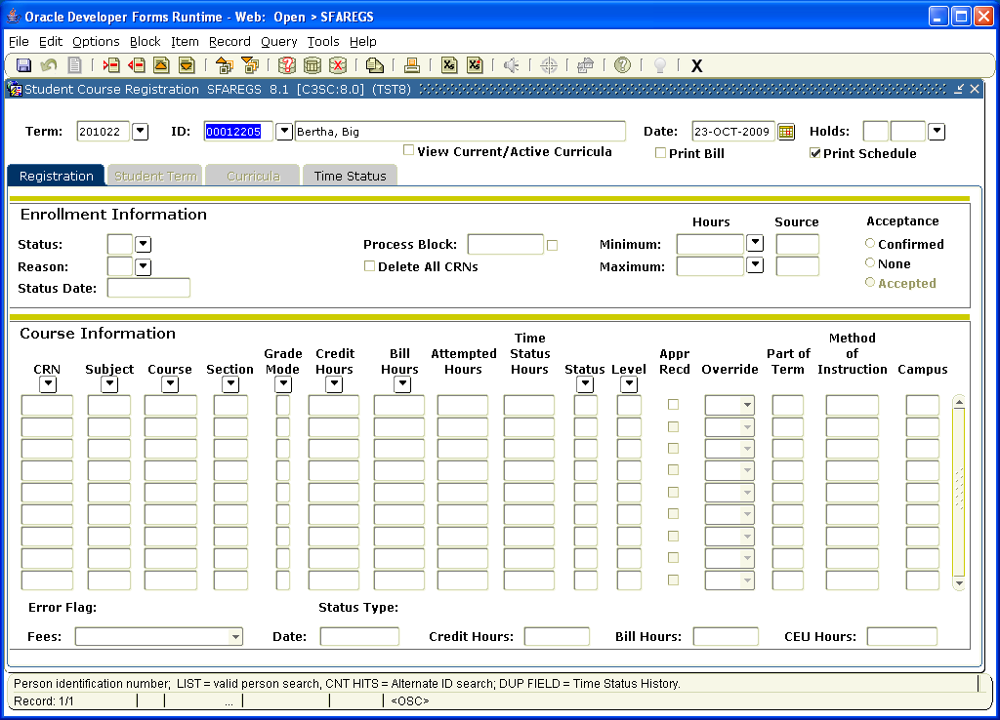
From the top block you can access the following screens. Theses are not all the screens but ones which would be helpful if you are registering a student:
The first screen is the registration history of the student. It is not an audit screen but an overview of the classes and registration for the student. (SFARHST). You would click on "Regisration History and Extenson
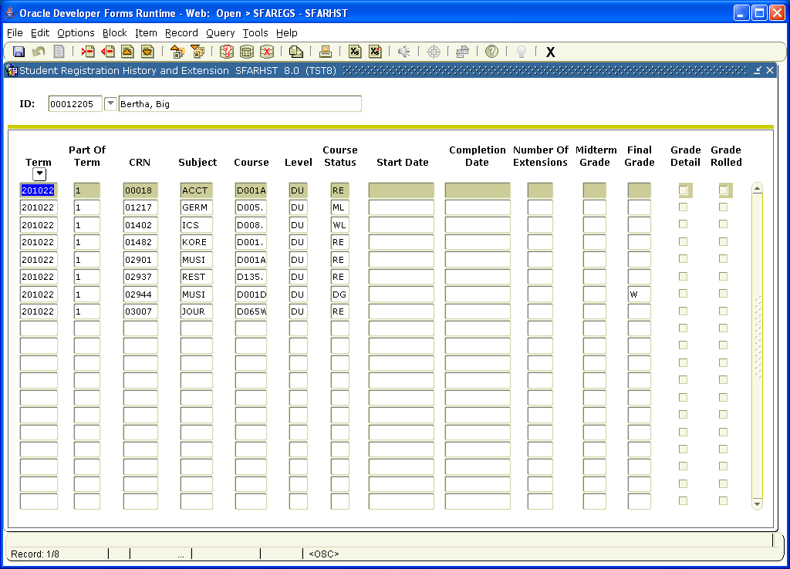
The next useful option is "Class Search". First put the quarter and year you want. You would go to subject, click the down button which would bring up all the different departments. You can pick and click. Then go to the top of the form and click on query and then execute query. You can also type in a department and course number and click on query and execute query . This should also give you the the enrollment and waitlist numbers.
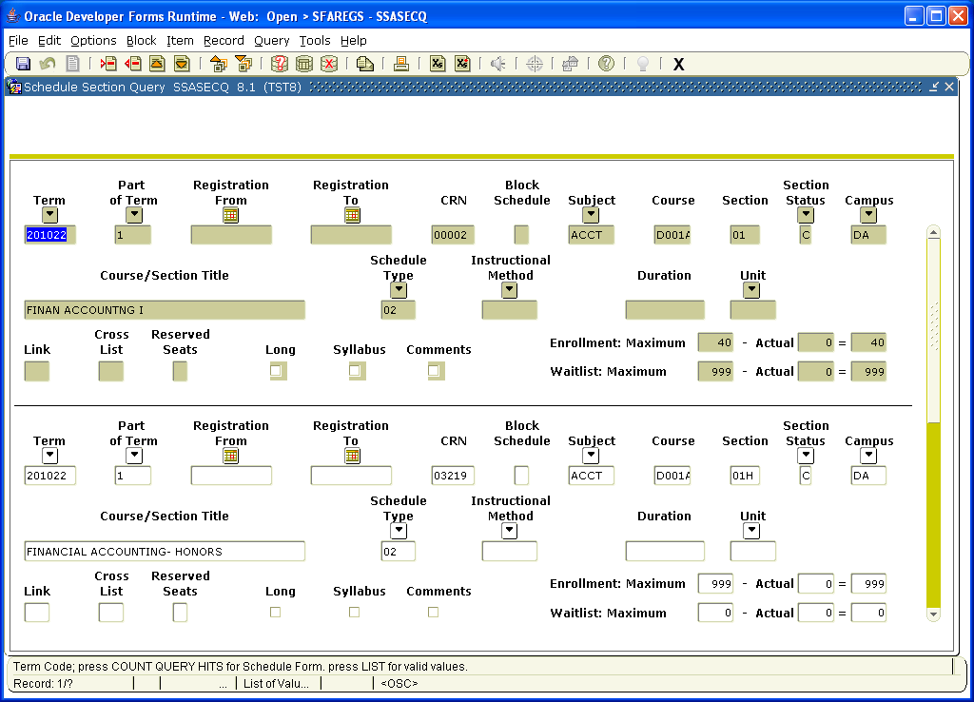
The next option is "ID, Names and Addresses which is "SPAIDEN" screen.
The next option is "Detailed Student Information" which is the SGASTDN screen.
The next option is "Quick Admit" which is the SAAQUIK screen
The next screen is "Student Attributes and Cohorts" which is SGASADD. You can view if the student is part of a special program such as EOPS, DSS, CARE etc.
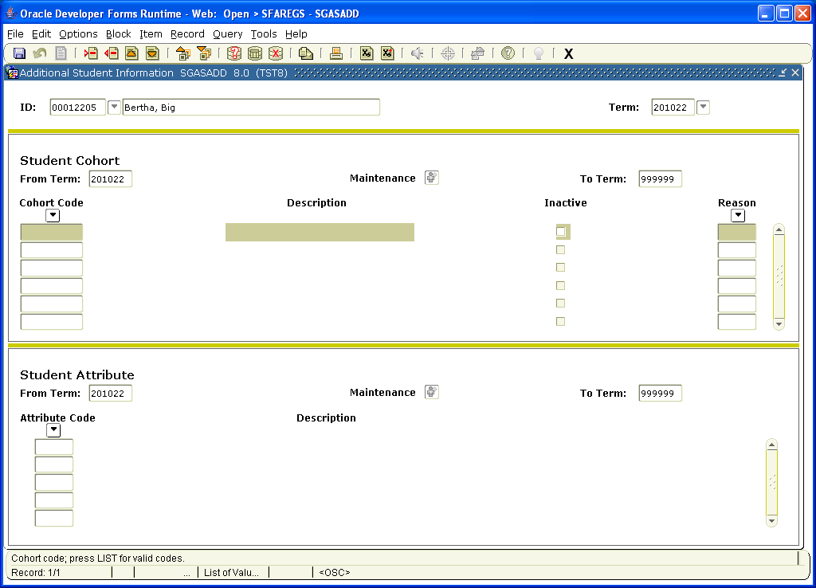
The next option is "Student Schedule of classes" or SFAREGQ. You can view the classes the student is registered, waitlisted or dropped from: Ths will show the days and times of the class.
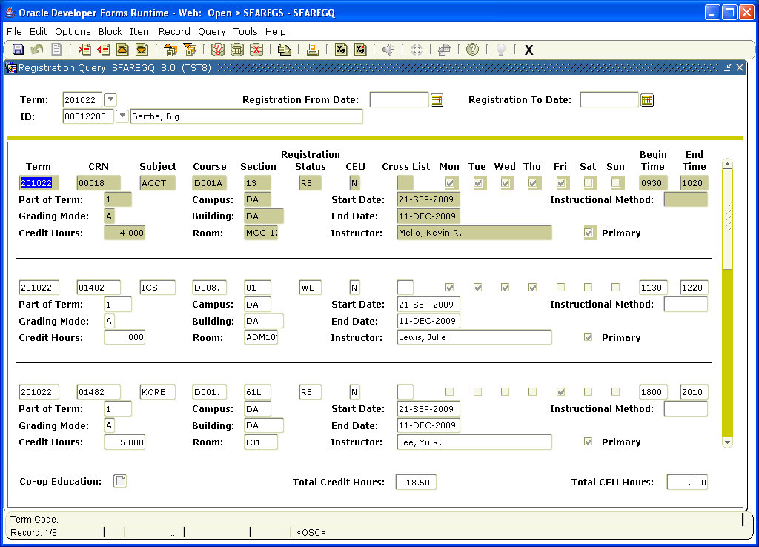
The next screen is "Test Score Information" SOATEST. You can see the placement test scores of the student:
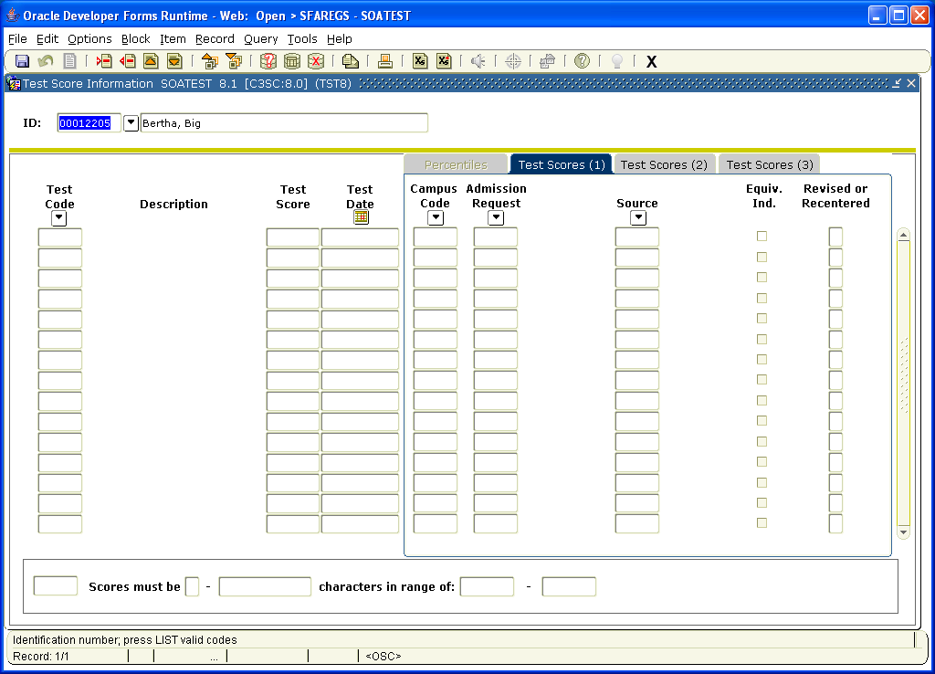
The next option is "Review Account Detail" TSAAREV which will give you the breakdown of fees for the specific quarter.
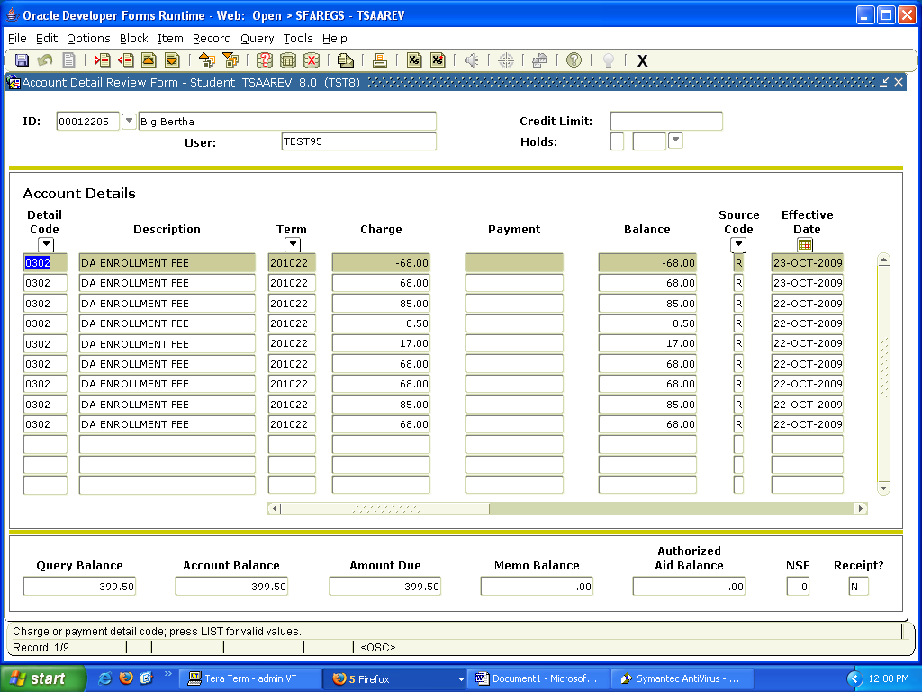
The next option is "Review students classes and charges". This will bring up several screens. The intial screen will be SFAREGF which is the students schedule for the quarter
If you go up to the options menu once you are in this screen you can also view the student fees in several different ways. You can look at the overall fees if you choose "Fess assessment with Min/Max applied". You can look an audit of the fees (step by step activity) if you choose "Registration Fee Assessment Audit"
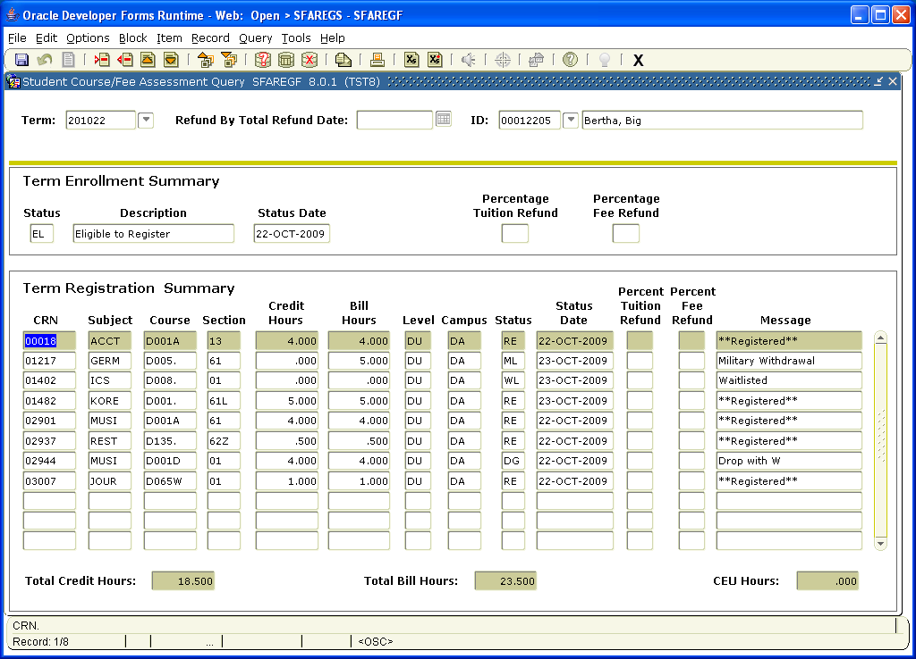
The next option is "Summary Student Information" SGASTDQ which is used by counseling for Probation, Disqual etc.
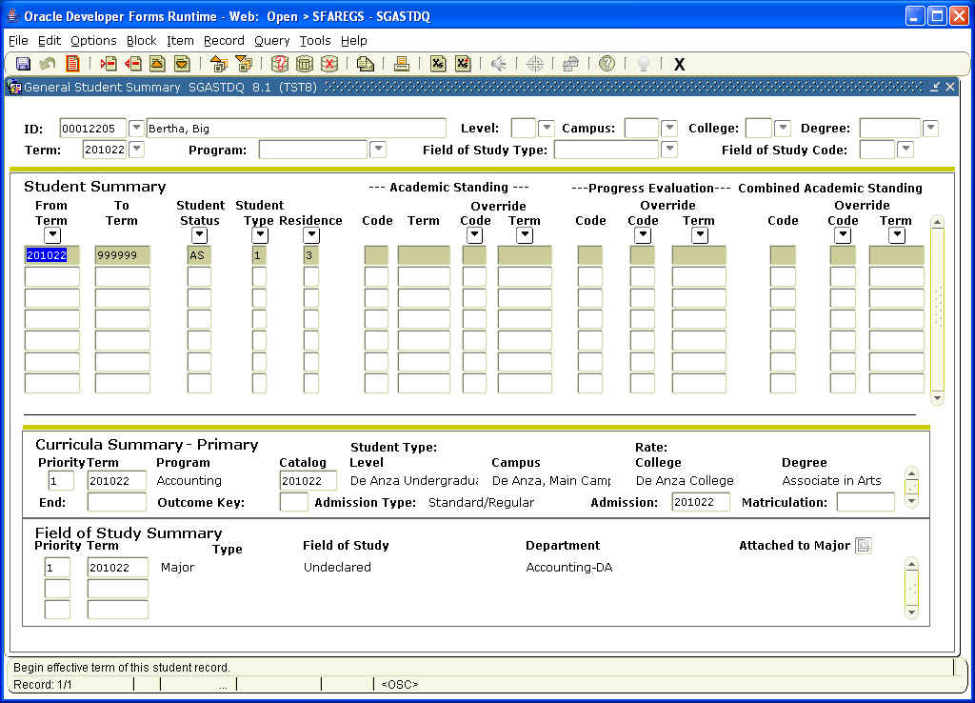
The next option is "Degrees Awarded and you can view that on screen SHADEGR.
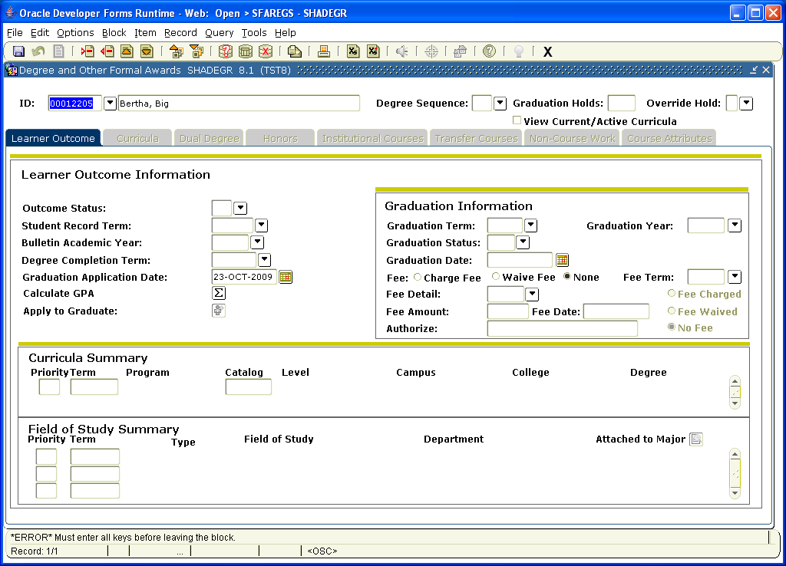
The next option is "Degree Application which no one but evaluators would be able to access.
The next option is "View Student Holds" Screen SOAHOLD where you can see what hold the student might have. This is where a hold is placed and removed.
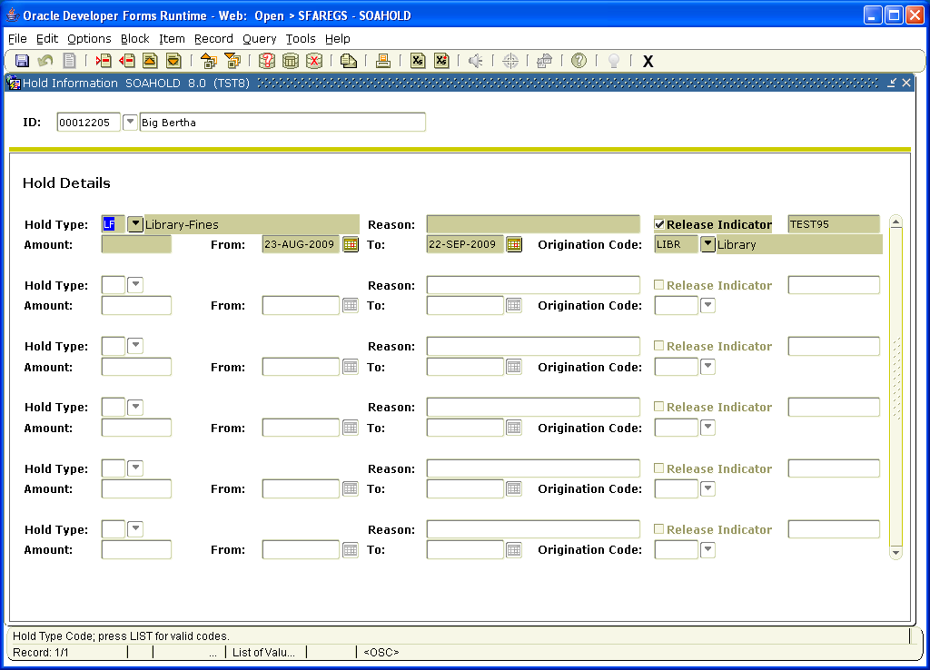
The next option is "Student System Identification" screen which tells you where the person was initiated in the system. For example is it staff from human resource, financial aid etc.
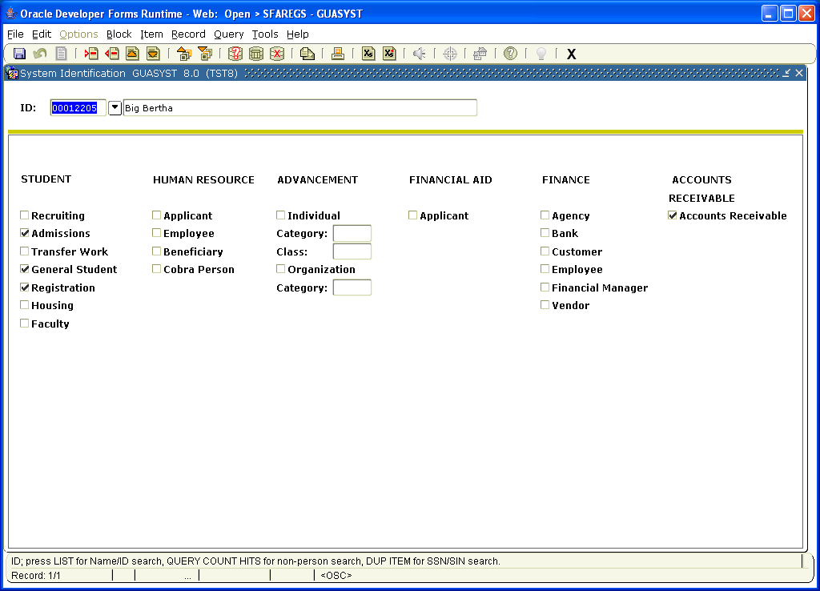
The next option is "Admissions Application Detail" which is just the application screen SAAADMS.
The next option is "Define Time Status Rules" SFATMST tells you what number of units define full time, half time etc.
The last is the "View time status Information" not sure about this one.
Barry Johnson
Admissions and Records
De Anza College
408.844.8722

