Paper Application Procedures

- Click on File at upper left hand corner.
- Click on QuickFlow
- Type SAPPL in the QuickFlow field (S-stands for Student & APPL-stands for application
- Click on the Start button
- Or if you know the Quickflow code SAPPL, you can type it in the GO TO… field at the upper left hand corner of the screen
- Hit Enter
- Banner will then automatically take you to the first screen used in the Application process – GOAMTCH
- Click on the Generate ID button (yellow man) and the word “Generated” will appear in the ID box
- Click on the down arrow next to the Matching Source field
- Click on ADMISSIONS “Applicant Matching”
- Click on the Start button
- Fill out all pertinent information: Last Name, First Name, Middle Name. Remember, Banner is K sensitive. Example: Smith, Bob A. (Do not use all capital letters )
- Under the Address Type field, enter PR for Permanent Address or click on the down arrow key next to the Address Type field. The Address Type Validation Table will appear. Scroll down until you see PR Permanent and click on it. Then click on the OK button.
- Fill in the student’s address by filling in Street Line 1, City, State or Province, and Zip or Postal Code. If you enter a street address that the system does not view is legitimate, a box will pop up with suggestions for legitimate addresses. Please confirm with the student if the address is correct. Then click on the OK button and correct the address or if the address is correct as is continue on with the application process.
- Under the SSN/SIN/TIN field enter the student’s social security number if they give it to you. (Do not enter dashes)
- Under the Birth Date fields, enter the student’s birthday
- Under the Gender field, click on the down arrow and choose Female or Male
- Under the Telephone Type field, enter the code PR for Personal or Home Num or CELL for Mobile/Cell Phone. Or click on the down arrow next to the Telephone Type field and click on the appropriate phone type then click the OK button.
- Under the Telephone fields, you will see three boxes. The first box is for the area code. The second box is for the phone number. (No dashes) The third box is for extensions.
- Under the E-mail type field, enter the code PE for Personal or Home. Or you can click on the down arrow and choose the appropriate e-mail type then click the OK button.
- Under the E-mail field, type in the student’s email address
- Click on the Duplicate Check icon (two yellow men). A box will pop up asking “No matches found, create as new?” Click on the Yes button. Another box will appear giving you the Personal Identification number of the student. Click on the OK button. However, of there is a match in names, the system will pull up all the students with the same name. You will need to determine if the student is new or already exits in the system. If this is a new student, click on the Create New icon (one yellow man). A box will then appear giving you the Personal Identification number of the new student. Then click on the OK button.
- Click on the Save button at upper left hand corner on the menu bar (top of screen). Or click on File at upper left hand corner then click
- Click on the black X button that is on the menu bar (top of screen). It is the X next to the Light Bulb button. Or click on File at upper left hand corner then click on Exit.

Example of GOAMTCH below:
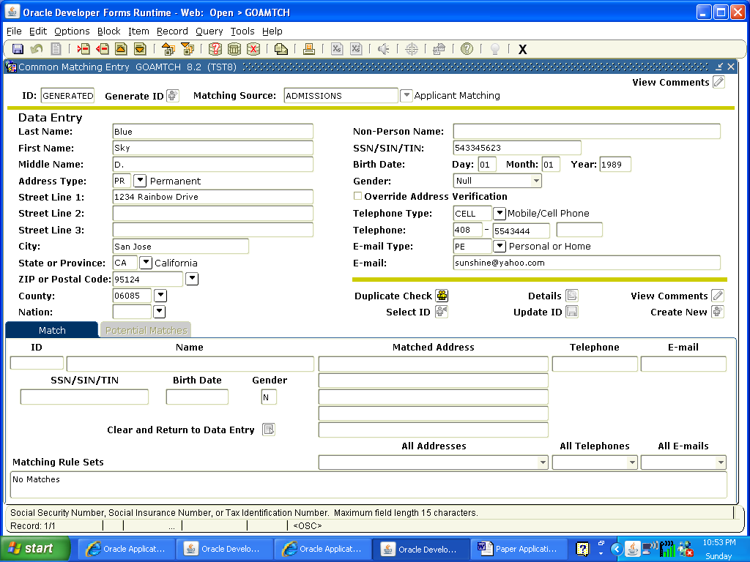

- Banner will then automatically take you to the next screen – SPAIDEN.
- The student’s name and ID# should already be populated in the ID fields.
- Click on Block at the menu bar (top of screen) then click on Next. Or click on the Next Block icon.
- The system will then automatically populate the student’s information under the Current Identification tab, the Address tab, the Telephone tab, and the E-mail tab. (Note: if the student has more then one telephone number and/or e-mail address, you would add the additional telephone number under the Telephone tab and the additional e-mail address under the E-mail tab.
- Click on the Biographical tab.
- Gender should already be populated from GOAMTCH, if it is not, click on either Male or Female.
- Under the Citizenship field, click on the down arrow and choose the appropriate citizen type then click on the OK button.
- Under the Ethnicity field, click on the down arrow and choose the appropriate ethnicity of the student then click on the OK button.
- Birth Date and SSN/SIN/TIN (if they have one) should already be populated from GOAMTCH, if they are not, fill them in.
- Click on the Save button at upper left hand corner on the menu bar (top of screen). Or click on File at upper left hand corner then click on Save.
- Click on the black X button that is on the menu bar (top of screen). It is the X next to the Light Bulb button. Or click on File at upper left hand corner then click on Exit.

Example of SPAIDEN:
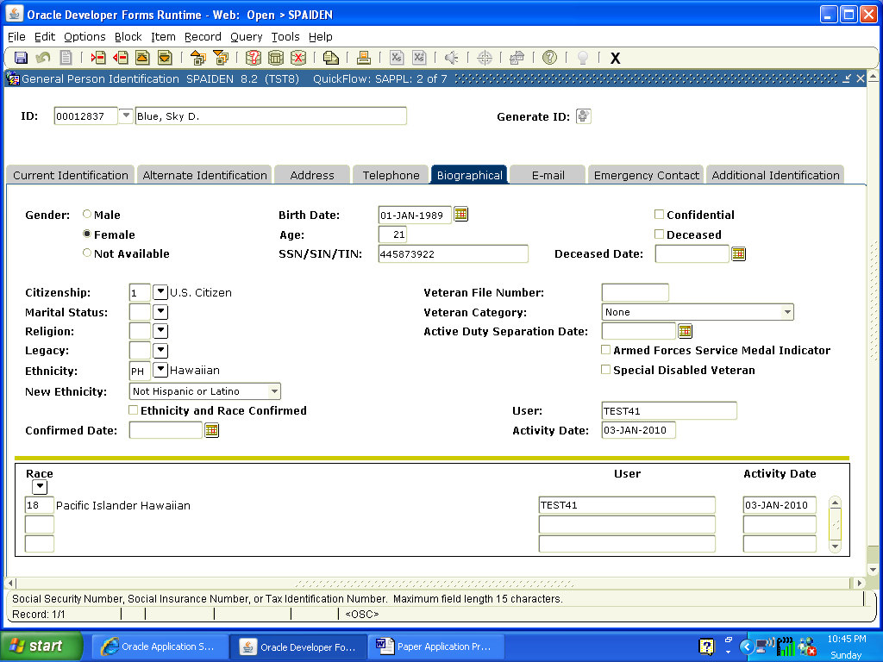

- Banner will then automatically take you to the next screen – GOAINTL. (If the student is a US Citizen and/or you do not need to enter a VISA type, just exit out of GOAINTL by clicking on the black X button that is on the menu bar (top of screen). However, if you need to enter a VISA type for the student, continue to step 2.)
- The student’s name and ID# should already be populated in the ID fields.
- Click on Block at the menu bar (top of screen) then click on Next. Or click on the Next Block icon.
- Under the Visa Type field, click on the down arrow and choose the appropriate Visa type then click on the OK button.
- Under the Date Issued field, enter the date that the student was issued his Visa. (For example: if you want to enter the date December 6, 2008, type 12062008) Or you can click on the small calendar icon and choose the appropriate date.
- Under the End Date field, enter the date that the student’s Visa will expire. (For example: if you want to enter the date December 6, 2018, type 12062018) Or you can click on the small calendar icon and choose the appropriate date.
- Click on the Save button at upper left hand corner on the menu bar (top of screen). Or click on File at upper left hand corner then click on Save.
- Click on the black X button that is on the menu bar (top of screen). It is the X next to the Light Bulb button. Or click on File at upper left hand corner then click on Exit.

Example of GOAINTL:
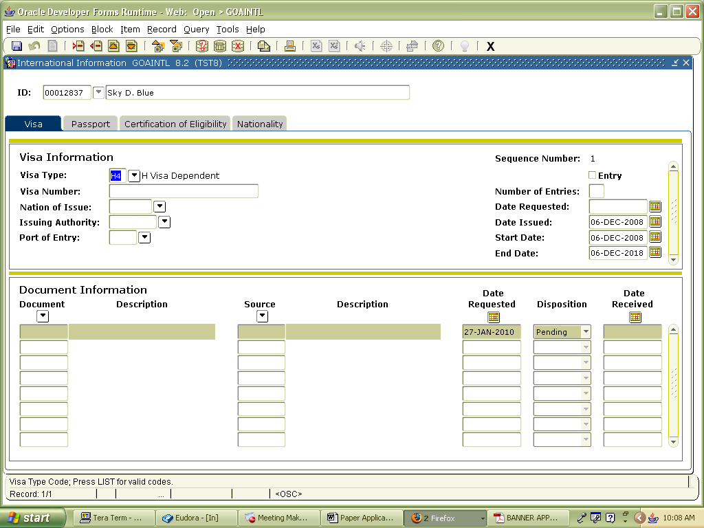

- Banner will then automatically take you to the next screen – SAAADMS.
- The student’s name and ID# should already be populated in the ID fields.
- Under the Term field, click on the down arrow and click on the term and college that the student is applying for. Then click on the OK button.
- Click on Block at the menu bar (top of screen) then click on Next. Or click on the Next Block icon.
- Under the Admission Type field, click on the down arrow and choose the appropriate admission type then click on the OK button.
- Under the Student Type field, click on the down arrow and choose the appropriate student type then click on the OK button.
- Under the Residence field, click on the down arrow and choose the appropriate residency type then click on the OK button.
- Under the Site field, click on the down arrow and choose the appropriate campus that the student will be attending then click on the OK button.
- Under the Application field, enter D for “Decision Made/Accepted”. Or click on the down arrow and choose the D – Decision Made/Accepted then click on the OK button.
- The Application Status Date field and the Maintained By field will automatically be populated.
- Click on the Save button at upper left hand corner on the menu bar (top of screen). Or click on File at upper left hand corner then click on Save.

Example of the Application screen under SAAADMS:
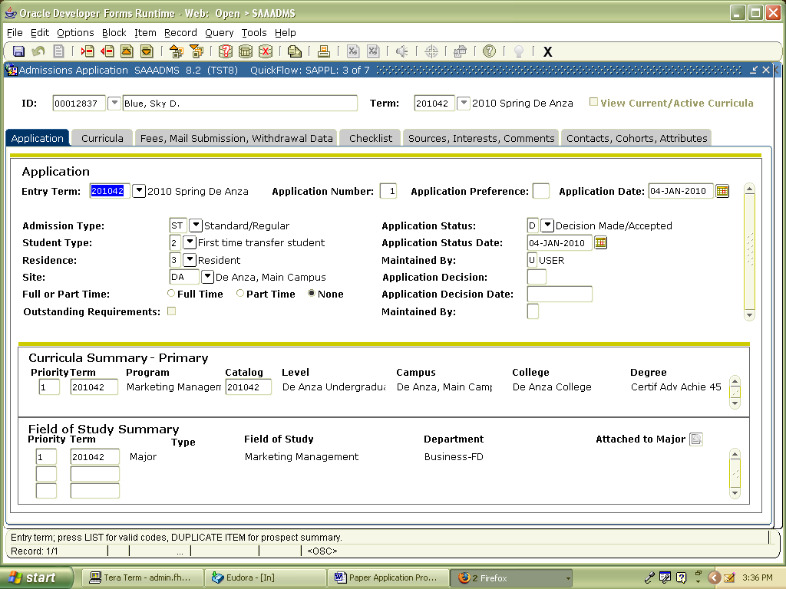
- Click on the Curricula tab
- Under the Program field, click on the down arrow and click on Change Curriculum. A pop up box will appear stating “Base Curriculum Items will be Replaced.” Then click on the OK button.
- A list of active programs/majors will appear. Look on your Program/Major Sheet to choose the correct code. Make sure that it begins with DA for De Anza. Then click on the OK button.
- Click on the Save button at upper left hand corner on the menu bar (top of screen). Or click on File at upper left hand corner then click on Save.
- Click on the black X button that is on the menu bar (top of screen). It is the X next to the Light Bulb button. Or click on File at upper left hand corner then click on Exit.

Example of the Curricula screen under SAAADMS:
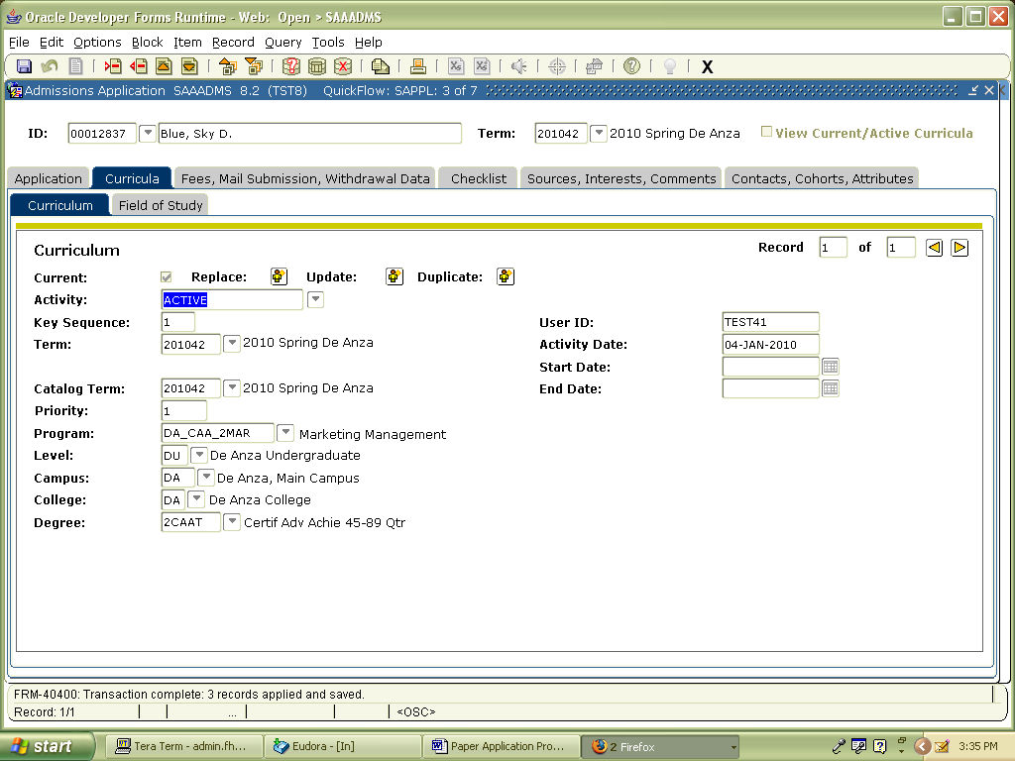

- Banner will then automatically take you to the next screen – SAADCRV.
- Click on Block at the menu bar (top of screen) then click on Next. Or click on the Next Block icon.
- Under the Decision Code field (at the bottom left hand corner), enter the code ST for Standard Admit or SP for Special Admit-High School. Or click on the down arrow and choose the appropriate code (ST or SP) then click on the OK button.
- Click on the Save button at upper left hand corner on the menu bar (top of screen). Or click on File at upper left hand corner then click on Save.
- A pop up box will appear stating “Learner Record Created”. Click on the OK button.
- Click on the black X button that is on the menu bar (top of screen). It is the X next to the Light Bulb button. Or click on File at upper left hand corner then click on Exit.

Example of SAADCRV:
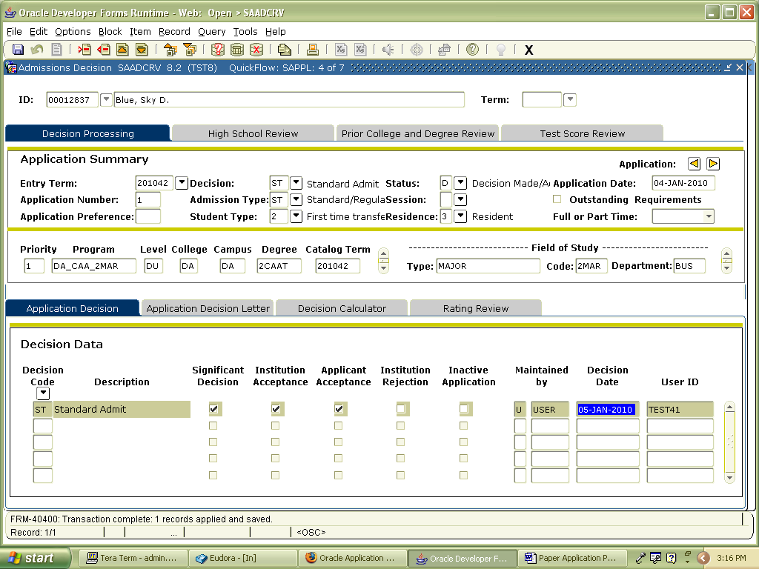

- Banner will then automatically take you to the next screen – SGASTDN.
- Click on Block at the menu bar (top of screen) then click on Next. Or click on the Next Block icon.
- Click on the Miscellaneous tab on the far right side of the screen.
- Under the Educational Goal field, enter the appropriate code or click on the down arrow and choose the appropriate educational goal for the student then click on the OK button.
- Click on the Save button at upper left hand corner on the menu bar (top of screen). Or click on File at upper left hand corner then click on Save.
- Click on the black X button that is on the menu bar (top of screen). It is the X next to the Light Bulb button. Or click on File at upper left hand corner then click on Exit.

Example of SGASTDN:
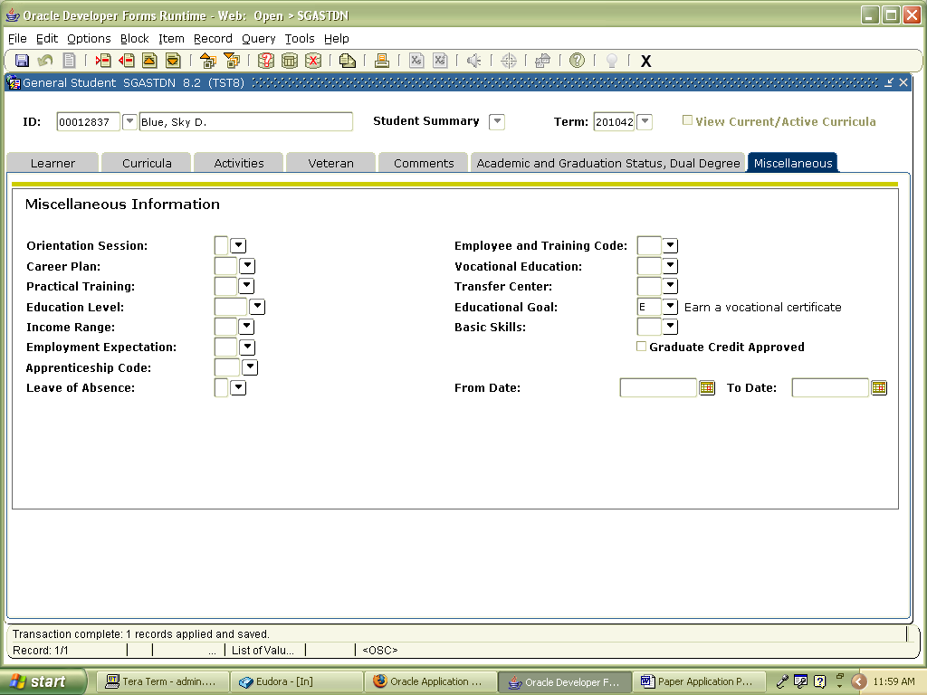

- Banner will then automatically take you to the next screen – SOAHSCH.
- Click on Block at the menu bar (top of screen) then click on Next. Or click on the Next Block icon.
- Under the High School field, click on the down arrow. The SOISBGI screen will pop up. This is the screen where you are going to choose a high school.
- Click on the button for HS. Then tab over to the Name field and type in the first letter or two of the high school name and type % next to it. (Example: for Mount Pleasant High School, I would enter M%)
- Tab over to the City field and enter the city that the high school is in.
- Click on Query at the menu bar (top of screen) then click on Execute. Or click on the Execute Query icon.

Example of the query:
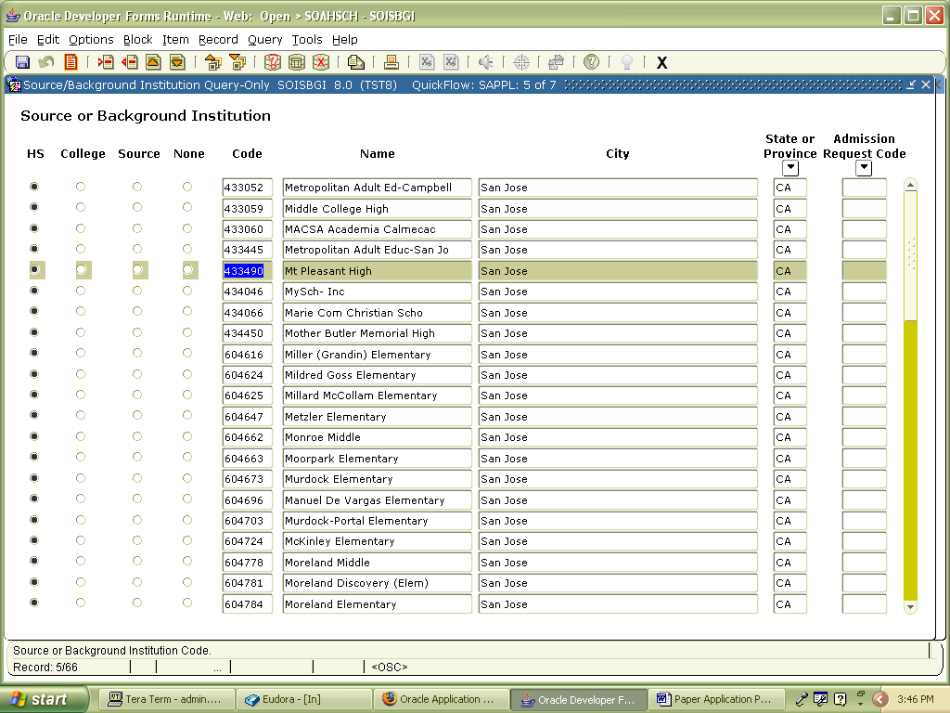

- Double click on the high school’s code that you were looking for. This will then take you back to SOAHSCH.
- Under the Graduation Date field, enter the date that the student graduated from high school. (For example: if you want to enter the date June 6, 2007, type 06062007) Or you can click on the small calendar icon and choose the appropriate date.
- Under the Diploma field, click on the down arrow and choose the correct diploma type then click on the OK button.
- Click on the Save button at upper left hand corner on the menu bar (top of screen). Or click on File at upper left hand corner then click on Save.
- Click on the black X button that is on the menu bar (top of screen). It is the X next to the Light Bulb button. Or click on File at upper left hand corner then click on Exit.

Example of SOAHSCH:
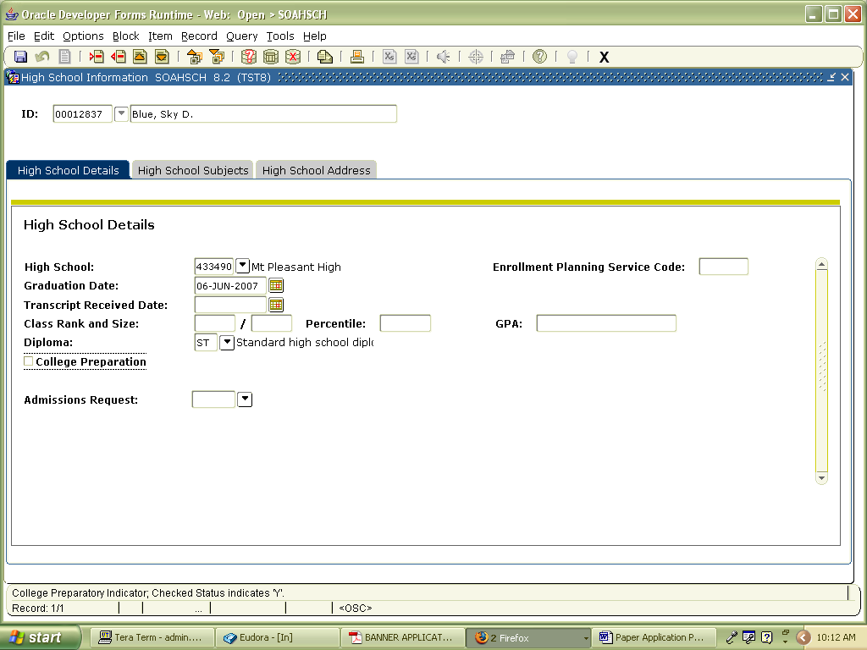

- Banner will then automatically take you to the next screen – SOAPCOL.
- Click on Block at the menu bar (top of screen) then click on Next. Or click on the Next Block icon.
- Under the Prior College field, click on the down arrow. The SOISBGI screen will pop up. This is the screen where you are going to choose a college/University.
- Click on the button for College. Then tab over to the Name field and type % then enter part of the name of the college/university then type %. (Example: for University of California Davis, you would enter %Davis%)
- Tab over to the City field and/or State field and enter the city and/or state of the college/university.
- Click on Query at the menu bar (top of screen) then click on Execute. Or click on the Execute Query icon.

Example of the query:
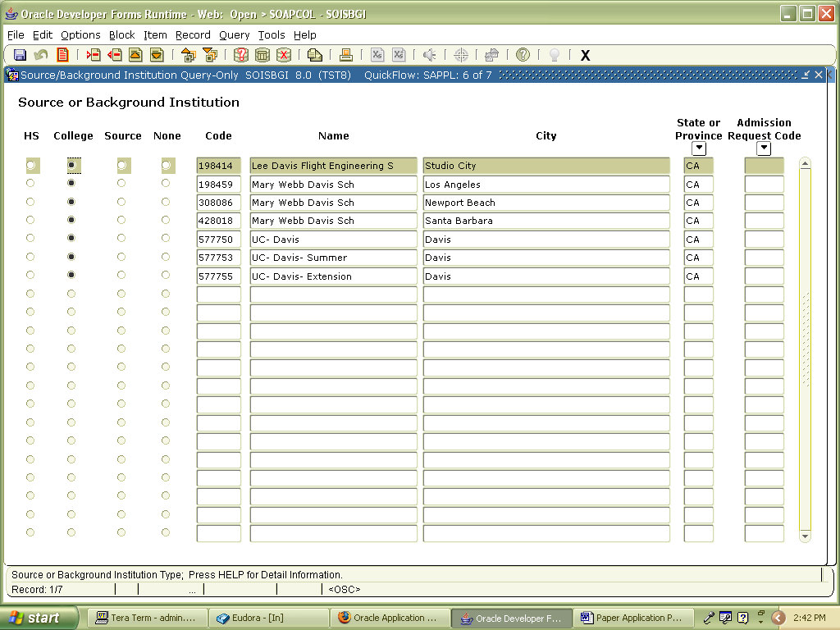

- Double click on the college/university’s code that you were looking for. This will then take you back to SOAPCOL.
- Click on the Save button at upper left hand corner on the menu bar (top of screen). Or click on File at upper left hand corner then click on Save.
- Click on Block at the menu bar (top of screen) then click on Next. Or click on the Next Block icon.
- Under the Degree field, enter the type of degree the student received from the college/university.
Codes to enter: 2AA.A Associate in Arts
2AS.A Associate in Science
BA Baccalaureate Degree
MS Master’s Degree
PHD Doctoral Degree
2ND No Degree
Or under the Degree field, click on the down arrow and choose the appropriate degree type.
- Under the Degree Date field, enter the date that the student received his degree. (For example: if you want to enter the date December 22, 2009, type 12222009) Or you can click on the small calendar icon and choose the appropriate date.
- Under the Attended From field, enter the date that the student first started attending the college/university. (For example: if you want to enter the date September 4, 2007, type 09042007) Or you can click on the small calendar icon and choose the appropriate date.
- Under the Attended To field, enter the date that the student stopped attending the college/university. (For example: if you want to enter the date December 22, 2009, type 12222009) Or you can click on the small calendar icon and choose the appropriate date.
- Click on the Save button at upper left hand corner on the menu bar (top of screen). Or click on File at upper left hand corner then click on Save.
- Click on the black X button that is on the menu bar (top of screen). It is the X next to the Light Bulb button. Or click on File at upper left hand corner then click on Exit.

Example of SOAPCOL:
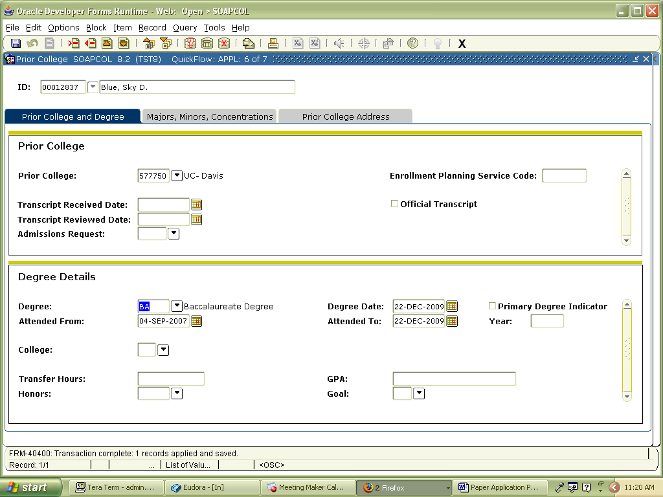

- Banner will then automatically take you to the next screen – SOAPCOL. For Student Cohorts, EOPS, Athletics, OTE, International Office, or other Special Programs will be using these. For the most part, the front counter staff in Admissions and Records will be using the Student Attributes. (Note for A&R staff: if the student is a regular college student not high school or an employee, then just exit out of the screen. If the student is a high school student or an employee, then go to step 2.)
- Under the Term field, click on the down arrow and click on the term and college that the student is applying for. Then click on the OK button.
- Click on Block at the menu bar (top of screen) then click on Next. Or click on the Next Block icon.
- Once again click on Block at the menu bar (top of screen) then click on Next. Or click on the Next Block icon.
- This should bring you down to the Student Attribute. The From Term will default to the term you indicated in the beginning. The To Term will have no limitations and default to 9999999.
- Under the Attribute Code field, enter SPHS for Special Admit High School Student or enter STAF for Staff.
- Click on the Save button at upper left hand corner on the menu bar (top of screen). Or click on File at upper left hand corner then click on Save.
- A pop of box will appear stating “Changing Student Attribute values may impact Registration Fee Assessment.” Click on the OK button.
- Click on the black X button that is on the menu bar (top of screen). It is the X next to the Light Bulb button. Or click on File at upper left hand corner then click on Exit.

Example of SGASADD:
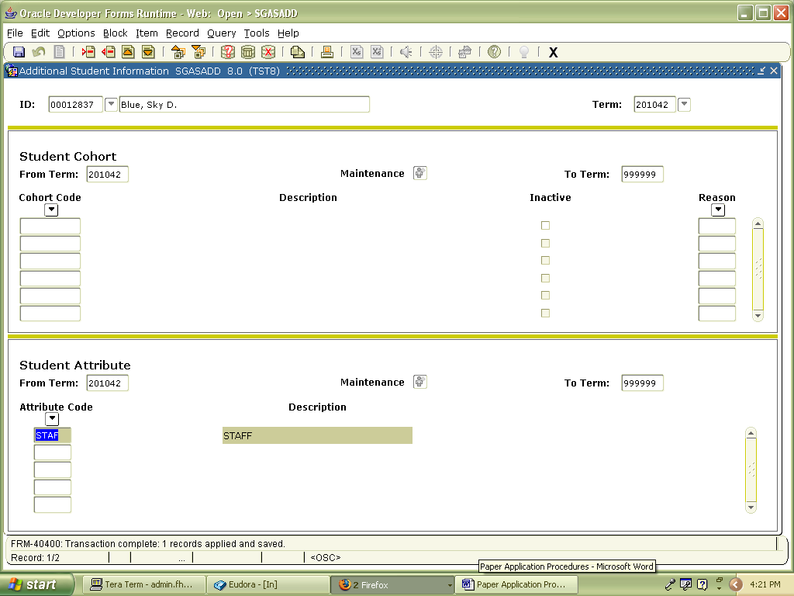

Last update on January 27, 2010

