#1: Run the following Script: NSPACAT.SQL

This script can be run as any user who has insert/update privileges in SQL to tables owned by POSNCTL.

The script will prompt you to name the following:

Approval Category: Name It:

Job salary approval category: SPJSAL
Default hours approval category: SPEARN
Job labor distribution category: SPJLBD
Combined job approval category: SPCOMB

Approval Type: Name It:

Job salary approval type: SPJSAL
Default hours approval type: SPEARN
Job labor distribution approval type: SPJLBD

#2: Establish access to the Salary Planner Menu in Employee Self Service through Web Tailor. (This task has to be performed only if you have customized the Employee Self Service Module.)

Apply the following steps if you have customized the Employee Self-Service Main Menu.
That is, if one LOCAL row (twgrmenu_source_ind=L) is found in the twgrmenu table for pmenu.p_MainMnu.
- Log on to Employee Self-Service with an ID that has access to Web Tailor Administration.
- Select the Web Tailor Administration menu.
- Select Menu Items.
- Select the Web menu, pmenu.p_MainMnu, from the pull-down list.
- Select the Customize Menu Items button
- You will see a list of menu entries for the Employee Main Menu. If at least one LOCAL entry is displayed then continue with the following steps. Otherwise, exit Employee Self-Service making no changes.
- Select the Add a New Menu Item button
- On the Create a New Menu Item page, enter the following information:
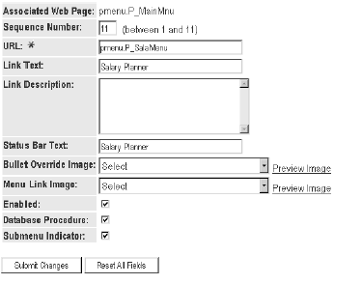

- Select the Submit Changes button

Note: All Web packages and Web procedures specific to the Salary Planner are delivered as seed data by SCT. For a complete list of all packages/procedures delivered for the Salary Planner, refer to the topic, New Web Procedures on page 144 of the 6.1 Employee Self Service Release Guide.

#3: Assign Roles to Salary Planner Users

Two types of users can access the Salary Planner. Each user type is identified by their role in the Salary Planner. These include:

• Master Salary Planners
• HR Managers

These new roles are added to the Web Tailor table, TWTVROLE, via the install script, UTWTVORLE.SQL and the role(s) can be assigned to each user by your Web Tailor Administrator. To define the role of each user in the Salary Planner, access the Web Tailor application.

- Log on to Employee Self-Service with your Web Tailor Administrator ID and Password.
- Select the Web Tailor Administration menu.
- Select the User Roles menu option.
- Enter the ID of the employee who is to be assigned the user role and select Submit.
- On the Update User Roles page, mark the corresponding check box to assign the employee any of the following roles in the Salary Planner:

• HR Manager
• Master Salary Planner

Note: Master Salary Planners have all the privileges of the HR Manager role, plus the ability to create scenarios and edit the Initial scenario. Therefore, it is not necessary to assign the HR Manager role to a user who has the Master Salary Planner role.

#4: Update User Ids with access to new forms and processes:

- NTVBPRO
- NTRSPEX
- NSASPSC
- NBPSPEX
- NBPSPUP

