REGISTRATION FOR SPECIAL COHORT GROUPS (HONORS, MPS, FIRST YEAR ETC)

In order to allow registration for special groups you would need to check the following three screens STVCHRT, SSARRES, SGASADD. This are for classes that are not open to the general student population.

- STVCHRT – You would look at the list of possible Cohorts to find the cohort and the code associated with the cohort. The code is on the far left of the screen.

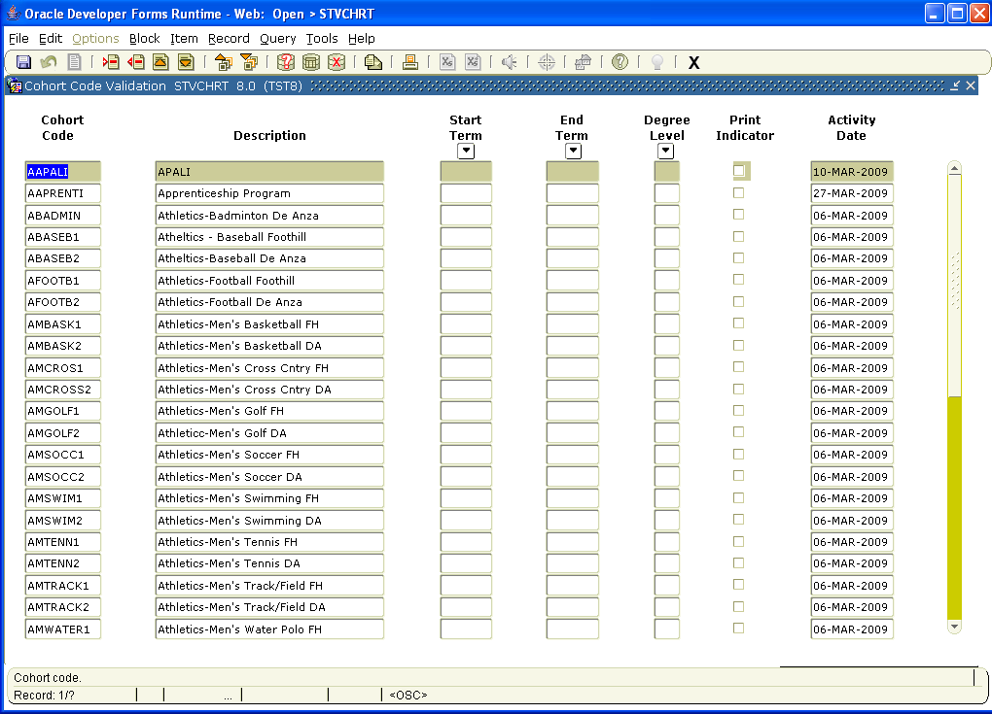

- SSARRES. Choose the Student Attribute and Cohort tab once in the screen. Go to the second block and type in the Cohort code. Also click on the Include button and save. This should be done by the person who schedules classes for the department.

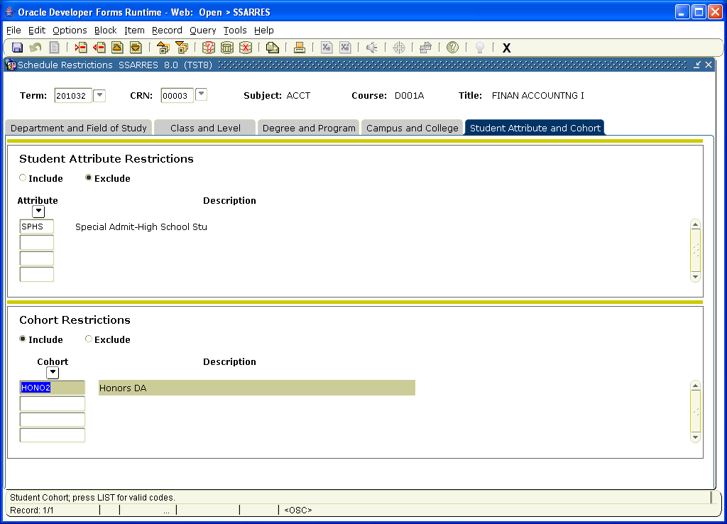

- SGASADD. Go to the first block and type in the Cohort code and save.

