Registration Procedures

- Type SFAREGS in the Go To… field (upper left hand corner) and hit Enter.
- The SOADEST screen will pop up. (This is where you will designate a printer for your computer.) But at this time, just Exit out of this screen and the system will then take you to SFAREGS.
- Under the Term field, type in the term that the student is registering for or you can click on the down arrow, click on List of Terms, click on the appropriate term, and then click on the OK button.
- Enter the student’s ID# or SS# under the ID field or you can type in the student’s name and hit Enter.
- The current date will automatically default under the Date field. However, if you have the approval of the admissions supervisor and he or she wants you to back date a drop or add, this is where you will change the date. (But remember, if you plan on adding or dropping other classes, make sure you change the date back to the current date.)
- If the student has a hold on his record, there will be a “Y” in the Holds field. To find out what the hold is, click on the down arrow. (The student must clear their hold before you can register them.)
- Click on the Next Block icon.
- Under the Status: field, the code EL for Eligible to Register should automatically be appearing. If it does not, the student needs to fill out an application before you can register them in any classes.
- Under the Reason: field, click on the down arrow and choose the appropriate drop reason, and then click the OK button. (You would only use this field if the student is planning on dropping from all of his classes and is withdrawing completely from the college. He should have turned in a petition to withdraw.)
- Under the Status Date: field, this is usually the current date or the date that you will be withdrawing the student from the college.
- The Process Block: field is used for students who need to be registered in a block of classes.
- Please don’t ever check the Delete All CRNs box because it will not only drop all of the students’ classes, but it will delete any record of the student ever registering for the classes. We always want to keep a trail of when a student adds and/or drops.
- Under the Minimum: & Maximum: Hours fields, the unit amounts will automatically default in. However, if a student has an approved petition to exceed 21.5 units, you can change the unit amount under the Maximum: Hours fields.
- The Acceptance indicators are used by the cashiers to indicate whether they have accepted payment from a student and will not drop him for non-payment.
- Click on the Next Block icon.
- The Course Information block is where you can register students.
- Adding a class.
  - If the student is already in classes, you must move your cursor to a blank line.
  - If the student’s schedule is filled with classes and you can not easily move to a blank line, click on Record located at the top of the screen and then click on Insert.
  - If you know the Call number of the class, you can type it in the CRN field then either hit the ‘tab’ button or the ‘enter’ button.
  - Or you can click on the down arrow for CRN, Subject, or Course and it will take you to the SFQSECM screen. (Note: if you click on the down arrow for CRN, you will then need to click on Search For Sections.)
  - Then Click on the down arrow for Subject which will bring up all the departments offered at De Anza and Foothill.
  - Click on the appropriate subject/department of the class and then click on the OK button.
  - If you know the course number of the class, you can then type it into the Course field.
  - Click on the Execute Query button. (All of the classes under that department will appear.)

Example of SFQSECM:
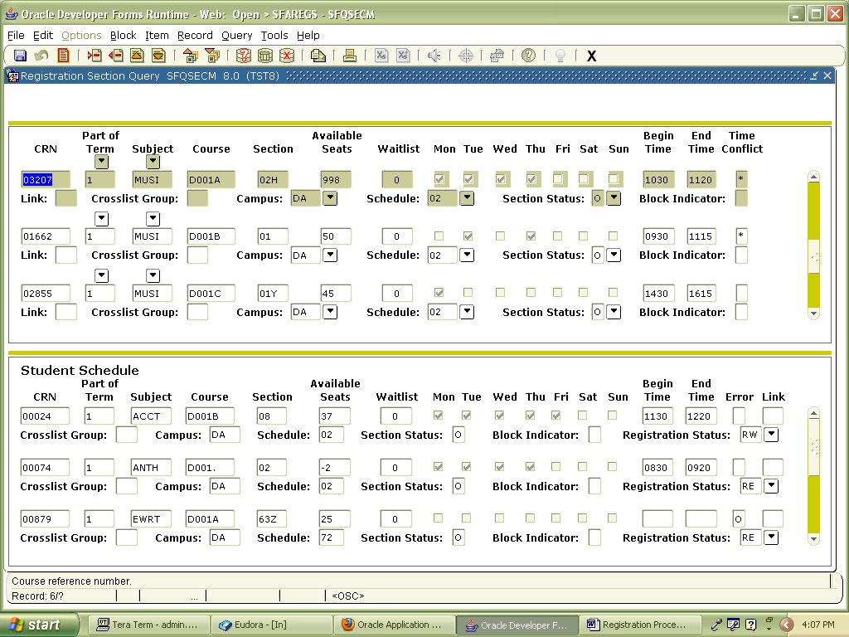

  - Before you choose a class to add to the student’s schedule, look at the Time Conflict field that is located on the right side of the screen. If there is a * in the field that means there is a time conflict with an existing class on the student’s schedule. (The student’s schedule is shown at the bottom of the screen if you need to look at.)
  - Double click on the CRN # of the class you want to add to the student’s schedule. It will then take you back to SFAREGS.
  - Click on the Save button. This is when the system will let you know if there are any problems adding the class.
  - If there are no errors, click on the Save button again.
  - A box will appear stating “Fee Assessment Processed”. Click on the OK button.
- Removing a class if there is an error like a time conflict, prerequisite problem, etc.
  - If the class has a time conflict, prerequisite problem, etc., it will appear on the Course Information block.
Example of time conflict below.

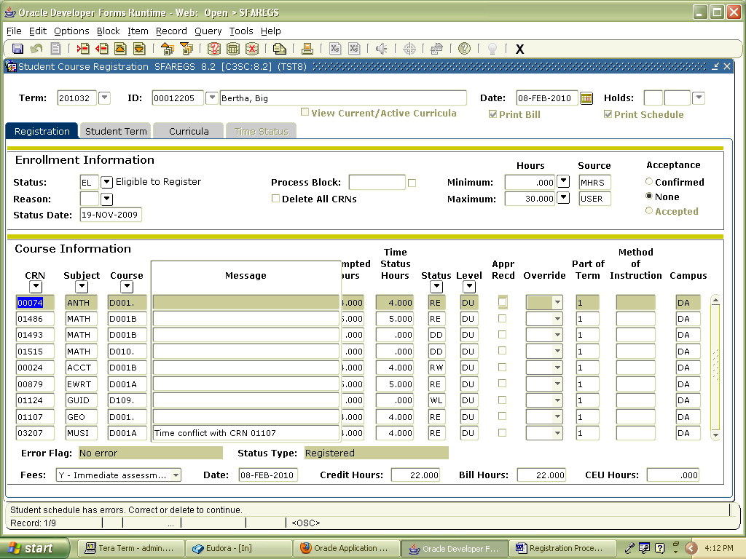
- You will see the code RE under the Status field. Type over the RE code with DD for Drop Delete.
- Then click on Record located at the top of the screen and then click on Remove. This will remove the class from the student’s records.
- Click on the Save button.
- If there are no further errors, click on the Save button again.
- A box will appear stating “Fee Assessment Processed”. Click on the OK button.
- If the class comes up with a prerequisites or co-requisite error and you know that the student is OK to take to the class. (For example: they took the co-requisite the previous quarter.)
- Under the Override field, click on the down arrow and then click on Yes. If there is more than one error for the same class, you can click on All, and the system will then let you add the class by overriding the errors. This should only be used under very special circumstances.
- Click on the Save button.
- If there are no further errors, click on the Save button again.
- A box will appear stating “Fee Assessment Processed”. Click on the OK button.
- Dropping a class.
  - Type a D in the Status field of the class that you would like to drop.
  - Hit the enter key or tab key or the space bar. The correct drop reason will then appear under the Status field.
  - Click on the Save button.
  - Click on the Save button again.
  - A box will appear stating “Fee Assessment Processed”. Click on the OK button.
- Under the Grade Mode field, you can sign up a student for Pass/No Pass.
  - The system automatically gives the student an A in the Grade Mode field. A stands for letter grade.
  - If the student has requested to receive a Pass/No Pass grade, you would type a P in the Grade Mode field. Or you can click on the down arrow, click on P, and then click on the OK button.
  - Click on the Save button.
  - Click on the Save button again.
  - A box will appear stating “Fee Assessment Processed”. Click on the OK button.
- Adding classes with add codes.
  - If the student is already in classes, you must move your cursor to a blank line.
  - If the student’s schedule is filled with classes and you can not easily move to a blank line, click on Record located at the top of the screen and then click on Insert.
  - Enter Call number of the class in the CRN field then either hit the ‘tab’ button or the ‘enter’ button.
  - Click on the Save button.
  - A message will appear stating “Authorization Required: Closed Section.”
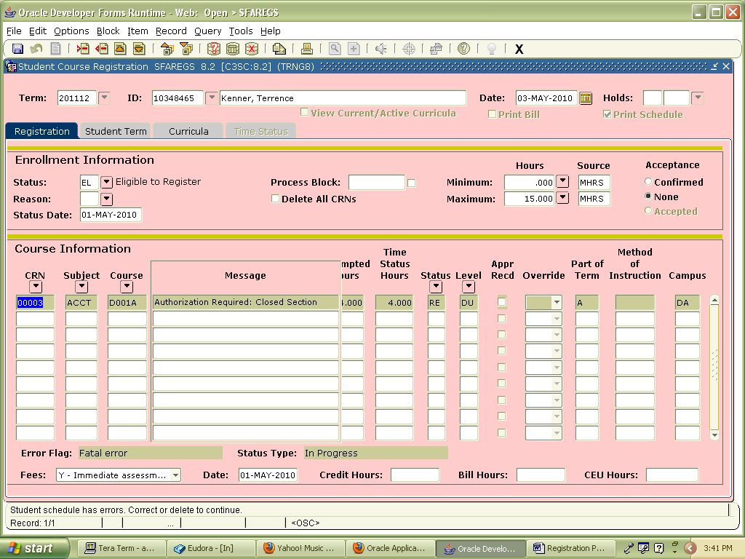
  - Click on Options located at the top of the screen and the click on the last option Enter Registration Add Authorization Code.
  - The system will automatically take you to SVAAUTH.
  - Under the field Authorization Code (Next to the word “INCOMPLETE”), type in the 4 digit authorization code.
  - Located on the bottom right hand corner, click on the Validate button. If the add code is valid, the word “APPROVED” will appear next to the add code you just typed in.
  - Click on the Submit button located on the bottom right hand corner of the screen which will take you back to SFAREGS.

Example of an approved add code below:
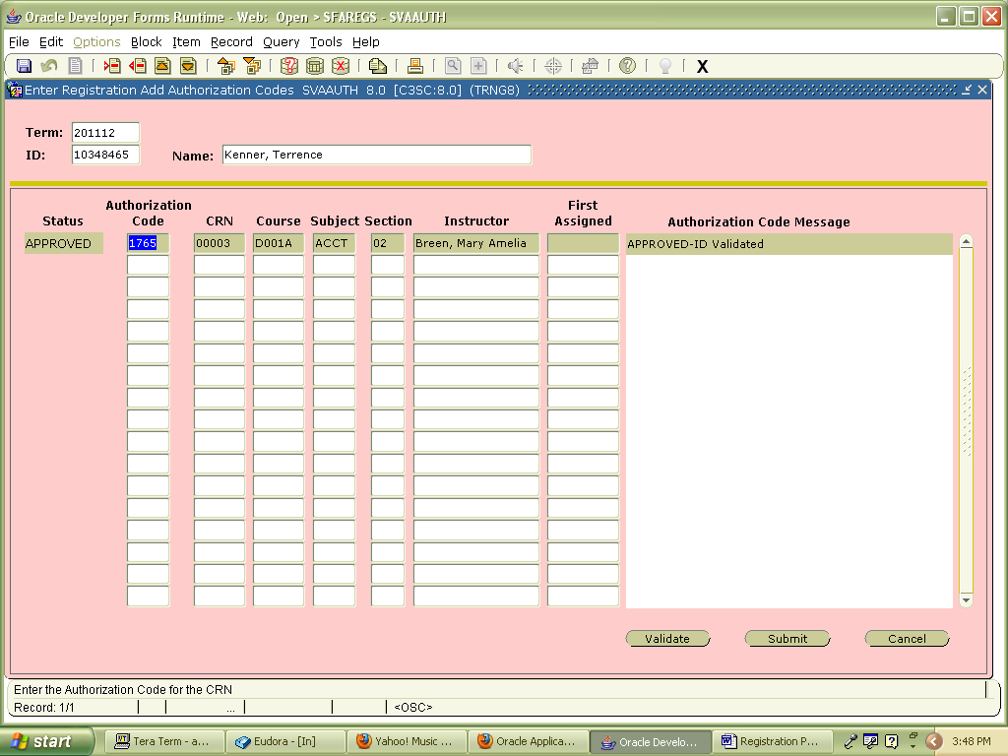

- Click the Save button
- Then click the Save button again. This will bring up a message stating “FEE Assessment processed”. Click the OK button.
- Click the Save button again. This will bring the cursor back to the very top of the screen.
- If you need to add or drop more classes, continue from here.
- If you are all done, Exit from SFAREGS.

Last updated May 3, 2010

