SAP Implementation at FHDA
Whitelaw – August 20, 2009
Updated January 14, 2010

SUMMARY

With Cindy, Kevin, Carol, Sheila and I in attendance, SAP processes were discussed, pros and cons of different implementation methods presented and the conclusion was:
- FHDA will create a district wide SAP status for each active student at the end of each quarter – see POP-SEL logic below
- To create a district SAP status, cumulative and quarter statistics for FH and DA will need to be combined to be used in the RORRULE logic that determines SAP status. Term stats need to include, for instance, the stats from both FU and DU levels for both the FH and DA terms. Cum stats need to include both FU and DU levels as well as any additional (not-in-Banner) transfer hours in ROBNYUD_VALUE_1.
- One SAP status will therefore be calculated for the quarter (combination of FH and DA stats used) and stored for the student with the lowest numbered effective term which happens to be Foothill’s term. This will make it possible to find the effective SAP status for any given term where the SAP effective term <= to the given term.
- Since the combined criteria used to calculate the SAP status is not visible on any form, a PL/SQL procedure needs to run immediately after ROPSAPR to populate user defined fields so the FA counselors can see what the criteria was – ie. date, stats etc.
- NEEDED
  - POP-SEL
  - SAP Statuses set up on RTVSAPR
  - RORRULEs for each rule based SAP status
  - Function to calculate the combined stats to be used by the RORRULEs and the PL/SQL procedure
  - PL/SQL procedure to calculate and post to user defined fields the criteria used to calculate the SAP status
  - Appworx - a 3 step chain
    - Pop-sel, ROPSAPR, Procedure

POP-SEL

The pop-sel logic is too complex to put on GLRSLCT so a script below mimics what GLBDATA would do – delete current PIDM list for the pop-sel then insert new PIDM list.

Create Dummy Pop-sel on GLRSCLT

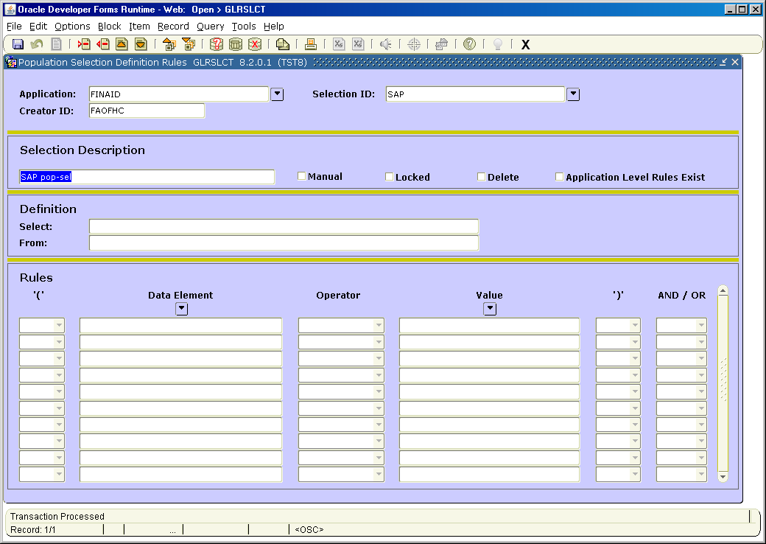

Logic

(Qtr units attempted >= 6 OR Cum Att Units >= 120)
AND
Latest SAP not ‘X’
AND
Has a cum strip for the calc term (SHRTGPA record)

Script

MAKE SURE YOU CHANGE THE TERM ON LAST LINE TO THE CORRECT CALC TERM.

--UPDATE THE CALC TERM VALUE ON LAST LINE !!!!!!!!!!!!!!!!!!
DELETE FROM GLBEXTR
WHERE GLBEXTR_APPLICATION = 'FINAID'
AND GLBEXTR_SELECTION = 'SAP'
AND GLBEXTR_CREATOR_ID = 'FAOFHC'
AND GLBEXTR_USER_ID = 'FAOFHC';
COMMIT;
INSERT INTO GLBEXTR
SELECT DISTINCT
'FINAID',
'SAP',
'FAOFHC',
'FAOFHC',
SFBETRM_PIDM,
TRUNC(SYSDATE),
'S',
' '
FROM SFBETRM
WHERE
(
baninst1.fhda_fa_sap_calc_stats(sfbetrm_pidm,sfbetrm_term_code,'TA') >= 6
or
baninst1.fhda_fa_sap_calc_stats(sfbetrm_pidm,sfbetrm_term_code,'CA') >= 120
)
and not exists
(select 'x'
from rorsapr
where rorsapr_pidm = sfbetrm_pidm
and rorsapr_term_code =
(select max(rorsapr_term_code)
from rorsapr
where rorsapr_pidm = sfbetrm_pidm
)
and rorsapr_sapr_code = 'X'
)
and exists
(select 'x'
from shrtgpa
where shrtgpa_pidm = sfbetrm_pidm
and shrtgpa_term_code = sfbetrm_term_code
)
and sfbetrm_term_code like '20101%';
COMMIT;

SAP STATUSES

Each of the SAP statuses that begin with ‘R’ represents a status that will be calculated by the computer and therefore needs a corresponding RORRULE. Each RORRULE contains the logic that identifies a person that should have this SAP status. RORRULEs will be prioritized so that the desired SAP status will be assigned to the student even if the student may be out of compliance on more than one compliance criteria. Using the translation table, this R-type status will be translated into the final SAP status.

SAP Compliance Criteria

There are four SAP compliance criteria that determine a student’s SAP status.

Units completed
Quarterly GPA
Cumulative GPA
Maximum Time Frame

Since each of the above criteria can have two possible outcomes (in compliance, out of compliance) there are 2^{4th} = 16 combinations. Prioritizing the SAP statuses is important for assigning the correct SAP status

Stats Defined – assume calc term of 201021 as example

QTR institutional attempted units - TA
Sum of term institutional attempted units for both levels FU and DU for both terms 201021 and 201022
QTR institutional earned units - TE
Sum of term institutional earned units for both levels FU and DU for both terms 201021 and 201022
QTR institutional GPA - TG
Combined calculated term institutional GPA for both levels FU and DU for both terms 201021 and 201022
CUM institutional attempted units - CA
Sum of cum overall attempted units for both levels FU and DU plus any not-in-Banner units on ROBNYUD_VALUE_1
CUM institutional GPA - CG
Combined calculated cum institutional GPA for both levels FU and DU
CUM institutional GPA Prior - CP
Combined calculated cum institutional GPA for both levels FU and DU as it was prior to the calc term 201021

SAP Statuses with Rules

RPMAX Rule – Close to Max Time Fr 10
RGOOD Rule - Good Standing 20
RMAX Rule - Maximum Time Frame 30
RCOMP Rule - Units Completed 40
RDCOND Rule – Fails Conditional Prob 50
RGPAQ Rule - Quarterly GPA 60
RCOND Rule - Conditional Probation 70
RGPAC Rule - Cumulative GPA 80

RPMAX – within warning range for Max Timeframe
SAME logic as RGOOD but max timeframe hours test is…
Cum institutional attempted units >= 100 and <120

RGOOD – in compliance for all four criteria

Units Completed – in compliance if…
( QTR institutional attempted units >= 6 and < 9
AND QTR institutional earned units >= 6
OR
QTR institutional attempted units >= 9 and < 12
AND QTR institutional earned units >= 7.5
OR
QTR institutional attempted units >= 12
AND QTR institutional earned units >= 10
)

Quarterly GPA – in compliance if…
QTR institutional attempted units >= 6
AND
QTR institutional GPA >= 2

Cumulative GPA – in compliance if…
QTR institutional attempted units >= 6
AND
Cum institutional GPA >= 2

Max Timeframe – in compliance if…
Cum institutional attempted units < 120
OR
Current SAP like PMAX1-6

RMAX – out of compliance for Max Timeframe
NOT
(
Cum institutional attempted units < 120
OR
Current SAP like PMAX1-6
)

RCOMP – out of compliance for Units Completed
NOT
( QTR institutional attempted units >= 6 and < 9
AND QTR institutional earned units >= 6
OR
QTR institutional attempted units >= 9 and < 12
AND QTR institutional earned units >= 7.5
OR
QTR institutional attempted units >= 12
AND QTR institutional earned units >= 10
)

RGPAQ – out of compliance for Quarterly GPA
NOT
(
QTR institutional attempted units >= 6
AND
QTR institutional GPA >= 2
)

RDCOND – out of compliance for Conditional Probation
Latest SAP code is PCOND
AND
NOT
(
Cum institutional GPA >= Cum institutional GPA as it was end of prior term
AND
Cum institutional attempted units <= 90
)

RCOND – in compliance for Conditional Probation
Latest SAP code is PCOND
AND
(
Cum institutional GPA >= Cum institutional GPA as it was end of prior term
AND
Cum institutional attempted units <= 90
)

RGPAC – out of compliance for Cumulative GPA
NOT
(
QTR institutional attempted units >= 6
AND
Cum institutional GPA >= 2
)
FUNCTION FHDA_FA_SAP_CALC_STATS (owned by BANINST1)

This function calculates the stats and is used by the RORRULEs and the Procedure. It calculates district wide stats by combining both FU and DU levels for both the FH and DH calc terms. Only one of six values is returned as specified by the parameters. If there’s any kind of error calculating a value a null will be returned.

Parameters

PIDM
Calc term
- SAP calc term, term grades just posted
- Always use the FH term and the DA term values will be included automatically
Stat Type (one of the following, see Stats Defined above)

TA - Term institutional attempted hours
TE - Term institutional earned hours
TG - Term institutional GPA
CA - Cumulative institutional attempted hours
CG - Cumulative institutional GPA
CP - Cumulative institutional GPA as of prior term

PROCEDURE FHDA_POST_SAP_STATS (owned by BANINST1)

This procedure runs through the pop-sel PIDM list (ideally the same pop-sel PIDM list used to run ROPSAPR) and posts the stats that were used to calculate the student’s SAP to the appropriate term fields on ROAUSDF values 41-59.

This procedure should be run immediately after ROPSAPR so the stats are as close to what was used for calculating the student’s SAP. If ROAIMMP is used to update a student’s SAP or if a SAP status is manually changed, this procedure will not be run, so the stats on ROAUSDF may be out-of-sync with the newly calculated SAP code.

Since SAP will be run for all enrolled students for the calc term (SFBETRM record exists), this procedure will create a ROBUSDF record and/or the corresponding RORSTAT record if they do not exist. The aid year used will be the STVTERM_FA_PROC_YR associated with the calc term parameter. So because of this, just because a RORSTAT record exists for the aid year does not mean the student is active in FA for the year.

Parameters

Calc_term – same calc term just used by ROPSAPR
Application of pop-sel – same as just used by ROPSAPR
Name of pop-sel – same as just used by ROPSAPR
Creator_ID of pop-sel – same as just used by ROPSAPR
User_ID of pop-sel – same as just used by ROPSAP

LABELS

Each year, labels for values 41-59 need to be set up on RORUSER for the aid year.

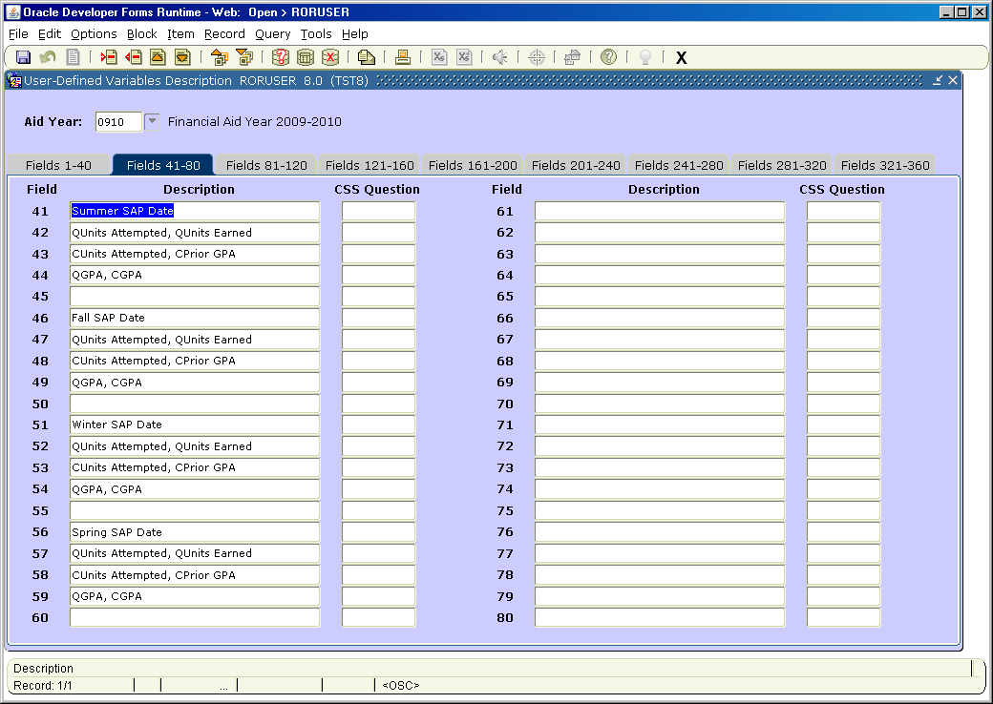

SAMPLE RESULTS

As the example below shows for 0910 combined stats are displayed. The date is the date the stats were posted, not necessarily the date the student’s SAP code was created.

Summer 201011, 201012 stats show in values 41-44
Fall 201021, 201022 stats show in values 46-49
Winter 201031, 201032 stats show in values 51-54
Spring 201041, 201042 stats show in values 56-59

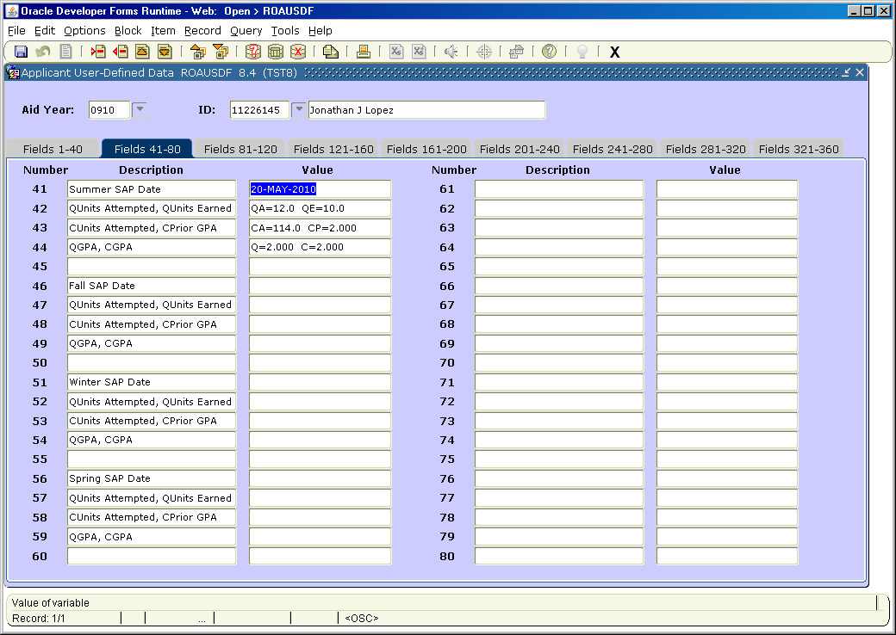

APPWORX – Execution Order

- Execute the pop-sel script to get the PIDM list of students for whom SAP will be run.
  - Make sure the correct calc term is entered into the script on the last line
  - Used, for example, ‘20101%’, with the wild card character to make sure it picks up all students with an enrollment record in either of FH or DA terms

- Run the ROPSAPR process with the correct calc term, effective term and pop-sel defining parameters.
  - Verify that it ran successfully
  - Check the distribution of codes on ROIGRPI for the effective term

- Execute the procedure to post the stats to ROAUSDF

exec baninst1.fhda_post_sap_stats('201011','FINAID','SAP','FAOFHC','FAOFHC');

