SFARCTL/SFARCTT/SFARGRP

These screens are used to set up time tickets for registration. This is considered “Static” time tickets. There is also “Dynamic” time tickets. “Static” should be used because the student will be able to view their date and time to register on the WEB. If you use Dynamic you will not be able to see the dates to register. For Static the ETS department will need to create a script for priority groups and the following are screens are done on Admissions part to set up the dates to register. The drawback is you have to keep running to catch any new applicants. Dynamic is up to the second accurate. Also with Static you do not pull the priority group from the Cohorts screen. You have to attaché the student to the defined group on SFARGRP. That means the persons responsible for flagging the students (Eops, DSS etc) would need to have access to this screen in order to flag the student. The information would not be taken from the existing co-hort screen. You could only do that on the “Dynamic” time ticket.

SFARCTL
This form is used to define registration group codes and the assigned registration priorities for those group codes for student Self Service Web.

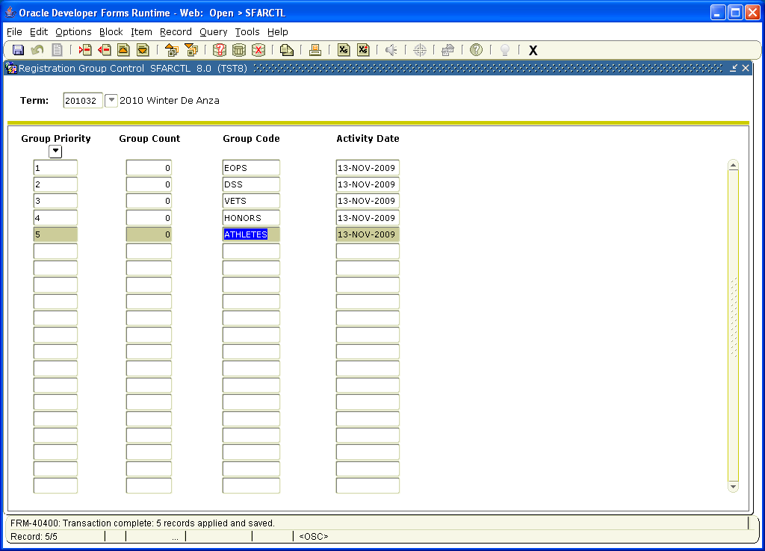

SFARCTT
This control form is used to define rules that assign the begin and end dates and times, and priority assignment for each registration time slot for student Self-Service Web registration.
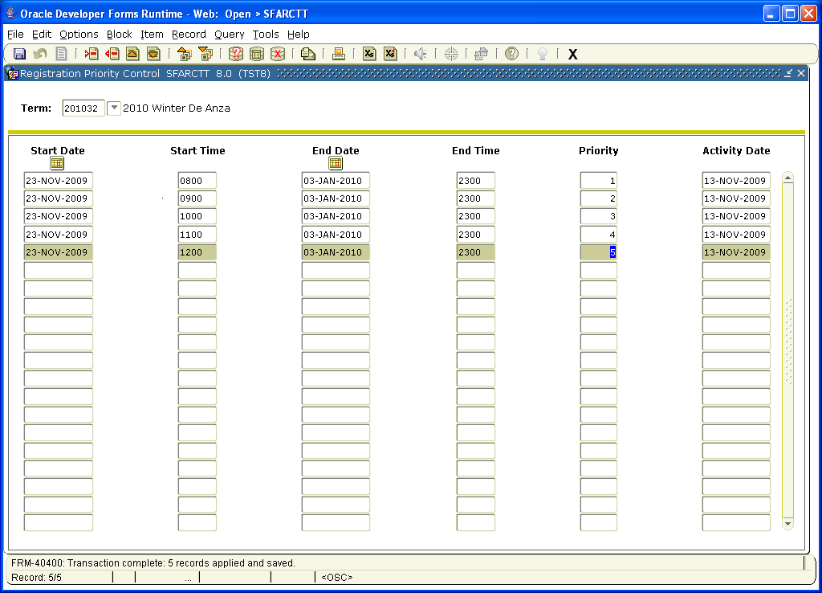

SFARGRP
This form is used to assign a registration group to individual students on a term by term basis. A registration group that has been defined, but not associated with a priority cannot be assigned to a student on this form. Only one registration group can be assigned to a student for a specific term.
