SFAREGS

The SFAREGS screen is the registration screen.
In the FIRST BLOCK:
You would enter the quarter, year and student ID.
You can backdate the date (in the date space) and all the adds and drops will be backdated to the date used.
The hold box will show a “Y” if there is a hold. If there is a hold you can click on the down arrow to see what the hold is.

In the SECOND BLOCK you will find “Enrollment Information” (click on next block to get to the second block. You would click on Block at the top of the page and choose next)
The STATUS should be “EL” for eligible to register.
Under “REASON” you can put a drop reason if you would like to drop the students from all the classes they are enrolled in. This would be a withdraw from school.
The “STATUS DATE” will be the current date.
The space after “PROCESS BLOCK” would be used for students who have no choice in registration and need to be registered in a block of classes.
If you check the “DELET ALL CRNS” all the courses will be drop deleted from the students schedule.
You can change or specify the unit amounts in the spaces following “MINIMUM” and “MAXIMUM” hours. If the student has the exceeding units petition approved you would increase the unit amount after the “Maximum Hours”.
The “ACCEPTANCE INDICATOR” is used to indicate the cashiers have accepted payment from the student and will not be dropped for non payment.

THIRD BLOCK (click on next block to get to the third block)
In the third block of SFAREGS you can register students. If you know the Call number you can type it in the CRN space. If not you can click on the down arrow of “CRN”, “SUBJECT”, “COURSE” or “SECTION” it will bring up up SFQSECM (you can view that screen on the bottom of this page). You can click on to the “Subject” arrow which will bring up all the departments offered at De Anza and Foothill. You can click on the subject you are interested in and it will populate in the subject box. You can also type in the course number if you know it. You then can click on QUERY at the top of the form. Choose EXECUTE and all the classes under the department will appear. You can then choose and click on the class you are interested in and it will bring it to the SFAREGS screen. Before you choose the class view the TIME CONF:LICT at the end of the page. If there is a * in the space that means there is a time conflict with an existing class on the students schedule. (The students schedule is shown on the bottom of the page for you to look at).
Once you have the class listed on the SFAREGS you would go to the top of the page and click on the save ICON (it looks like a disk) on the top left hand side of the form. If the class is good to go it will give you a message at the bottom of the page. It the class is good you need to click the save ICON again to process the fees.
If the class has a time conflict, prerequisite problem etc it will appear on the class portion of the page. If you have an error like prerequisite or time conflict you can go to the status column (in the middle of the page) and change the status to DD for drop delete. You then go to RECORD at the top of the page and choose RECORD REMOVE. Then click on save to process the delete. Then save again to process fees.
If the class comes up with a problem like prerequisites or Co-requisites and you know they are really ok for the class ( for example they took the co requisites a previous quarter) you can click on the down arrow in the OVERIDE column and then click on YES. The system will then let you override the student and add the class. This should only be used under very special circumstances.
Once the drop and withdraw periods begin you can go to Status, type in the letter D and hit the space bar and the correct drop reason should appear for that period. Then hit the save button. Then hit the save button a second to process fees.
SFAREGS
Also on the third block is the “Grade Mode” option . If the student had requested Pass/No Pass online it would be indicated in this space. You also can manually enter a Pass/No Pass on this option by typing in “P” or clicking on the down arrow and choosing P.

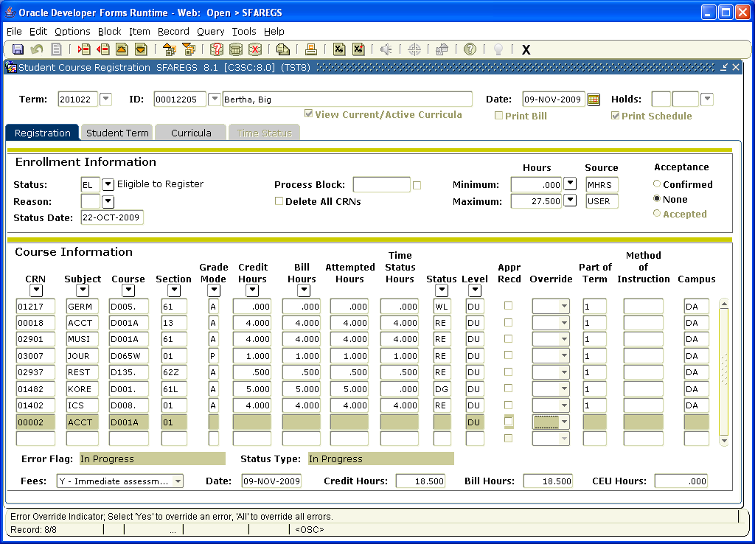
The bottom screen is the schedule screen that comes up when you are searching for a class SFQSECM:

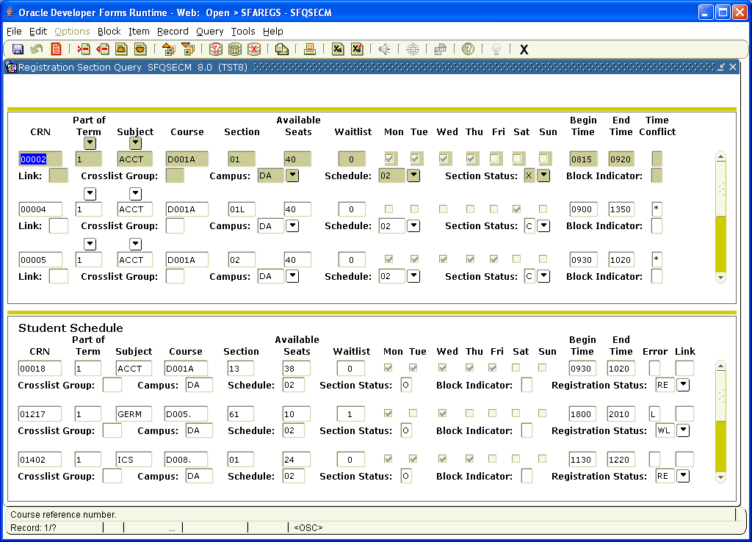

Once the quarter has begun and the add code is required for registration you would go to the top of the form and click on options. You would need to choose the last option “Enter registration add authorization codes” which would bring up “SVAAUTH”.
On this form you would type in the code under Authorization Code, the call number and then click on “Validation” on the bottom right of the page. You will get a message that it is valid and then you would click submit to add the student. This would bring back to the SFAREGS where you would click on the save button twice to add and assess fees. The add code is attached to the student ID and can be used again for two days. This means if the students drops the class they can readd themselves back into that class for 48 hours.
