SFAREGS – Second block-Options Menu

On the SFAREGS screen you can access other screens by going to the options menu at the top of the screen. You can get different options depending on what Block you are in. Each Screen in Banner is divided into blocks. SFAREGS has three blocks. This is the guide for the Options menu in the second block. There are several options that are in all three of the blocks Options Menu and I will indicate them

The first option in the second block is “Detailed Student Information”. This is the SGASTDN screen or general person screen you use when you enter an application manually. This is also in the block one menu.

The next option is “Update Students Term Information” This screen tells you the status of the student (New, Transfer, Returning etc), whether the student is active and the residency. You can update on this screen also
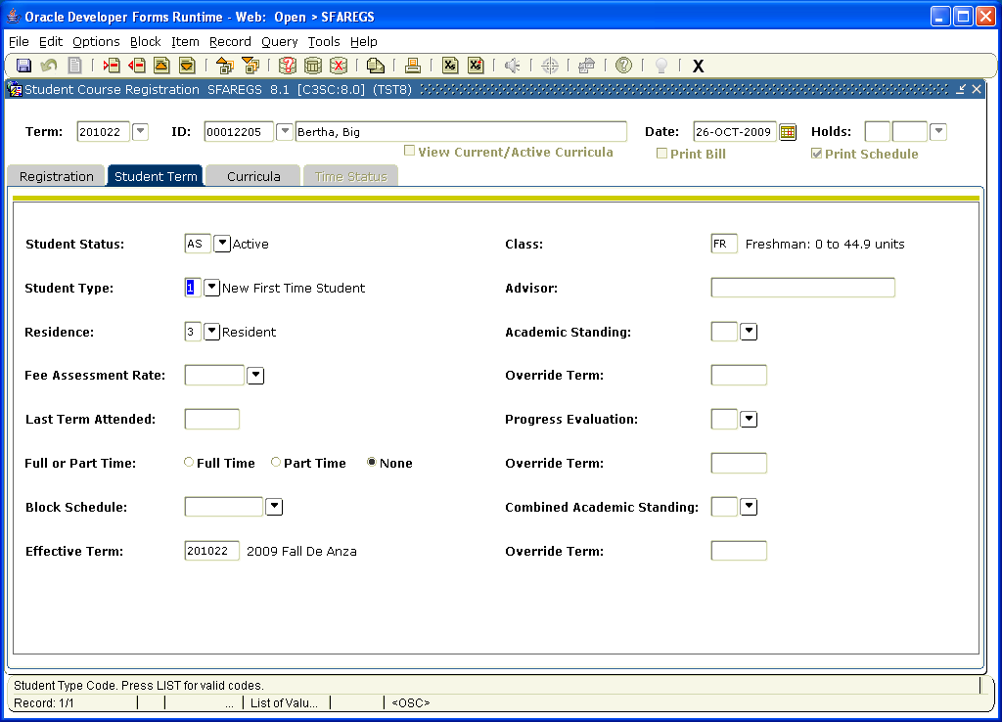

The next option is the “Student Withdrawal Information” SFWDRL. This would be used if the student withdrew from school. Not a screen we would likely use much.
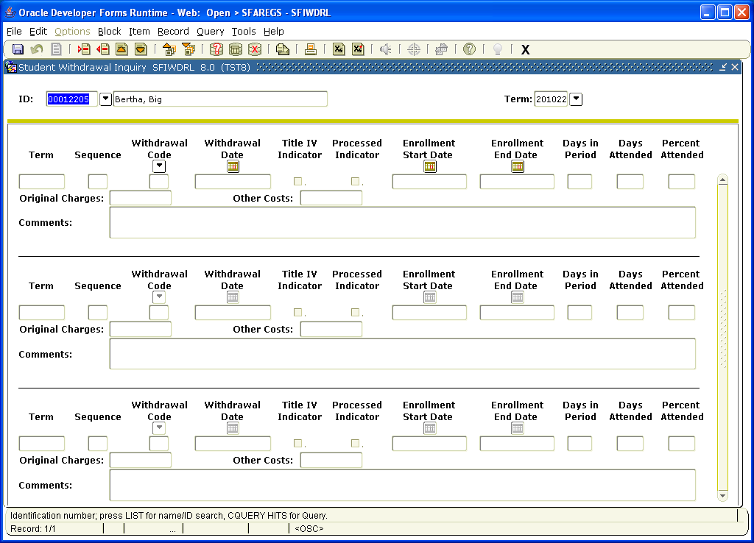

The next option is “Update Curriculum” This is basically the screen you would put the students major or you can update the major. 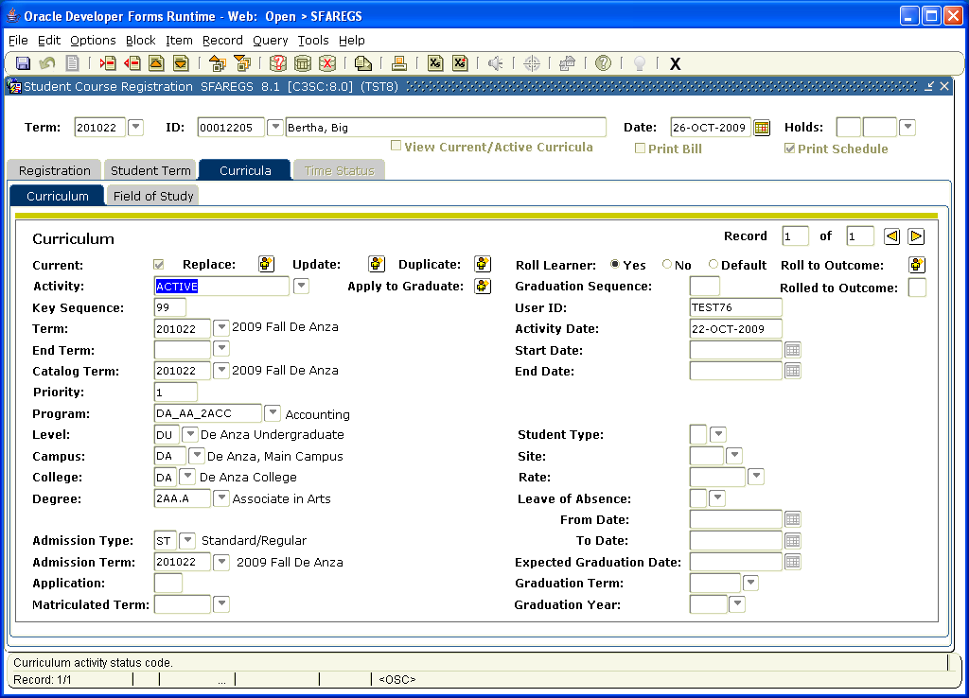

The next screen “View Student Schedule of Classes” SFAREGQ gives you the schedule for the student for a particular quarter and year. The will be broken down by class and the days and time of the class. This is also in the first block option.
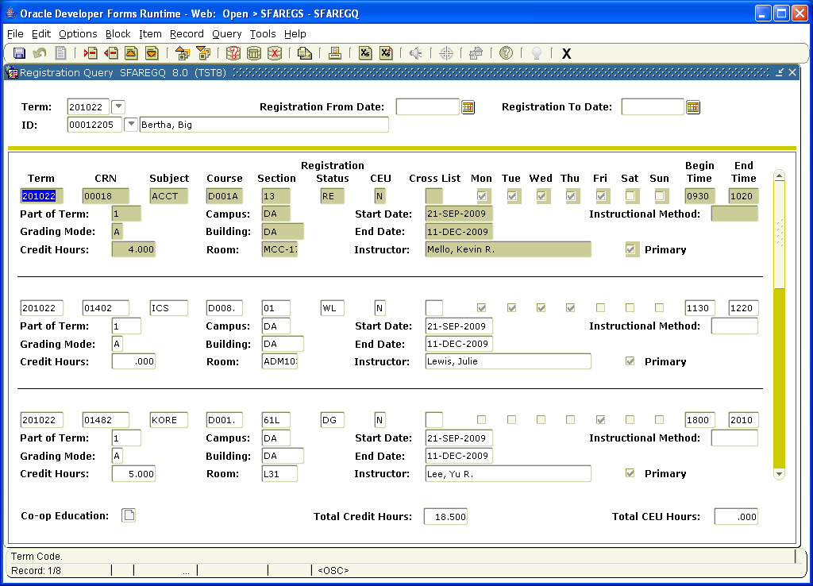

The next option is “Student Attributes and Cohorts” which would give you any special programs the student is part of like EOPS or Athletics. You can also add them to cohorts. This is also in the first block options.
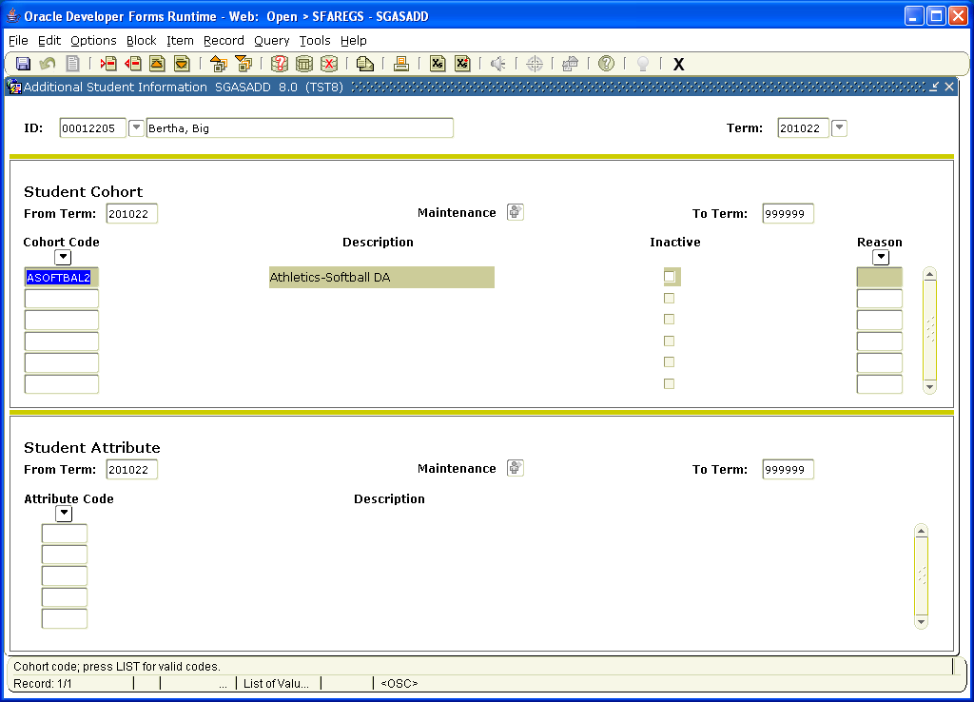

The next option is “Test Score Information” SOATEST where you can view the placement test scores. This is also in the first block options. 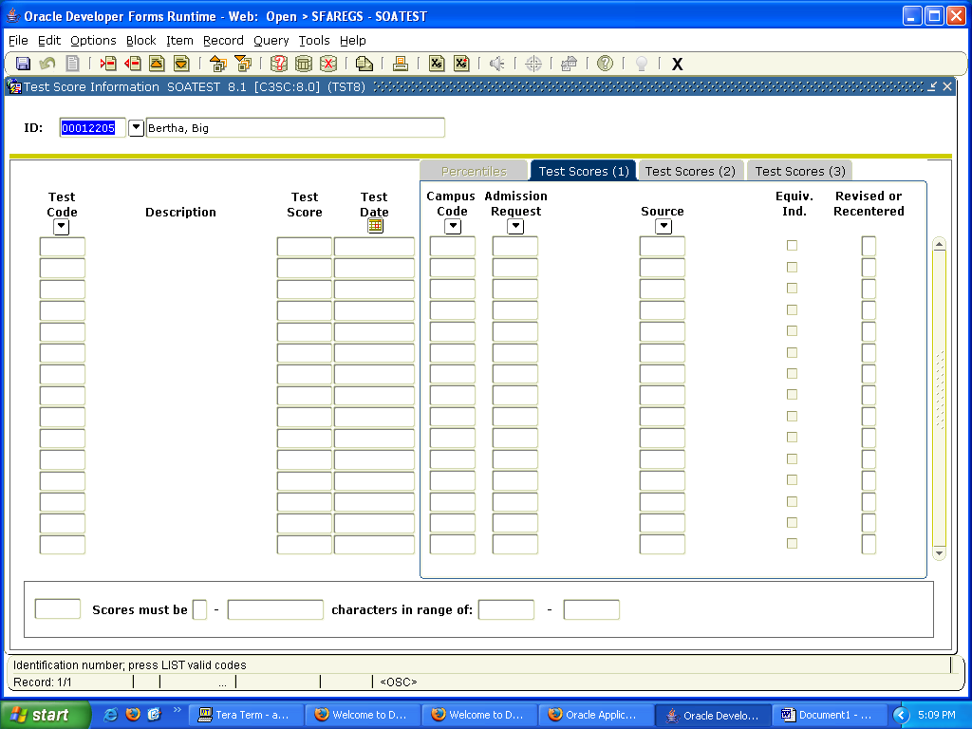

The next option “Charge Optional Registration Fees” SFAEFEE would be used by the Cashiers office only. This also is also in the first block options. 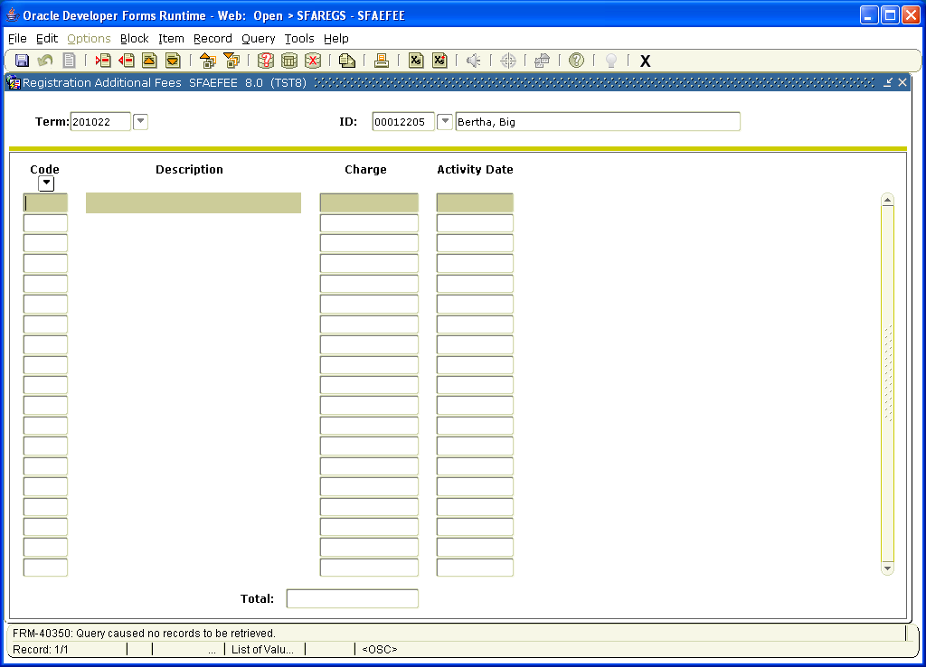

The next option is “Review Account Detail” TSAAREV where you can see the fee detail in a certain quarter and year. This is also in the first block options.
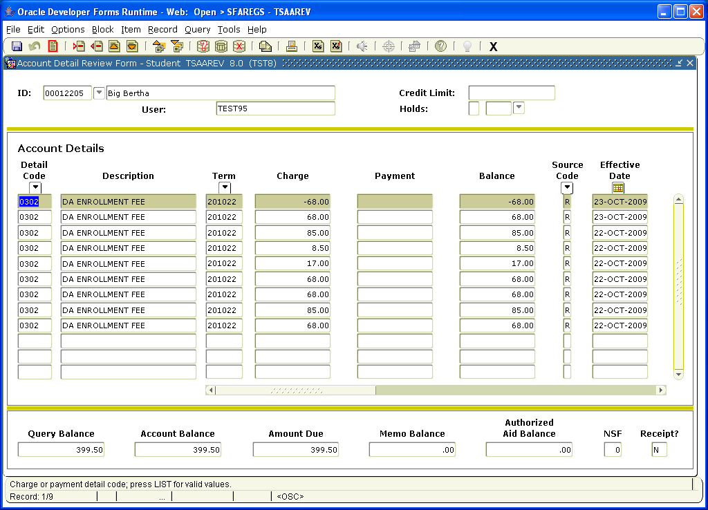

The next option is “Review Student Classes and Charges” SFAREGF. You can view the student schedule per quarter and year. Once you are in the class schedule you can hit the Options again and view the fees with Min/Max applied or an Audit trail for fees SFAFAUD. This is also in the first block option.
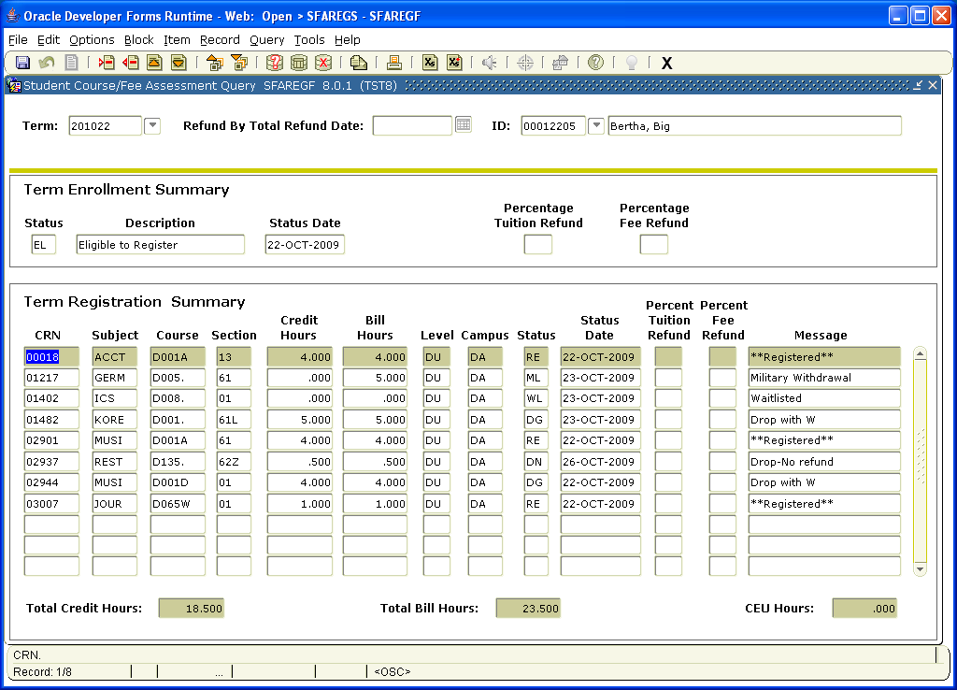

The next option is “Summary student information” “SGASTDQ” where you can see if someone is on probation or Dismissal. This is also in the first block option.
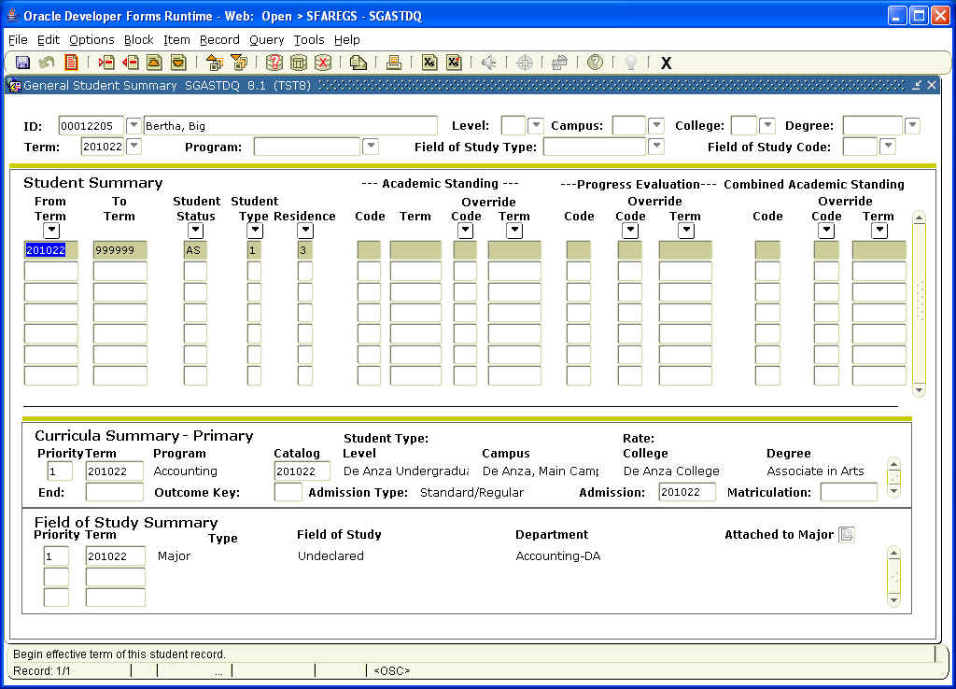

The next option is “Degrees and Awards “ SHADEGR” where you can see a students graduation and degree status at De Anza. This is also in the first block option.
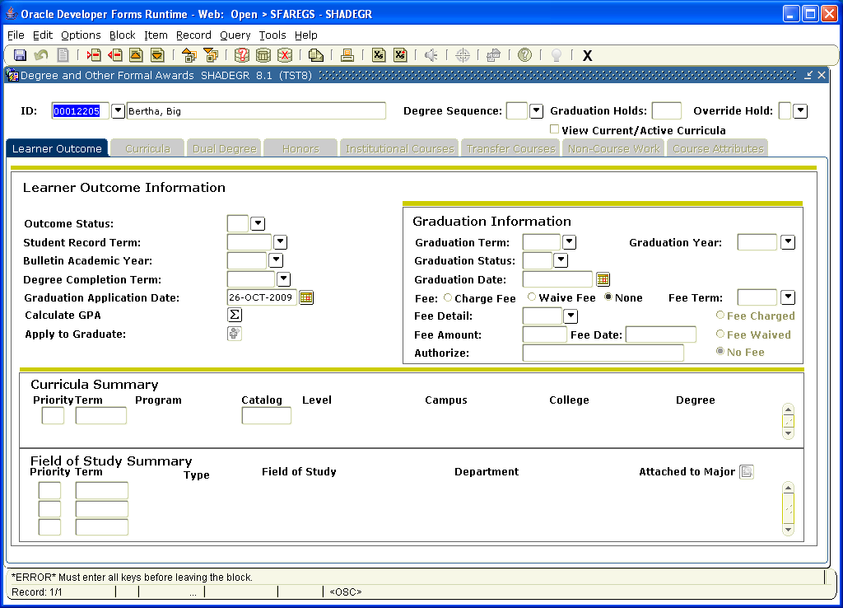

The next option is “Graduation Application” which only the evaluators have access to. This is also in the first block options.

The next option is “Person System Identification” GUASYST which gives you information on what area the person originated. For example if the person is staff and falls under human resources or if the person is a student and was admitted. This is also in the first block options.
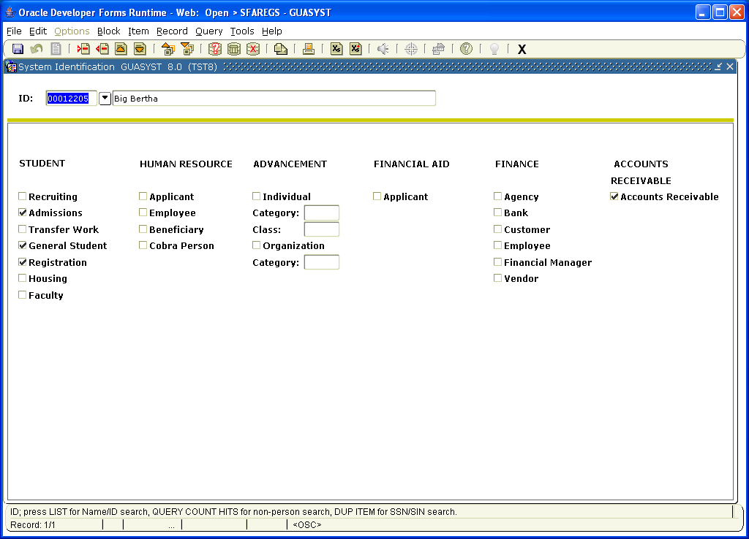

The next option is the “Admissions Application Detail” SAAADMS which is the application screen which has already been reviewed. This is also in the first block options.

The next option is “Define Time Status Rules” SFATMST which tells you how many units constitutes Full time, Half time or less than Half time. This is also in the first block options.

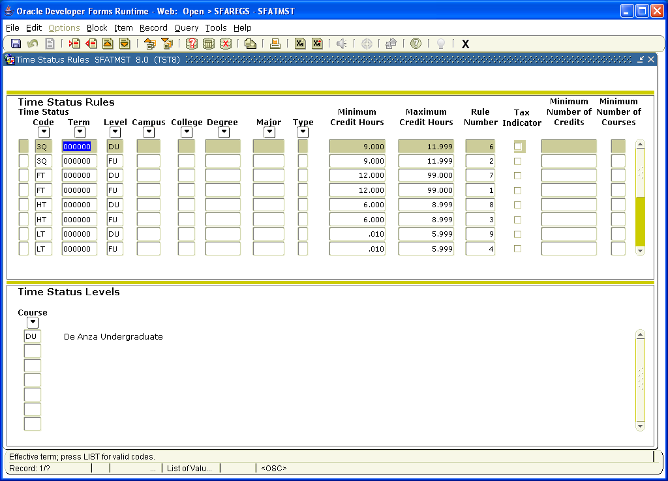

The next option is “View Registration Messages”. Once you click on that option any classes that the student is enrolled, dropped or waitlisted in that appear on the bottom block of SFAREGS will come up with specific messages about the registration. This will include the date the transaction occured.
