SFAREGS Third Block Options Menu

This is the SFAREGS (registration screen in banner) options menu for the third block of the screen. This is the bottom portion of the screen where you would add/drop and waitlist classes. For different options and screens you can access from this block you would click on the options menu at the top of the screen.

The first option is “Detailed Student Information” SGASTDN. This is a screen used for general student information and is also listed in the menu options in the first and second blocks.

The next option is “Update Students Term Information” which is a screen you can view to see if the student is active, type (new, former etc) and their residency. This is also an option in the second block.

The next option is “Update Curriculum” where you can view and update the students major. This is an option you can in the second block also.

The next option is “Student Attributes and Cohorts” SGASADD where you can see any special programs the student is in (Athletics, EOPS, Veterans etc). This is also an option in the first and second blocks.

The next option is “View Student Schedule of Classes” “SFAREGQ”. You can view the students schedule of classes for a specific quarter and year. You can see the days, times, location and instructor. This is also an option the second block.

The next option is “Section Information” SSASECT. There are four tabs going across the top of the page. The first tab is Course Section information. This would include accounting method, days, units, whether its open etc.
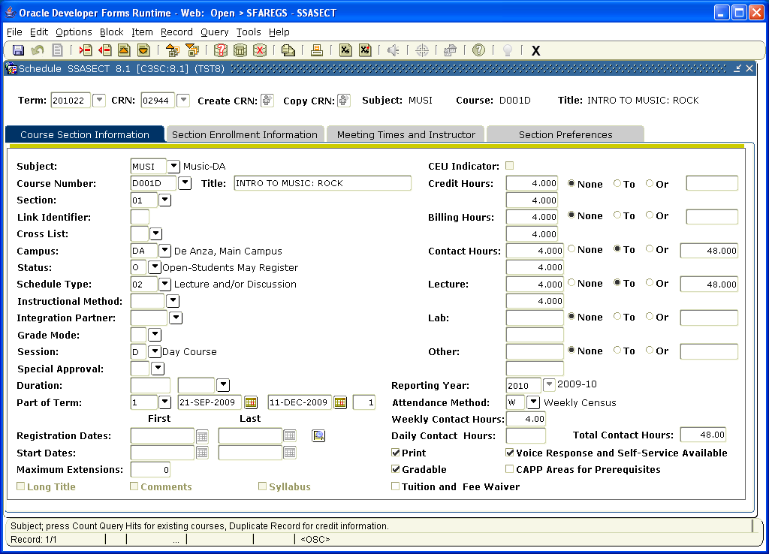

The next tab in the “Section Information” SSASECT is the section enrollment information. This would tell you how many seats open, how many enrolled, how many possible on a waitlist and how many on the waitlist.
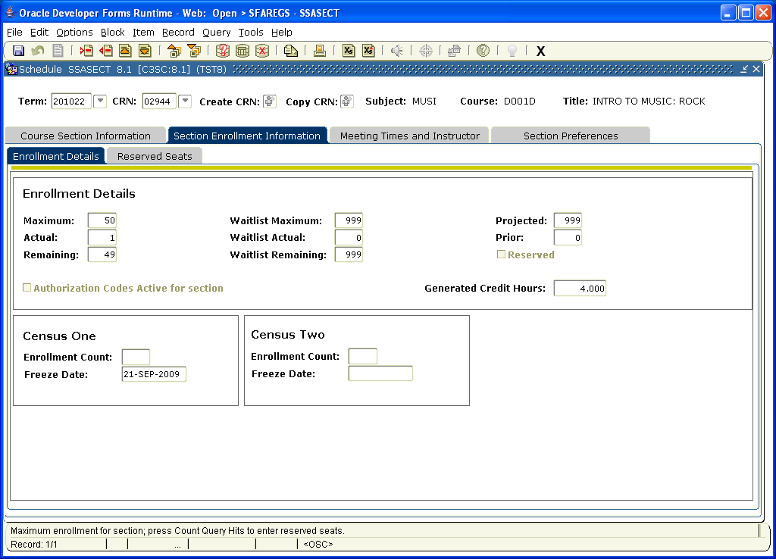

The next tab in the “Section Information” SSASECT is meeting time and instructor.
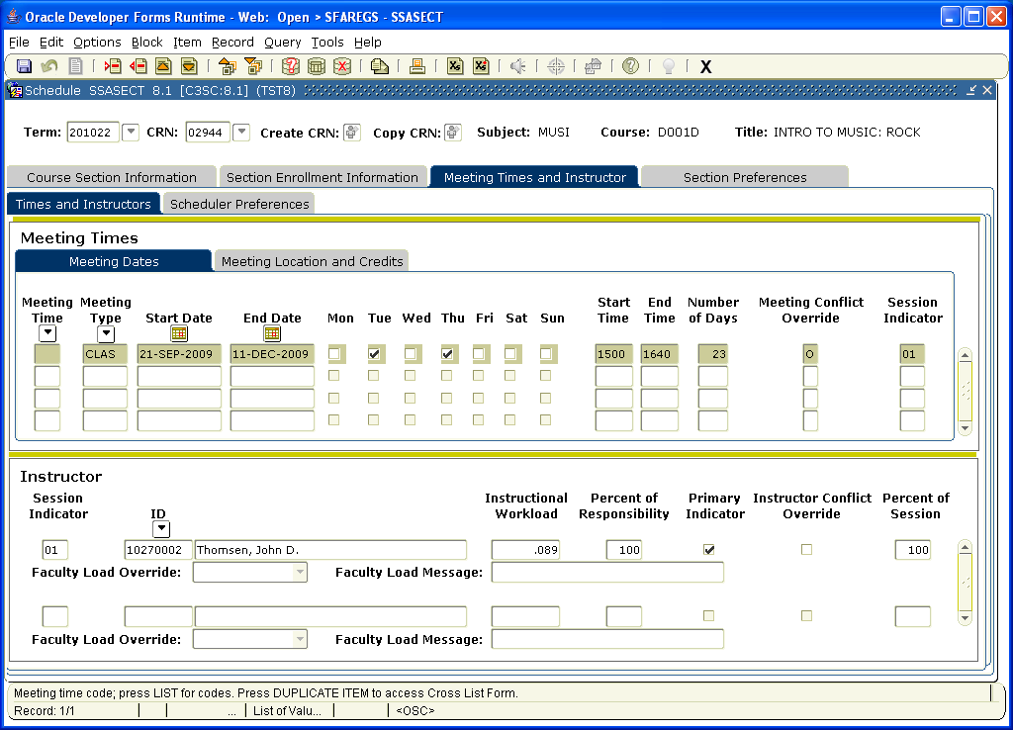

The fourth and last tab in “Section Information” SSASECT is Section preferences.
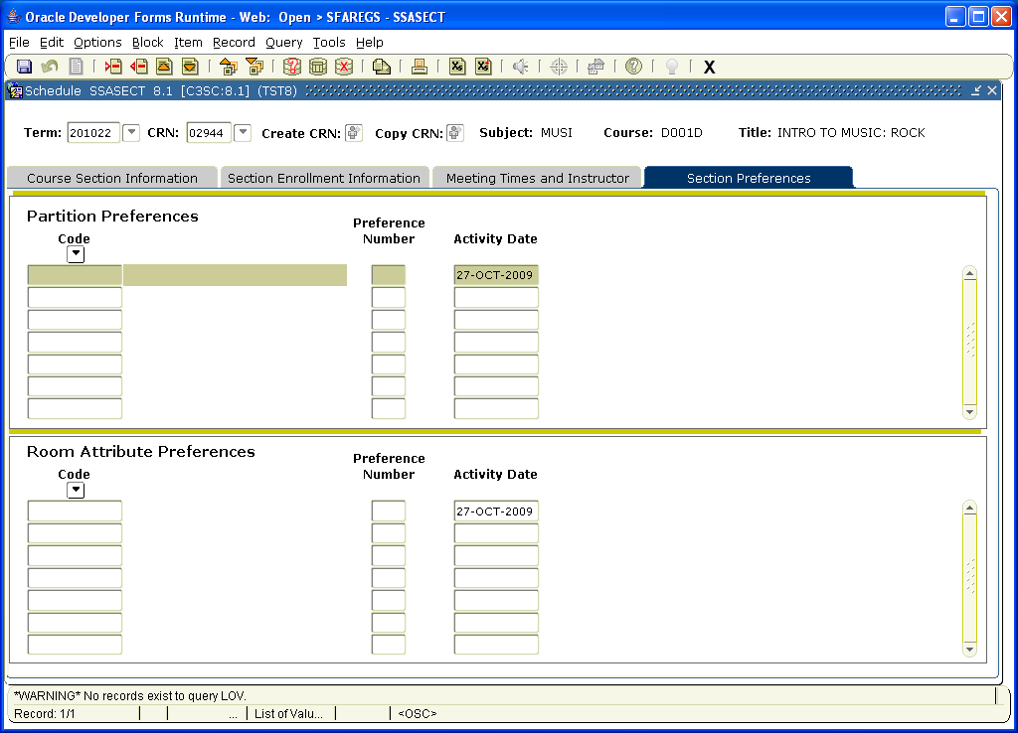

The next option is “View Class Roster” SFASLST. You can see the student who are enrolled, waitlisted and dropped for specific section of a class.
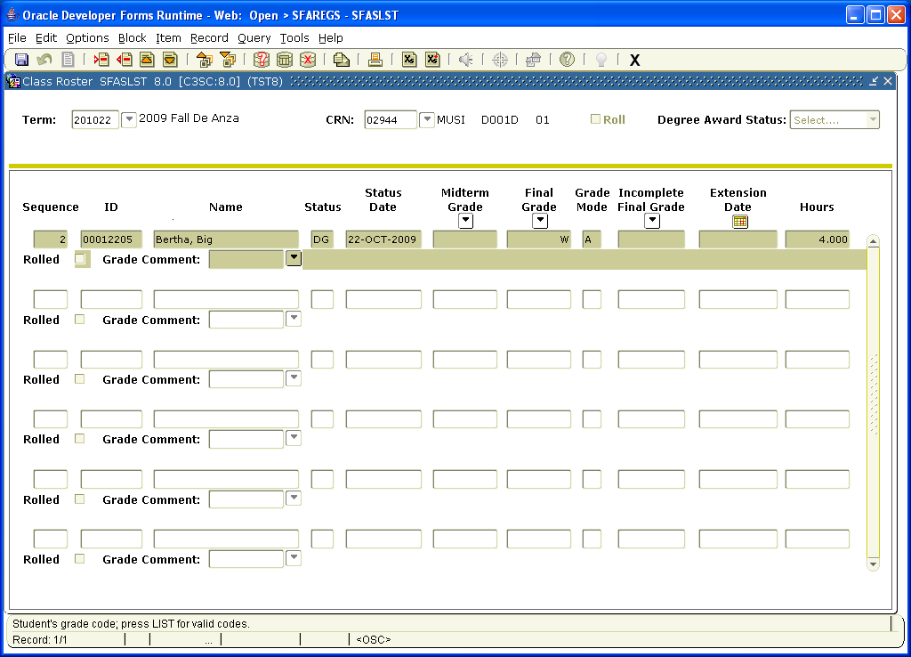

The next option is “Test Score Information” SOATEST. You can view the placement test results for students. This option is also in the first and second blocks.

The next option is “Charge Optional Registration Fees” SFAEFEE. This would be used by the Cashiers office. This option is also in the first and second blocks.

The next option is “Review Account Detail” TSAAREV. You can view the fees and what has been paid and any outstanding balances. This option is also in the first and second blocks.

The next option is “Review Students Classes and Charges” SFAREGF. You can view the student schedule on this option. Once in this screen you can click on options to view the fee audit trail also. These options are also in the first and second block

The next option “Schedule Cross List Information” SSAXLSQ. This screen would show you the enrollment of a cross listed course and what the total seats are and how many seats remaining. In Banner cross listed course seating is combined. The seating is not separate as in SIS Plus.
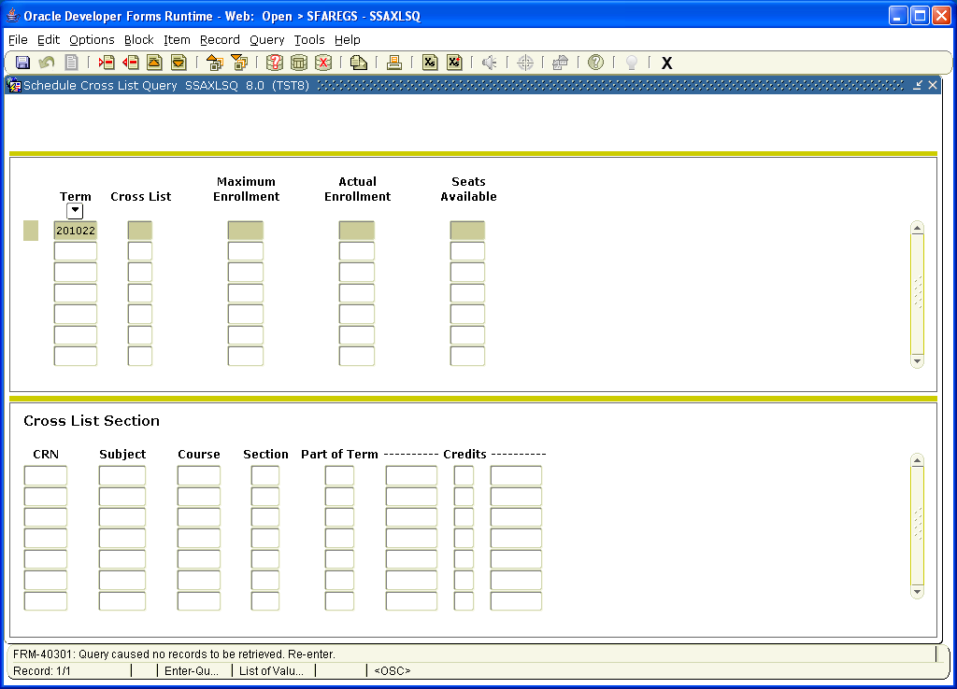

The next option “Summery Student Information” SGASTDQ” shows the Academic Standing of a student and if they are on Probation or Dismissal . This option is also in the first and second block.

The next option is “Degrees and Awards” SHADEGR. This will show any degrees or certificates the student has. This option is also in the first and second blocks.

The next option is “Graduation Application” and only the evaluators will have access to this screen. This option is also in the first and second blocks.

The next option is “Person System Identification” GUASYST. This screen tells you where the student originated. If the student was entered into the system through an application, human resources or financial aid. This option is also in the first and second blocks.

The next option is “Schedule Restrictions” SSARRES. This screen will stop students from registering from classes with five different categories. The screen has five different tabs specifying the categories.

The first is Department and Field of Study.
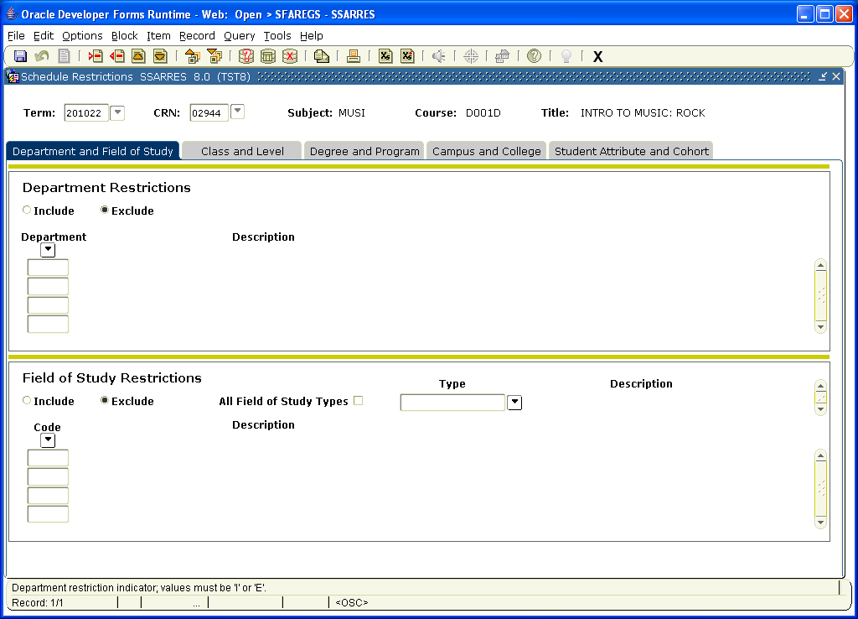

The next tab is Class and Level. You could for example prohibit a high school student from taking a class on this screen
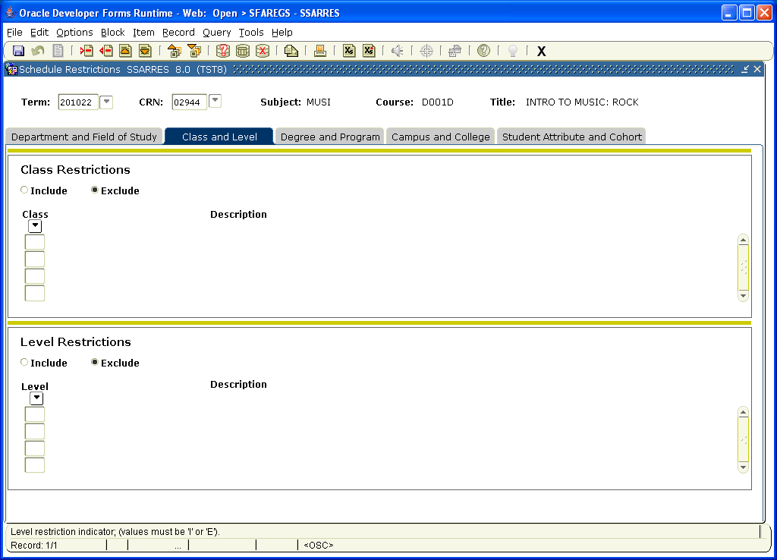

The next tab is degree and program.
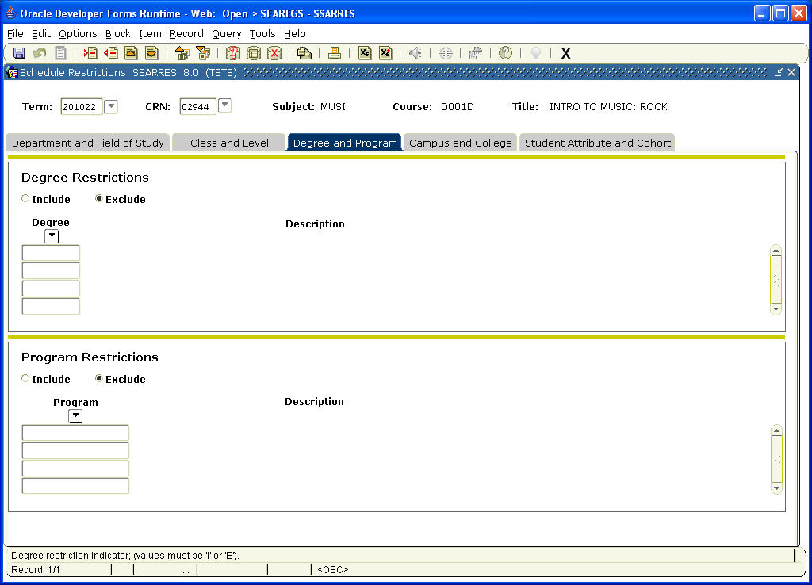

The next tab is Campus and College.
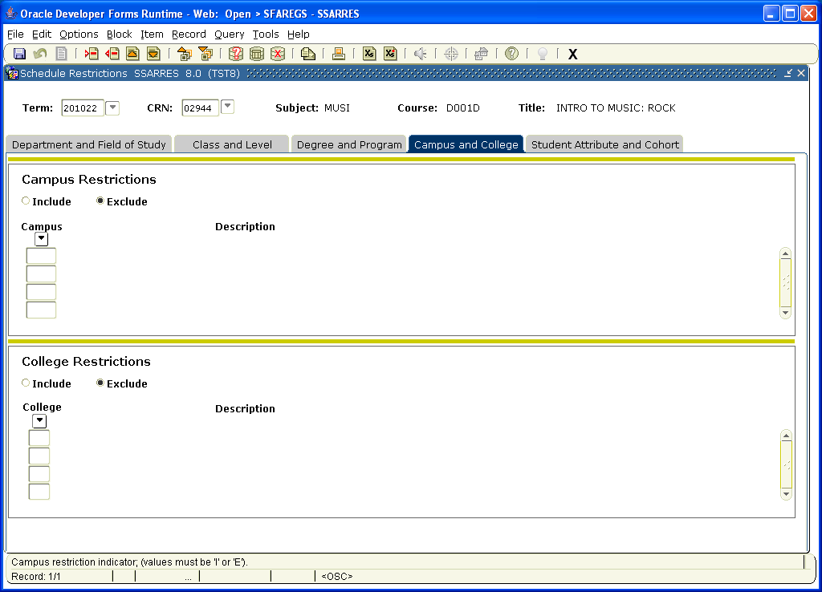

The next tab is Student Attribute and Cohort.
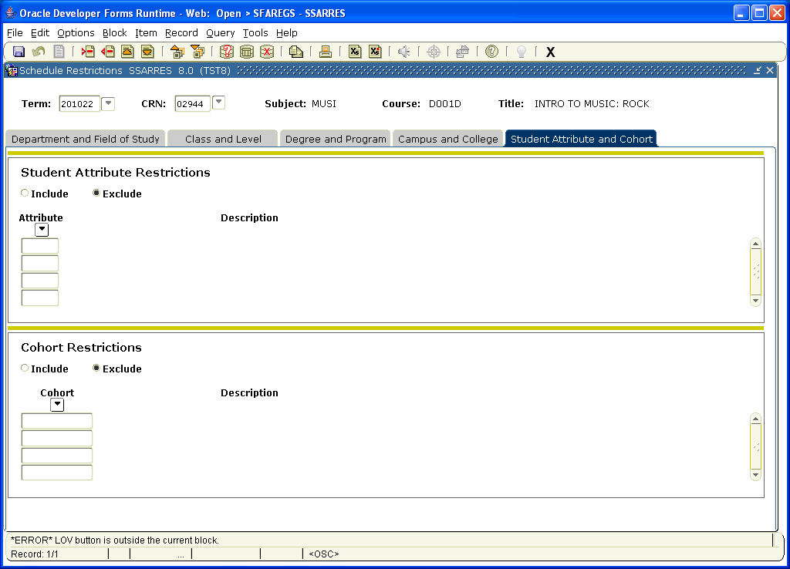

The next option is Schedule Detail SSADETL. This screen has four tabs. The first is Section links and Corequisites. This screen will show whether a section has classes that are linked with it or whether a class has corequisites.
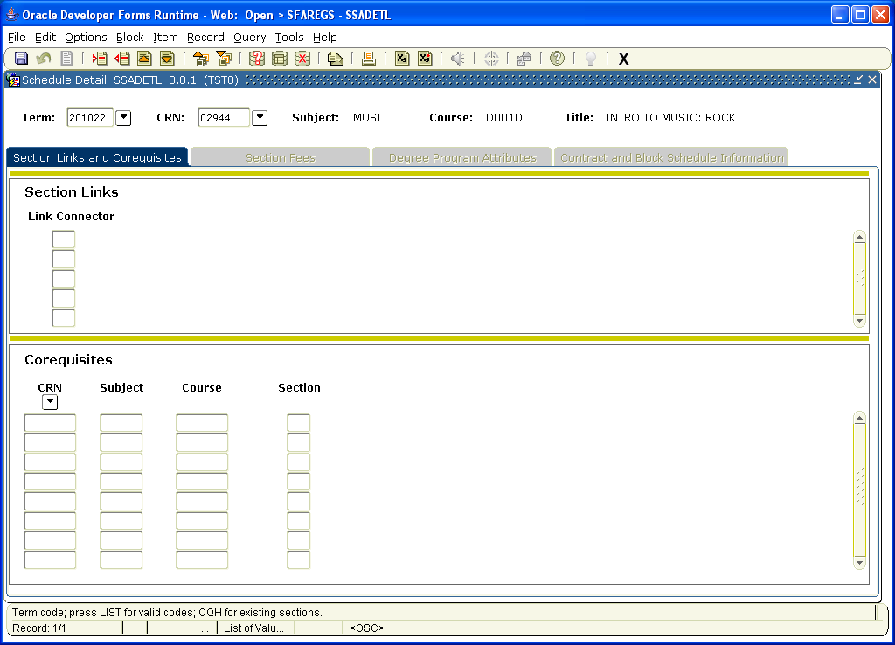

The next tab in this screen is section fees. This will show if the class section has fees associated with it.
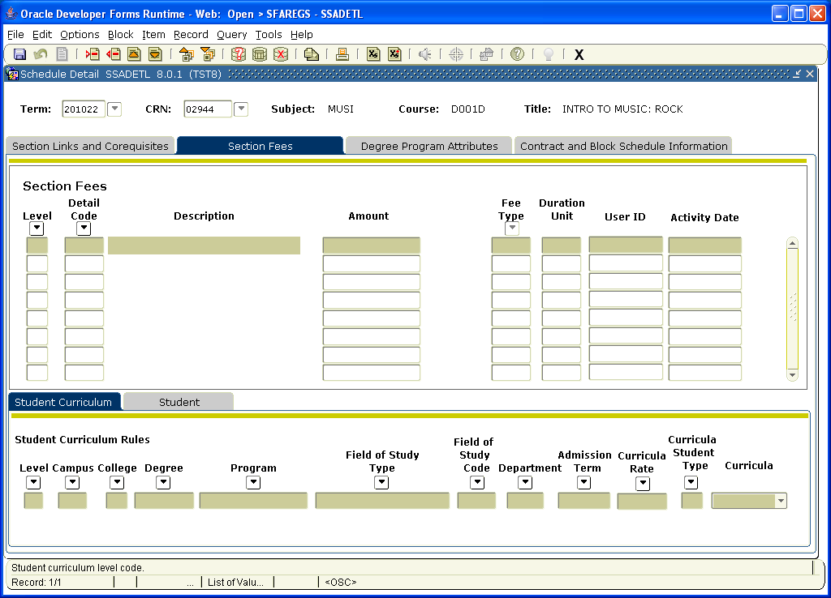

The third tab in this screen is Degree Programs and attributes.
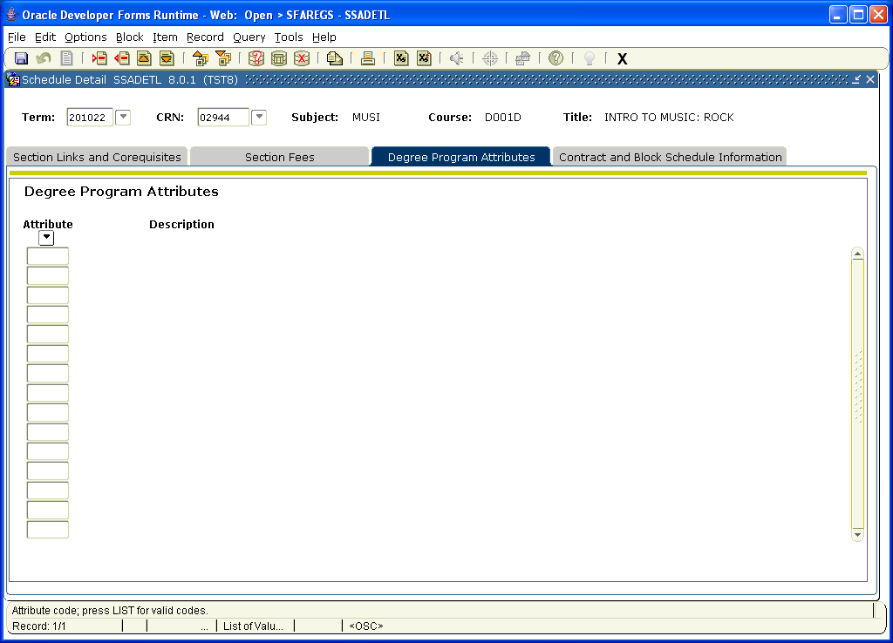

The fourth tab in this screen is Contract and Block Schedule Information.
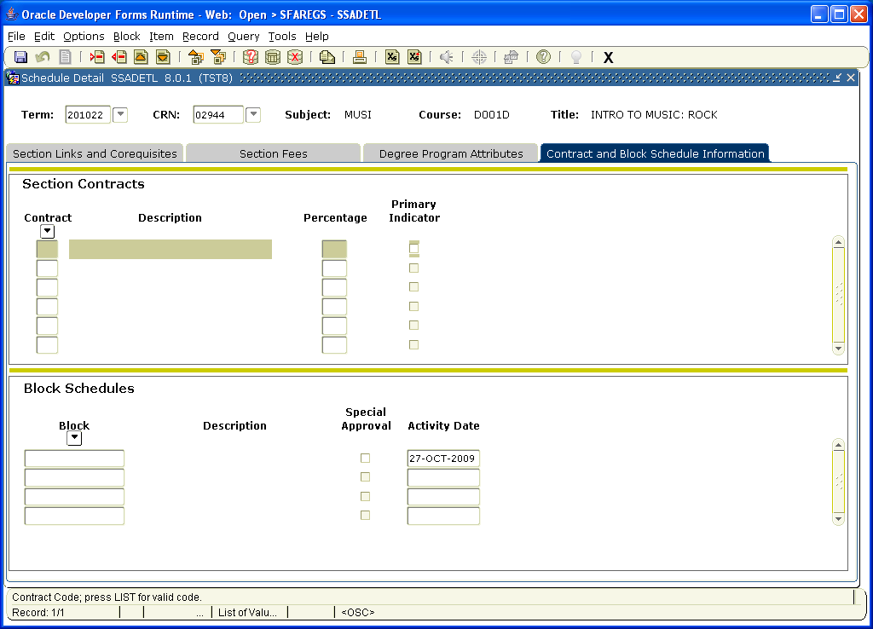

The next option is “Admissions Application Detail SAAADMS. This is the application screen. This option is also in the first and second blocks.

The next option is “Define Time Status Rules” SFAREGS. This screen identifies what constitutes Full Time, Half Time, Less than Half Time and three quarter time. It is year and term specific. This option is also in the second block.

The next option is “Assign Permits/Overrides to Student” SFASRPO. This screen would allow you to give permit students to override them into a class whether perquisites, repeating a course, exceeding units etc.
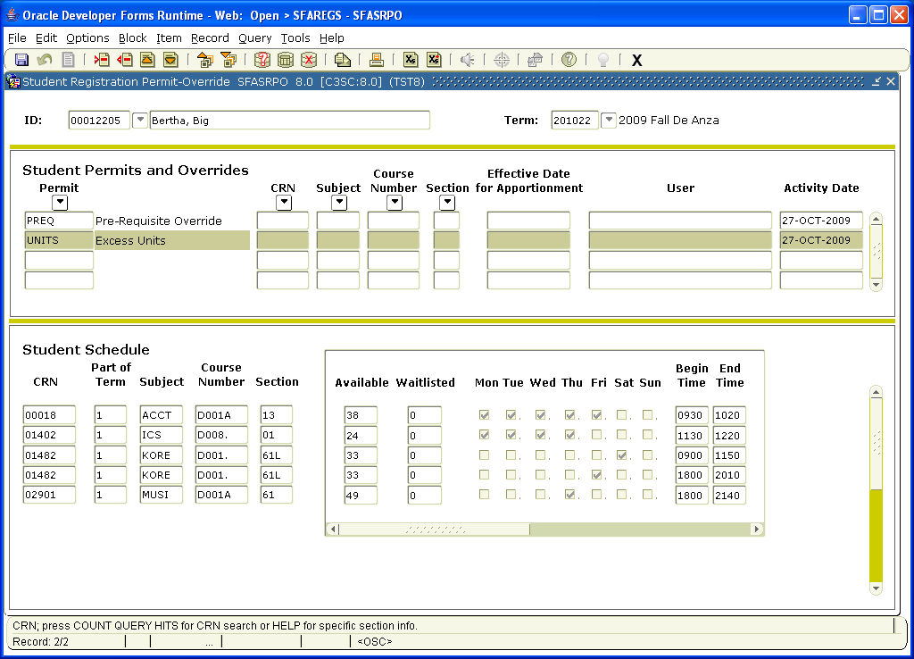

The next option is “View Registration Audit Trail” SFASTCA. This will give you a step by step audit trail of a students registration for a specific year and quarter (our screen 139 in SISPLUS).
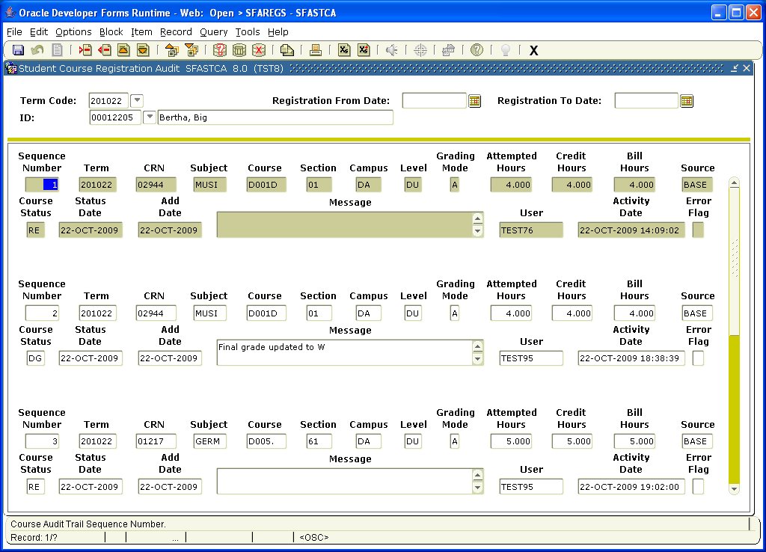

The next option is “View Registration Messages”. Once you click on this option the classes listed in the block will come up with the message they are added, dropped, waitlisted and the date this happened. This option is also in the second block.

The last option is “Enter Registration Add Authorization Codes”. This screen cannot be accessed yet but would involve the add authorization codes.

