SFAROVR/SFASRPO

This form is used to build override codes term by term. You would use these codes for a specific student. These are the permit override codes that will be used to let the student override into classes (for example high school students). You would enter this code into screen SFASRPO.

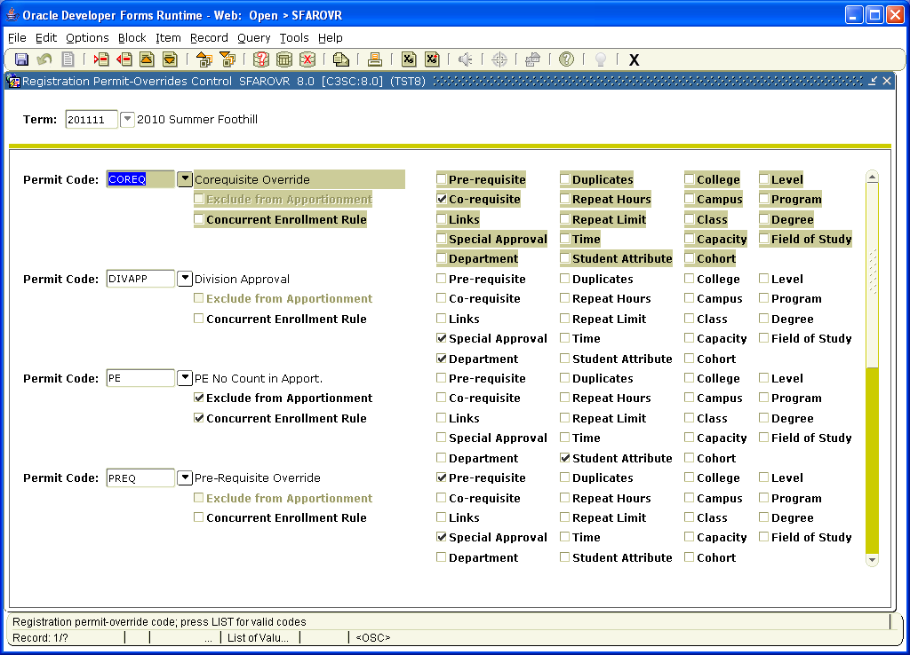

This screen SFASRPO is used when a student is being given an override code to allow them to register on the Web. This can be specified by a call number or by a general Course.
