SFRSLST

The SFRSLST screen is a report to run the missing grades. You would go to the Third block and fill out the following for each line:

Line 1 under Values (Report Title Override) you would leave the line blank
Line 2 Term you would put the term
Line 3 Part of term you would type in %
Line 4 Start Range from date you would leave blank
Line 5 Start Range to date you would leave blank
Line 6 CRN you would type in % (for all the CRNS for the term)
Line 7 No grade report option you would type in “Y”
Line 8 Sort Option should be “I” for instructor. You can also sort by C for Department but we would not use that.
Line 9 is Campus and you would type a %
Line 10 is Schedule Type and you would type a %
Line 11 Intructional Method and you type %
Line 12 Regisration Codes you type a %
Line 13 Degree Status you would type in %
Line 14 Combine Crosslisted Sections you would type a Y for yes
Line 15 Print Student Addresses you would type N for no
Line 16 Address Selection Date you would leave blank
Line 17 Address Priority and Type you would type a 1MA
Line 18 Primary Instructors only you would type a “Y”
Line 19 Print Long Section Title you would type a “N”
Line 20 Run Mode you would type in a R (for report)

Fourth Block-
Click into the fourth block. You can name and save this report (so you don’t have to create it again). You would click on the Save Parameter Set box and then name the report “NOGRD” and then type a brief description (No grade roster)
You would then go to the save icon (gray disk ) on the top left hand side of the screen (under word File) and save twice.
Then you would go to the the options menu on the top of the page and click on “REVIEW OUTPUT”.
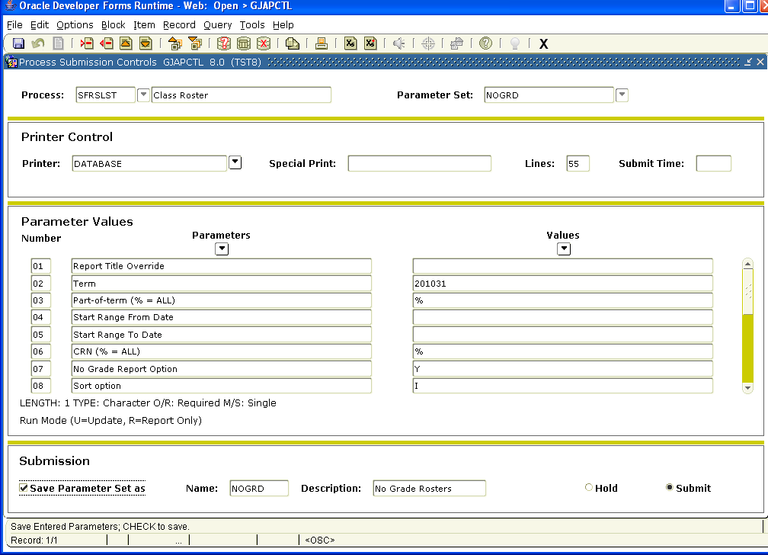

Once you have clicked on Review Output your report will come up. You need to click twice on the space following File Name and the report should appear on the lower part of the page. You would choose the report ending LIS.
