SHACRSE/SHATCKN/SHATCMT

The screen SHACRSE and SHATCKN are used to view the students grades per term and also input grade changes and Redlining.

The SHACRSE is the screen you can view the students classes and grades per quarter. You can go to the grade change screen SHATCKN if you click on the paper icons (on the far left hand side of the page under Select).

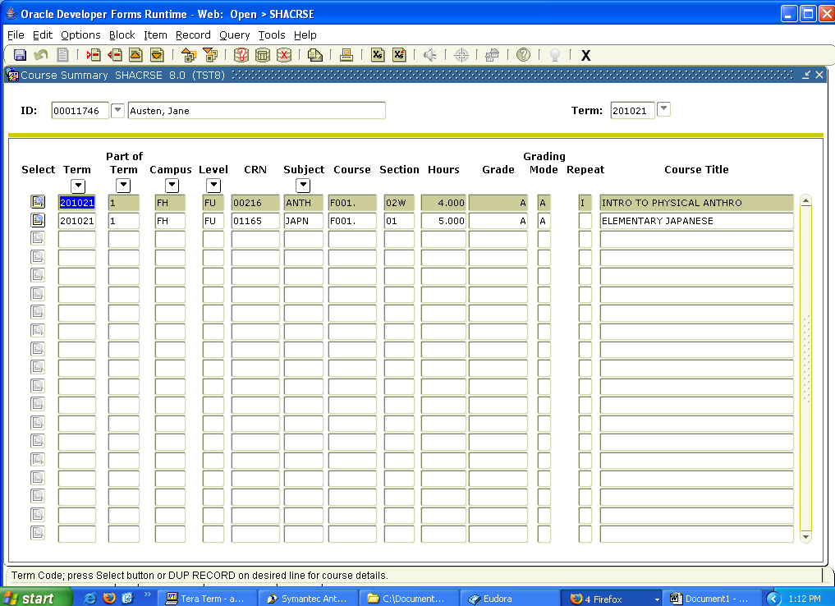

The SHATCKN screen is where you would enter a grade change and also enter the I (include) or E (exclude) for redlining classes that have been repeated. Once you go to SHATCKN from SHACRSE and all the blocks should be populated.

When a class is to be redlined or if you are entering an Academic Renewal you would go to the Second Block to the repeat space. You would choose to Include or Exclude the class in the GPA. You also need to put a message in the comment area saying Academic Renewal or Redlining. You also need to put a comment on SHATCMT That way it will appear on the transcript.
Then click the save icon.

To change a grade you would go to the Third block and go to the Grade Sequence Numbers area. There should be a grade in the first space under the word “Grade”. You would go to the second space and enter the grade change.
Under “Grade Mode” enter an A
Under “Credit Hours” you would type in the hours
Under “Attempted Hours” you would type in the attempted hours
Under “Change Reason” you would need to choose the reason (you can do so by clicking the down arrow to choose the reason most appropriate.)
Then click the save icon.

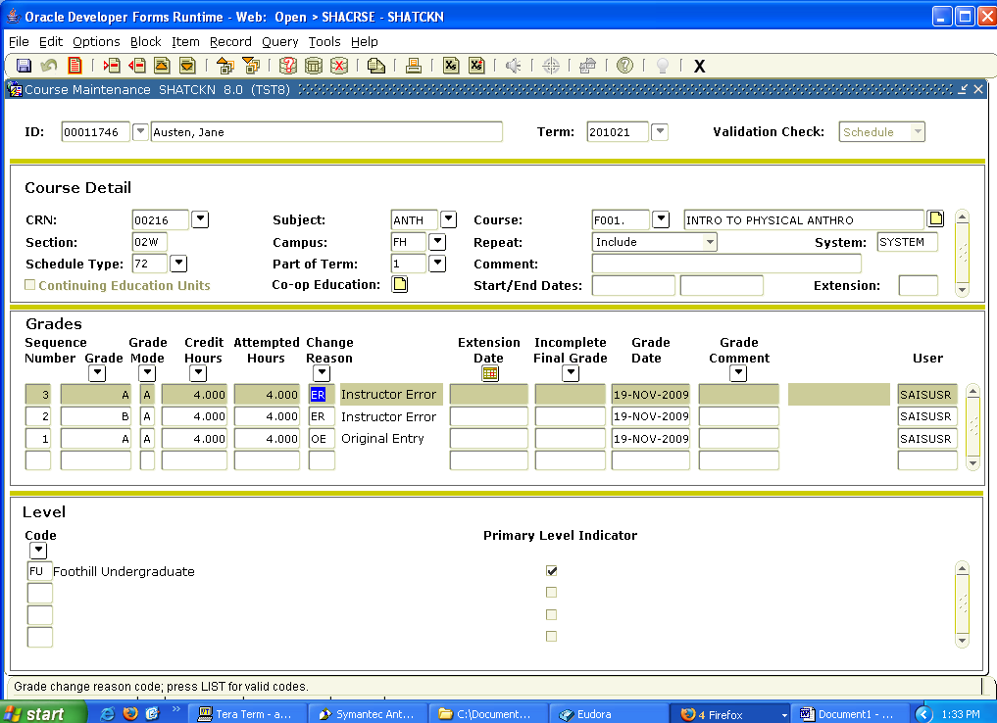

SHATCMT is the screen you post a comment that will appear on the transcript. This would be things like Academic Renewal.
