SHRCGPA

The SHCGPA screen is a report used to Calculate the GPA.

Third Block:
- Under Term you would type in the term under the Value column
- Select All, Rolled or Collector you would choose “A” for all in the Value column

Click to next block then go to the Save Icon (the gray disk at the top left hand side of the screen under the word FILE) and save.

Then you would go to Options and choose REVIEW OUTPUT. The report may take a few minutes to come up as it is a large report.
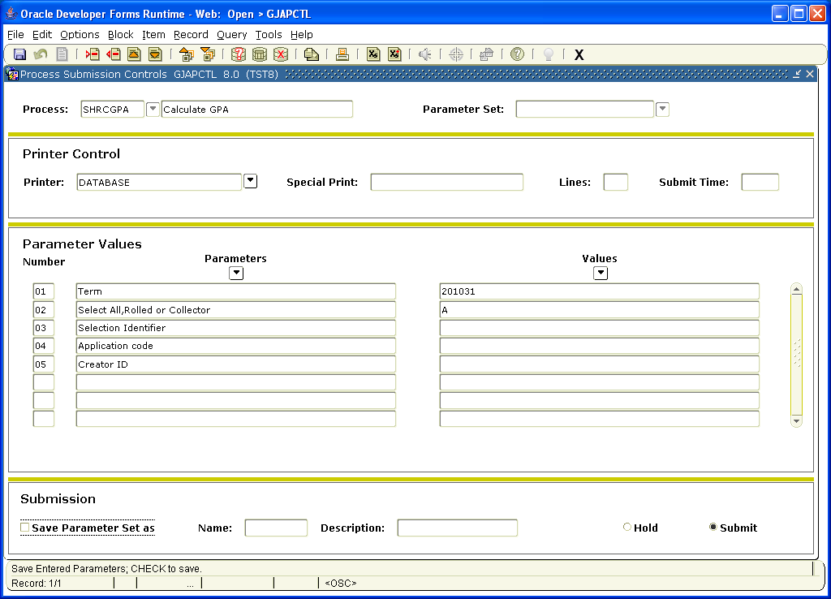

Once the report comes up you would click twice on the space after File Name. This may take a few minutes. The report will show below. You would click on the one ending in lis to review the output. Once the GPA’s have been calculated the Counseling office needs to be notified so they can do Academic Standing.
