SHRROLL

The SHRROLL is the report to be run each quarter as part of the end of term Processing. This is a report to be run to check substitute grades and does the grade roll for academic History (this brings the grades from the instructor portal into Academic History). Your can run this report as many times as you like.

Second Block- you would type in a printer if you are using one or type in “DATABASE”.

Third Block-
In the first line under VALUES (across from Term Code) you would type the term you want the report for.
Under part of term you would type %
Under course reference number you would type %
Under User ID you would type your User ID
Under Report Mode you would type A (for Audit) or U (for Update). Audit means you are going to look at the outcome without running the job. Update means you are running the job. You would do this in Audit first to see how many grades are missing and if its worth running.
Under Print Selection type in E (for error). You do not want to print out the data because it would be too big.
Under Grade Term you would leave the space blank
Under Roll Long Section Title you would type N. You would want a brief title to save space.

Forth Block-
You just click into the box and then click the Save icon on the top left of the page (the gray disk under the word file) It will state on the bottom of the page if the report ran.

Go to the top of the page to options and choose REVIEW OUTPUT.

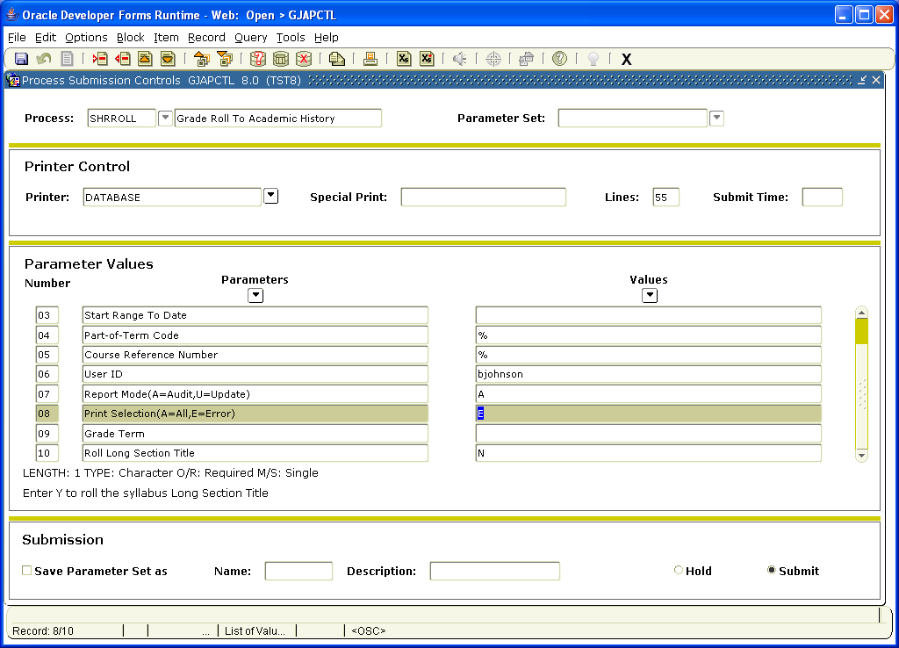

Once you choose options (Review Output) the report will come up. You will want to click the space after File Name twice to produce the report. You will come up with two reports One report will end in LIS and that is the one you want. The other report is LOG (if there is anything in LOG that means the report crashed and burned and there is not data).

