SHRRPTS

SHRRPTS is a repeat checking report.
Third Block:
- Term Code – you would put the term under the Value
- Level Code - you would choose the school, FU for Foothill or DU for De Anza.
- Report or Update – you would type in R for report.
- Print Transfer Work – you would type “Y”
- Application Code you would leave blank
- Selection Identifier you would leave blank
- Creator ID you would leave blank
- User ID you would leave blank

You then would click down to the Fourth block and click on the save icon in the upper left hand side of the page (gray disk under the word FILE).

Then go to the Options and click on “REVIEW OUTPUT”.
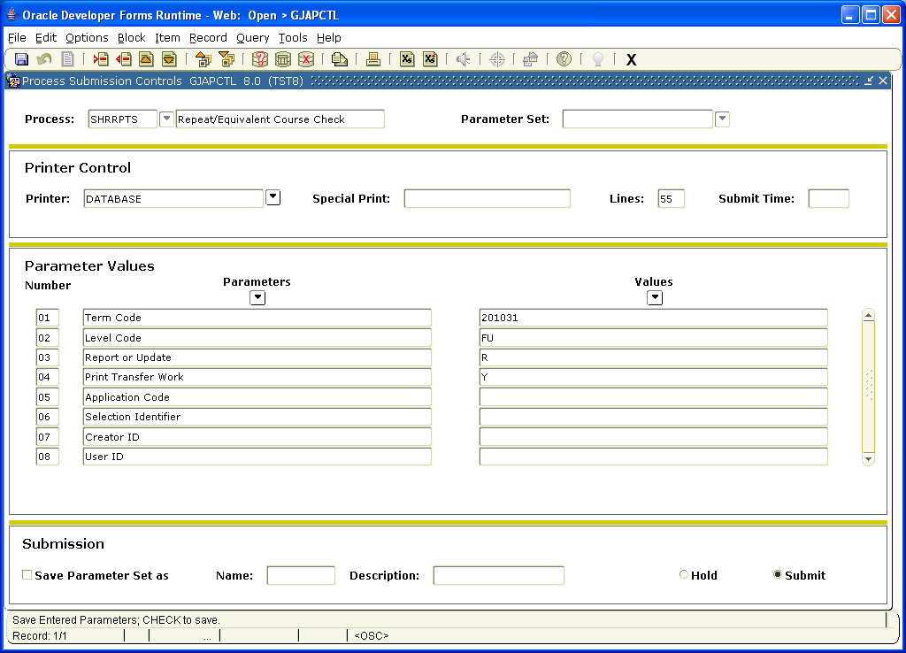

This will bring up the Output Review form. You would click twice in the space after File to bring up the reports. Two reports will come up, one ending in lis and one ending log. You would click on the lis to see the outcome. The log looked is used when the job is unsuccessful and you looking for errors. If the run is good you would redo the report and put a “U” for update instead of “R” to run and process.
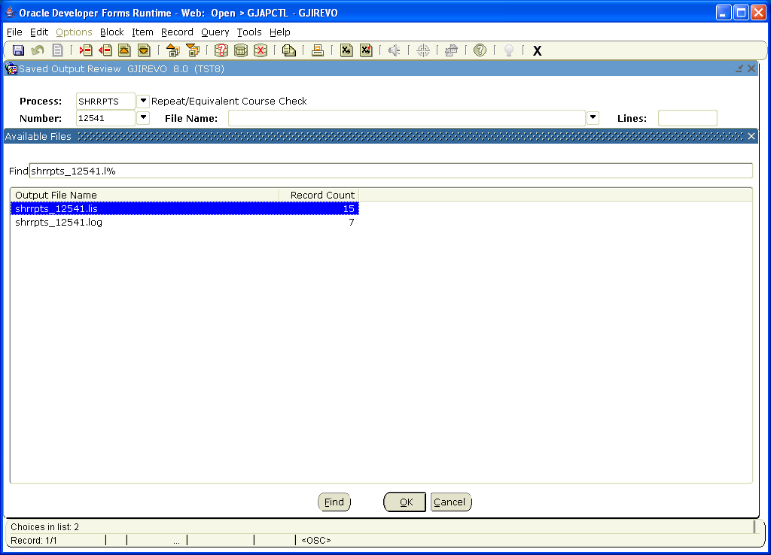

You then need to check SHACRSE to see if the repeats are correct. You will look for the I (include) and E (exclude) on students listed from the report.

