SOAWLTC/GTVLETR/SOAELTL/SOAELTR
Setting up the waitlist and creating the email letter

You can define how automated waitlist processing works on SOAWLTC. On the first tab (Waitlist Term Control) you would specify on the top form that you want the “Automatic Waitlist Notification” by checking the box. This will automatically notify the students there is a space in the class and that they must register in the class. Across from this it the “Waitlist Notification Deadline” where you type in how many hours the student has to add the class after notification (email to student). If they do not add the class they are taken off the waitlist when the hours have expired.
You also can check the box “Show Waitlist Position on Student Self Service” for the students to see on the web the number they are on the waitlist.
Under the waitlist notification deadline is “On Line Waitlist Notification” If you check the box the students are notified by email that a space is available in the class. If you leave it unchecked then there is no notification. You would want to turn that off (by unchecking the box) each night so that the student will not be notified and then not dropped from the waitlist during the night. You want to make sure the students have enough time to see the email and add the class online.
If you click on next block you would check who gets the email. It can go to “Student”, “Primary Instructor”, “Primary Advisor” and “Registrar”. Probably for us we really just care about the student getting the email. You would also click on the down error next to “Student Notification Letter” which will bring up the formula “S_STUDENT_WL” which specifies the email to go out to the student. (On the bottom portion of this email is the steps to create the email for waitlist)
On the bottom portion “E_mail Host you would type in the email address that we are sending the notification from For De Anza that would be WEBREGDA@FHDA.EDU
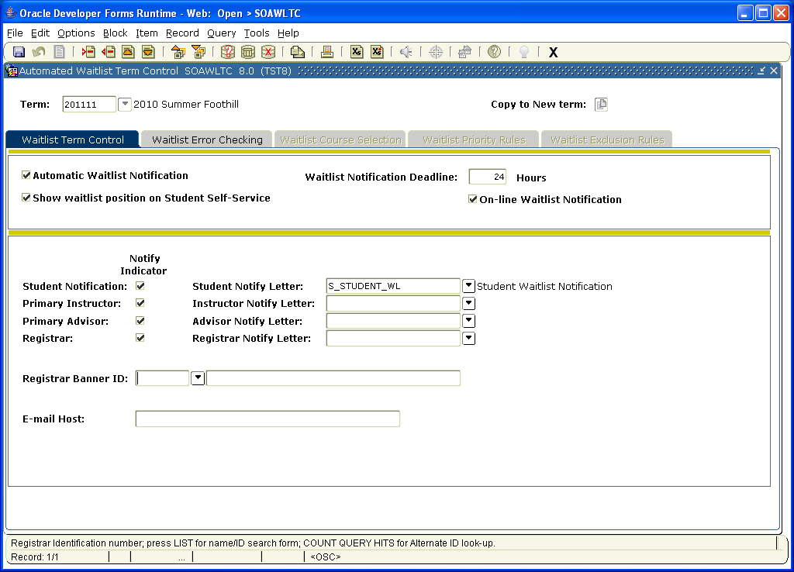

The second TAB over is “WAITLIST ERROR CHECKING”. Under the first box on the left “Include Waitlist courses in Student Option error checking” you would click yes on those items that should checked against when the student is attempting to waitlist. For Deanza you would check No for Duplicates . Yes for Links (so the student cannot waitlist in a linked program without all the classes required being enrolled or waitlisted), Yes for Corequisites (so that the system will check for classes with their corequisites), Yes for Prerequisites (so system will check for the prerequisites to be sure the student has met the requirement before it lets them waitlist) and Yes for Time ( so that the student can’t waitlist for classes that overlap in time).

On the right side of the form is “Section Options” You would specify Options to be checked (those would be marked Fatal) and options that would not be checked (No Check). You would not click warning as that only give the student a warning and will not enforce the options.
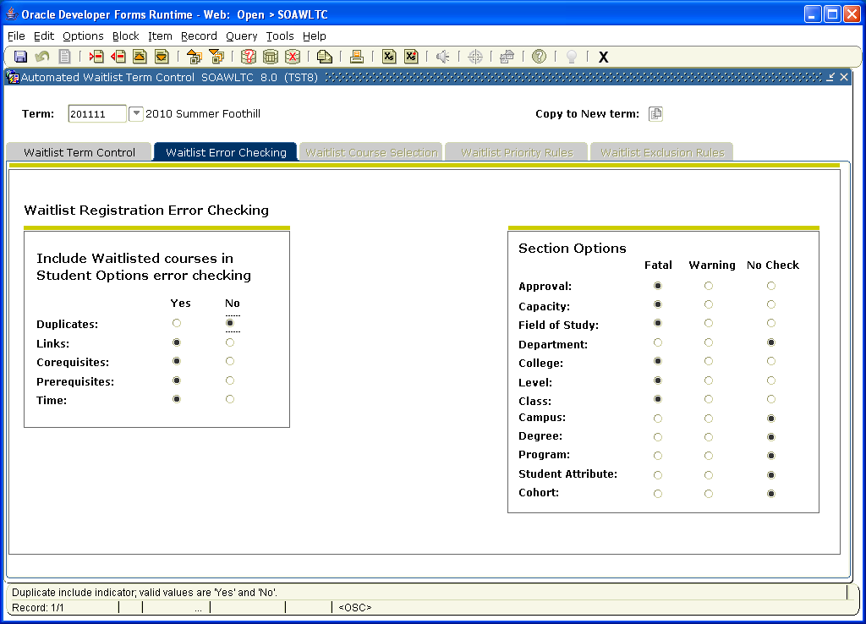

In order to create the email to attach to the SOAWTL you need to do the following:

- Go to GTVLETR to define a code for the email.
a.Under Letter Code you would create a code for the email. For example you might put F-Student-WL . F for Foothill, Student and then WL for waitlist.
b. Under Description you would type a description. For example F wl notification.
c. Check the Allows Duplicates box.
d. Save

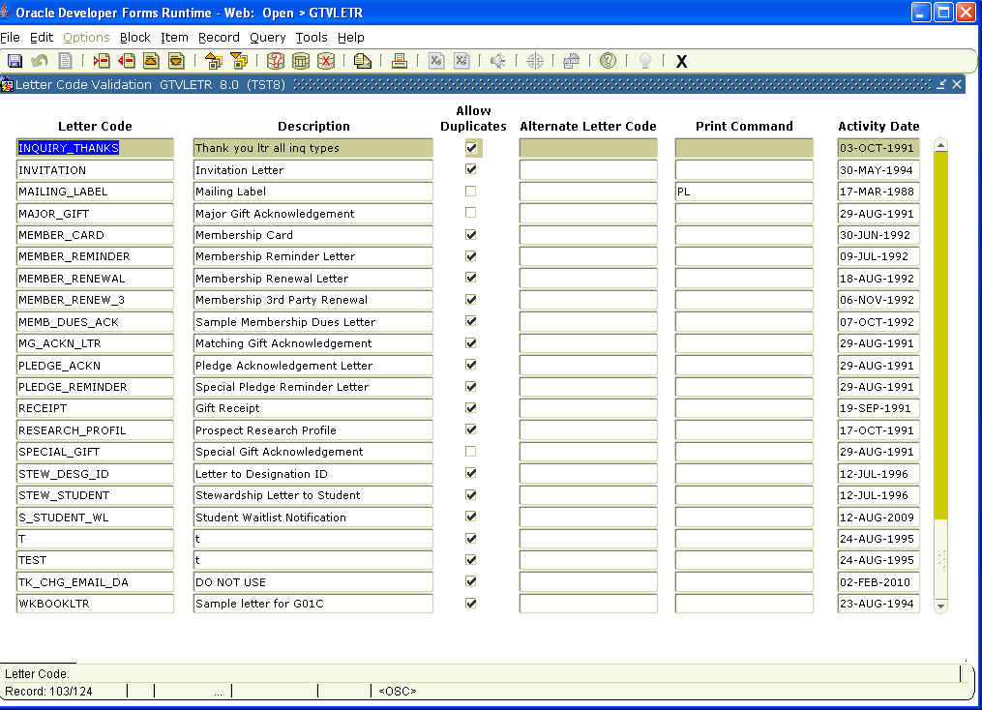

2. Go to SOAELTL to associate with a module.

a. Under Letter go to the code you defined.

b. Across your code under Module you need to associate a module to it. For waitlist you would choose R for registration. All the choices are:
Admissions
Electronic App
Registration
Electronic Prospect
Recruit
Student
Transcripts

c. Save

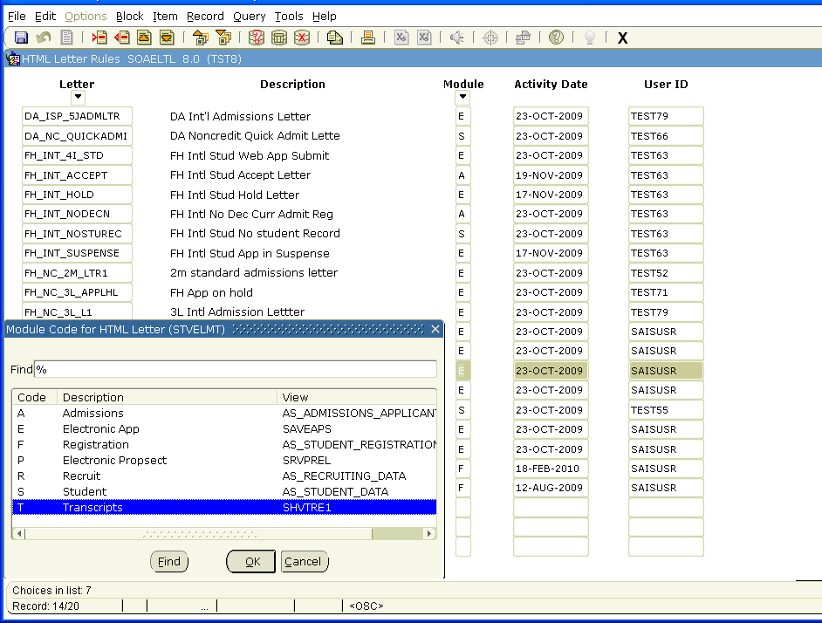

- Go to SOAELTR to write the email response:
First Block
a. Type or choose (with the down arrow) the appropriate code (that you just created)
Second Block
b. Write the letter. As you write you in the formatting line you can choose New Paragraph/New Line/Horizontal Rule. Under Variable you can choose different elements to automatically be populated when the job is run. For example you can have the name of student/class/subject/ etc.
c. Once you are done you can click on the Display Letter Icon to see how the letter will look.
d. When you are satisfied save the document.

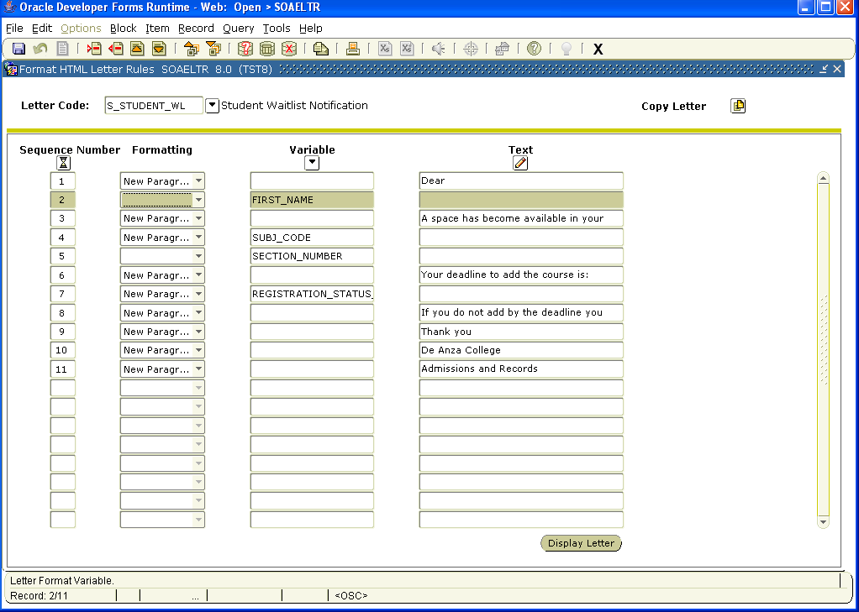

Example of Display Letter:

