STVHLDD/SOAHLD

The STVHLDD screen is the screen where you create and define holds. You can indicate whether it affects registration by checking the box next to“REGISTRATION”. The student can only view what hold type is on their record if the “WEB INDICATOR” box is checked.
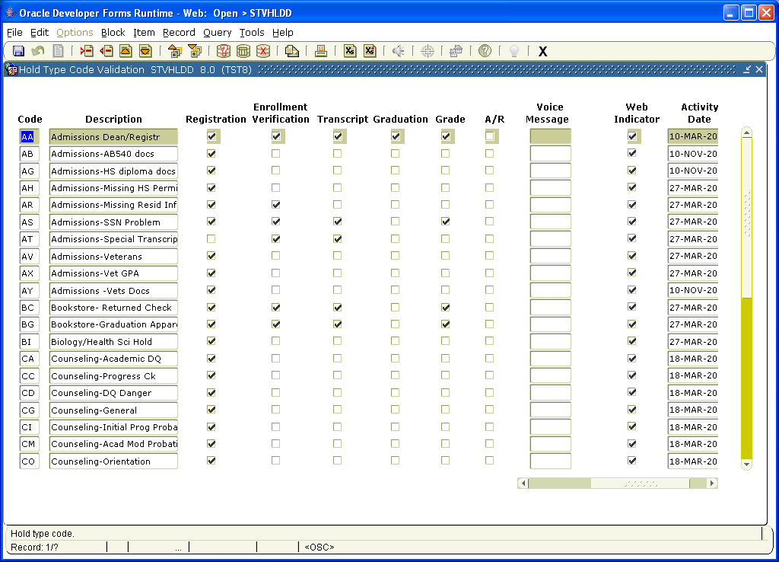

The SOAHOLD screen is where you place the hold for a student. This screen is not term based so once a hold is placed it will affect any term that is within the dates defined on the screen.
You would choose the “HOLD TYPE” by clicking on the down arrow to bring up the menu of choices. You would put a date in the “FROM” box and a date in the “TO” box. The hold would be activated within the dates defined. To remove the hold you would put a date that has passed in the “TO” box.
In the “REASON” box you can put a short reason for the hold. This has to be short because it will show on the web for the student. Since the “HOLD TYPE” will also show online for the student you may want to put a contact phone number for assistance with removing the hold.
If the “RELEASE INDICATOR” box is checked the only person who can remove the hold is the operator that placed the hold.
