STVRSTS

This is the form for course registration statuses. There are four system required codes RE (registered), RW(web registered), DD(drop delete), DW(drop delete but from the web).

You also need to have:

DROP CODES:
DB -drops before classes start
DR – Drop after start with full refund
DC- Drop before census no refund
DA- Drop after census no grade no refund
DP- Drop with a W
You can have other drops but they are optional not state required.

ADD CODES :
RW- web registered , the student added on the class on the web
RA- readd , the student dropped and readded the class
RE- registered by an operator on campus

Other codes needed would be WL for waitlist, CC for cancelled, ML for military leave and AU for audit.

You do need to check the different options that pertain to each status. All the registration statuses should have “Allowed to Enter” checked.

Here is some information on the other options to help you decide whether they should be checked against each enrollment status:

Count in Assessment – you want to check for drops so they are charged. If not all funds would be reversed.

Count in Attempted – The status will be counted in attempted hours

Count in Time Status – means it will count in the determination of whether a student is Full time/ Half time/less than half time.

Waitlist Indicator- will show as on waitlist

Gradable indicator – a grade will show at end of term

Auto Grade – automatically gets a grade (like a “w”)

Print on schedule – (course will print on the students schedule)

Status type – Tells web what type of activity is being performed

Web indicator- Code can be used on the web

Extension Indicator – only for open learning courses which Deanza does not have. This option should never be checked.

Apportionment indicator- Indicates the status is used in apportionment.
Audit – does not count in Apportionment.

Under “STATUS TYPE” you would indicate whether each status code is REGISTERED, WITHDRAWN, DROPPED or WAITLISTED.

First half of form:

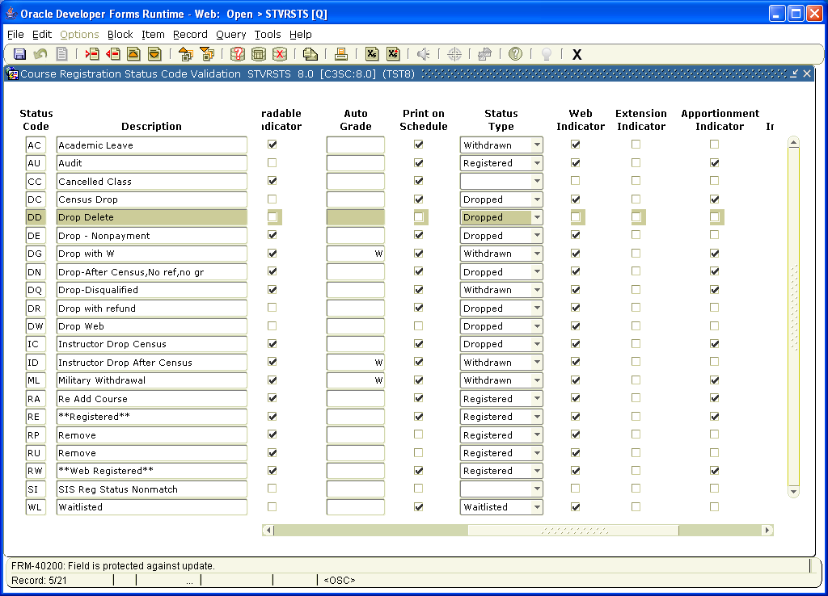

Second half of form:
