Self Service for Faculty in Banner

There are three levels of security for Faculty:
- Open – All faculty /Advisors can see transcripts of students (ALLFAC)
- Roll based security – designated by faculty and attribute (example Advisor) (FACFATT)
- Only Primary Instructor – Only the primary instructor can see transcripts and information on the student. (PRIMINSTER)

Validation tables to set up:

STVFATT - faculty member attributes (department chair/Program Director)

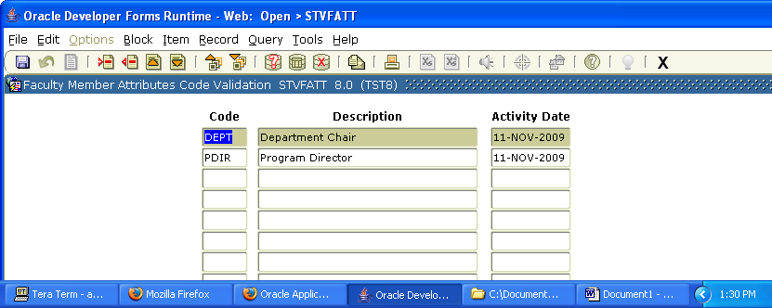

STVADVR - Advisor type (financial aid, International, Eops etc)
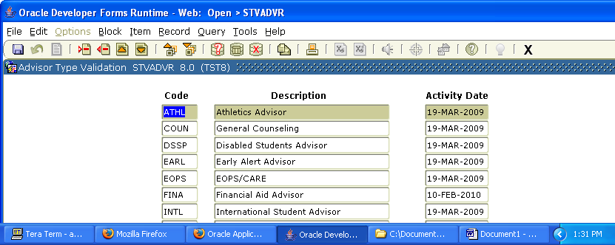

STVROLE – This would be either Faculty or Advisor
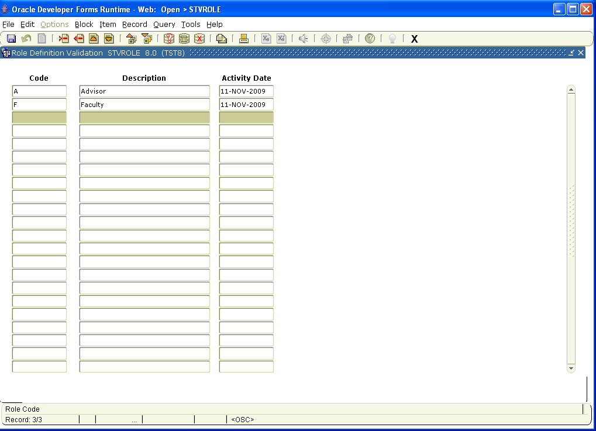

STVPROC- Process Control Code Validation
You would specify whether the faculty or advisor could 1.Dislpay Grades 2. Enter Grades 3. Transcript Request
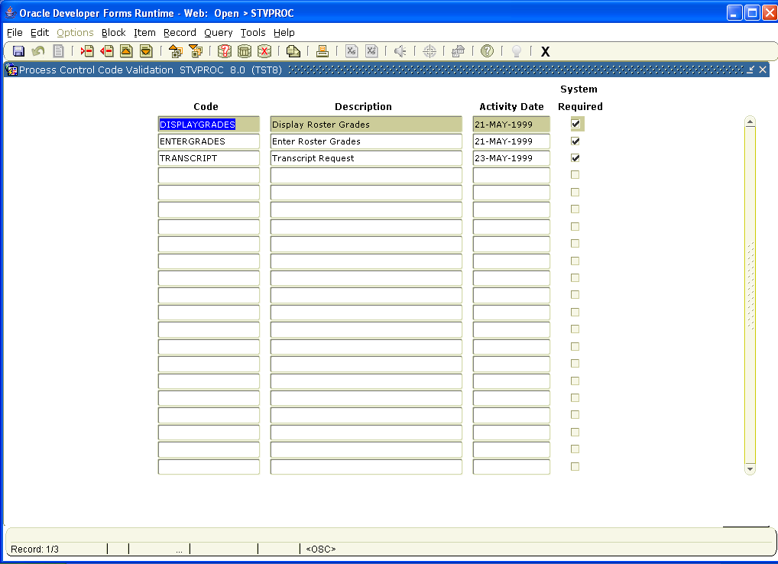

SOAFAPC- Faculty Attribute/Advior Type Control
This is the validation table where you would include or exclude to the faculty and advisor type access the the three processes (display grades/enter grades/transcript request).
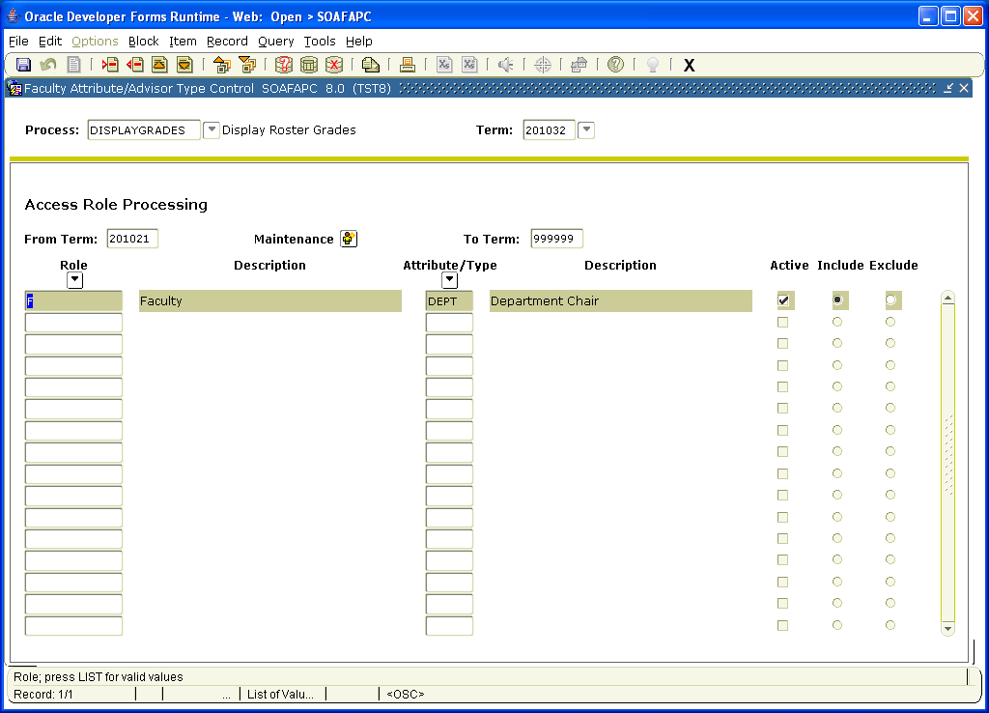

GTVEMAL – Email Address Type Validation

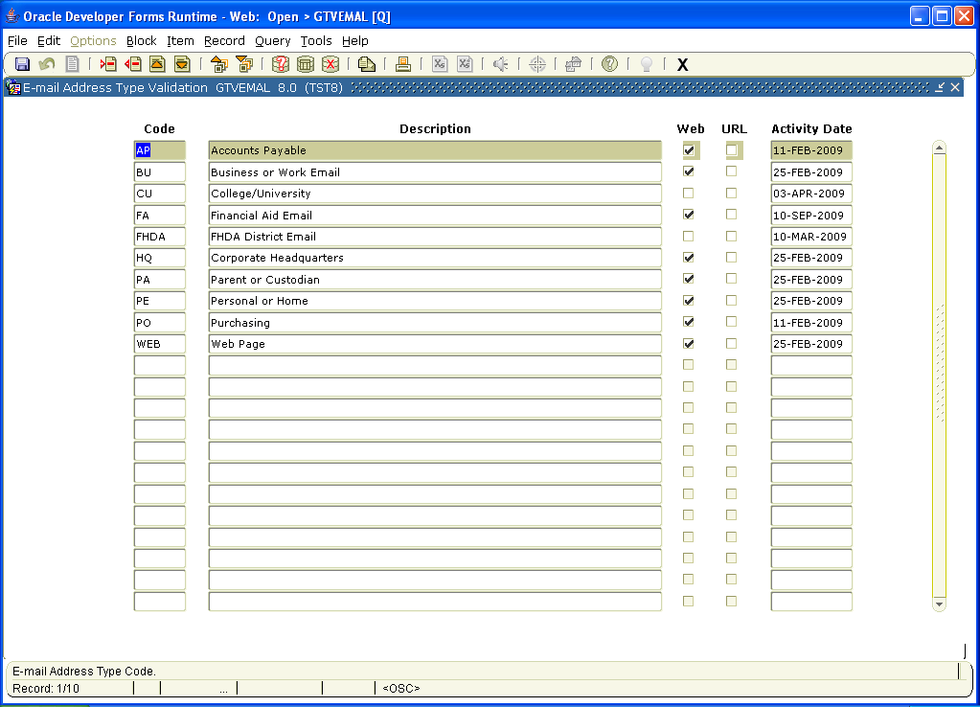

STVPRNT – Compliance Print Code Validation
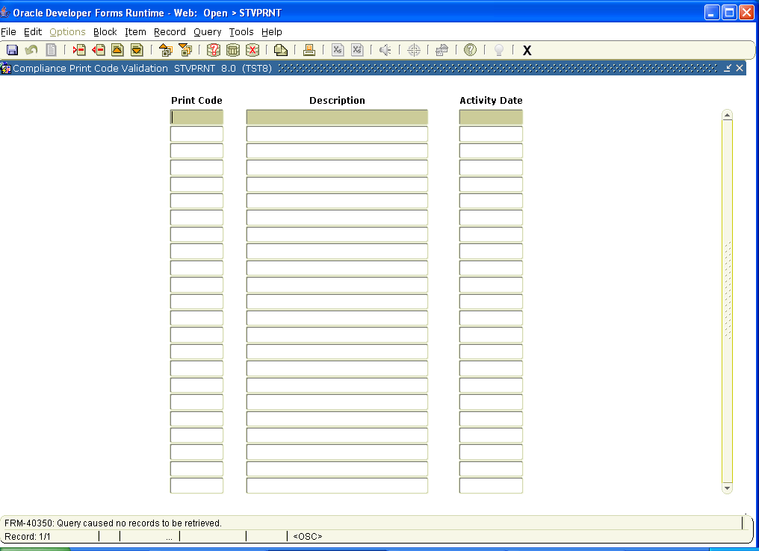

SIAINST – This screen is where you make a person a faculty and or advisor.

In the first block you would put the ID of the person
Second block –
- Put the term
- Pat an A to Activate or I to inactivate the person as a faculty or staff
- Check Faculty/ Advisor or both
- Under category you would choose the category for the faculty
ADJUNT – for adjunct faculty
ASCPRF – for associate professor
ASTPRF – for assistant professor
PROF - for professor
PTFAC - for part time faculty
- Under workload Rule just put in GEN for generic rule
- Save by clicking on the save icon (gray disk) in the upper left hand

SGAADVR – This is the screen where you can assign a faculty or advisor to a specific student.
First block – put in the ID of the Student and the term
Second block –
- Type in the ID of the faculty.
- Indicate the type of advisor.
- Check Primary Indicator box.
- Then save

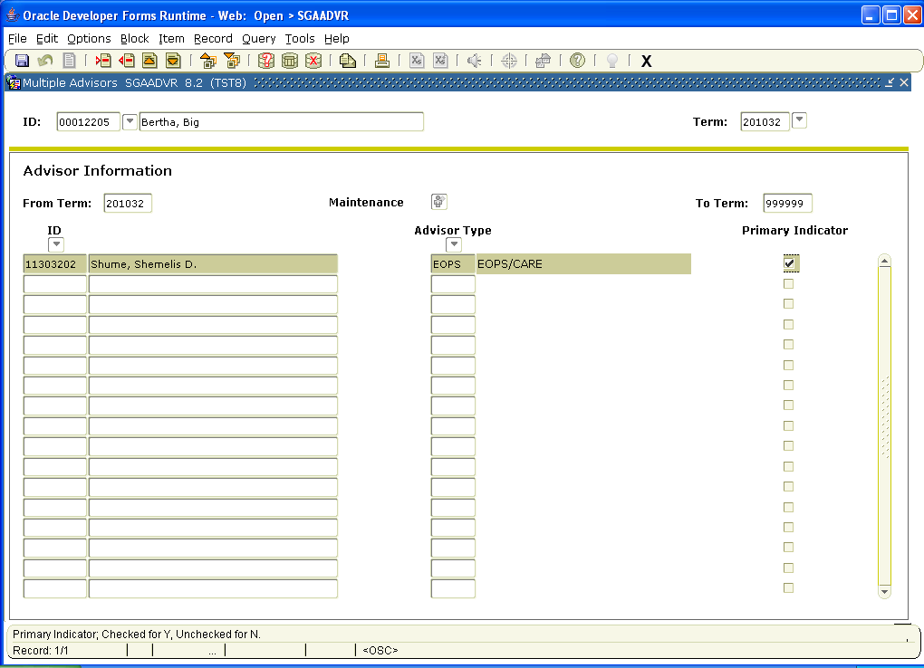

PLEASE LOOK AT SOATERM DOCUMENT FOR FACULTY SETUP ON BASE PART OF TERM AND WEB PROCESSING CONTROL OPTIONS:

