Transcript Name

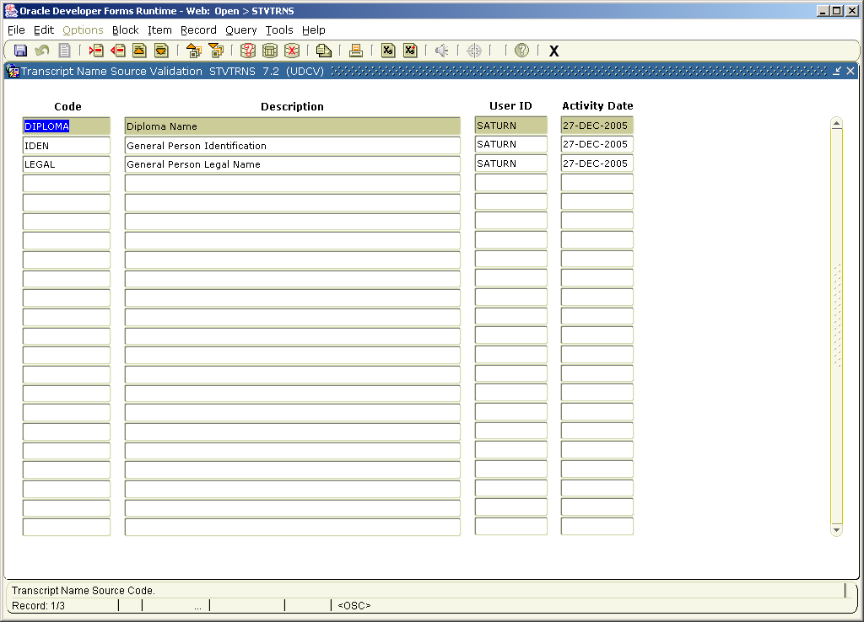

SHATPRT – print options for transcripts

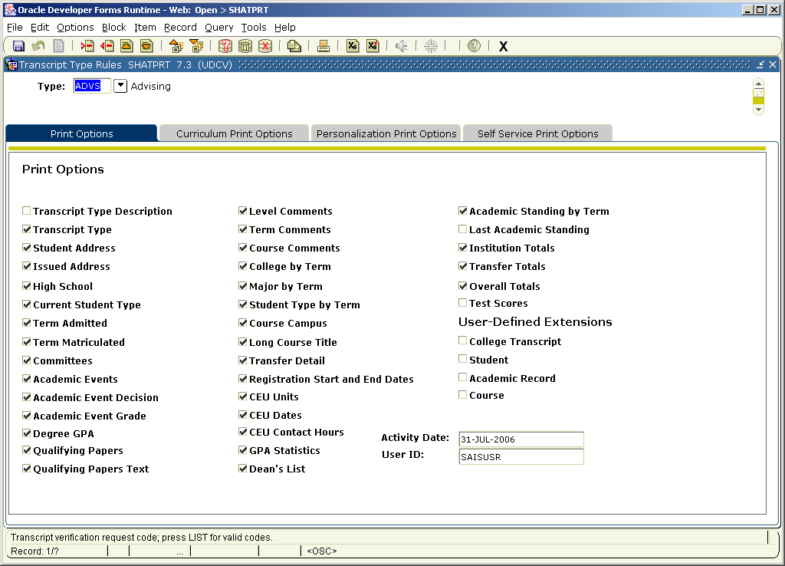
SHARQTC – printer options

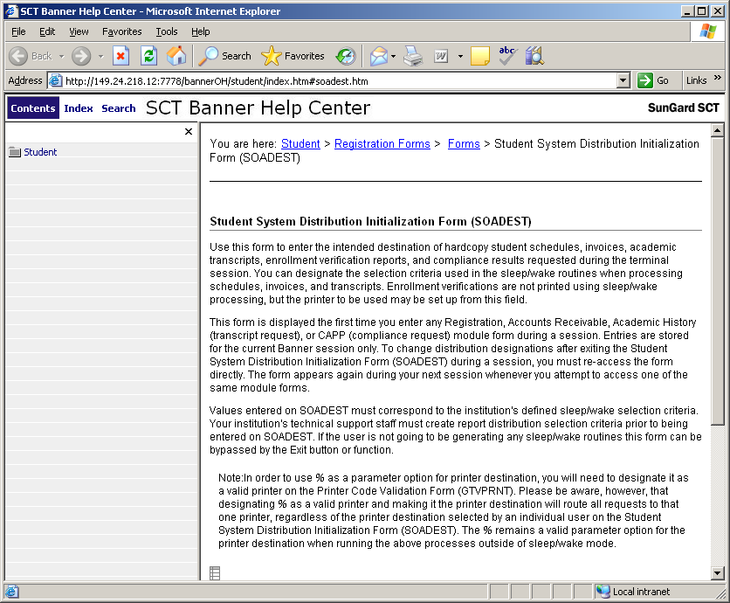

When you EXIT that form it brings up the transcript request form.

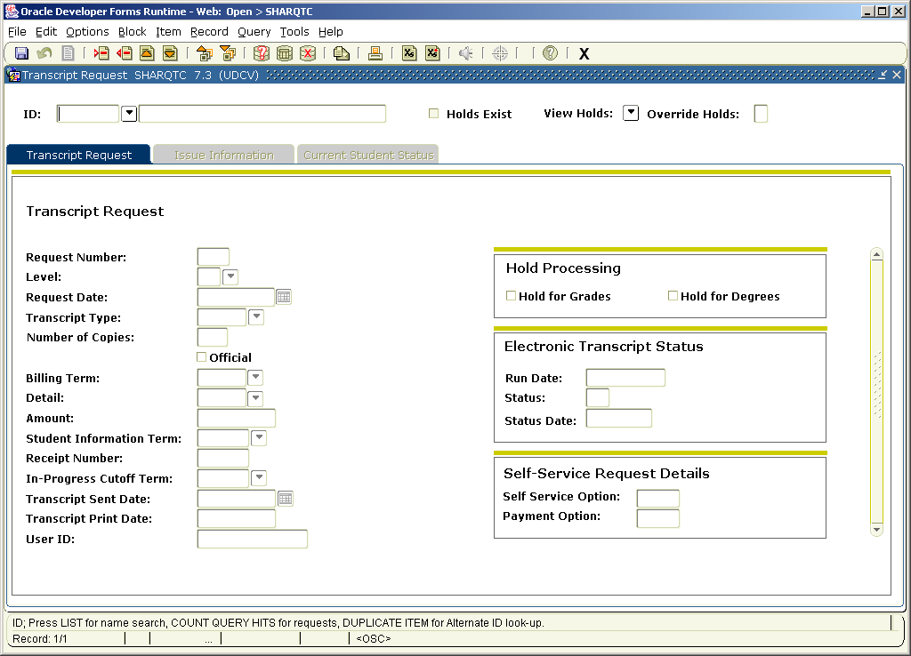
Under the ISSUE INFORMATION the Name Hierarchy window is displayed.

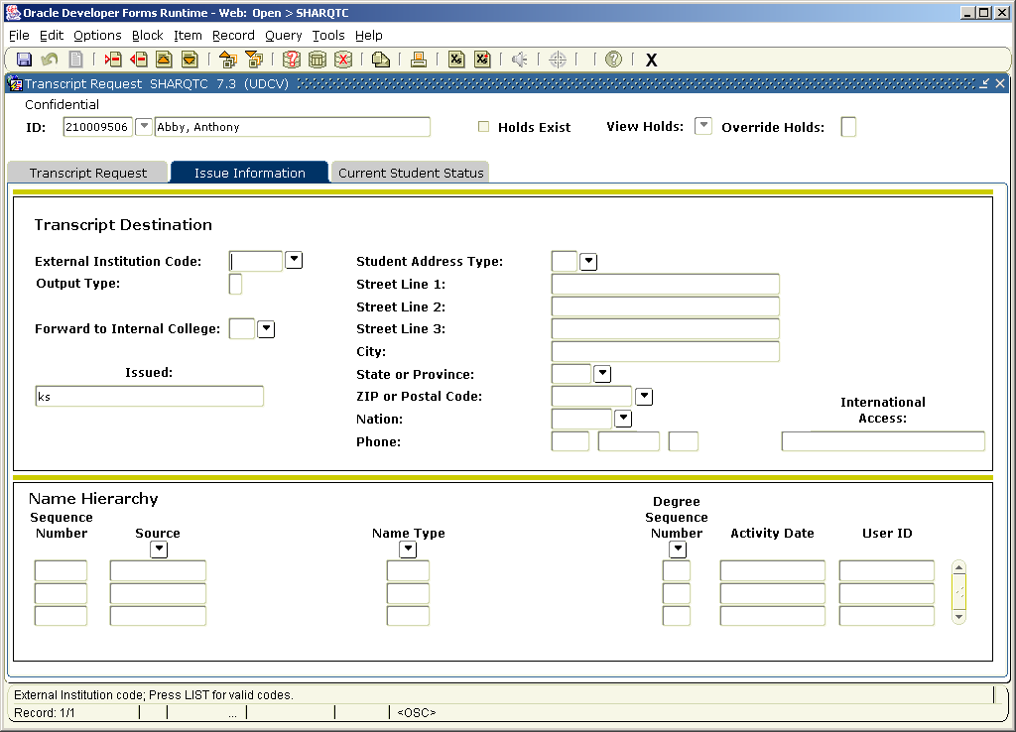

NAME TYPE comes from GTVNTYP
A unique name type should be on the table to reflect the transcript name regardless of what the key block version of the name shows.

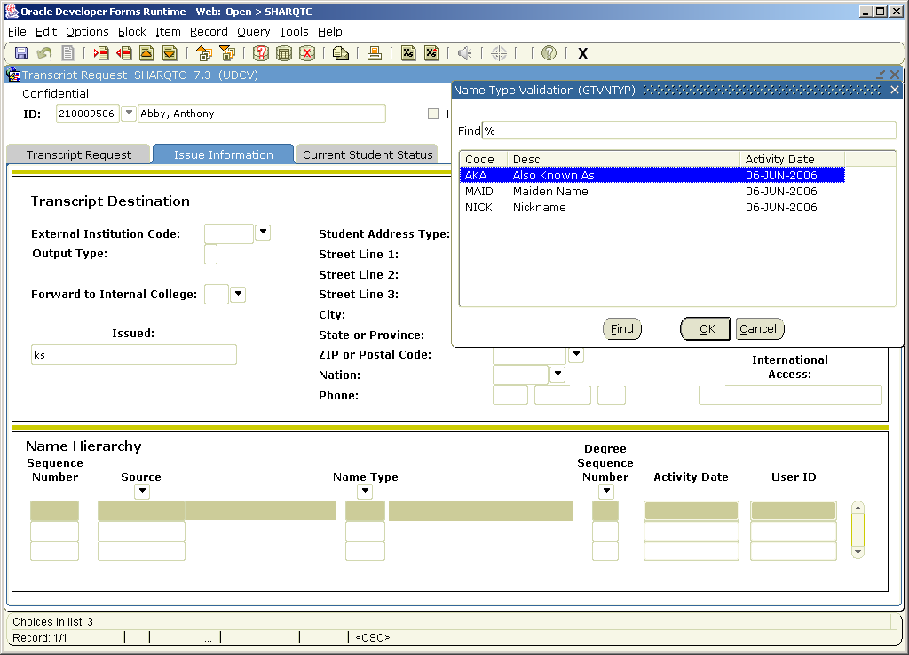

SHRTRTC under job submission prints the transcript for one or for a population

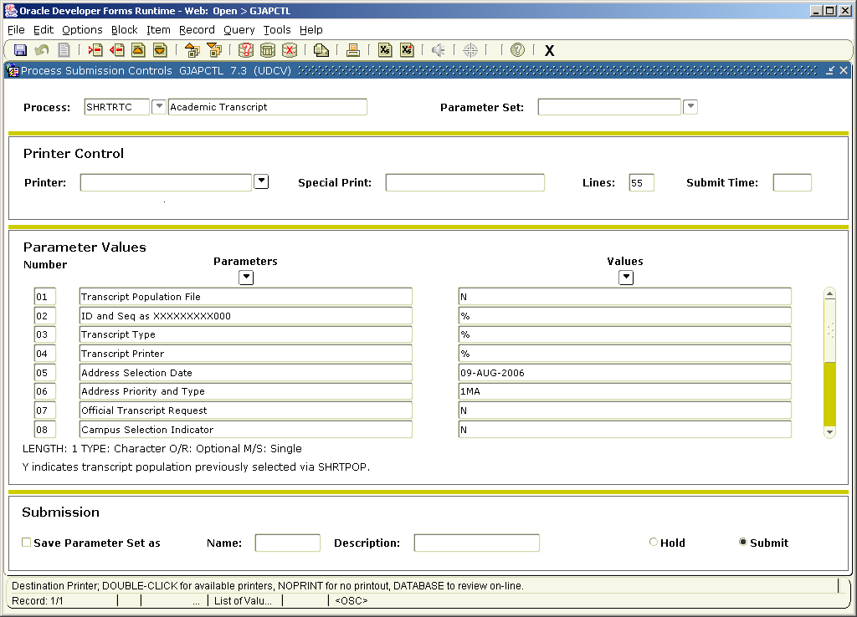
SHRTRTC

