Foothill De Anza

Follow-up Report for Banner Student

March 08-12, 2010

Account Information
Project name: | Foothill De Anza
Prepared by: | Xiaobin Li
 | Technical Consultant
 | Xiaobin.Li@sungardhe.com

Distribution
Foothill De Anza | Kari Elliott elliottkari@fhda.edu | PM
SunGard Higher Education | Debra Treacy | PM

Objectives

The goals this week were to assist FHDA staff with reporting needs and other data conversion/migration issues.

Progress Report

Accomplishments

The week started on the work on building a prototype of a trigger that could be used to implement access control for Scheduling. A sample of the trigger code can be as follows:
CREATE OR REPLACE TRIGGER BANINST1."FHDA_SSBSECT_CHKBXES_CTL" AFTER
INSERT OR UPDATE
OF SSBSECT_PRNT_IND,
SSBSECT_VOICE_AVAIL,
SSBSECT_TUIW_IND,
SSBSECT_GRADABLE_IND,
SSBSECT_CAPP_PREREQ_TEST_IND
ON "SATURN"."SSBSECT" FOR EACH ROW

DECLARE
flag1 varchar2(1);
cursor privileged_c is
select 'x' from gorfbpr r
where r.gorfbpr_fgac_user_id =user
and r.gorfbpr_fbpr_code='COLLEGE_BU';

BEGIN

open privileged_c;
fetch privileged_c into flag1;

if privileged_c%notfound and updating then
RAISE_APPLICATION_ERROR(gb_common_strings.ERR_CODE,
gb_common.f_err_msg_add_delim(dml_common.DML_UPDATE_FAILED));
END IF;

close privileged_c;

END;

When activated on form SSASECT, the trigger behaves as follows:
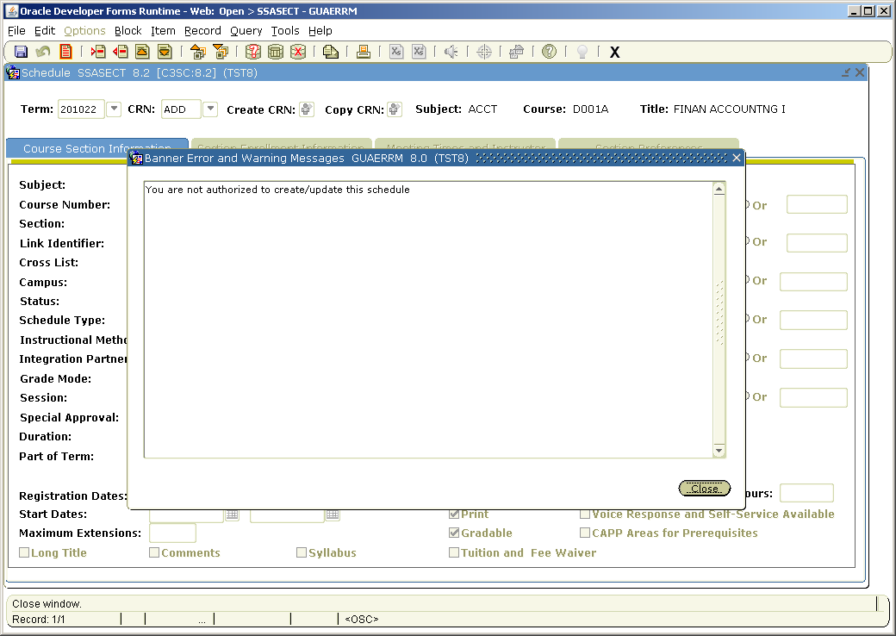

In the morning we met with Andrew to go over the approach we planned to use for writing the Discrepancy report. Details such as the location of the report, logic used to generate each field on the report, report data archiving for possible use in ODS were discussed. Then I worked with Jerrick studying the legacy version of this report, we conclude that the following fields in Banner Student would be used to compare catalog and section entries and mark the differing entries with an asterisk when displaying the report.

Later on we had the Instructional Support meeting with Tom, Shien and other team members on checklist moving instance elements between instances. Various issues were discussed, such as Scheduling security, Discrepancy Report status update, TRNG8 data migration, catalog and scheduling conversion progress, 3rd party course management data extract and job submission writing, Schedule 25 interface to Banner, etc. Among these tasks, I will be assisting Jerrick on writing the 3rd course management data extract and job submission for end user to execute this process.

Wednesday was mostly dedicated to the work on Discrepancy Report. We had a meeting with Jane and Denise from Scheduling and talked in great detail about the progress we made so far. They were able to look at the report and pointed out some of the changed that needed to be made, such as the removal of some of the fields deemed not necessary in Banner system, realignment of some of the logic used in generating some of the field values, export of the page to some file format like Excel or PDF for easy distribution among end users. I also got an opportunity to demonstrate the prototype of the scheduling security using a trigger on SSASECT. Questions such as the timing of the trigger messages, content of the messages were discussed. Jane and Denise would discuss with team leaders to determine when this implementation would take place. As a follow-up to our previous discussions, I also showed them the Banner Self-Service baseline Course Catalog search and Class Schedule Search. They really liked what they saw. I also reminded users that extra fields such as faculty workload information could be added to the baseline packages for these pages to be more informative to end users. Jane and Denise also discussed Room Report task, the significance of having a fully functional report based on Banner data. They would communicate with team leaders to determine if I would get involved in creating this report.

The rest of the Wednesday was spent working to implement the changes users brought forward during the aforementioned meeting.

Thursday started with the continuation of work on Discrepancy Report. Also worked on was the page export option as PDF file format. At this point, the export uses a PL/SQL package that helps generate PDF file on the fly. Due to its limitations handling size and certain formatting, we may consider using Apache FOP to have a more robust solution. The report itself was complete at this point.

Upon Andrew’s request, a local table was created to archive report runs so that this data could be used for ODS reporting purposes:
b. Create temp table to be used by Andrew for ODS reporting.
-- Create table
create table SWRDRPT_FHDA
(
SWRDRPT_FHDA_CTG_KEY NUMBER not null,
SWRDRPT_FHDA_SCH_KEY NUMBER,
SWRDRPT_FHDA_TERM_CODE VARCHAR2(8),
SWRDRPT_FHDA_SUBJ VARCHAR2(6) not null,
SWRDRPT_FHDA_CRSE_SEQ VARCHAR2(20) not null,
SWRDRPT_FHDA_CRN VARCHAR2(6),
SWRDRPT_FHDA_COLL VARCHAR2(3),
SWRDRPT_FHDA_DEPT VARCHAR2(6),
SWRDRPT_FHDA_TITLE VARCHAR2(40),
SWRDRPT_FHDA_INSTR VARCHAR2(20),
SWRDRPT_FHDA_CREDITS NUMBER(7,3),
SWRDRPT_FHDA_LEC_HRS NUMBER(7,3),
SWRDRPT_FHDA_LAB_HRS NUMBER(7,3),
SWRDRPT_FHDA_OTH_HRS NUMBER(7,3),
SWRDRPT_FHDA_CONT_HRS NUMBER(7,3),
SWRDRPT_FHDA_WEEKS NUMBER(3),
SWRDRPT_FHDA_T_X_W NUMBER(7,3),
SWRDRPT_FHDA_TOT_LOAD NUMBER(7,3),
SWRDRPT_FHDA_ACTIVITY_DATE DATE not null,
SWRDRPT_FHDA_DB_INSTANCE VARCHAR2(10)
)
tablespace DEVELOPMENT
pctfree 10
initrans 1
maxtrans 255
storage
(
initial 64K
minextents 1
maxextents unlimited
);
-- Add comments to the table
comment on table SWRDRPT_FHDA
is 'This table is used to store report runs of the FHDA Discrepancy Report';
-- Add comments to the columns
comment on column SWRDRPT_FHDA.SWRDRPT_FHDA_CTG_KEY
is 'sequence number for course catalog entry';
comment on column SWRDRPT_FHDA.SWRDRPT_FHDA_SCH_KEY
is 'will be null if current row is course catalog entry, not null if section';

create public synonym SWRDRPT_FHDA for SWRDRPT_FHDA;
grant select on SWRDRPT_FHDA to public;

Information about the Discrepancy Report and the use of this table has been communicated to Andrew.

Other items covered/discussed included possible SDE application for tracking HR certifications on one of the INB forms, downward change of Banner form security on TSADETC and its impact on non-Finance users, unmasking the Active indicator on TSADETC.

On Friday, Jerrick reported production errors on one of the detail code tables TBBEACT when he attempted to update the effective date on some details codes to July 1, 2009, upon request from the Finance group. We worked together to investigate this issue. This issue was also related to the disappearance of some of the FOPAL information on TSADETC form. The root cause of this problem was the multiple entries for certain detail codes in TBBEACT and TBRACCT tables. Jerrick thought these extra entries were manually entered by end users not realizing there were already entries brought in by conversion processes. Once the extra entries were cleared, effective dates for those detail codes were successfully updated. With these two steps completed, FOPAL information on TSADETC form now displayed correctly. The SQL statements used to update these two tables were handed over to Jerrick. Information about these transactions was also sent to Vicki for possible future references.

Progress Report

Decisions Made and/or Actions Taken

Attendance
Name | Responsibility | Tues | Wed | Thurs

Action Items and/or Assignments for SunGard Higher Education
Date Assigned | Description | Owner | Critical Date for Completion | Status
2/17 | Discrepancy Report | Xiaobin Li | 3/18 | Complete
Status: New, Open, Completed, Cancelled, Deferred

Action Items and/or Assignments for Client
Date Assigned | Description | Owner | Critical Date for Completion | Status
3/11 | Discrepancy Report | FHDA | 3/18 | Open
Status: New, Open, Completed, Cancelled, Deferred

Concerns / Decisions to be made
Description | Owner | Target Date for Closure | Action Plan

Other

