Viewing or Printing Unofficial Transcripts

- Click on File at the top left hand corner of Banner
- Click on QuickFlow
- Enter the QuickFlow name for viewing and/or printing transcripts called STRAN
- Click on Start button

Will take you to SHARQTC (this is where you order the transcript)

- When you first log into Banner for the first time and you go to SHARQTC, Banner will automatically take you to the form SOADEST.
- Just Exit out of this form and the system will then take you to SHARQTC
- Enter the students ID#, SS# or Name and hit enter
- If the student has grades at both De Anza and Foothill, a message will pop up stating *Warning* Multiple levels exist. Use AL for level to print all levels. Click on the OK button.
- If the student has a hold on his record, you can override the hold by entering a Y in the Override Holds field
- Click on the Next Block icon. If the student has never requested a transcript before the cursor will jump to the Level field. (go to step 7) If the student has requested a transcript before, then the system will pull up the information about the last transcript request. (go to step 6)
- Click on the Insert Record icon or click on Record then Insert
- Under the Level field, enter DU for De Anza Undergraduate or FU for Foothill Undergraduate or AL for both colleges.
- Under the Transcript Type field, enter DAUN for De Anza Unofficial or FHUN for Foothill Unofficial (If you entered AL in the Level field, it does not matter if you enter DAUN or FHUN at this time.)
- Under the Number of Copies field, enter a 1
- Billing Term, Student Information Term and In-Progress Cutoff Term should automatically populate. If they do not, then enter the last term the student received grades.
- Click on the Saved Icon (The gray disk in the upper left hand side of the screen under File)
(Example of SHARQTC’s Transcript Request tab below)

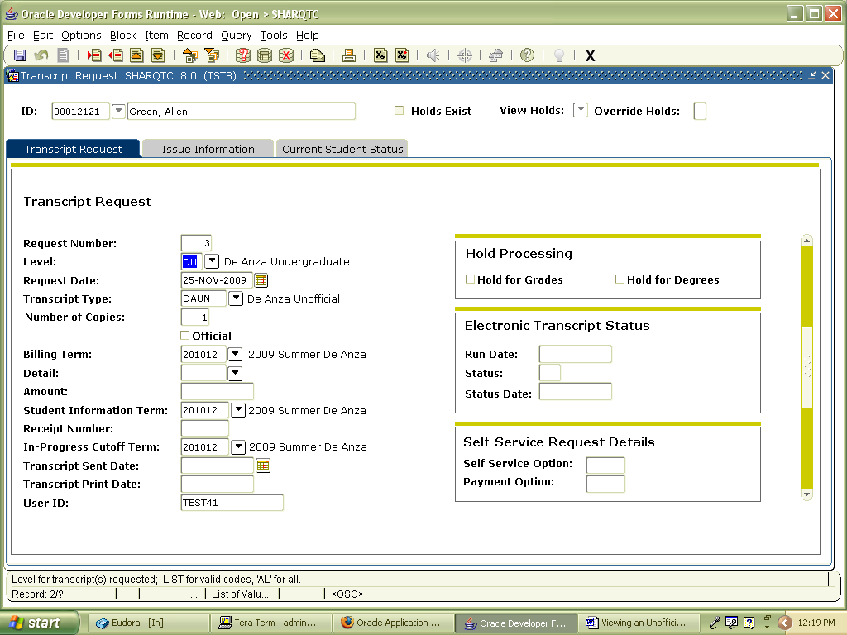

- Click on the Issue Information tab
- Under the Issued field, enter your initials. Because we are just viewing the transcript and we are not mailing it, we do not need to enter an address. But we must enter something in the Issued field or you can not print it or view it.
- Save
- Exit out of SHARQTC. QuikFlow will then automatically take you to the next form called GJAPCTL
(Example of SHARQTC’s Issue Information tab below)

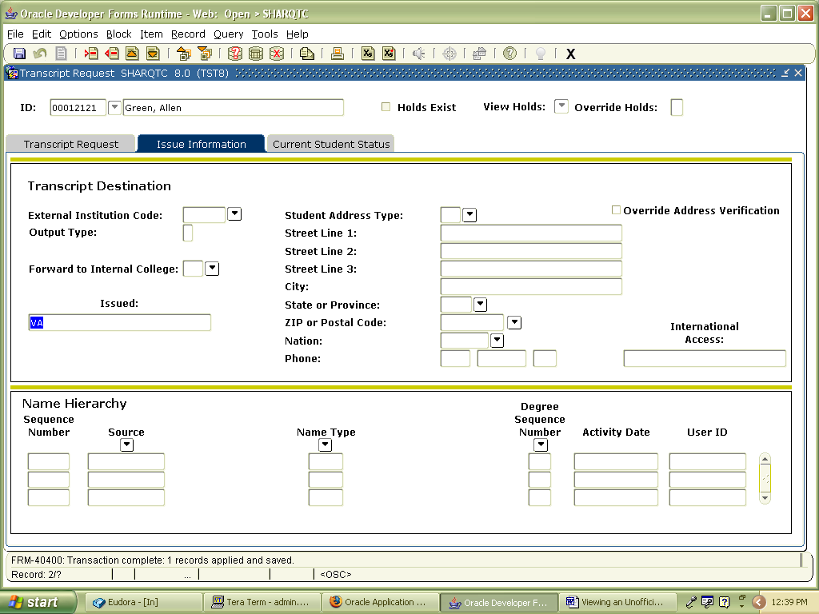

Now you should be at the GJAPCTL form (this is where you can print the transcript or you could also just view it as a report on the database)

- Under the Process field, enter SHRTRTC
- Under the Parameter Set field, type in the word UNOFFICIAL.
- Click on the Next Block icon.
- Under the Printer field, click on the down arrow key and choose DATABASE if you just want to view the transcript or choose the printer that you would like the transcript printed to.
- Click on the Next Block icon.
- Under the Parameter Values, you must fill in Lines 02, 05, 015, and 020. The rest of the Lines will populate automatically as follows:
01. Transcript Population N
02. ID and Seq as xxxxx000 enter students ID# / SS#
03. Transcript Type %
04. Transcript Printer %
05. Address Selection Date leave blank (enter the
Date only when you want
to print all requested
transcripts for that date)
06. Address Priority and Type 1MA
07. Official Transcript Request N
08. Campus Selection Indication N
09. Campus Selected leave blank
010. Control Report N
011. Page Alignment N
012. Run in Sleep/Wake Mode N
013. Sleep Interval 60
014. Substitute In Progress Title leave blank
015. Sort Order 5
016. Process Rqst awaiting grades? N
017. Process Rqst awaiting degree? N
018. Web Self Service Options leave blank
019. Web Payment Options leave blank
020. Print Expanded Hours Formats N

- Click on Next Block
- Check the box for Save Parameter Set as
- SAVE
- A box will appear stating Saving current parameter values as UNOFFICIAL. Click on the OK button.
(You have now programmed your Parameter Set for viewing and/or printing unofficial transcripts. So the next time you reach GJAPCTL, you will just have to type UNOFFICIAL under the Paramater Set field. Click on Next Block. And the system will automatically remember your parameter values and will enter them for you. Just make sure the student’s ID number is correct.)

(Example of GJAPCTL below)

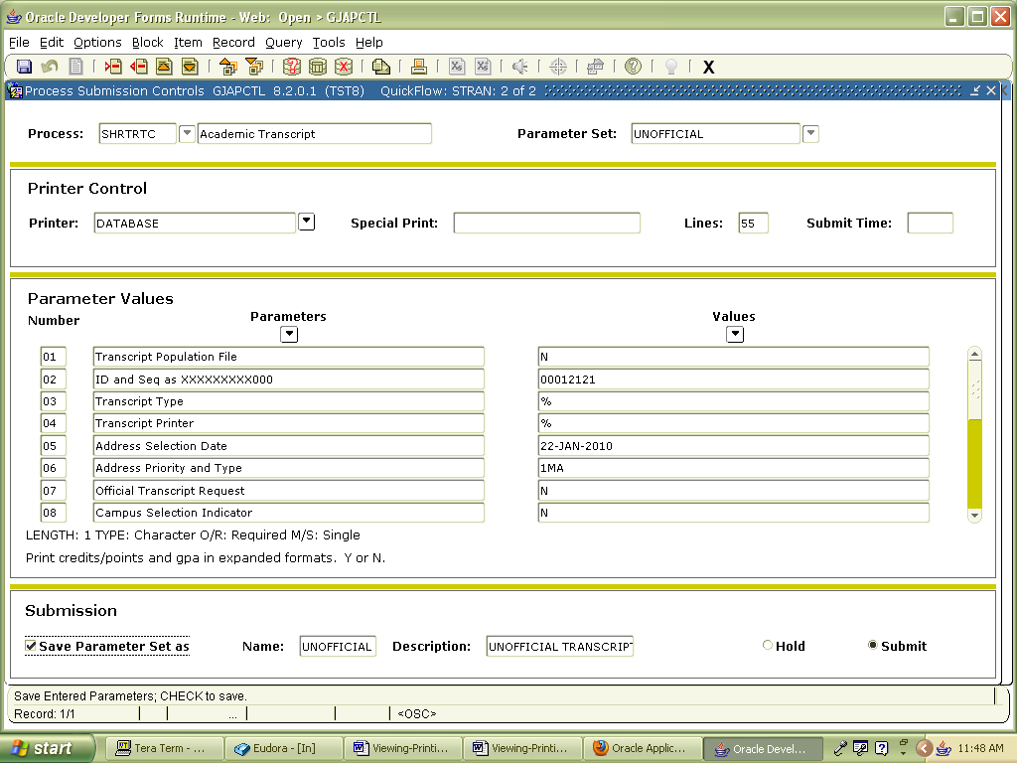

- Click on Options and then click on Review Output
- The system will then take you to GJIREVO
- Double click on the File Name field
- A report will appear with a few files on it. Click on the first file and then click on the OK button
- The transcript you requested should now appear.
- If you would like to view the unofficial transcript in a more user friendly way, Click on Options and then click on Show Document (Save and Print File)
- A box will appear stating You have selected to Show File…. Just click on the Yes button.
- Once you are done reviewing the transcript, exit out.

(Example of GJIREVO before the transcript appears)

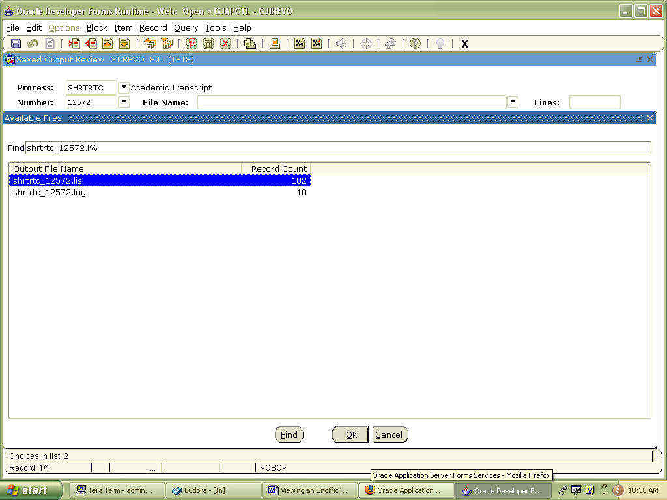

FYI: Once you have printed or viewed the transcript and cancel out, you must go through the whole QuickFlow process again if you would like to view it or print it again.

Updated on February 11, 2010

